Lattice Structure EDM Project — Full Report
Phase 1 & 2 analysis, geometry (pore 235.6 um, tool 900 um), 16 lab runs, SEM validation, and final EDM recommendations.

1. Introduction
Goal: nearly circular machined pore with continuous supporting-material (black) boundary. Nodes may be destroyed. Tool 900 um; pore 235.6 um; unit cell 500 um; tool/pore ratio 3.82.

2. Geometry
Lattice geometry
parameter | value_um | source | notes
unit_cell_side | 500 | SEM scale bar / user calculation | Width of square unit cell
pore_diameter | 235.6 | user calculation | 3x = 500*sqrt(2); x = 235.6 um
node_diameter_assumed | 235.6 | user assumption | pore diameter = node diameter = x
unit_cell_diagonal | 707.1 | calculated | 500 * sqrt(2)
tool_tip_diameter | 900 | lab document / handwritten notes | EDM electrode
tool_to_pore_diameter_ratio | 3.82 | calculated | 900 / 235.6 - tool much larger than pore
pore_radius | 117.8 | calculated | 235.6 / 2
tool_radius | 450 | calculated | 900 / 2
working_area_3x3_cells | 1500 | calculated | 3 unit cells for 900 um tool footprint
clearance_if_centered | -332.2 | calculated | tool_radius - pore_radius (overlap into nodes/struts)

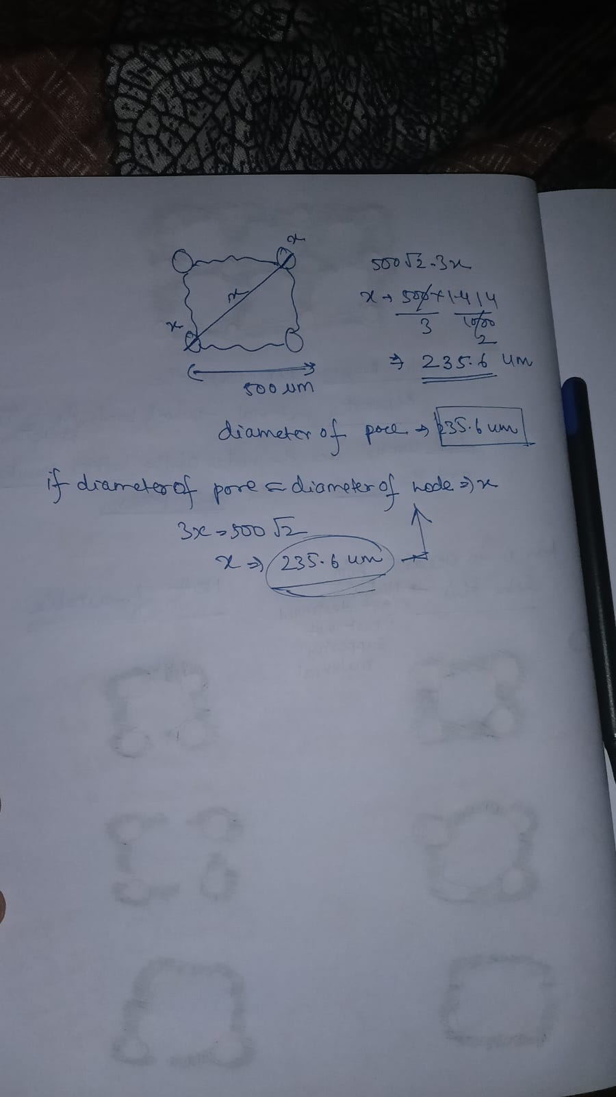
Figure 5: Pore diameter 235.6 um calculation

3. Problem diagrams
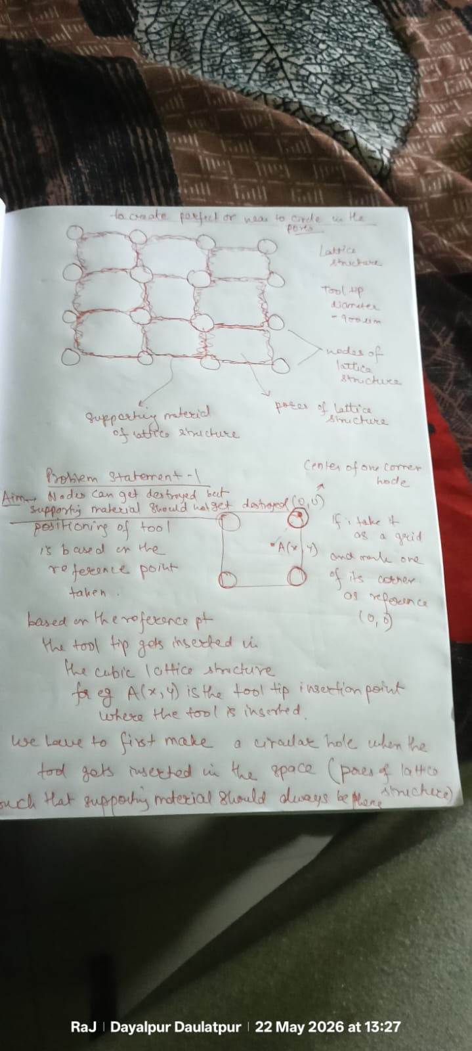
Figure 1: Lattice structure, 900 um tool, reference (0,0)

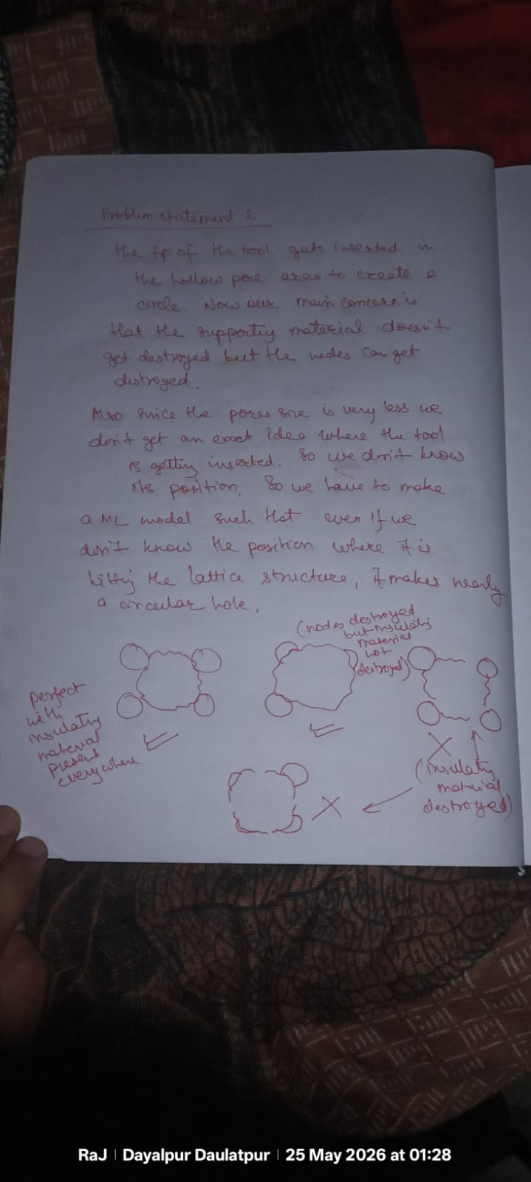
Figure 2: Unknown tool position — Phase 1

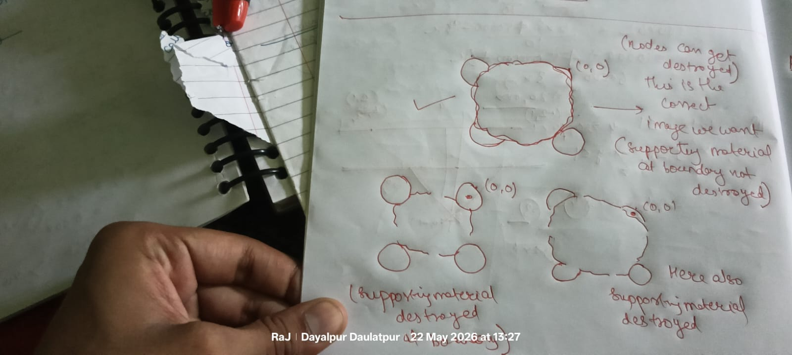
Figure 3: Favourable vs unfavourable outcomes

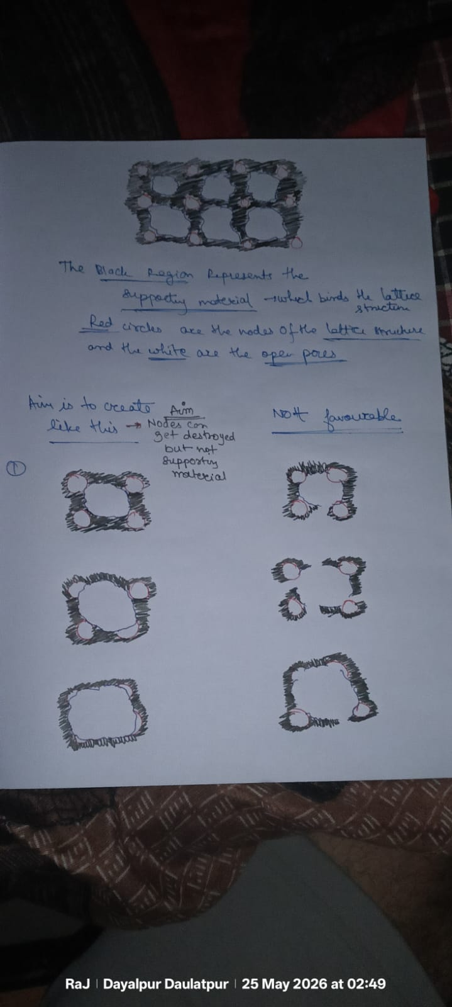
Figure 4: Target — black supporting ring circular

4. LLM / grid ideation
Phase 2 working area: 3x3 unit cells = 1500 x 1500 um (tool exceeds single 500 um cell). Grid points (a,b) map tool landing positions for circularity prediction.
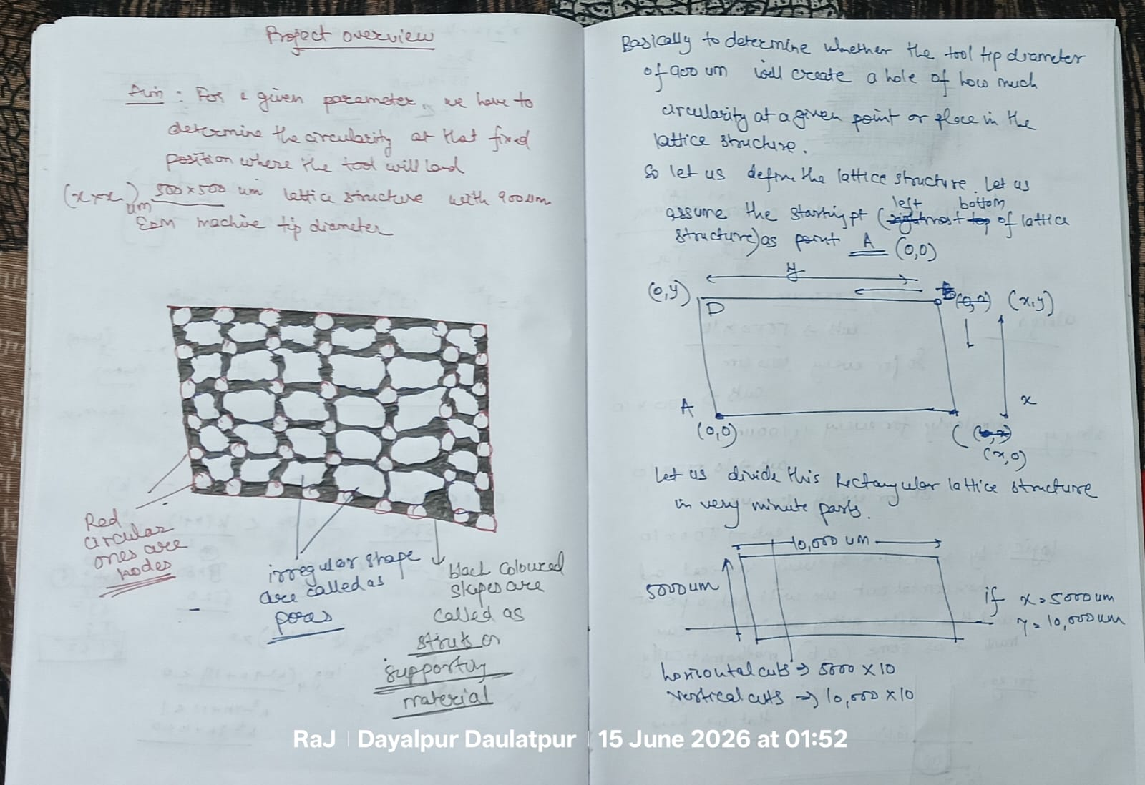
Figure 6: Project overview — 500 um unit cell, grid logic

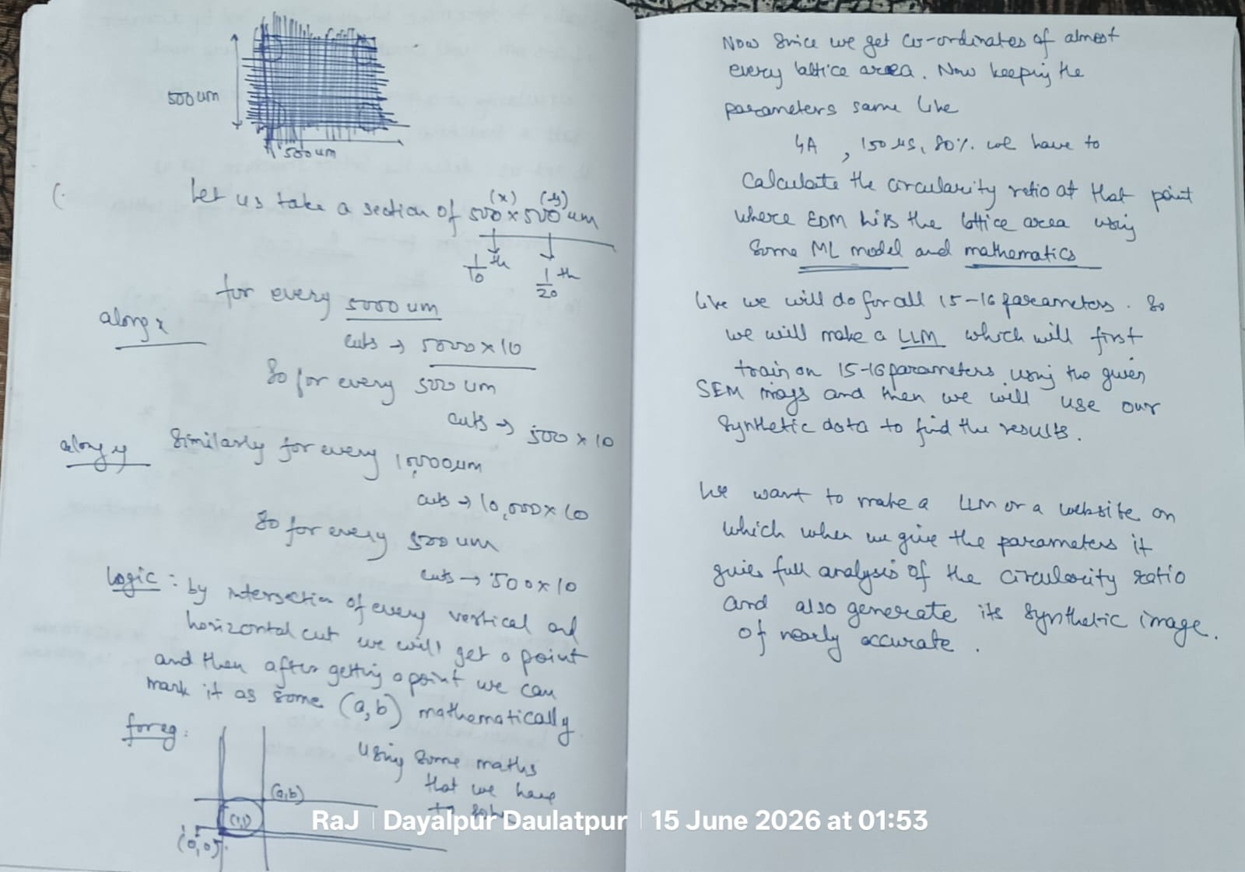
Figure 7: Grid subdivision and ML circularity map idea

5. Experimental data
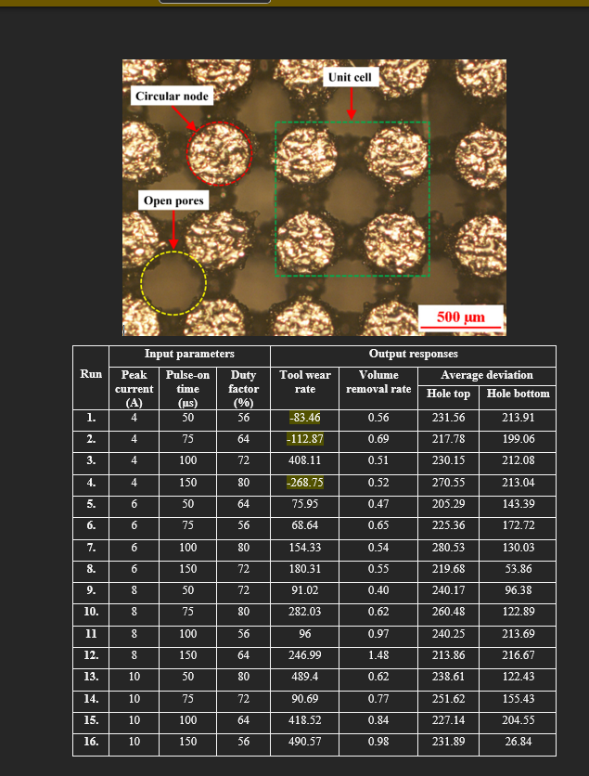
Figure 8: Lattice unit cell and 16-run data table

16 experimental runs
Run | Peak_Current_A | Pulse_On_Time_us | Duty_Factor_pct | Tool_Wear_Rate | Volume_Removal_Rate | Hole_Dev_Top_um | Hole_Dev_Bottom_um
1 | 4 | 50 | 56 | -83.46 | 0.56 | 231.56 | 213.91
2 | 4 | 75 | 64 | -112.87 | 0.69 | 217.78 | 199.06
3 | 4 | 100 | 72 | 408.11 | 0.51 | 230.15 | 212.08
4 | 4 | 150 | 80 | -268.75 | 0.52 | 270.55 | 213.04
5 | 6 | 50 | 64 | 75.95 | 0.47 | 205.29 | 143.39
6 | 6 | 75 | 56 | 68.64 | 0.65 | 225.36 | 172.72
7 | 6 | 100 | 80 | 154.33 | 0.54 | 280.53 | 130.03
8 | 6 | 150 | 72 | 180.31 | 0.55 | 219.68 | 53.86
9 | 8 | 50 | 72 | 91.02 | 0.40 | 240.17 | 96.38
10 | 8 | 75 | 80 | 282.03 | 0.62 | 260.48 | 122.89
11 | 8 | 100 | 56 | 96.00 | 0.97 | 240.25 | 213.69
12 | 8 | 150 | 64 | 246.99 | 1.48 | 213.86 | 216.67
13 | 10 | 50 | 80 | 489.40 | 0.62 | 238.61 | 122.43
14 | 10 | 75 | 72 | 90.69 | 0.77 | 251.62 | 155.43
15 | 10 | 100 | 64 | 418.52 | 0.84 | 227.14 | 204.55
16 | 10 | 150 | 56 | 490.57 | 0.98 | 231.89 | 26.84

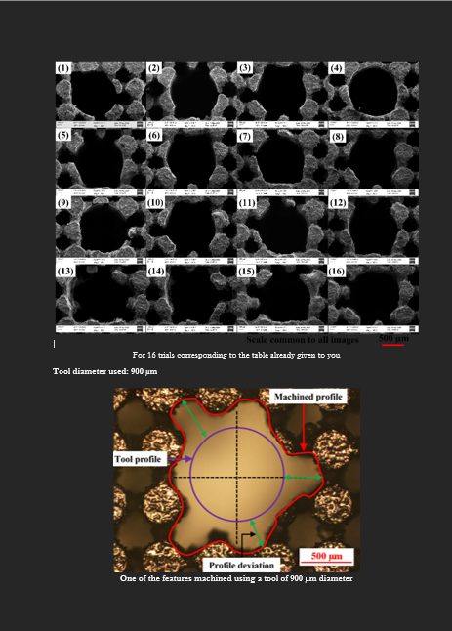
Figure 9: SEM images runs 1-16

SEM visual labels
Run | Boundary_circularity_1to5 | Supporting_boundary_intact | Nodes_damaged_ok | Notes
1 | 1 | 0 | 1 | Irregular boundary; supporting material destroyed
2 | 2 | 0 | 1 | Not circular; boundary damaged
3 | 1 | 0 | 1 | Irregular; supporting destroyed
4 | 5 | 1 | 1 | TARGET: nearly circular hole; supporting material forms circular boundary (SEM reference)
5 | 2 | 0 | 1 | Lower deviation numbers but boundary not circular in SEM
6 | 2 | 0 | 1 | Boundary irregular in SEM
7 | 1 | 0 | 1 | Highly irregular; supporting destroyed
8 | 2 | 0 | 1 | Asymmetric; boundary not circular
9 | 2 | 0 | 1 | Moderate but boundary irregular
10 | 1 | 0 | 1 | Elongated irregular hole; supporting destroyed
11 | 1 | 0 | 1 | Irregular boundary
12 | 2 | 0 | 1 | Similar top/bottom deviation but SEM shows non-circular boundary
13 | 1 | 0 | 1 | Irregular; supporting destroyed
14 | 2 | 0 | 1 | Boundary not circular
15 | 2 | 0 | 1 | Boundary not circular
16 | 1 | 0 | 1 | Highly irregular despite low bottom deviation

6. Methodology
- Extract 16 runs; label SEM (Run 4 = only success)
- Phase 1: unknown position — GP + LOOCV on boundary circularity
- Phase 2: known (x,y) in 1500 um working area
- Compare with/without SEM images
- Scripts: phase1_model_actual.py, phase1_model.py

7. Final results
Phase 1 WITH images: 4 A, 150 us, 80 % (Run 4)
Phase 1 WITHOUT images: 6 A, 50 us, 64 % — NOT recommended
Phase 2 WITH images: 4 A at center; 3.5 A near struts
Recommended trials
Phase | Use_SEM_images | Position | Peak_Current_A | Pulse_On_Time_us | Duty_Factor_pct | Pore_diameter_um | Tool_diameter_um | Priority | Notes
1 | Yes | Unknown | 4 | 150 | 80 | 235.6 | 900 | PRIMARY | Run 4 - tool/pore ratio 3.82
1 | Yes | Unknown | 3.5 | 150 | 80 | 235.6 | 900 | Secondary | Softer for small pore
1 | Yes | Unknown | 4 | 140 | 78 | 235.6 | 900 | Secondary | Near Run 4
1 | No | Unknown | 6 | 50 | 64 | 235.6 | 900 | Not recommended | Deviation only - breaks boundary
2 | Yes | Center | 4 | 150 | 80 | 235.6 | 900 | PRIMARY | Pore center in 500um cell
2 | Yes | Near strut | 3.5 | 150 | 78 | 235.6 | 900 | PRIMARY | 900um tool near 500um strut
2 | Yes | Near node_0_0 | 3.5 | 145 | 76 | 235.6 | 900 | PRIMARY | Corner reference
2 | Yes | Mid pore | 4 | 148 | 79 | 235.6 | 900 | Secondary | Between center and strut
2 | No | Center | 6 | 100 | 64 | 235.6 | 900 | Not recommended | No SEM validation

8. Conclusion
Use Run 4 parameters with fine feed and stable gap. Synthetic 1100 points are AI-generated, not independent lab data. Future: web tool for circularity heatmap over 1500x1500 um grid.

