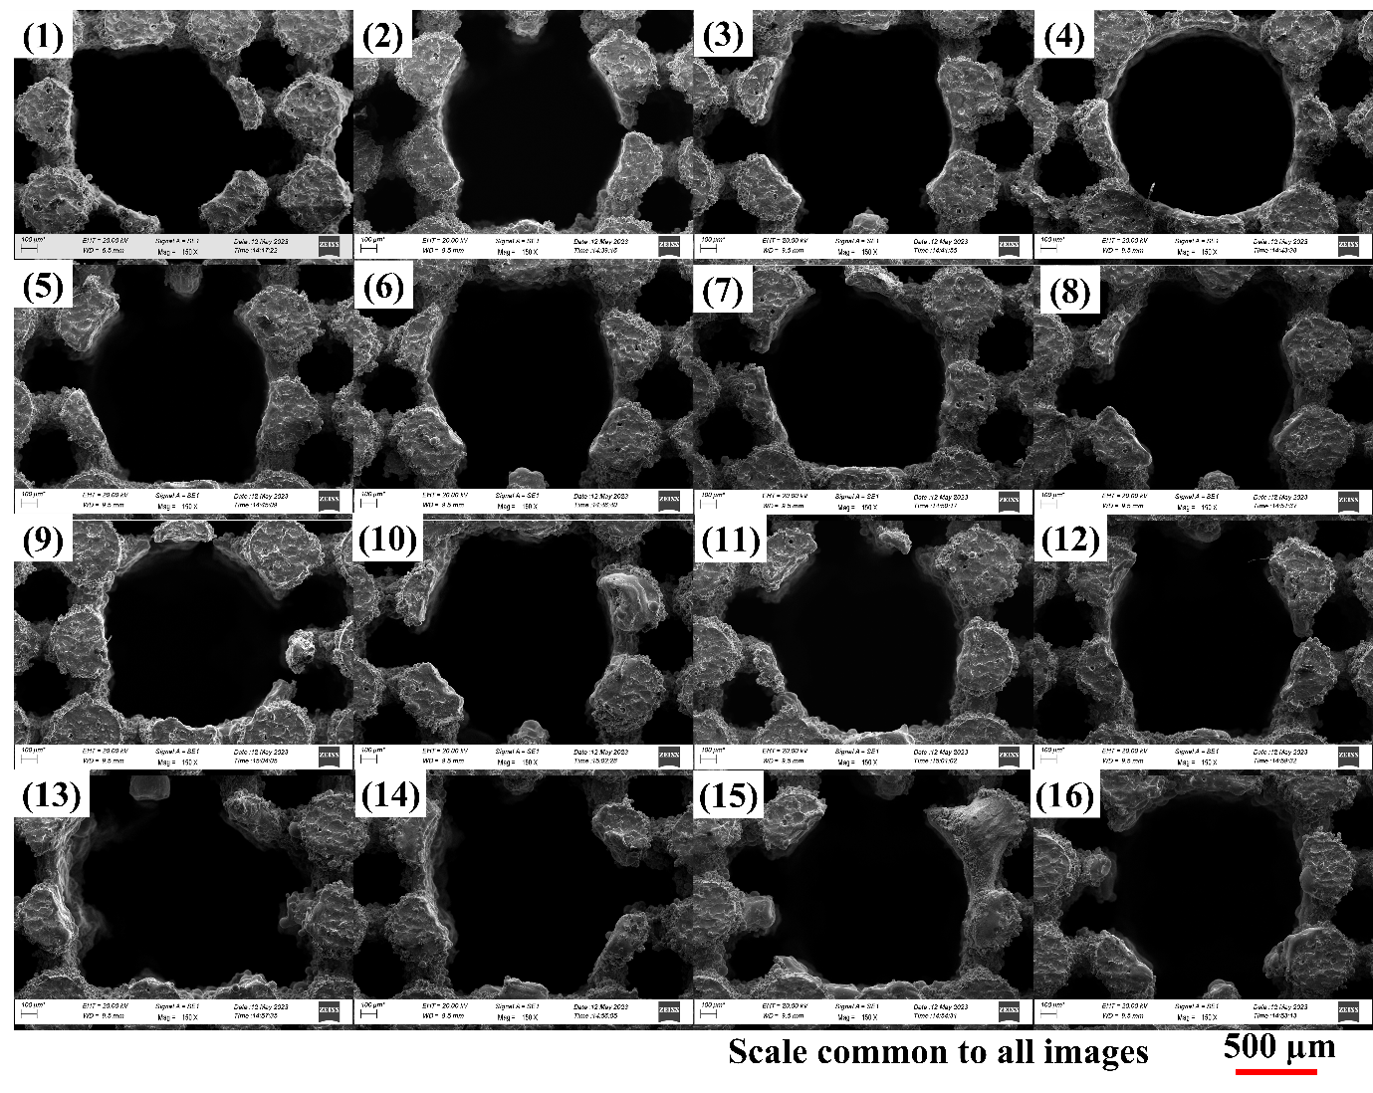
For 16 trials corresponding to the table already given to you
Tool diameter used: 900 µm

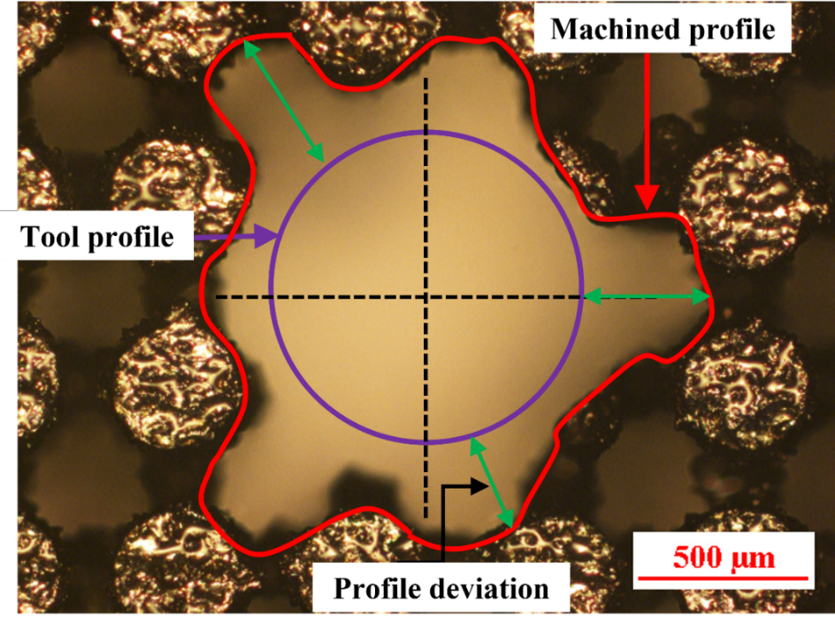
One of the features machined using a tool of 900 µm diameter

