
IP FABRICS: COLLAPSED CORE

Anurag Shekhar
TOPOLOGY

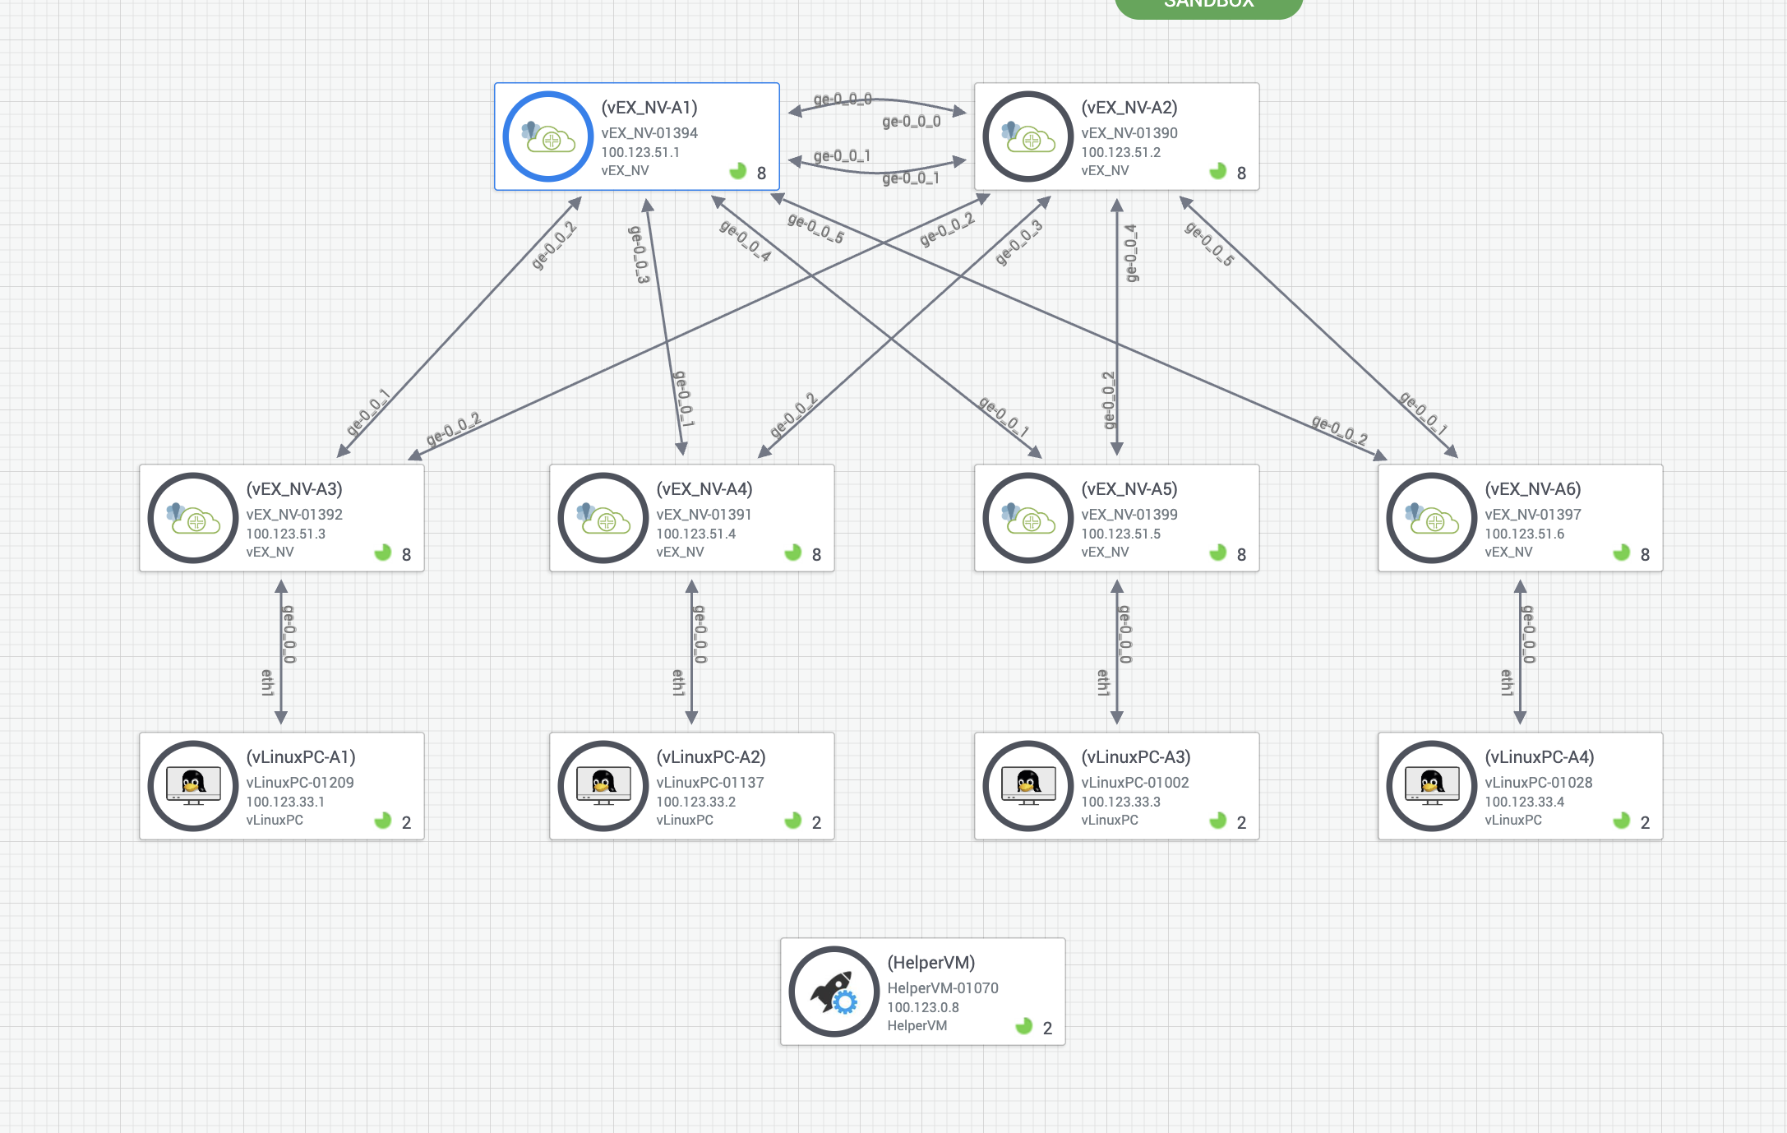

RFC:
https://datatracker.ietf.org/doc/html/rfc8365
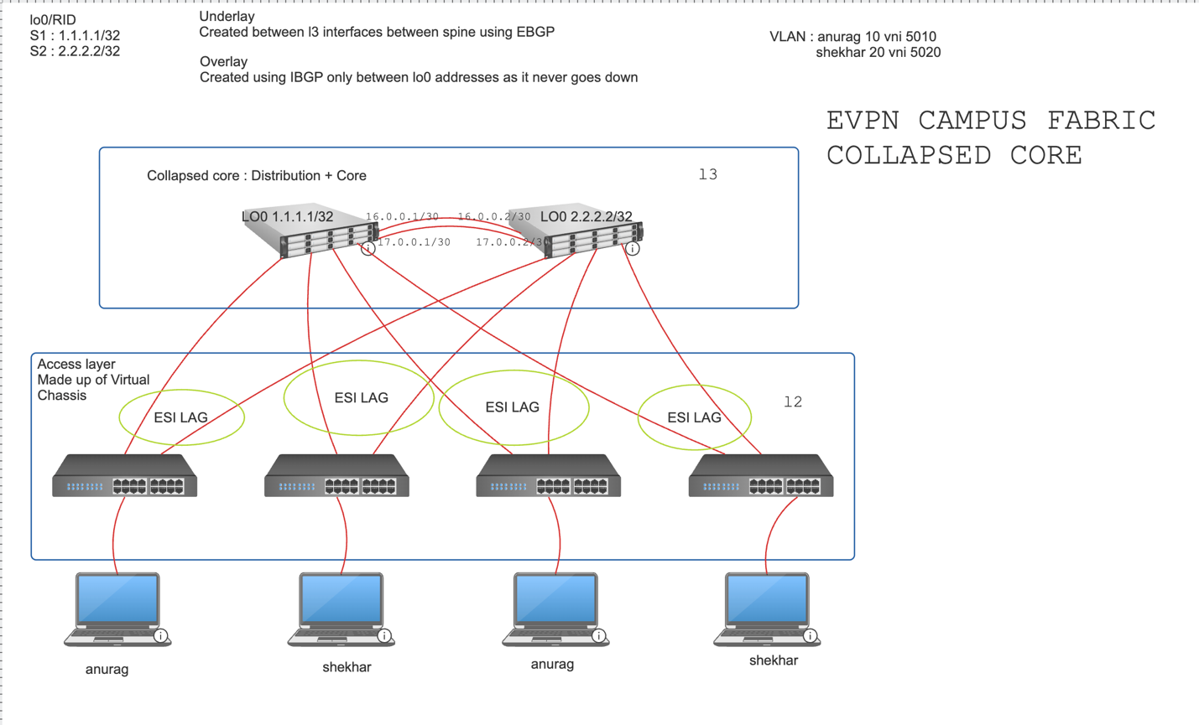

[Chapter 1] — COLLAPSED CORE CAMPUS FABRIC
This is one of the models offered by HPE Juniper for campus use. As the name suggest collapsed core means, we have one layer that works both as a core and aggregation/distribution. This model is quite simple and have only two layers collapsed core and access. All the L3 is in the collapsed core switch while the access switches are pure L2. Also note that to achieve load balancing, redundancy and smooth movement of users across the location in the campus we will use ESI-LAG, each access switches are multihomed to all the spine switches.



The main work will only be done on the two spine switches. Please check the above diagram to get parameters for this design. Let us start the build.
SPINE 1 CONFIG:

---------------------------------------------------------------------------------------------------------------------
EBGP UNDERLAY : THE PRIMARY PURPOSE IS TO MAKE THE LO0 OF BOTH THE SPINES REACHABLE : PING SHOULD BE SUCCESSFUL

[edit]

interfaces {
ge-0/0/0 {
These are the L3 interfaces that is connecting the two spines. We want to connect them to avoid split brain behavior
unit 0 {
family inet {
address 16.0.0.1/30;
}
}
}
ge-0/0/1 {
unit 0 {
family inet {
address 17.0.0.1/30;
}
}
}

lo0 {
Best practice to keep the lo0 and Router id same
unit 0 {
family inet {
address 1.1.1.1/32;
}
}
}
}
routing-options {
router-id 1.1.1.1;
autonomous-system 2000;
}

[edit]
protocols {
Note that EBGP import everything but do not export anything by default. We only want to advertise/export lo0 in underlay for security reasons and that is why we must set export policy
bgp {
group EBGP_UNDERLAY {
type external;
peer-as 6000;
local-as 5000;
export ADV-LO0;
neighbor 16.0.0.2 {
local-address 16.0.0.1;
}
neighbor 17.0.0.2 {
local-address 17.0.0.1;
}
}
}
}

Export policy using route filter to only advertise/export lo0 addresses
policy-options {
policy-statement ADV-LO0 {
term 1 {
from {
protocol direct;
route-filter 1.1.1.1/32 exact;
}
then accept;
}
}
}

---------------------------------------------------------------------------------------------------------------------
VALIDATION

jcluser@spine1> show bgp summary

Warning: License key missing; requires 'bgp' license

Threading mode: BGP I/O
Default eBGP mode: advertise - accept, receive - accept
Groups: 1 Peers: 2 Down peers: 0
Table Tot Paths Act Paths Suppressed History Damp State Pending
inet.0
2 1 0 0 0 0
Peer AS InPkt OutPkt OutQ Flaps Last Up/Dwn State|#Active/Received/Accepted/Damped...
16.0.0.2 6000 49 47 0 0 20:46 Establ
inet.0: 1/1/1/0
17.0.0.2 6000 49 47 0 0 20:42 Establ
inet.0: 0/1/1/0
As you can see above, both EBGP peering have been established.

jcluser@spine1> show route

inet.0: 6 destinations, 7 routes (6 active, 0 holddown, 0 hidden)
Limit/Threshold: 1048576/1048576 destinations
+ = Active Route, - = Last Active, * = Both

1.1.1.1/32 *[Direct/0] 00:31:41
> via lo0.0
2.2.2.2/32 *[BGP/170] 00:11:08, localpref 100
AS path: 6000 I, validation-state: unverified
> to 16.0.0.2 via ge-0/0/0.0
[BGP/170] 00:11:08, localpref 100
AS path: 6000 I, validation-state: unverified
> to 17.0.0.2 via ge-0/0/1.0
16.0.0.0/30 *[Direct/0] 00:31:41
> via ge-0/0/0.0
16.0.0.1/32 *[Local/0] 00:31:41
Local via ge-0/0/0.0
17.0.0.0/30 *[Direct/0] 00:31:41
> via ge-0/0/1.0
17.0.0.1/32 *[Local/0] 00:31:41
Local via ge-0/0/1.0

mgmt_junos.inet.0: 3 destinations, 4 routes (3 active, 0 holddown, 0 hidden)
+ = Active Route, - = Last Active, * = Both

0.0.0.0/0 *[Static/5] 00:51:04
> to 100.123.0.1 via fxp0.0
[Access-internal/12] 00:51:03, metric 0
> to 100.123.0.1 via fxp0.0
100.123.0.0/16 *[Direct/0] 00:51:04
> via fxp0.0
100.123.51.1/32 *[Local/0] 00:51:04
Local via fxp0.0

If you see above we have now routes to the loopbacks of both the spines. 1.1.1.1/32 is the local lo0, so it is direct and the spine 2 lo0 2.2.2.2/32 has two paths of same local preference of 100, this effectively load balance the traffic between the two links. Also note the 6000 I, it means you are going from one AS to another.

jcluser@spine1> show route advertising-protocol bgp 16.0.0.2

Warning: License key missing; requires 'bgp' license

inet.0: 6 destinations, 7 routes (6 active, 0 holddown, 0 hidden)
Limit/Threshold: 1048576/1048576 destinations
Prefix Nexthop MED Lclpref AS path
* 1.1.1.1/32 Self

jcluser@spine1> show route advertising-protocol bgp 17.0.0.2

Warning: License key missing; requires 'bgp' license

inet.0: 6 destinations, 7 routes (6 active, 0 holddown, 0 hidden)
Limit/Threshold: 1048576/1048576 destinations
Prefix Nexthop MED Lclpref AS path
* 1.1.1.1/32 Self

This command show that what your router is exporting to its neighbour, as expected it is exporting the lo0 of the spine 1

jcluser@spine1> show route receive-protocol bgp 16.0.0.2

Warning: License key missing; requires 'bgp' license

inet.0: 6 destinations, 7 routes (6 active, 0 holddown, 0 hidden)
Limit/Threshold: 1048576/1048576 destinations
Prefix Nexthop MED Lclpref AS path
* 2.2.2.2/32 16.0.0.2 6000 I

mgmt_junos.inet.0: 3 destinations, 4 routes (3 active, 0 holddown, 0 hidden)

jcluser@spine1> show route receive-protocol bgp 17.0.0.2

Warning: License key missing; requires 'bgp' license

inet.0: 6 destinations, 7 routes (6 active, 0 holddown, 0 hidden)
Limit/Threshold: 1048576/1048576 destinations
Prefix Nexthop MED Lclpref AS path
2.2.2.2/32 17.0.0.2 6000 I

mgmt_junos.inet.0: 3 destinations, 4 routes (3 active, 0 holddown, 0 hidden)

This command show that what your router is receiving from its neighbour, as expected it is receiving the lo0 of the spine 2

SPINE 2 CONFIG:
These are the L3 interfaces that is connecting the two spines. We want to connect them to avoid split brain behavior

[edit]
interfaces {
ge-0/0/0 {
unit 0 {
family inet {
address 16.0.0.2/30;
}
}
}
ge-0/0/1 {
unit 0 {
family inet {
address 17.0.0.2/30;
}
}

}
Best practice to keep the lo0 and Router id same
lo0 {
unit 0 {
family inet {
address 2.2.2.2/32;
}
}
}
}
routing-options {
router-id 2.2.2.2;
autonomous-system 2000;
}

protocols {
bgp {
group EBGP_UNDERLAY {
type external;
Note that EBGP import everything but do not export anything by default. We only want to advertise/export lo0 in underlay for security reasons and that is why we must set export policy
peer-as 5000;
local-as 6000;
export ADV-LO0;
neighbor 16.0.0.1 {
local-address 16.0.0.2;
}
neighbor 17.0.0.1 {
local-address 17.0.0.2;
}
}
}
}
policy-options {
Export policy using route filter to only advertise/export lo0 addresses

policy-statement ADV-LO0 {
term 1 {
from {
protocol direct;
route-filter 2.2.2.2/32 exact;
}
then accept;
}
}
}

---------------------------------------------------------------------------------------------------------------------
VALIDATION
---------------------------------------------------------------------------------------------------------------------

jcluser@spine2> show bgp summary

Warning: License key missing; requires 'bgp' license

Threading mode: BGP I/O
Default eBGP mode: advertise - accept, receive - accept
Groups: 1 Peers: 2 Down peers: 0
Table Tot Paths Act Paths Suppressed History Damp State Pending
inet.0
2 1 0 0 0 0
Peer AS InPkt OutPkt OutQ Flaps Last Up/Dwn State|#Active/Received/Accepted/Damped...
16.0.0.1 5000 77 76 0 0 33:16 Establ
inet.0: 1/1/1/0
17.0.0.1 5000 77 76 0 0 33:12 Establ
inet.0: 0/1/1/0

As you can see above, both EBGP peering have been established.

jcluser@spine2> show route

inet.0: 6 destinations, 7 routes (6 active, 0 holddown, 0 hidden)
Limit/Threshold: 1048576/1048576 destinations
+ = Active Route, - = Last Active, * = Both

1.1.1.1/32 *[BGP/170] 00:28:04, localpref 100
AS path: 5000 I, validation-state: unverified
> to 16.0.0.1 via ge-0/0/0.0
[BGP/170] 00:28:04, localpref 100
AS path: 5000 I, validation-state: unverified
> to 17.0.0.1 via ge-0/0/1.0
2.2.2.2/32 *[Direct/0] 00:44:17
> via lo0.0
16.0.0.0/30 *[Direct/0] 00:44:17
> via ge-0/0/0.0
16.0.0.2/32 *[Local/0] 00:44:17
Local via ge-0/0/0.0
17.0.0.0/30 *[Direct/0] 00:44:17
> via ge-0/0/1.0
17.0.0.2/32 *[Local/0] 00:44:17
Local via ge-0/0/1.0

mgmt_junos.inet.0: 3 destinations, 4 routes (3 active, 0 holddown, 0 hidden)
+ = Active Route, - = Last Active, * = Both

0.0.0.0/0 *[Static/5] 01:03:28
> to 100.123.0.1 via fxp0.0
[Access-internal/12] 01:03:28, metric 0
> to 100.123.0.1 via fxp0.0
100.123.0.0/16 *[Direct/0] 01:03:28
> via fxp0.0
100.123.51.2/32 *[Local/0] 01:03:28
Local via fxp0.0

If you see above we have now routes to the loopbacks of both the spines. 2.2.2.2/32 is the local lo0, so it is direct and the spine 1 lo0 1.1.1.1/32 has two paths of same local preference of 100, this effectively load balance the traffic between the two links. Also note the 5000 I, it means you are going from one AS to another.

jcluser@spine2> show route advertising-protocol bgp 16.0.0.1

Warning: License key missing; requires 'bgp' license

inet.0: 6 destinations, 7 routes (6 active, 0 holddown, 0 hidden)
Limit/Threshold: 1048576/1048576 destinations
Prefix Nexthop MED Lclpref AS path

* 2.2.2.2/32 Self I

jcluser@spine2> show route advertising-protocol bgp 17.0.0.1

Warning: License key missing; requires 'bgp' license

inet.0: 6 destinations, 7 routes (6 active, 0 holddown, 0 hidden)
Limit/Threshold: 1048576/1048576 destinations
Prefix Nexthop MED Lclpref AS path
* 2.2.2.2/32 Self I

This command show that what your router is exporting to its neighbour, as expected it is exporting the lo0 of the spine 2

jcluser@spine2> show route receive-protocol bgp 16.0.0.1

Warning: License key missing; requires 'bgp' license

inet.0: 6 destinations, 7 routes (6 active, 0 holddown, 0 hidden)
Limit/Threshold: 1048576/1048576 destinations
Prefix Nexthop MED Lclpref AS path
* 1.1.1.1/32 16.0.0.1 5000 I

mgmt_junos.inet.0: 3 destinations, 4 routes (3 active, 0 holddown, 0 hidden)

jcluser@spine2> show route receive-protocol bgp 17.0.0.1

Warning: License key missing; requires 'bgp' license

inet.0: 6 destinations, 7 routes (6 active, 0 holddown, 0 hidden)
Limit/Threshold: 1048576/1048576 destinations

Prefix Nexthop MED Lclpref AS path
1.1.1.1/32 17.0.0.1 5000 I

mgmt_junos.inet.0: 3 destinations, 4 routes (3 active, 0 holddown, 0 hidden)

This command show that what your router is receiving from its neighbour, as expected it is receiving the lo0 of the spine 1

---------------------------------------------------------------------------------------------------------------------
IBGP OVERLAY : IT WILL ONLY BE SET BETWEEN THE LO0 OF BOTH THE SPINES

SPINE 1
[edit protocols]
WE ARE USING MP BGP WITH EVPN SIGNALING: THIS TYPE OF BGP WILL BE ABLE TO CARRY EVPN ATTRIBUTES
bgp {
group IBGP_OVERLAY {
type internal;
local-address 1.1.1.1;
family evpn {
signaling;
}
cluster 1.1.1.1;
neighbor 2.2.2.2;
}
}

jcluser@spine1> show bgp summary

Warning: License key missing; requires 'bgp' license

Threading mode: BGP I/O
Default eBGP mode: advertise - accept, receive - accept
Groups: 2 Peers: 3 Down peers: 0
Table Tot Paths Act Paths Suppressed History Damp State Pending
inet.0
2 1 0 0 0 0
bgp.evpn.0
24 24 0 0 0 0
Peer AS InPkt OutPkt OutQ Flaps Last Up/Dwn State|#Active/Received/Accepted/Damped...
2.2.2.2 2000 1264 1281 0 1 9:17:45 Establ
bgp.evpn.0: 24/24/24/0
default-switch.evpn.0: 22/22/22/0
__default_evpn__.evpn.0: 2/2/2/0
16.0.0.2 6000 1352 1348 0 0 10:09:19 Establ
inet.0: 1/1/1/0
17.0.0.2 6000 1351 1347 0 0 10:09:15 Establ
inet.0: 0/1/1/0

SPINE 2
WE ARE USING MP BGP WITH EVPN SIGNALING: THIS TYPE OF BGP WILL BE ABLE TO CARRY EVPN ATTRIBUTES
[edit protocols]
bgp {
group IBGP_OVERLAY {
type internal;
local-address 2.2.2.2;
family evpn {
signaling;
}
cluster 1.1.1.1;
neighbor 1.1.1.1;
}
}

jcluser@spine2> show bgp summary

Warning: License key missing; requires 'bgp' license

Threading mode: BGP I/O
Default eBGP mode: advertise - accept, receive - accept
Groups: 2 Peers: 3 Down peers: 0
Table Tot Paths Act Paths Suppressed History Damp State Pending
inet.0
2 1 0 0 0 0
bgp.evpn.0
24 24 0 0 0 0
Peer AS InPkt OutPkt OutQ Flaps Last Up/Dwn State|#Active/Received/Accepted/Damped...
1.1.1.1 2000 1286 1265 0 0 9:19:12 Establ
bgp.evpn.0: 24/24/24/0
default-switch.evpn.0: 22/22/22/0
__default_evpn__.evpn.0: 2/2/2/0
16.0.0.1 5000 1352 1353 0 0 10:10:45 Establ
inet.0: 1/1/1/0
17.0.0.1 5000 1352 1352 0 0 10:10:41 Establ
inet.0: 0/1/1/0

---------------------------------------------------------------------------------------------------------------------
VLAN VXLAN EVPN

SPINE 1
There are two vlans named on my two-name Anurag and Shekhar. I have mapped them to their respective vnis

vlans {
anurag {
vlan-id 10;
l3-interface irb.10;
vxlan {
vni 5010;
ingress-node-replication;
There is a lot about ingress node replication: Check it in official Juniper documentation. Related to flooding optimization and recommendation is not to use this keyword. If this keyword is added/removed from active network, outage will happen and the network will reconverge
}
}
shekhar {
vlan-id 20;
l3-interface irb.20;
vxlan {
vni 5020;
ingress-node-replication;
}
}
}
switch-options {
Route distinguisher tells that the routes advertised in from the switch with lo0 1.1.1.1.
Also vxlan encapsulation happens at the lo0 which is the vtep. This is the start of the vxlan tunnel
vtep-source-interface lo0.0;
route-distinguisher 1.1.1.1:2000;
vrf-target target:2000:100;
}
evpn {
encapsulation vxlan;
multicast-mode ingress-replication;
vni-options {
vni 5010 {
EVPN has many algorithms for encapsulation, we are using here is VXLAN.
vrf-target target:2000:5010;
}
vni 5020 {
vrf-target target:2000:5020;
}
}
extended-vni-list [ 5010 5020 ];

SPINE 2

vlans {
anurag {
vlan-id 10;
l3-interface irb.10;
vxlan {
vni 5010;
ingress-node-replication;
}
}
shekhar {
vlan-id 20;
l3-interface irb.20;
vxlan {
vni 5020;
ingress-node-replication;
}
}
}
switch-options {
vtep-source-interface lo0.0;
route-distinguisher 2.2.2.2:2000;
vrf-target target:2000:100;
}
evpn {
encapsulation vxlan;
multicast-mode ingress-replication;
vni-options {
vni 5010 {
vrf-target target:2000:5010;
}
vni 5020 {
vrf-target target:2000:5020;
}
}
extended-vni-list [ 5010 5020 ];

---------------------------------------------------------------------------------------------------------------------
SETTING UP ESI LAG

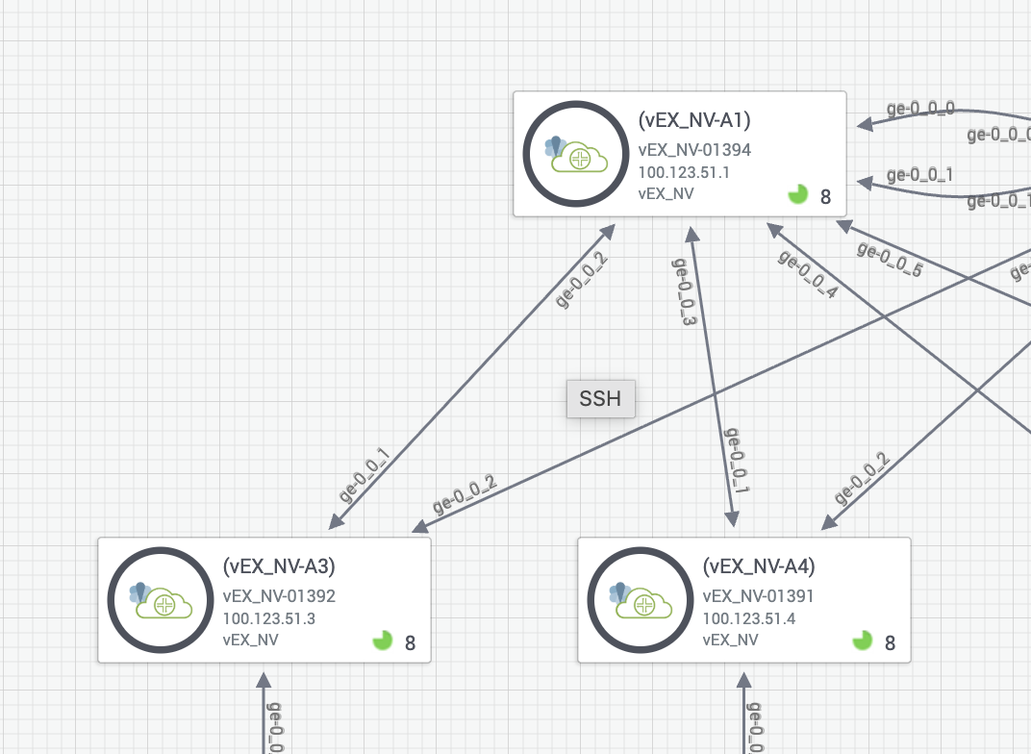
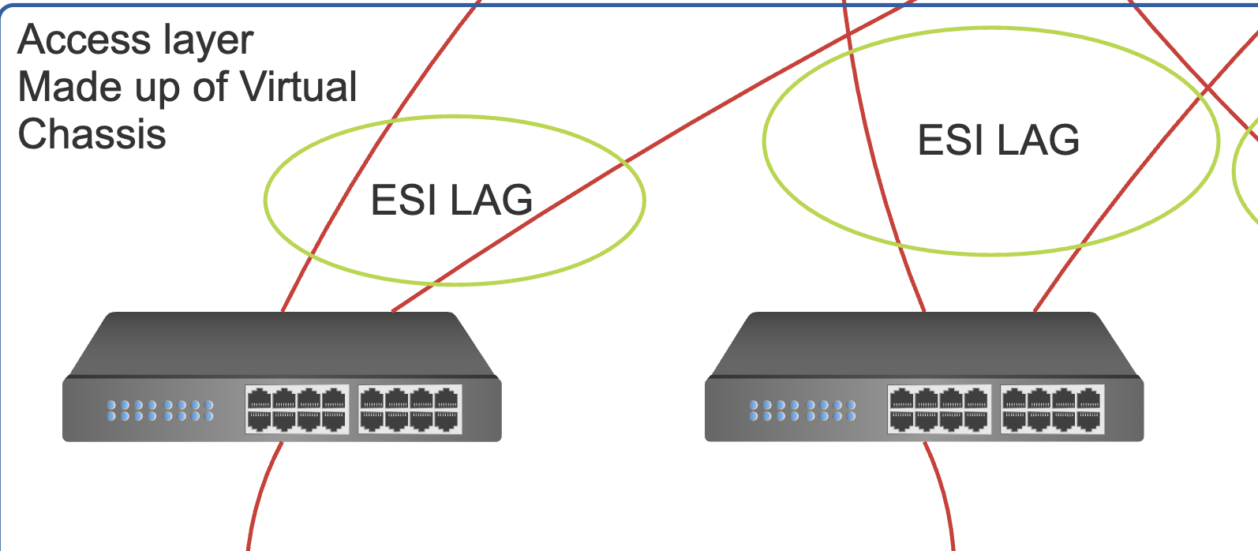

SPINE 1
jcluser@spine1> show configuration interfaces ge-0/0/2
gigether-options {
802.3ad ae0;
}

jcluser@spine1> show configuration interfaces ge-0/0/3
gigether-options {
802.3ad ae1;
}
jcluser@spine1> show configuration interfaces ae0
Separate esi and lacp system id for each ae but it must match for same ae in different spine. These are in hex
esi {
00:11:22:33:44:55:66:77:88:99;
all-active;
}
aggregated-ether-options {
lacp {
active;
system-id 00:00:00:11:11:11;
}
}
unit 0 {
family ethernet-switching {
interface-mode trunk;
vlan {
members [ anurag shekhar ];
}
}
}

jcluser@spine1> show configuration interfaces ae1
esi {
00:11:22:33:44:55:66:77:88:aa;
all-active;
}
aggregated-ether-options {
lacp {
active;
system-id 00:00:11:11:11:11;
}
}
unit 0 {
family ethernet-switching {
interface-mode trunk;
vlan {
members [ anurag shekhar ];
}
}
}

SPINE 2
jcluser@spine2> show configuration interfaces ge-0/0/2
gigether-options {
802.3ad ae0;
}

jcluser@spine2> show configuration interfaces ge-0/0/3
gigether-options {
802.3ad ae1;
}

jcluser@spine2> show configuration interfaces ae0
esi {
00:11:22:33:44:55:66:77:88:99;
all-active;
}
aggregated-ether-options {
lacp {
active;
system-id 00:00:00:11:11:11;
}
}
unit 0 {
family ethernet-switching {
interface-mode trunk;
vlan {
members [ anurag shekhar ];
}
}
}
jcluser@spine2> show configuration interfaces ae1
esi {
00:11:22:33:44:55:66:77:88:aa;
all-active;
}
aggregated-ether-options {
lacp {
active;
system-id 00:00:11:11:11:11;
}
}
unit 0 {
family ethernet-switching {
interface-mode trunk;
vlan {
members [ anurag shekhar ];
}
}
}
ACCESS 1
jcluser@vEX_NV> show configuration interfaces ae0
aggregated-ether-options {
lacp {
active;
}
}
unit 0 {
family ethernet-switching {
interface-mode trunk;
vlan {
members [ anurag shekhar ];
}
}
}
jcluser@vEX_NV> show configuration interfaces ge-0/0/1
gigether-options {
802.3ad ae0;
}

jcluser@vEX_NV> show configuration interfaces ge-0/0/2
gigether-options {
802.3ad ae0;
}
jcluser@vEX_NV> show configuration vlans
anurag {
vlan-id 10;
}
shekhar {
vlan-id 20;
}

ACCESS 2
jcluser@vEX_NV> show configuration interfaces ae1
aggregated-ether-options {
lacp {
active;
}
}
unit 0 {
family ethernet-switching {
interface-mode trunk;
vlan {
members [ anurag shekhar ];
}
}
}
jcluser@vEX_NV> show configuration interfaces ge-0/0/1
gigether-options {
802.3ad ae1;
}

jcluser@vEX_NV> show configuration interfaces ge-0/0/2
gigether-options {
802.3ad ae1;
}
jcluser@vEX_NV> show configuration vlans
anurag {
vlan-id 10;
}
shekhar {
vlan-id 20;
}
---------------------------------------------------------------------------------------------------------------------
ESI VALIDATION

SPINE 1
jcluser@spine1> show lacp interfaces
Aggregated interface: ae0
LACP state: Role Exp Def Dist Col Syn Aggr Timeout Activity
ge-0/0/2 Actor No No Yes Yes Yes Yes Fast Active
ge-0/0/2 Partner No No Yes Yes Yes Yes Fast Active
LACP protocol: Receive State Transmit State Mux State
ge-0/0/2 Current Fast periodic Collecting distributing

Aggregated interface: ae1
LACP state: Role Exp Def Dist Col Syn Aggr Timeout Activity
ge-0/0/3 Actor No No Yes Yes Yes Yes Fast Active
ge-0/0/3 Partner No No Yes Yes Yes Yes Fast Active
LACP protocol: Receive State Transmit State Mux State
ge-0/0/3 Current Fast periodic Collecting distributing

jcluser@spine1> show interfaces esi terse
Interface Admin Link Proto Local Remote
esi up up
---------------------------------------------------------------------------------------------------------------------
FABRIC VALIDATION

jcluser@spine1> show evpn database
Instance: default-switch
VLAN DomainId MAC address Active source Timestamp IP address
5010 00:00:5e:00:01:01 05:00:00:07:d0:00:00:13:92:00 May 17 10:44:38 10.10.10.254
5010 00:50:56:be:0d:ff 00:11:22:33:44:55:66:77:88:99 May 17 10:47:33 10.10.10.9
5010 00:50:56:be:29:5c 00:11:22:33:44:55:66:77:88:99 May 17 10:44:38
5010 00:50:56:be:e3:a7 00:11:22:33:44:55:66:77:88:99 May 17 10:44:38
5010 2c:6b:f5:2c:1c:f0 2.2.2.2 May 17 10:44:27 10.10.10.2
5010 2c:6b:f5:65:8a:f0 irb.10 May 17 10:44:38 10.10.10.1
5010 fe:54:00:86:e1:0a 00:11:22:33:44:55:66:77:88:99 May 18 10:28:46
5020 00:00:5e:00:01:01 05:00:00:07:d0:00:00:13:9c:00 May 17 10:44:38 11.11.11.254
5020 00:50:56:be:42:e7 00:11:22:33:44:55:66:77:88:aa May 17 10:45:33 11.11.11.9
5020 2c:6b:f5:2c:1c:f0 2.2.2.2 May 17 10:44:27 11.11.11.2
5020 2c:6b:f5:65:8a:f0 irb.20 May 17 10:44:38 11.11.11.1

jcluser@spine1> show route table bgp.evpn.0

bgp.evpn.0: 49 destinations, 49 routes (49 active, 0 holddown, 0 hidden)
+ = Active Route, - = Last Active, * = Both

1:1.1.1.1:0::112233445566778899::FFFF:FFFF/192 AD/ESI
*[EVPN/170] 1d 02:37:22
Indirect
1:1.1.1.1:0::1122334455667788aa::FFFF:FFFF/192 AD/ESI
*[EVPN/170] 1d 00:50:19
Indirect
1:1.1.1.1:0::05000007d00000139200::FFFF:FFFF/192 AD/ESI
*[EVPN/170] 23:48:29
Indirect
1:1.1.1.1:0::05000007d00000139c00::FFFF:FFFF/192 AD/ESI
*[EVPN/170] 23:48:29
Indirect
1:1.1.1.1:2000::112233445566778899::0/192 AD/EVI
*[EVPN/170] 1d 02:37:23
Indirect
1:1.1.1.1:2000::1122334455667788aa::0/192 AD/EVI
*[EVPN/170] 1d 00:50:21
Indirect

1:2.2.2.2:0::112233445566778899::FFFF:FFFF/192 AD/ESI
*[BGP/170] 1d 02:37:22, localpref 100, from 2.2.2.2
AS path: I, validation-state: unverified
> to 16.0.0.2 via ge-0/0/0.0
1:2.2.2.2:0::1122334455667788aa::FFFF:FFFF/192 AD/ESI
*[BGP/170] 1d 00:50:20, localpref 100, from 2.2.2.2
AS path: I, validation-state: unverified
> to 16.0.0.2 via ge-0/0/0.0
1:2.2.2.2:0::05000007d00000139200::FFFF:FFFF/192 AD/ESI
*[BGP/170] 1d 02:33:32, localpref 100, from 2.2.2.2
AS path: I, validation-state: unverified
> to 16.0.0.2 via ge-0/0/0.0
1:2.2.2.2:0::05000007d00000139c00::FFFF:FFFF/192 AD/ESI
*[BGP/170] 1d 00:44:08, localpref 100, from 2.2.2.2
AS path: I, validation-state: unverified
> to 16.0.0.2 via ge-0/0/0.0
1:2.2.2.2:2000::112233445566778899::0/192 AD/EVI
*[BGP/170] 1d 02:37:23, localpref 100, from 2.2.2.2
AS path: I, validation-state: unverified
> to 16.0.0.2 via ge-0/0/0.0
1:2.2.2.2:2000::1122334455667788aa::0/192 AD/EVI
*[BGP/170] 1d 00:50:21, localpref 100, from 2.2.2.2
AS path: I, validation-state: unverified
> to 16.0.0.2 via ge-0/0/0.0
2:1.1.1.1:2000::5010::00:00:5e:00:01:01/304 MAC/IP
jcluser@spine1> show ethernet-switching table

MAC flags (S - static MAC, D - dynamic MAC, L - locally learned, P - Persistent static, C - Control MAC
SE - statistics enabled, NM - non configured MAC, R - remote PE MAC, O - ovsdb MAC,
B - Blocked MAC)

Ethernet switching table : 8 entries, 8 learned

Routing instance : default-switch
Vlan MAC MAC GBP Logical SVLBNH/ Active
name address flags tag interface VENH Index source
anurag 00:00:5e:00:01:01 DRP esi.604 05:00:00:07:d0:00:00:13:92:00
anurag 00:50:56:be:0d:ff DLR ae0.0
anurag 00:50:56:be:29:5c DLR ae0.0
anurag 00:50:56:be:e3:a7 DLR ae0.0
anurag 2c:6b:f5:2c:1c:f0 DR vtep.32769 2.2.2.2
shekhar 00:00:5e:00:01:01 DRP esi.614 05:00:00:07:d0:00:00:13:9c:00
shekhar 00:50:56:be:42:e7 DLR ae1.0
shekhar 2c:6b:f5:2c:1c:f0 DR vtep.32769 2.2.2.2

jcluser@spine1> show route

inet.0: 14 destinations, 15 routes (14 active, 0 holddown, 0 hidden)
Limit/Threshold: 1048576/1048576 destinations
+ = Active Route, - = Last Active, * = Both

1.1.1.1/32 *[Direct/0] 1d 04:30:08
> via lo0.0
2.2.2.2/32 *[BGP/170] 1d 03:39:33, localpref 100
AS path: 6000 I, validation-state: unverified
> to 16.0.0.2 via ge-0/0/0.0
[BGP/170] 1d 03:39:33, localpref 100
AS path: 6000 I, validation-state: unverified
> to 17.0.0.2 via ge-0/0/1.0
10.10.10.0/24 *[Direct/0] 23:51:28
> via irb.10
10.10.10.1/32 *[Local/0] 23:51:28
Local via irb.10
10.10.10.9/32 *[EVPN/7] 23:48:32
> via irb.10

10.10.10.254/32 *[Local/0] 23:51:28
Local via irb.10
11.11.11.0/24 *[Direct/0] 23:51:28
> via irb.20
11.11.11.1/32 *[Local/0] 23:51:28
Local via irb.20
11.11.11.9/32 *[EVPN/7] 23:51:21
> via irb.20
11.11.11.254/32 *[Local/0] 23:51:28
Local via irb.20
16.0.0.0/30 *[Direct/0] 1d 04:30:08
> via ge-0/0/0.0
16.0.0.1/32 *[Local/0] 1d 04:30:08
Local via ge-0/0/0.0
17.0.0.0/30 *[Direct/0] 1d 04:30:08
> via ge-0/0/1.0
17.0.0.1/32 *[Local/0] 1d 04:30:08
Local via ge-0/0/1.0

