BIT216 SOFTWARE ENGINEERING PRINCIPLES
Assignment 1 — Task 1: Project Plan / Proposal
SavePlate
A Smart Food Waste Reduction Application

Module Code | BIT216
Module Name | Software Engineering Principles
Assignment | Assignment 1 — Task 1 (Project Plan / Proposal)
Submission Date | 12 June 2026

Group Members
Name | Student ID | Role
Shekhar Bhatt | [E2300153] | Project Manager
Manish Bhatta | [E2300139] | Developer
Nikhil Tamrakar | [E2300141] | Designer

Table of Contents
1. Overview 4
1.1 Background and Motivation 4
1.2 Target Users 4
1.3 What the Project Will Deliver 5
1.4 Is It a New Product? 5
1.5 Estimated Cost 5
1.6 Project Duration 6
2. Project Aims 7
3. Project Objectives 8
4. Project Scope 9
4.1 In Scope 9
4.2 Out of Scope 10
5. Project Schedule 11
5.1 Work Breakdown Structure 11
5.2 Milestones and Deliverables 13
5.3 Gantt Chart 13
6. Technical Description 16
6.1 Development Platform 16
6.2 Hardware Specification 17
6.3 Demonstration Platform 17
7. Risk Management Plan 18
8. Conclusion 19
GitHub Repo- https://github.com/shekharbhatt69/Save_Plate7 19
8. References 20

1. Overview
Food waste is a big issue in Nepal and is one which people do not generally think about until the food goes bad. Even in the Kathmandu Valley, families alone dump a significant amount of vegetables, cooked rice and packaged items every week because they simply forgot what was at the back of the refrigerator or purchased more than what they could consume. SavePlate is our solution! It is a web and mobile based application designed to assist the households of Nepal to keep track of the food they have at their disposal, to remind them before the food runs out and to provide them with a simple tool to share surplus food with neighbours rather than waste it.
SavePlate is a simple concept. When people are able to see what is in their kitchen and they can get a warning before it spoils, they will waste less and save money. Not to mention, users can also donate any food that's not being used to help families in the surrounding area that will need it. We feel this is in line with the existing work structures that already exist in Nepali communities where it is common to share food with neighbours and relatives, as part of everyday life.

1.1 Background and Motivation
Food imports into Nepal are high and their prices are also increasing annually. Meanwhile, a significant proportion of purchases made by households go into the bin. The reasons, however, are typically more practical than careless: load shedding and unreliable refrigeration, bulk purchases during festivals, and the lack of a system to keep track of the expiry dates. We selected this problem as a problem that we have faced at home, and also as far as we know, there is no single app in Nepal that combines all of these features of inventory, expiry alert, donation, and meal planning.

1.2 Target Users
SavePlate is built for three main groups of users:
- Household users: Individuals and families who purchase and store food items in urban areas such as Kathmandu, Lalitpur, Bhaktapur and Pokhara.
- Community members: Registered persons who can view and seek out food that other households have subscribed to for donation in their neighborhood.
- System administrator: The user who maintains user accounts and controls the smooth functioning of the platform.

1.3 What the Project Will Deliver
By the end of the development, SavePlate is expected to deliver a working application with six main features, based on the use cases given in the SavePlate case study:
- User registration with privacy and security settings (UC1)
- Food inventory management (UC2)
- Browsing and donating food items (UC3)
- A food analytics dashboard (UC4)
- Notifications and alerts (UC5)
- Weekly meal planning (UC6)

1.4 Is It a New Product?
Saveplate is a NEW product, not something we currently have. While there are apps available for ordering food in Nepal (like Foodmandu and Pathao Food), these are not for managing the food you have. There are no tools for some people to share the additional food they have in their possession via Facebook Groups or via Community conversations. SavePlate is designed to address this by providing a single, streamlined and user-friendly interface for Nepali families.

1.5 Estimated Cost
Since this is a student project, the cost is kept low. It will be developed with free and open source software and the application will be hosted locally for testing. This is the only “real” cost we have, as we share internet and data usage between the three of us.
Item | Details | Estimated Cost (NPR)
Software and tools | All free or open-source (VS Code, React, Node.js, MySQL) | 0
Hosting (testing) | Localhost and free-tier services | 0
Internet and data | Shared between three members | 800 – 1,500
Total |  | 800 – 1,500

1.6 Project Duration
Task 1 runs from 30 May 2026 to 12 June 2026, when the project plan is due. The requirements and design (Task 2) will run through to 26 June 2026. This is done through an iterative process (Task 1 is for planning and Task 2 is for detailed design).

2. Project Aims
The aims outline, in general terms, what we want SavePlate to do. They're the larger picture objectives of the project as opposed to its specific features.

- To assist the Nepali families to minimise food wastage by providing them a simple, practical tool in the management of existing food resources in their households
- To help people keep track of their food and remind them before things run out, they will end up buying carefully and saving money.
- To foster sharing of food within the communities by providing a convenient way for households to share food that they have in excess.
- In order to empower the user to understand his own behaviour through simple report and see how much he has saved and how he should get better in the future.
- To keep user’s personal information safe by including proper login security such as two-factor authentication.
- To use the knowledge gained in software engineering related to planning and iterative development to produce a well-documented and organized project.

3. Project Objectives
The goals are specific measurable things that the completed application would be able to accomplish. Each can can be checked and tested after the system is constructed.

- Create a secure registration process that allows users to set their privacy preferences – tested by ensuring valid registrations are accepted but invalid registrations (e.g. re-entering a valid email address or wrong code) are not accepted.
- Test and implement an inventory function that allows the user to add, edit, delete and categorize food items, and record their expiry dates, with each of these functions successfully saving and expiry dates being handled appropriately.
- Implement a donation functionality that allows users to begin a donation from an inventory item, and provide a list of pickup details for the item so it becomes a public donation, and test from beginning to end, from item listing to the other user picking it up.
- Create an analytics dashboard that displays the user's saved and donated food, showing through charts the values which can be filtered by week, month or category and can be confirmed by ensuring that the values are updated correctly.
- Establish an easy-to-use notification system to remind users of items about to expire, donation updates and meal reminders, and test to ensure each type is made and shown.
- Create weekly meal planner from a list of foods they have in the refrigerator or freezer and recommend recipes based on what is expiring soon; test this by checking that the meal plan saves, and the number of items reserved is correct.

4. Project Scope

4.1 In Scope
The table below lists the features that will be included in SavePlate, based on the six use cases from the case study. Each one is described in our own words.

Use Case | What It Covers
UC1 — Register and Privacy Settings | Users register using their name, email, and password and are able to enable 2-factor authentication via an email code. They're also able to set up their privacy restrictions, including who can notice their food lists.
UC2 — Manage Food Inventory | Each food item is added by the user with the information such as the name, quantity, expiry date, type of food and its place of storage. These items can be viewed, used, deleted and placed in items for donation category.
UC3 — Browse Food Items | Users can scroll and view their own inventory as well as inventory ordered for donation by others, and filter by category, expiry date or location to choose any item to take action on.
UC4 — Food Analytics | The app displays straightforward reporting and graphs of how much food has been saved and donated by the user, filtered by time period and/or food type.
UC5 — Notifications | It sends alerts when product is about to expire, updates on donations, reminders to eat products and activity in the account. These come within the application and also by e-mail.
UC6 — Weekly Meal Planning | Users will use what they already have to plan meals for the week—this app will indicate worth ideas based on products that are close to being expired.

4.2 Out of Scope
The following is not yet included in this version, for the sake of a realistic project time:

- Any online payment and purchasing or selling of food.
- Real time GPS tracking and donation of food.
- Linking up with a supermarket, local store and external recipe websites.
- Frequent user base in Nepali (Devanagari), the language will be English for now.
- Complete admin panel to maintain any user in the system.
- Single downloadable mobile app for iOS and Android (mobile responsive app is planned).
- Offline use, or SMS notifications for users without Internet access.

5. Project Schedule
We planned the project using a work breakdown structure and a Gantt chart made in GanttProject. There are three of us that do the work and Saturdays are not working days. Task 1: is the planning work period 30 May – 12 June 2026.

5.1 Work Breakdown Structure
Below is a work breakdown structure for Task 1 into five phases. Every task is associated with an owner and with dates indicating when it should be started and when it should be completed, and with an output it engenders.
ID | Task | Owner | Start | End | Deliverable
1.0 | Research and Drafting | All | 30 May | 2 Jun | Sections 1–4 drafted
1.1 | Research Nepali food waste data | All | 30 May | 31 May | Reference list
1.2 | Draft Section 1 — Overview | Shekhar | 1 Jun | 2 Jun | Overview section
1.3 | Draft Sections 2–3 — Aims, Objectives | Manish | 1 Jun | 3 Jun | Aims and objectives
1.4 | Draft Section 4 — Scope | Nikhil | 1 Jun | 3 Jun | Scope section
2.0 | Schedule Development | Shekhar | 4 Jun | 8 Jun | Section 5 complete
2.1 | Develop WBS table | Shekhar | 4 Jun | 5 Jun | WBS table
2.2 | Build and export Gantt chart | Shekhar | 7 Jun | 8 Jun | Gantt chart image
2.3 | Milestones table | Manish | 4 Jun | 5 Jun | Milestones table
3.0 | Technical Description | All | 4 Jun | 8 Jun | Section 6 complete
3.1 | Development tools table (6.1) | Manish | 7 Jun | 8 Jun | Tools table
3.2 | Hardware table (6.2) | Nikhil | 4 Jun | 5 Jun | Hardware table
3.3 | Demonstration table (6.3) | Nikhil | 7 Jun | 7 Jun | Demo table
4.0 | Risk Management | All | 8 Jun | 9 Jun | Section 7 complete
4.1 | Risk brainstorm session | All | 8 Jun | 8 Jun | Risk list
4.2 | Risk rows 1–3 | Shekhar | 9 Jun | 9 Jun | Three risks
4.3 | Risk rows 4–5 | Manish | 9 Jun | 9 Jun | Two risks
4.4 | Risk rows 6–7 | Nikhil | 9 Jun | 9 Jun | Two risks
5.0 | Review and Submit | All | 10 Jun | 12 Jun | Final document
5.1 | Peer review and formatting | All | 10 Jun | 10 Jun | Reviewed draft
5.2 | Insert Gantt, final commit | Shekhar | 11 Jun | 11 Jun | Final document
5.3 | Submit to Turnitin | All | 12 Jun | 12 Jun | Submitted

5.2 Milestones and Deliverables
The following are the key points in Task 1. All need to be complete before progressing to the next stage.
Milestone | What It Means | Date
M1 — Drafting done | Sections 1 to 4 written and shared on GitHub | 2 Jun 2026
M2 — Schedule done | WBS and Gantt chart finished | 8 Jun 2026
M3 — Technical and risk done | Section 6 tables and Section 7 risks complete | 9 Jun 2026
M4 — Review done | Document reviewed, formatted, and checked for similarity | 10 Jun 2026
M5 — Submission | Final document submitted to Turnitin | 12 Jun 2026

5.3 Gantt Chart
The Gantt chart was made in GanttProject. It displays each task as a bar over the calendar, and breaks up the task in the three members' stripes, while programming Saturdays as vacation days. Exported screenshot from GanttProject should now be used and replaces the chart below that follows before submission.

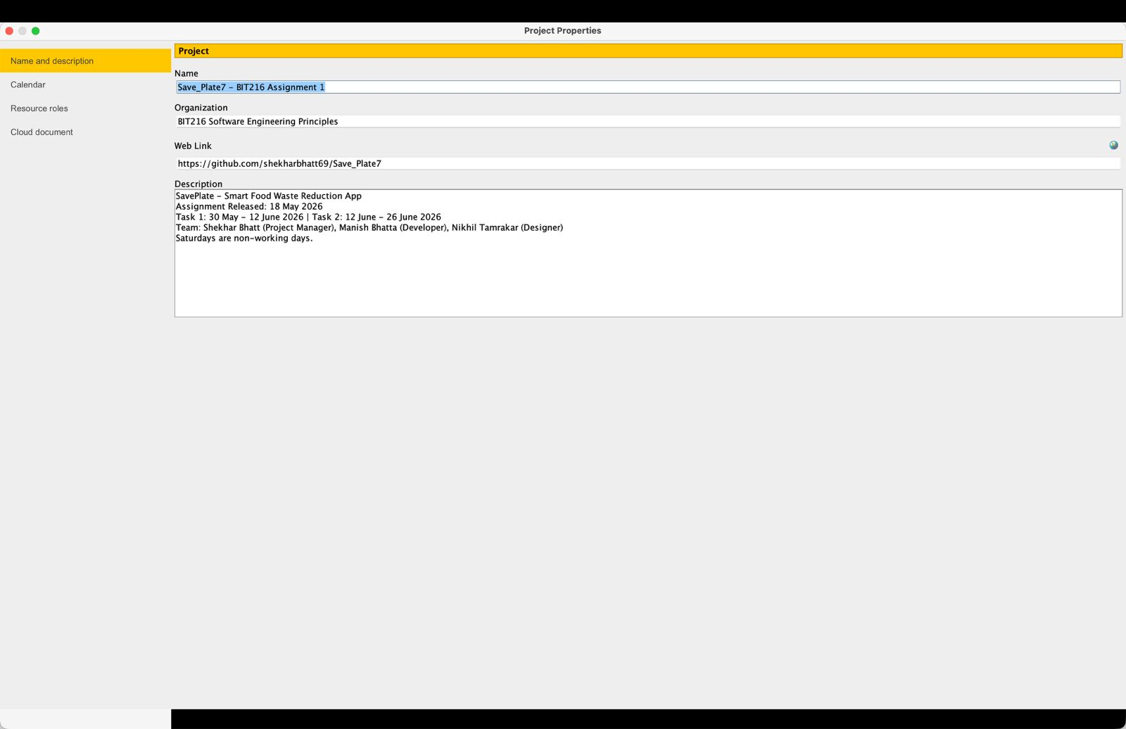
Figure 1: SavePlate Gantt Chart (30 May – 12 June 2026)
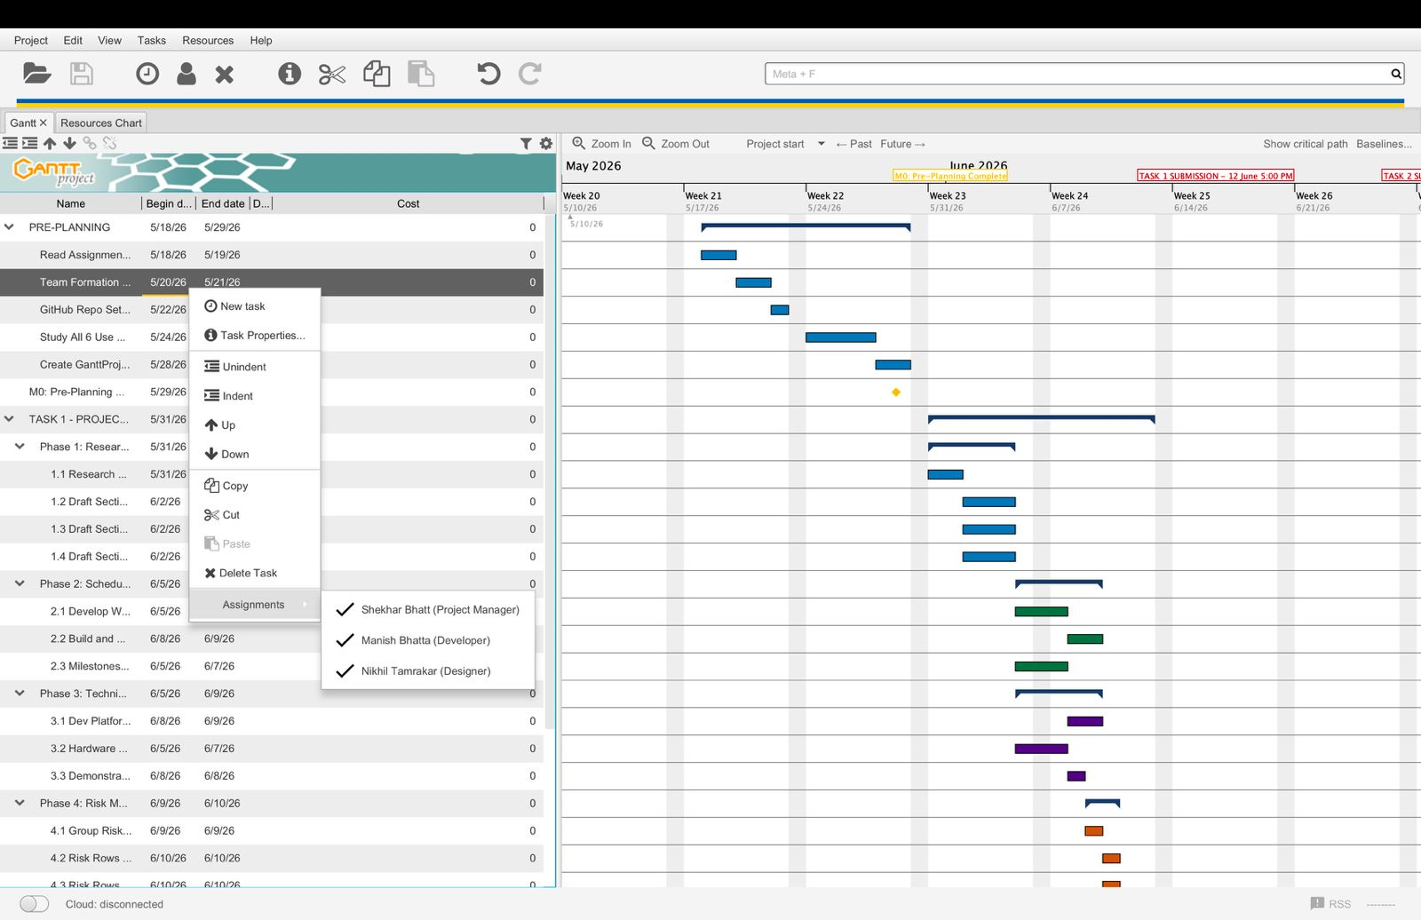

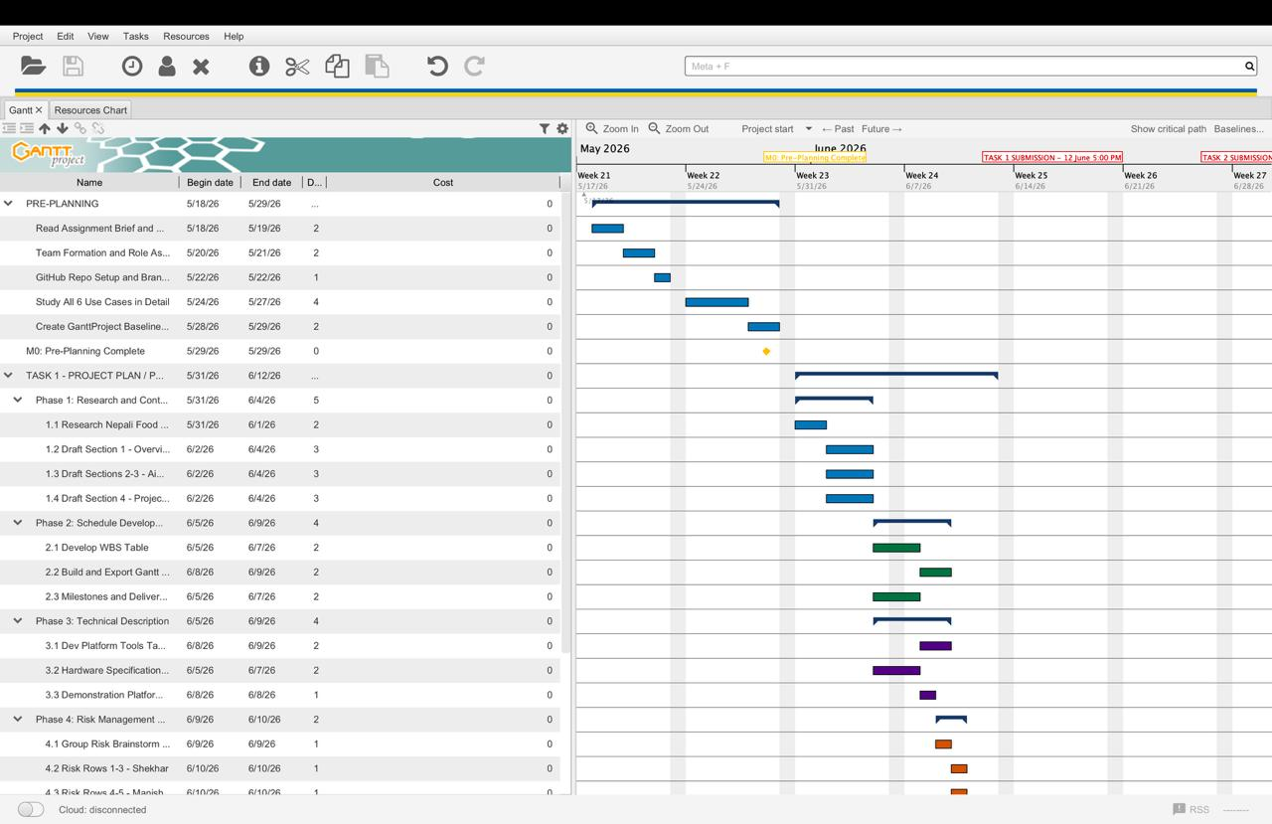
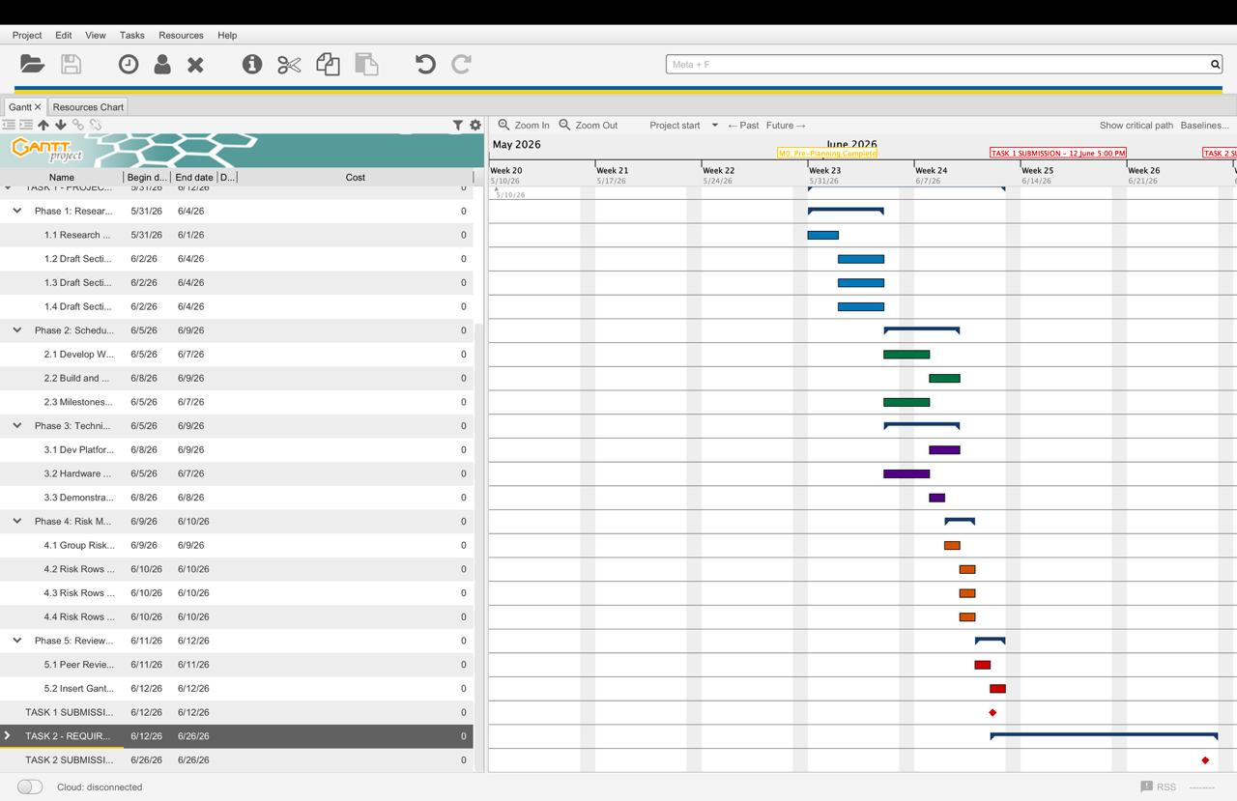

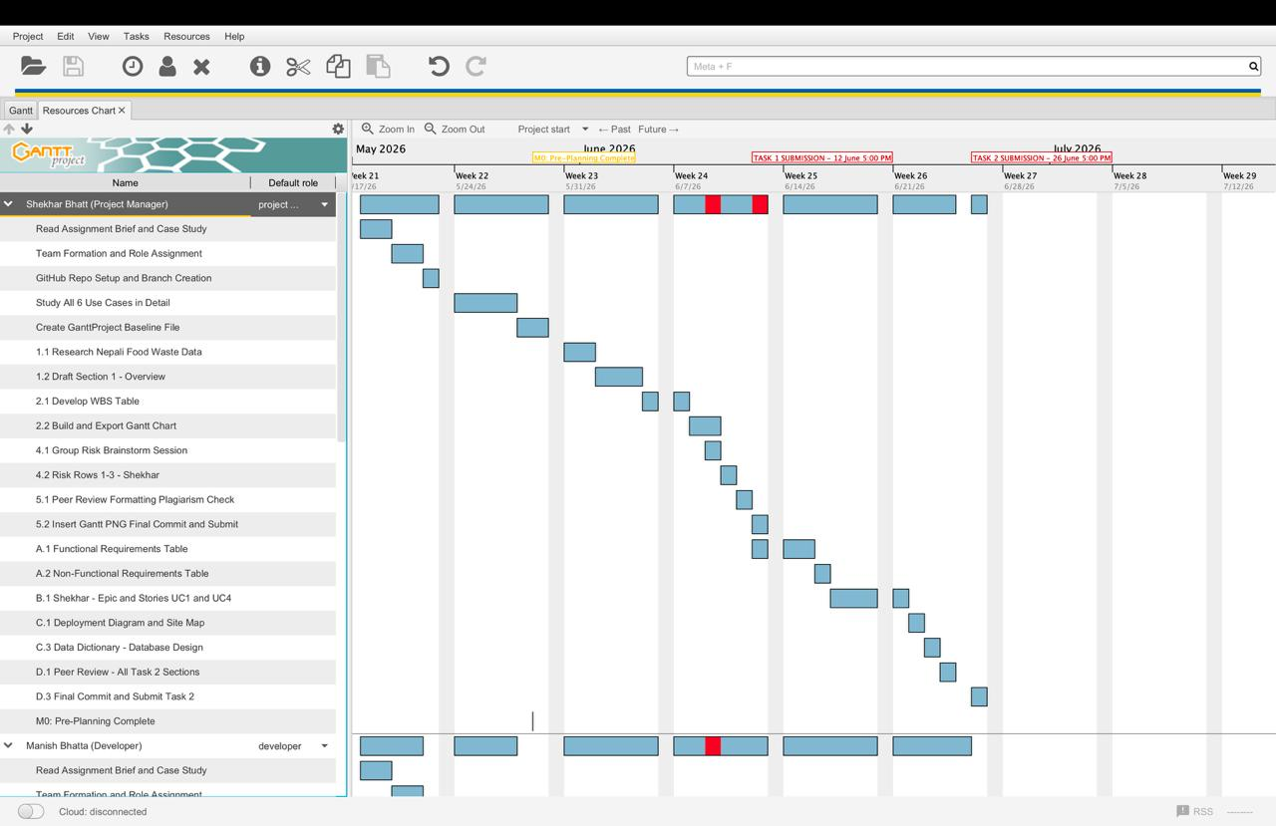

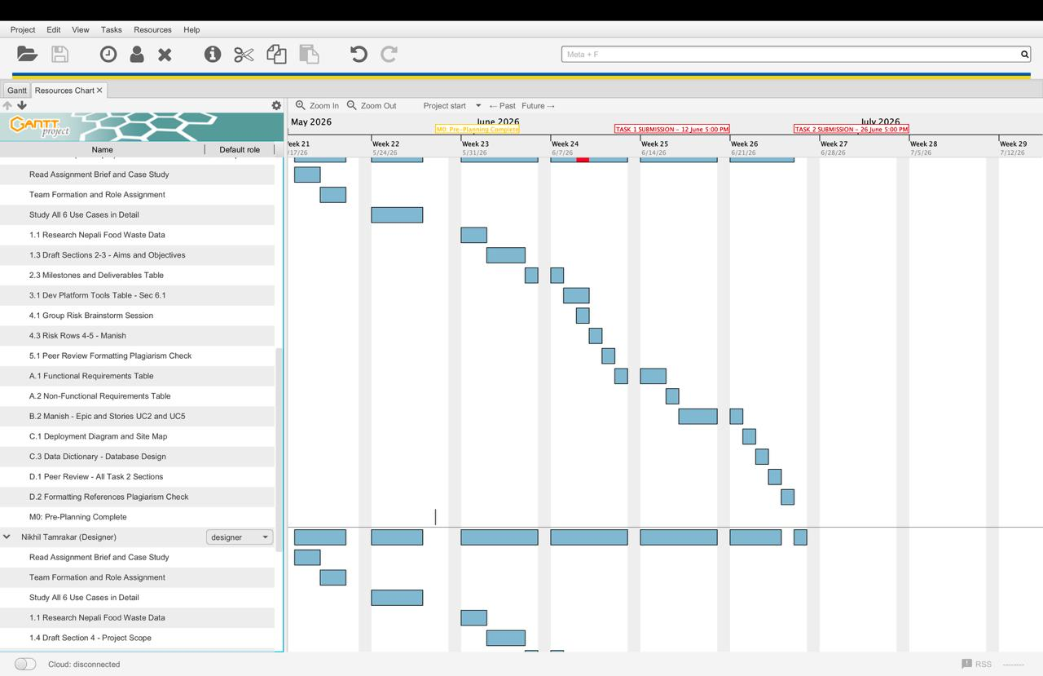

6. Technical Description
In this section I'll put together a list of tools and hardware that I would be using to create and test SavePlate. There were no costs involved and all three of us were familiar with these tools, so we selected free/open source selections.

6.1 Development Platform

Purpose | Tool | Why We Chose It
Diagrams | draw.io | Free, easy to use for use case and ER diagrams
Documentation | Microsoft Word | Standard tool for writing the report
UI design | Figma | Good for wireframes and free for students
Project planning | GanttProject | Free tool for WBS and Gantt chart
Version control | GitHub | Lets the three of us work together and track changes
Front end | React, HTML, CSS | Popular and well-supported for web apps
Back end | Node.js, Express | Works well with React and is free
Database | MySQL | Reliable and free relational database
Code editor | Visual Studio Code | Free, lightweight, and widely used

6.2 Hardware Specification

Component | Minimum Requirement
Laptop | Intel Core i5 or similar, capable of running the tools smoothly
RAM | 8 GB (so the editor, server, and browser run together)
Storage | 256 GB SSD for project files and the database
Operating system | Windows 10/11 or macOS
Browser | Google Chrome or Firefox for testing

6.3 Demonstration Platform

Item | Detail
Browser | Google Chrome for the live demo
Local server | XAMPP or Node.js local server to run the app
Screen sharing | Zoom or Google Meet if a remote demo is needed
Operating system | Windows or macOS

7. Risk Management Plan
All projects will have their dangers and ours is no exception. We have provided a list below of the main risks that we anticipate, how likely they are to happen, how serious they would be if they did occur and our actions to address them.
Risk | Likelihood | Impact | How We Will Handle It
Scope creep — adding features we did not plan for | Medium | High | Do not go off-piste from what was agreed in Section 4 and check it each week. Leave extra ideas for a future version.
Unequal work between members | Medium | High | Clear tasks at the WBS level; track these through commits on GitHub. If this can't be done, please consult the lecturer.
Not knowing the tools well enough | High | High | Practice React, Node and MySQL in the first week using online tutorials/exemplars and peer learning.
Load-shedding and weak internet | High | Medium | Use the offline mode in the case of a problem and push to GitHub when it is restored. Make sure you have some backup data in Google Drive, as well as mobile data.
Losing work or Git conflicts | Medium | High | Commit plenty of times and use separate branches. If they do not work out, roll back to the previous commit
Submitting late | Low | High | I'll adhere to the Gantt chart and make our own deadline two days earlier. Apply for extension if really necessary.
Plagiarism or too much AI content | Low | High | Always cite any use of AI and put in our own words. Please read similarity scores prior to submission.

8. Conclusion
The following is a summary plan of our project, detailing our offering: SavePlate, a web and mobile based application to reduce food wastage at the household level in Nepal. We have experienced the problem ourselves at home: food is bought, left in the fridge to rot and simply disposed of. SavePlate responds with six linked features, which are based on the case study and include secure registration with privacy settings, food inventory management, browsing and donating surplus items, an analytics dashboard to track your impact, notifications to ensure that food gets used before expiration management tool in one place.
Additionally, the plan demonstrates that the project is feasible under a student team of three members. We left payments, GPS tracking and an extensive admin panel for a future version, so the scope is intentionally kept tight. The task allocation and Gantt chart share Task 1 evenly between the three of us from 30 May to 12 June, 2026, all four tools selected are free and known to the team, and it only costs NPR <1500. It outlines our risk management plan, detailing the issues most within reach that could affect us (the scope creep movement, load shedding, consistent work) and enunciated steps to response.
SavePlate has a purpose, scope and schedule; step 1 of the plan is complete. Task 2 continues through to 26 June 2026, with the requirements and design — such as the use case details, storyboard and wireframes — iteratively developed from this plan. Execution of this project as described will yield you an application that is usable, cost-effective for households in the US depending on one another (a continuation of the food sharing culture prevalent in Nepali communities), and a testament to software engineering principles explored in this module.

GitHub Repo- https://github.com/shekharbhatt69/Save_Plate7

8. References

Food and Agriculture Organization of the United Nations. (2021). Food wastage footprint: Impacts on natural resources. FAO.
Government of Nepal, Ministry of Agriculture and Livestock Development. (2023). Statistical information on Nepalese agriculture. MoALD.
Pressman, R. S., & Maxim, B. R. (2020). Software engineering: A practitioner's approach (9th ed.). McGraw-Hill Education.
GanttProject Team. (2023). GanttProject user guide. https://www.ganttproject.biz

