Git =>

Git is a free and open source distributed version control system designed to handle everything from small to very large projects with speed and efficiency.

Version Control System =>

Version Control System (VCS) is a software that helps software developers to work together and maintain a complete history of their work.

Listed below are the functions of a VCS:

* Allows developers to work simultaneously.
* Does not allow overwriting each other’s changes.
* Maintains a history of every version.

Following are the types of VCS:

* Centralized version control system (CVCS).
* Distributed/Decentralized version control system (DVCS).

Git falls under distributed version control system.

Distributed Version Control System (DVCS) =>

DVCS clients not only check out the latest snapshot of the directory but they also fully mirror the repository. If the sever goes down, then the repository from any client can be copied back to the server to restore it. Every checkout is a full backup of the repository. Git does not rely on the central server and that is why you can perform many operations when you are offline. You can commit changes, create branches, view logs, and perform other operations when you are offline. You require network connection only to publish your changes and take the latest changes.

Advantages of Git =>

* Free and open source.
* Fast and small
* Implicit backup
* Security
* No need of powerful hardware
* Easier branching

Disadvantages of Git =>

* Steep learning curve: Many commands with many options, some commands are non-intuitive and need a level of understanding the internals of git, commands and arguments are inconsistent to some degree.

* Binary files are a big no: If your project has non-text files that are updated frequently (images for websites or MS Office documents), then git becomes bloated and slow. (I believe it still does better than most systems)

Installation of Git =>

1. sudo apt-get update
2. sudo apt-get install git-all

Customize Git Environment =>

Git provides the git config tool, which allows you to set configuration variables. Git stores all global configurations in .gitconfig file, which is located in your home directory. To set these configuration values as global, add the --global option, and if you omit --global option, then your configurations are specific for the current Git repository.

You can also set up system wide configuration. Git stores these values in the /etc/gitconfig file, which contains the configuration for every user and repository on the system. To set these values, you must have the root rights and use the --system option.

Setting username =>

This information is used by Git for each commit.

ankush@agami-ip10 ~ $ git config --global user.name "Ankush Singh"

Setting email id =>

This information is used by Git for each commit.

ankush@agami-ip10 ~ $ git config --global user.email "ankush10001@gmail.com"

Avoid merge commits for pulling =>

You pull the latest changes from a remote repository, and if these changes are divergent, then by default Git creates merge commits. We can avoid this via following settings.

ankush@agami-ip10 ~ $ git config --global branch.autosetuprebase always

Color highlighting =>

The following commands enable color highlighting for Git in the console.

ankush@agami-ip10 ~ $ git config --global color.ui true

ankush@agami-ip10 ~ $ git config --global color.status auto

ankush@agami-ip10 ~ $ git config --global color.branch auto

Setting default editor =>

By default, Git uses the system default editor, which is taken from the VISUAL or EDITOR environment variable. We can configure a different one by using git config.

ankush@agami-ip10 ~ $ git config --global core.editor vim/nano

Setting default merge tool =>

Git does not provide a default merge tool for integrating conflicting changes into your working tree. We can set default merge tool by enabling following settings.

ankush@agami-ip10 ~ $ git config --global merge.tool vimdiff

Listing Git settings =>

To verify your Git settings of the local repository, use git config –list command as given below.

ankush@agami-ip10 ~ $ git config --list

The above command will produce the following result.

user.name=Ankush Singh
user.email=ankush10001@gmail.com
push.default=nothing
branch.autosetuprebase=always
color.ui=true
color.status=auto
color.branch=auto
core.editor=vim
merge.tool=vimdiff

Git Life Cycle =>

General workflow is as follows:
* You clone the Git repository as a working copy.
* You modify the working copy by adding/editing files.
* If necessary, you also update the working copy by taking other developer's changes.
* You review the changes before commit.
* You commit changes. If everything is fine, then you push the changes to the repository.
* After committing, if you realize something is wrong, then you correct the last commit and push the changes to the repository.
Shown below is the pictorial representation of the work-flow.

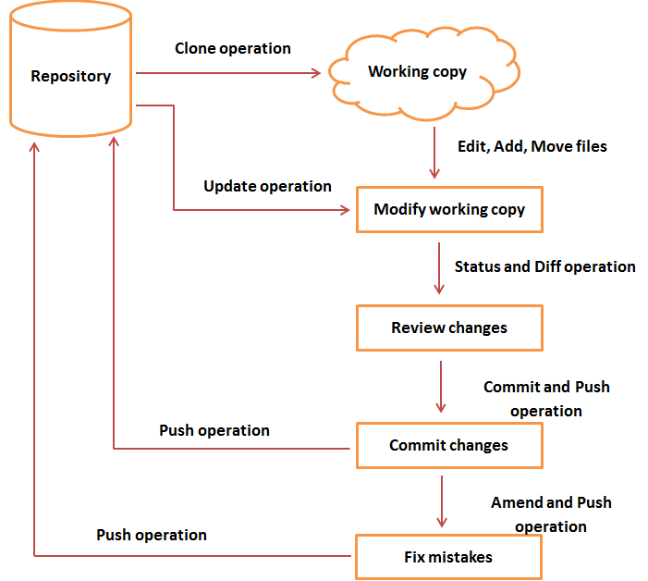

git init
Initialized empty Git repository in /home/ankush/.git/
git status
touch .gitignore
sudo nano .getignore
git add .getignore
git status
git commit -m 'first commit'

