1. **Frontend (Node.js with Express)**:

* Create a frontend using Express and Node.js.
* Include a form similar to the one from the Flask Assignment 2.
* Configure the form to send a request to the Flask backend.
* **Backend (Flask)**:
* Use the Flask backend to handle the form submission and process the data.
* **Folder Structure**:
* Organize the project with separate folders for the frontend and backend.
* **Docker Configuration**:
* Create a Dockerfile for both the frontend and backend.
* Write a .yaml file (Docker Compose) to connect both services in the same network.
* Upload both images to docker hub and push your whole code to github and add the node_modules and other non required files(.vscode) in .gitignore

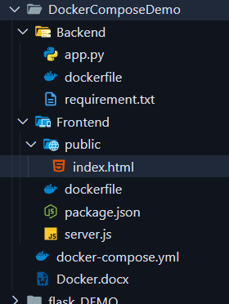

**DockerFile for backend   
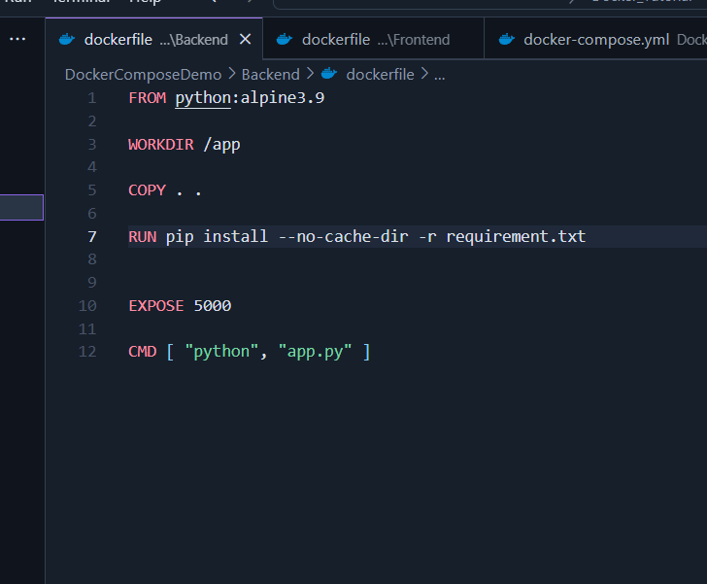**

**Dockerfile for frontend**

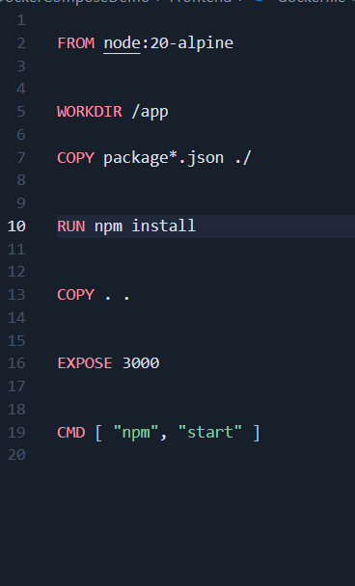

**Docker-compose.yml file**

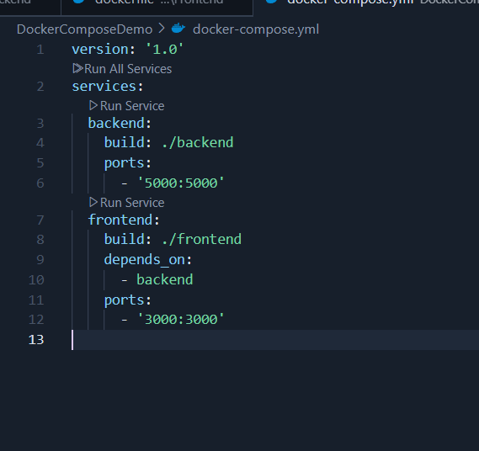

**Docker-compose**

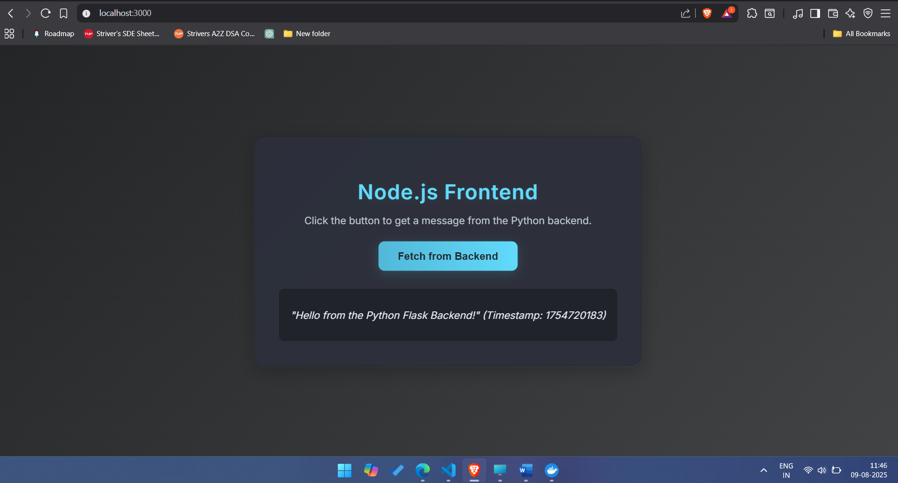

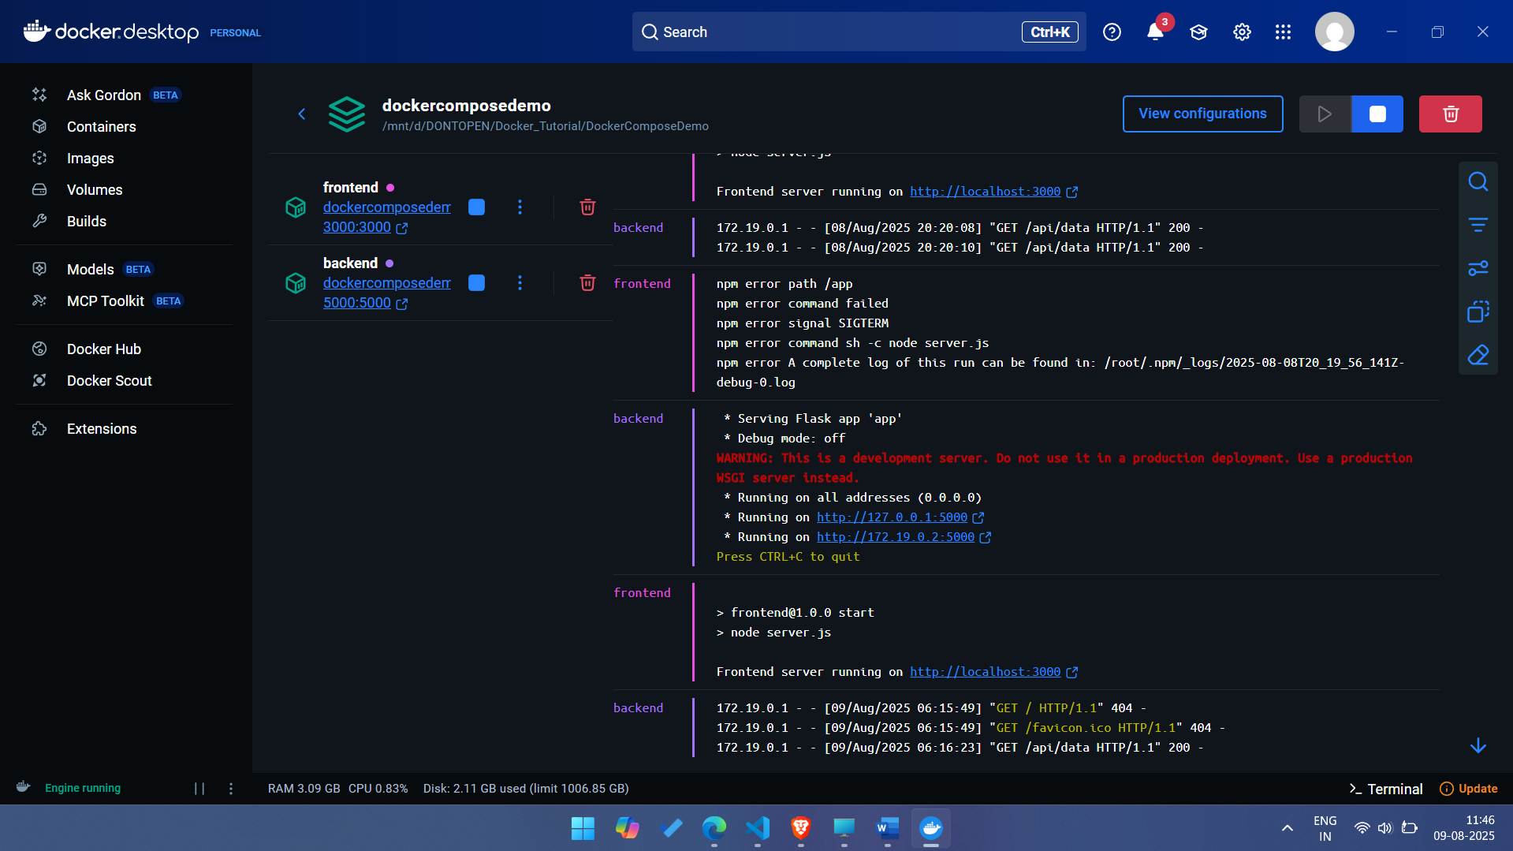

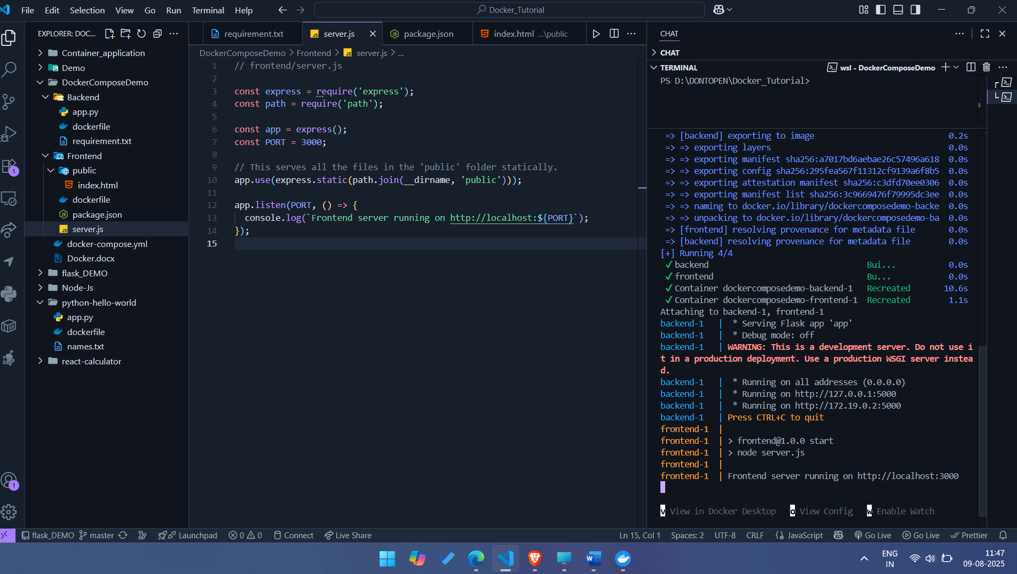

Link - https://github.com/Toto3107/flaskp

**Submission Guidelines -:** Share your github repo link