1. Create a Flask application with an /api route. When this route is accessed, it should return a JSON list. The data should be stored in a backend file, read from it, and sent as a response.

-> along with tutorial I’ve created a workout track application using flask and /api route

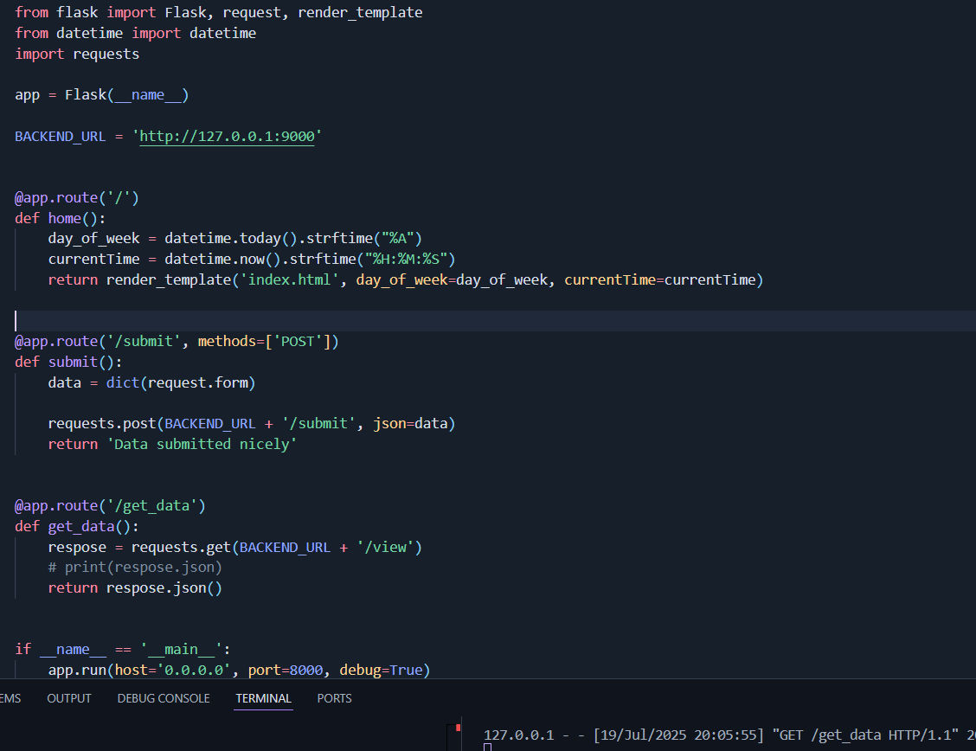

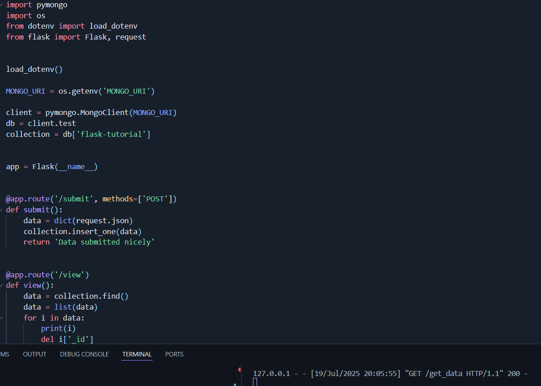

2. Create a form on the frontend that, when submitted, inserts data into MongoDB Atlas. Upon successful submission, the user should be redirected to another page displaying the message **"Data submitted successfully"**. If there's an error during submission, display the error on the same page without redirection.

-> It also show message Data submitted and uses mongoDB to store Data 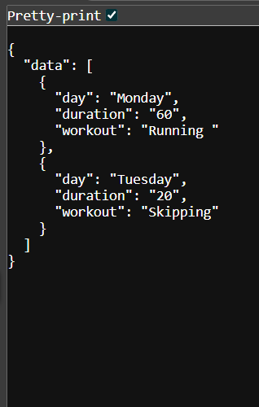

**Submission Guidelines -:** Attach Screenshots or command along with explanation and submit in doc(google doc or microsoft doc) format also attach github repo link

[shekhardase/Flask_Workout_Tracker](https://github.com/shekhardase/Flask_Workout_Tracker)