1. Creating and Renaming Files/Directories

Create a directory named test_dir using mkdir.

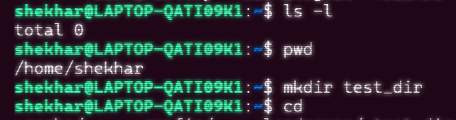

* Installed WSL , Ubantu on my local pc   
  First checked current working directiory with pwd
* Then created test_dir with mkdir

Inside test_dir, create an empty file called example.txt.

Rename example.txt to renamed_example.txt using mv

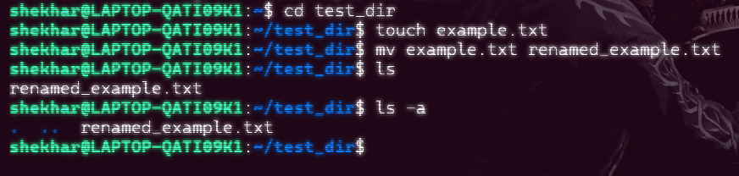

* Created empty example.txt file with touch command
* Renamed it to renamed_example.txt with mv
* Using ls -a checked the renaming of files in test_dir

2. Viewing File Contents

Use cat to display the contents of /etc/passwd.

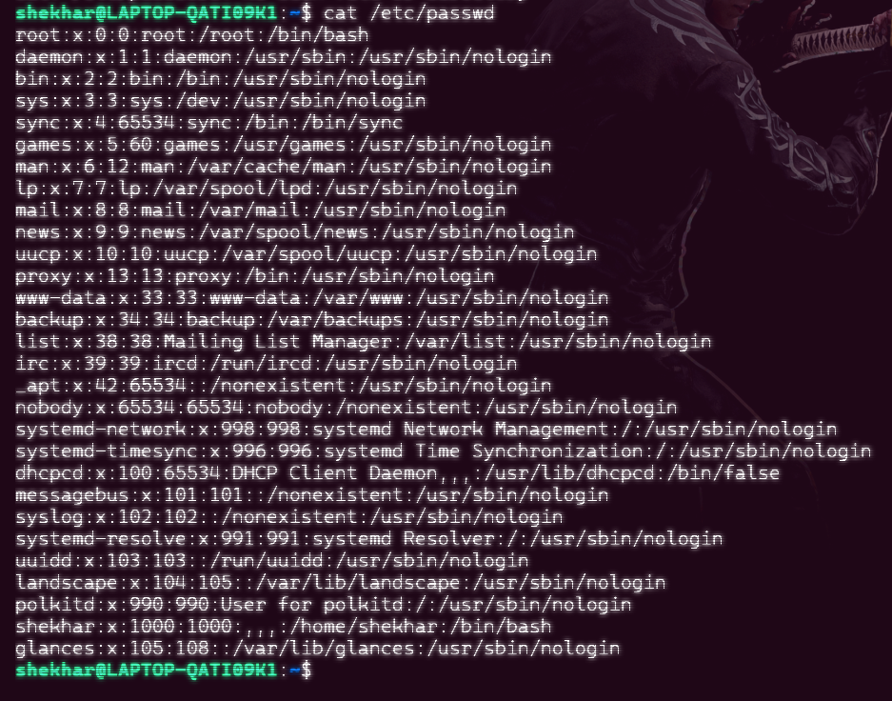

* Using cat viewed to content of etc/passwd

Though don’t know what it is …. ☺

Display only the first 5 lines of /etc/passwd using head.

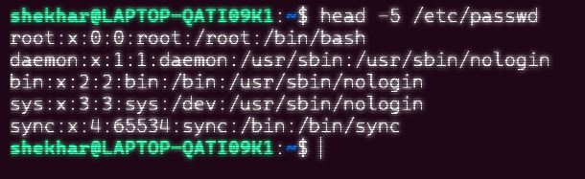

* First I was confused with slash but now understood

Display only the last 5 lines of /etc/passwd using tail.

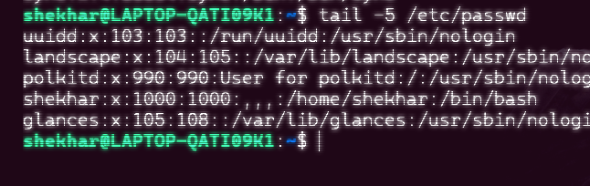

3.Searching for Patterns

Use grep to find all lines containing the word "root" in /etc/passwd.

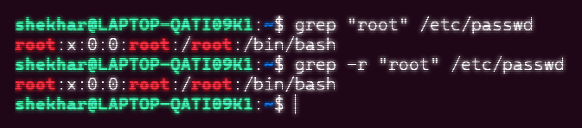

* Am not sure is it correct or not…

4. Zipping and Unzipping

Compress the test_dir directory into a file named test_dir.zip using zip.

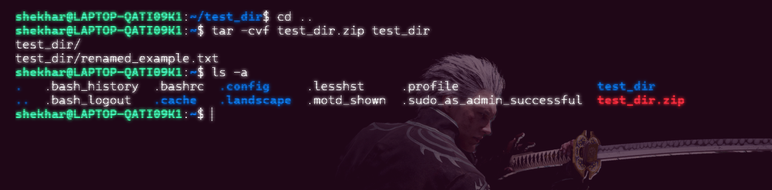

* Done
* Tar -cvf to compress then renamed_file then folder (folder to compress)

Unzip test_dir.zip into a new directory named unzipped_dir.

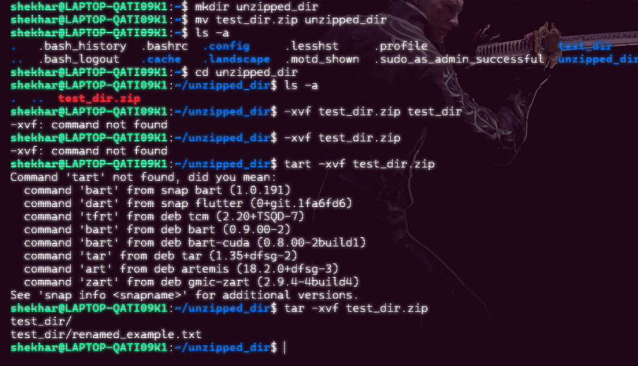

* Created new directiory unzipped_dir
* Move the zip file to it
* Extracted using tar -xvf test_dir.zip

5. Downloading Files

Use wget to download a file from a URL (e.g., <https://example.com/sample.txt>).

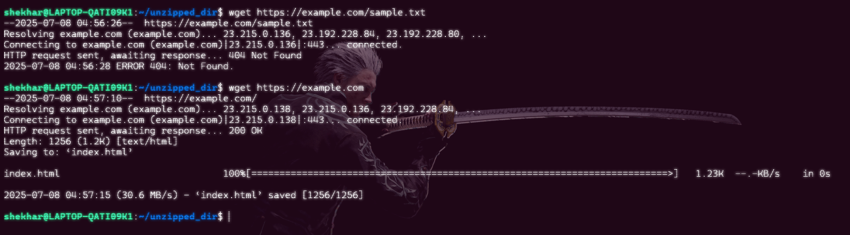

* I have checked for every possible solution for wget <https://example.com/sample.txt> for this
* but there is problem with url
* however wget <https://example.com> this works fine

6. Changing Permissions

Create a file named secure.txt and change its permissions to read-only for everyone using chmod.

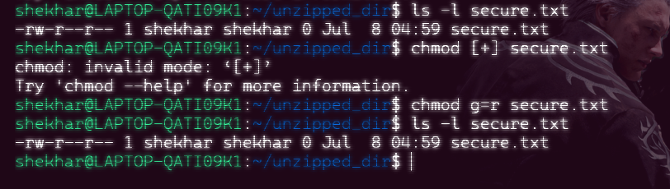

* Changed permission of secure.txt using chmod g=r
* Give the members of the group permission to read the file, but not to write and execute it

7. Working with Environment Variables

Use export to set a new environment variable called MY_VAR with the value "Hello, Linux!" 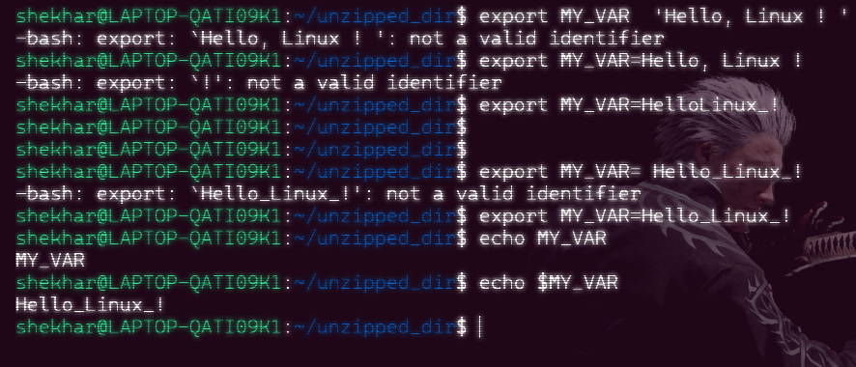

* OK No empty spaces and also for “!”

**Submission Guidelines -:** Attach Screenshots or command along with explanation and submit in doc(google doc or microsoft doc) format also attach github repo link

GithubRepo Link :