CREATE TABLE [dbo].CompanyMaster

(

[Id] INT NOT NULL PRIMARY KEY IDENTITY,

[Name] VARCHAR(50) NULL,

[status] BIT NULL

)

CREATE TABLE [dbo].FileMaster

(

[Id] INT NOT NULL PRIMARY KEY IDENTITY,

[FileName] VARCHAR(100) NULL,

[CompanyId] INT NULL

)

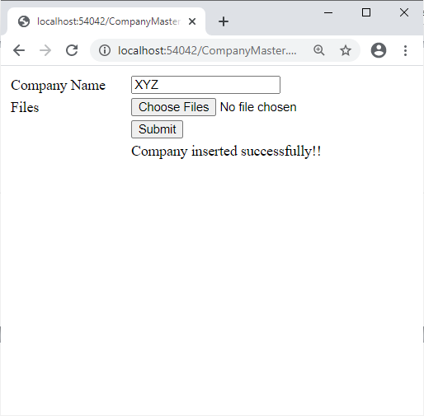

CompanyMaster.aspx

|  |
| --- |
| <%@ Page Language="C#" AutoEventWireup="true" CodeBehind="CompanyMaster.aspx.cs" Inherits="ShekharWebApplication.CompanyMaster" %>  <!DOCTYPE html>  <html xmlns="http://www.w3.org/1999/xhtml">  <head runat="server">  <title></title>  <style type="text/css">  .auto-style1 {  width: 100%;  }  </style>  </head>  <body>  <form id="form1" runat="server">  <div>  <table class="auto-style1">  <tr>  <td>Company Name</td>  <td>  <asp:TextBox ID="TextBox1" runat="server"></asp:TextBox>  &nbsp;</td>  </tr>  <tr>  <td>Files </td>  <td>  <asp:FileUpload ID="FileUpload1" runat="server" AllowMultiple="True" />  </td>  </tr>  <tr>  <td>&nbsp;</td>  <td>  <asp:Button ID="Button1" runat="server" OnClick="Button1_Click" Text="Submit" />  </td>  </tr>  <tr>  <td>&nbsp;</td>  <td>  <asp:Label ID="Label1" runat="server"></asp:Label>  </td>  </tr>  </table>  </div>  </form>  </body>  </html> |

CompanyMaster.aspx.cs

|  |
| --- |
| using System;  using System.Collections.Generic;  using System.Linq;  using System.Web;  using System.Web.UI;  using System.Web.UI.WebControls;  using System.Data.SqlClient;  namespace ShekharWebApplication  {  public partial class CompanyMaster : System.Web.UI.Page  {  SqlConnection con;  protected void Page_Load(object sender, EventArgs e)  {  con = new SqlConnection(@"Data Source=(localdb)\MSSQLLocalDB;Initial Catalog=Shekhar;Integrated Security=True;Pooling=False");  }  protected void Button1_Click(object sender, EventArgs e)  {  try  {  SqlCommand cmd1 = new SqlCommand("insert into CompanyMaster(name) values(@name);SELECT CAST(scope_identity() AS int)", con);  cmd1.Parameters.AddWithValue("@name", TextBox1.Text);  con.Open();  int id = (int)cmd1.ExecuteScalar();  String s1 = "";  if (FileUpload1.HasFiles)  {  string filepath = Server.MapPath("\\Upload");  HttpFileCollection uploadedFiles = Request.Files;  for (int i = 0; i < uploadedFiles.Count; i++)  {  HttpPostedFile userPostedFile = uploadedFiles[i];  try  {  if (userPostedFile.ContentLength > 0)  {  s1 += userPostedFile.FileName + ",";  userPostedFile.SaveAs(filepath + "\\" + userPostedFile.FileName);  }  }  catch (Exception Ex)  {  Label1.Text += "Error: <br>" + Ex.Message;  }  }  SqlCommand cmd2 = new SqlCommand("insert into FileMaster(FileName,CompanyId ) values(@filename,@id)", con);  cmd2.Parameters.AddWithValue("@filename", s1);  cmd2.Parameters.AddWithValue("@id", id);  cmd2.ExecuteNonQuery();  Label1.Text = "Company inserted successfully!!";    }  }  catch (Exception ex)  {  Label1.Text = ex.Message;  }    }  }  } |

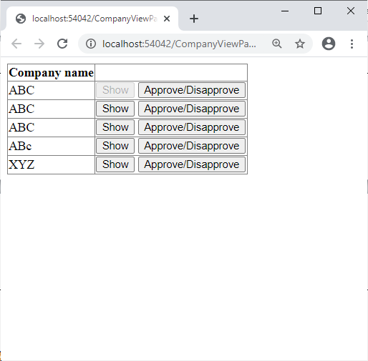

CompanyViewPage.aspx

|  |
| --- |
| <%@ Page Language="C#" AutoEventWireup="true" CodeBehind="CompanyViewPage.aspx.cs" Inherits="ShekharWebApplication.CompanyViewPage" %>  <!DOCTYPE html>  <html xmlns="http://www.w3.org/1999/xhtml">  <head runat="server">  <title></title>  </head>  <body>  <form id="form1" runat="server">  <div>  <asp:GridView ID="GridView1" runat="server" AutoGenerateColumns="False" OnRowCommand="GridView1_RowCommand">  <Columns>  <asp:BoundField DataField="name" HeaderText="Company name" />  <asp:TemplateField>  <ItemTemplate>  <asp:Button ID="Button1" runat="server" CommandName="cmdshow" Enabled='<%# Eval("Status").ToString()!="False"? true : false %>' CommandArgument='<%# Eval("id") %>' Text="Show" />  <asp:Button ID="Button2" runat="server" CommandName="cmdapproved" CommandArgument='<%# Eval("id") %>' Text="Approve/Disapprove" />  </ItemTemplate>  </asp:TemplateField>  </Columns>  </asp:GridView>  <br />  <br />  <asp:Panel ID="Panel1" runat="server" Visible="False">  </asp:Panel>  <br />  <br />  <asp:Panel ID="Panel2" runat="server" Visible="False">  <asp:CheckBox ID="CheckBox1" runat="server" Text="Approved" />  <br />  <br />  <asp:Button ID="Button3" runat="server" OnClick="Button3_Click" Text="Submit" />  &nbsp;<asp:Label ID="Label1" runat="server" Text="Label" Visible="False"></asp:Label>  <br />  <br />  <br />  <asp:Label ID="Label2" runat="server" Text="Label"></asp:Label>  </asp:Panel>  </div>  </form>  </body>  </html> |

CompanyViewPage.aspx.cs

|  |
| --- |
| using System;  using System.Collections.Generic;  using System.Linq;  using System.Web;  using System.Web.UI;  using System.Web.UI.WebControls;  using System.Data.SqlClient;  using System.Data;  namespace ShekharWebApplication  {  public partial class CompanyViewPage : System.Web.UI.Page  {  SqlConnection con;  protected void Page_Load(object sender, EventArgs e)  {  con = new SqlConnection(@"Data Source=(localdb)\MSSQLLocalDB;Initial Catalog=Shekhar;Integrated Security=True;Pooling=False");  if(IsPostBack==false)  display();  }  void display()  {  SqlDataAdapter da = new SqlDataAdapter("select * from CompanyMaster", con);  DataSet ds = new DataSet();  da.Fill(ds,"company");  GridView1.DataSource = ds.Tables["company"];  GridView1.DataBind();  }  protected void GridView1_RowCommand(object sender, GridViewCommandEventArgs e)  {  string id = e.CommandArgument.ToString();  if(e.CommandName.Equals("cmdshow"))  {  Panel1.Visible = true;  Panel2.Visible = false;  SqlCommand cmd = new SqlCommand("select FileName from FileMaster where companyid=" + id,con);  con.Open();  SqlDataReader dr = cmd.ExecuteReader();  if(dr.Read())  {  String s = dr["FileName"].ToString();  String[] arr = s.Split(',');  if (arr != null)  {  for (int i = 0; i < arr.Length - 1; i++)  {  HyperLink h = new HyperLink();  h.Text = arr[i];  h.NavigateUrl = "upload/"+arr[i];  Panel1.Controls.Add(h);  }  }  }  con.Close();  }  else  {  Panel1.Visible = false;  Panel2.Visible = true;  Label1.Text = id;  }  }  protected void Button3_Click(object sender, EventArgs e)  {  SqlCommand cmd;  if (CheckBox1.Checked)  cmd = new SqlCommand("update CompanyMaster set Status=1 where id=" + Label1.Text, con);  else  cmd = new SqlCommand("update CompanyMaster set Status=0 where id=" + Label1.Text, con);  con.Open();  cmd.ExecuteNonQuery();  Label2.Text = "status updated";  con.Close();  }  }  } |

