---------------Setup environment for Angular 4+-------------------

1)Environment Setup required for Angular 4. To install Angular 4, we require the following −

Nodejs

Npm

Angular CLI

IDE for writing your code

2)Download the node js got to the following url:- <https://nodejs.org/en/download/> and click on windows installer same as attached screenshot and it will download node js.

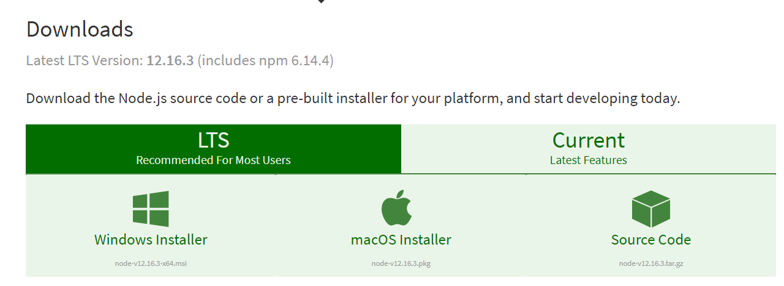

3) After the installation of NodeJs, install Angular CLI using the command npm install -g @angular/cli.

4) Open the Application in IDE and run the command npm install in the terminal.

5) Now, run the application through ng serve. The Application can be accessed in browser using http://localhost:4200.

6) To install JSON server run the command npm install -g json-server.

7) To run the JSON file, open the CMD prompt from the parent json folder and execute the command json-server -p 5555 users.json.