**Assignment-4 HOSTING CONTENT OF 3 DIFFERENT REPOSITORIES ON HTTPD SERVER USING “GitHub hook trigger for GITScm polling” AS BUILD TRIGGER.**

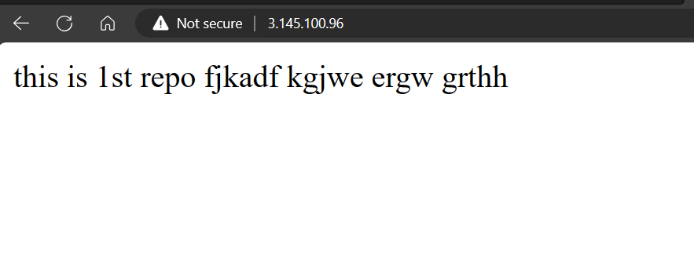

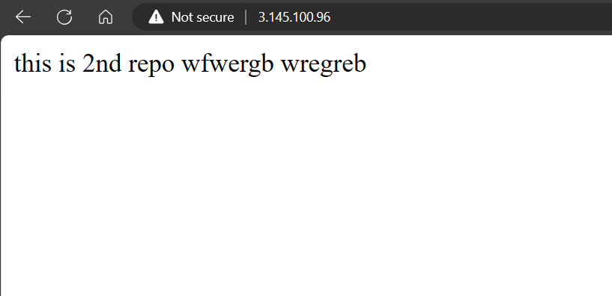

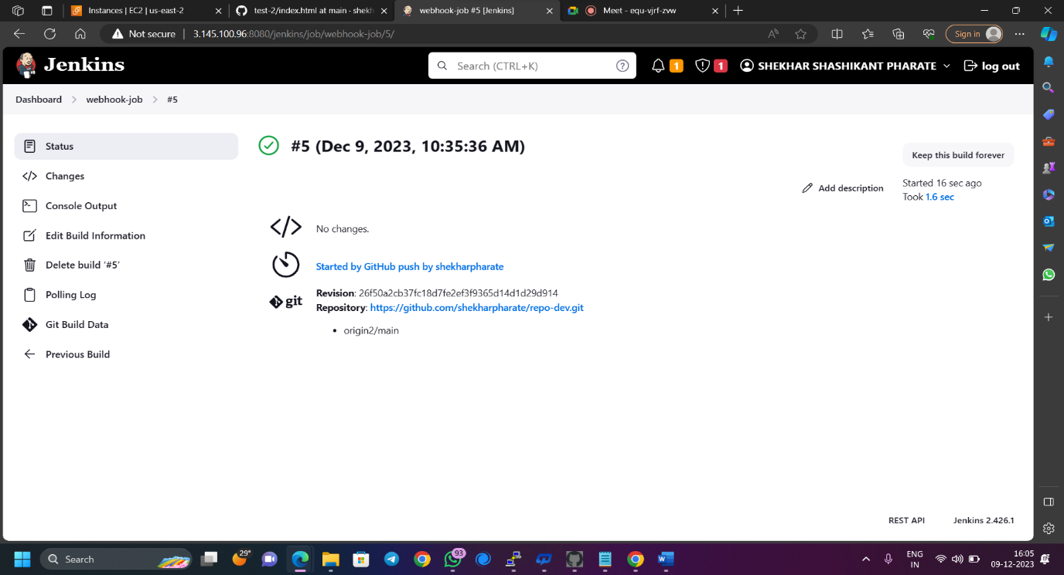

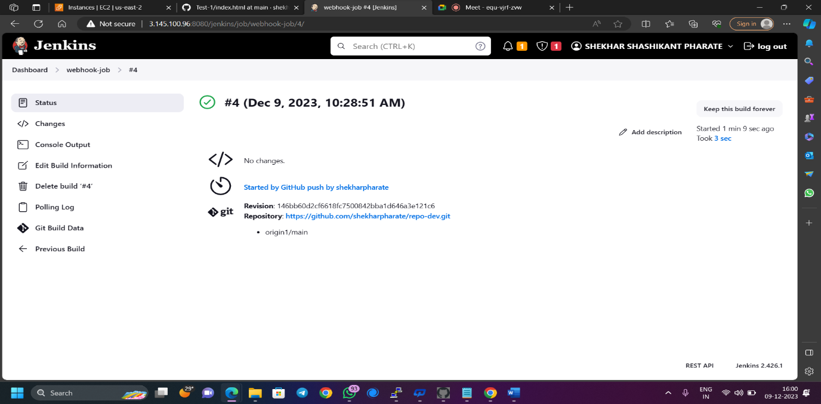

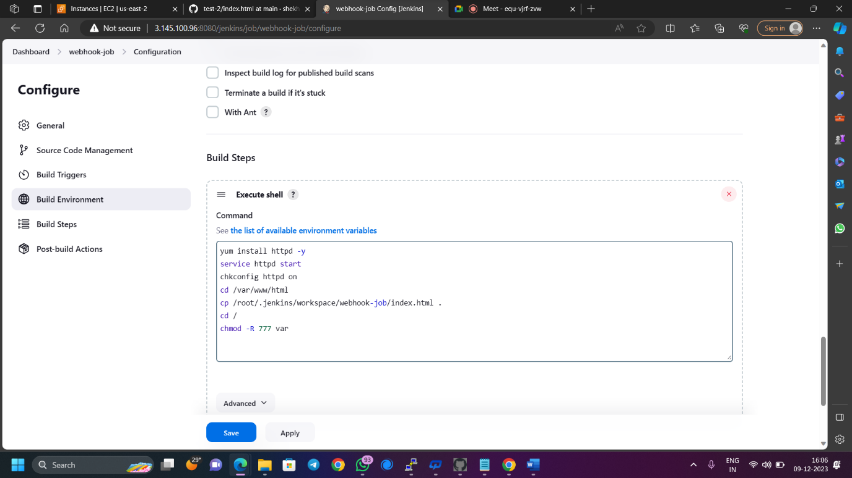

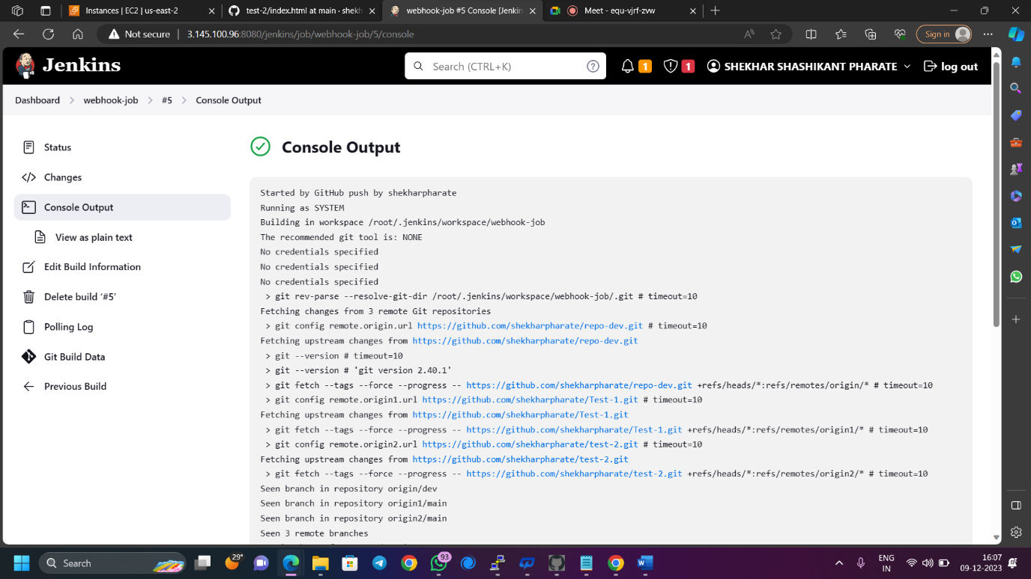

**STEPS: -**

* Launch an instance and host Jenkins on tomcat 9 server. (use java-11-amazon-corretto.x86_64)
* Configure Jenkins.
* Add GitHub server
* Go to manage Jenkins >> system >> GitHub (GitHub servers) >> add GitHub server
* Enter name – my-GitHub
* Add new credentials
* select “secret text” in kind
* Enter GitHub token in secret.
* Enter GitHub-webhook in ID and description.
* Add
* Apply and save
* Now create webhook for repositories which we want to host.
* Go to repository >> settings >> webhooks >> add webhook
* Enter payload URL - http://publicIP:8080/jenkins/github-webhook/
* Content type – application/json
* Secret – GitHub token
* Select event – just push event
* Add webhook
* Once the webhook is created it must show ✓ tick before it.
* Test the webhook connection
* Go to manage Jenkins >> system >> GitHub >> test connection
* Create a freestyle job
* Select git in source code management
* Enter repositories URL (if multiple repositories add repository and enter URL)
* Enter branch */main (before entering branch name check on GitHub once. Sometimes branch name is master sometime it is main)
* Select “GitHub hook trigger for GITScm polling” in build triggers.
* Select execute shell in build setup.

Enter commands: -

* + - yum install httpd -y
    - service httpd start
    - chkconfig httpd on
    - cd /var/www/html
    - cp /root/.jenkins/workspace/project/index.html .
    - cd /
    - chmod -R 777 var
  + Apply and save
* Now when we make change in any repository and commit the change, the job will automatically build and we will see the content of that repository hosted on httpd server. (check public_ip)