Direct \text{CO}2-to-Dimethyl Ether (DME) Catalytic Membrane Reactor: Comprehensive Technical Project Report
**Document Title:** Physical Modeling, Geometric Intensification, Machine Learning Optimization, and Continuum CFD Simulation of Catalytic Membrane Reactors for Direct \text{CO}_2 Hydrogenation to Dimethyl Ether
**Author / Lead Investigator:** Sameer Shekhar
**Repository Source:** [`p1`](file:///Users/sameershekhar/Documents/GitHub/p1) & [`paper1`](file:///Users/sameershekhar/Documents/GitHub/LLM-/paper1%20)
**Kinetic Standard:** W. Lu et al. (2004) / Poto et al. (2021) Formulations
**Geometric Baseline:** Unified Invariant Cross-Section (A_c = 2.3562\text{ cm}^2, D_{\text{shell}} = 20.00\text{ mm}, L = 1.00\text{ m})
Table of Contents
- [Executive Summary & Scope Definition](#1-executive-summary--scope-definition)
- [Fundamental Chemistry & Reaction Network](#2-fundamental-chemistry--reaction-network)
- [Thermodynamic Equilibrium Constants & Verifications](#3-thermodynamic-equilibrium-constants--verifications)
- [Chemical Reaction Kinetics & Adsorption Formulations](#4-chemical-reaction-kinetics--adsorption-formulations)
- [One-Dimensional Multi-Component Transport Model](#5-one-dimensional-multi-component-transport-model)
- [Comprehensive Engineering Assumptions Register](#6-comprehensive-engineering-assumptions-register)
- [Dimensionless Quantities & Transport Criteria](#7-dimensionless-quantities--transport-criteria)
- [Reactor Topologies & Invariant Geometric Baseline](#8-reactor-topologies--invariant-geometric-baseline)
- [Detailed Dimension & Spatial Clearance Comparison](#9-detailed-dimension--spatial-clearance-comparison)
- [Operating Conditions, Flow Rates & Sweep Mechanics](#10-operating-conditions-flow-rates--sweep-mechanics)
- [Multi-Architecture Simulation Benchmark (Lu Kinetics)](#11-multi-architecture-simulation-benchmark-lu-kinetics)
- [Process Intensification Factors & Transport Timescales](#12-process-intensification-factors--transport-timescales)
- [Deconstruction of the "8 Percent Water" Literature Myth](#13-deconstruction-of-the-8-percent-water-literature-myth)
- [Machine Learning Surrogate Modeling & Sensitivity Analysis](#14-machine-learning-surrogate-modeling--sensitivity-analysis)
- [ANSYS Fluent Continuum CFD Replication Manual](#15-ansys-fluent-continuum-cfd-replication-manual)
- [Project Repository File Index](#16-project-repository-file-index)
1. Executive Summary & Scope Definition
1.1 The Decarbonization Context
The catalytic hydrogenation of captured carbon dioxide (\text{CO}_2) utilizing green hydrogen (\text{H}_2) generated via renewable water electrolysis represents a closed-loop carbon capture and utilization (CCU) framework. Among synthetic e-fuels, **dimethyl ether (\text{CH}_3\text{OCH}_3, DME)** is an ultra-clean alternative fuel with a high cetane number (55\text{--}60), low particulate soot emissions, and physical properties identical to liquified petroleum gas (LPG, condensing at 0.5\text{ MPa} at ambient temperature).
1.2 Two-Stage Indirect vs. Intensified Direct Synthesis
- **Conventional Indirect Route:** Operates in two distinct units:
- Methanol synthesis over \text{Cu/ZnO/Al}_2\text{O}_3 (50\text{--}100\text{ bar}, 220\text{--}280^\circ\text{C}).
- Intermediate condensation, depressurization, multi-column distillation to remove water, reheating, and gas-phase dehydration over solid acid catalysts (\gamma\text{-Al}_2\text{O}_3 or \text{H-ZSM-5}) at 250\text{--}350^\circ\text{C} (2\text{CH}_3\text{OH} \to \text{DME} + \text{H}_2\text{O}).
- **Direct Intensified Route:** Co-pelletizes or admixes both catalytic functions into a single reactor bed. While direct synthesis eliminates intermediate separation trains, it suffers from a thermodynamic bottleneck: **stoichiometric byproduct water accumulation**.
1.3 The Catalytic Membrane Reactor (CMR) Solution
In a conventional closed packed bed (TR), water partial pressure builds up, driving reaction quotients to the equilibrium constant (Q \to K_{eq}), which caps single-pass DME yield at **19.65\%** (kinetic limit) or **46.54\%** (Gibbs ceiling) while poisoning the copper active sites.
By embedding an **in-situ hydrophilic NaA zeolite membrane**, water vapor is continuously extracted from the catalytic zone into a co-current permeate sweep channel (J_{\text{H}_2\text{O}} = \Pi_{\text{H}_2\text{O}} \Delta p_{\text{H}_2\text{O}}). This maintains Q < K_{eq} along the entire bed length, shifting the reaction forward by Le Chatelier's principle and driving DME single-pass yield to **86.16\%** with **99.53\%** water evacuation.
2. Fundamental Chemistry & Reaction Network
Direct DME synthesis comprises three simultaneous, reversible reactions:
Reaction 1: \text{CO}2 Hydrogenation to Methanol
\text{CO}_2 + 3\text{H}_2 \rightleftharpoons \text{CH}_3\text{OH} + \text{H}_2\text{O}, \quad \Delta H^\circ_{298\text{ K}} = -49.5\text{ kJ/mol}
- Exothermic reaction with significant molar contraction (\Delta n = -2).
- Favored by high operating pressure and low-to-moderate temperature.
Reaction 2: Reverse Water-Gas Shift (RWGS)
\text{CO}_2 + \text{H}_2 \rightleftharpoons \text{CO} + \text{H}_2\text{O}, \quad \Delta H^\circ_{298\text{ K}} = +41.2\text{ kJ/mol}
- Endothermic equimolar side reaction (\Delta n = 0).
- Favored at elevated temperatures; unaffected by pressure. Produces parasitic \text{CO} byproduct.
Reaction 3: Solid Acid Methanol Dehydration to DME
2\text{CH}_3\text{OH} \rightleftharpoons \text{CH}_3\text{OCH}_3\text{ (DME)} + \text{H}_2\text{O}, \quad \Delta H^\circ_{298\text{ K}} = -23.6\text{ kJ/mol}
- Exothermic equimolar reaction (\Delta n = 0).
- Consumes intermediate methanol, pulling Reaction 1 forward by chemical coupling.
Overall Net Direct Synthesis
2\text{CO}_2 + 6\text{H}_2 \rightleftharpoons \text{CH}_3\text{OCH}_3 + 3\text{H}_2\text{O}, \quad \Delta H^\circ_{298\text{ K}} = -122.6\text{ kJ/mol}
- Strongly exothermic with large molar contraction (\Delta n = -4).
3. Thermodynamic Equilibrium Constants & Verifications
Thermodynamic equilibrium expressions are evaluated as functions of absolute temperature T (Kelvin):
3.1 Methanol Synthesis (K{eq1}): Graaf et al. (1986)
\log_{10} K_{eq1} = \frac{3066}{T} - 10.592 \implies K_{eq1} = 10^{\left(\frac{3066}{T} - 10.592\right)} \quad [\text{bar}^{-2}]
- **At T = 523.15\text{ K} (250.0^\circ\text{C}):**
\log_{10} K_{eq1} = -4.7313 \implies \mathbf{K_{eq1} = 1.8563 \times 10^{-5}\text{ bar}^{-2}}
3.2 Reverse Water-Gas Shift (K{eq2}): Graaf et al. (1986)
\log_{10} K_{eq2} = -\frac{2073}{T} + 2.029 \implies K_{eq2} = 10^{\left(-\frac{2073}{T} + 2.029\right)} \quad [-]
- **At T = 523.15\text{ K} (250.0^\circ\text{C}):**
\log_{10} K_{eq2} = -1.9335 \implies \mathbf{K_{eq2} = 0.011654}
3.3 Methanol Dehydration (K{p,3}): W. Lu et al. (2004) / Poto et al. (2021)
\ln K_{p,3} = \frac{4019}{T} + 3.707 \ln T - 2.783 \times 10^{-3} T + 3.8 \times 10^{-7} T^2 - \frac{6.561 \times 10^4}{T^3} - 26.64 \quad [-]
- **At T = 523.15\text{ K} (250.0^\circ\text{C}):**
\ln K_{p,3} = 2.8953 \implies \mathbf{K_{p,3} = 18.0881}
4. Chemical Reaction Kinetics & Adsorption Formulations
4.1 Reactions 1 & 2: Mignard & Pritchard (2008) Langmuir-Hinshelwood Kinetics
Evaluated over commercial \text{Cu/ZnO/Al}_2\text{O}_3 catalyst:
r_1 = \frac{k_1 p_{\text{CO}_2} p_{\text{H}_2} \left[ 1 - \frac{p_{\text{H}_2\text{O}} p_{\text{CH}_3\text{OH}}}{K_{eq1} p_{\text{H}_2}^3 p_{\text{CO}_2}} \right]}{D_k^3} \quad \left[\frac{\text{mol}}{\text{kg}_{\text{cat}}\cdot\text{s}}\right]
r_2 = \frac{k_2 p_{\text{CO}_2} \left[ 1 - \frac{p_{\text{H}_2\text{O}} p_{\text{CO}}}{K_{eq2} p_{\text{H}_2} p_{\text{CO}_2}} \right]}{D_k} \quad \left[\frac{\text{mol}}{\text{kg}_{\text{cat}}\cdot\text{s}}\right]
Competitive Adsorption Denominator (Dk):
D_k = 1 + K_{\text{H}_2\text{O},\text{H}_2} \left(\frac{p_{\text{H}_2\text{O}}}{p_{\text{H}_2}}\right) + \sqrt{K_{\text{H}_2} p_{\text{H}_2}} + K_{\text{H}_2\text{O}} p_{\text{H}_2\text{O}}
Temperature-Dependent Kinetic Parameters (R = 8.314462\text{ J}/(\text{mol}\cdot\text{K})):
k_1 = 1.07 \exp\left(\frac{40000}{R T}\right) \implies k_1(523.15\text{ K}) = 10547.79\text{ mol}/(\text{kg}_{\text{cat}}\cdot\text{s}\cdot\text{bar}^2)
k_2 = 1.22 \times 10^{10} \exp\left(-\frac{98084}{R T}\right) \implies k_2(523.15\text{ K}) = 1.9643\text{ mol}/(\text{kg}_{\text{cat}}\cdot\text{s}\cdot\text{bar})
K_{\text{H}_2\text{O}} = 6.62 \times 10^{-11} \exp\left(\frac{124119}{R T}\right) \implies K_{\text{H}_2\text{O}}(523.15\text{ K}) = 16.143\text{ bar}^{-1}
\sqrt{K_{\text{H}_2}} = 0.499 \exp\left(\frac{17197}{R T}\right) \implies \sqrt{K_{\text{H}_2}}(523.15\text{ K}) = 2.628\text{ bar}^{-0.5}
K_{\text{H}_2\text{O},\text{H}_2} = 3453.38 \quad [-]
4.2 Reaction 3: Solid Acid Methanol Dehydration (Lu et al. 2004 / Poto et al. 2021)
Evaluated over \text{H-ZSM-5} solid acid zeolite:
r_3 = k_3 \left( \frac{p_{\text{CH}_3\text{OH}}^2}{p_{\text{H}_2\text{O},\text{safe}}} - \frac{p_{\text{DME}}}{K_{p,3}} \right) \quad \left[\frac{\text{mol}}{\text{kg}_{\text{cat}}\cdot\text{s}}\right]
Reaction Rate Constant (k3):
k_3 = 8.2894 \times 10^4 \exp\left(-\frac{5.2940 \times 10^4}{R T}\right) \quad \left[\frac{\text{kmol}}{\text{kg}_{\text{cat}}\cdot\text{s}\cdot\text{bar}}\right]
k_3 = 8.2894 \times 10^7 \exp\left(-\frac{5.2940 \times 10^4}{R T}\right) \quad \left[\frac{\text{mol}}{\text{kg}_{\text{cat}}\cdot\text{s}\cdot\text{bar}}\right]
- **Activation Energy:** E_{a,3} = 5.2940 \times 10^4\text{ J/mol} = 52.94\text{ kJ/mol}
- **Value at T = 523.15\text{ K} (250.0^\circ\text{C}):**
k_3 = \mathbf{429.2974\text{ mol}/(\text{kg}_{\text{cat}}\cdot\text{s}\cdot\text{bar})} = \mathbf{0.4293\text{ kmol}/(\text{kg}_{\text{cat}}\cdot\text{s}\cdot\text{bar})}
- **Numerical Inlet Safeguard:**
p_{\text{H}_2\text{O},\text{safe}} = \max(p_{\text{H}_2\text{O}}, 10^{-6}\text{ bar})
5. One-Dimensional Multi-Component Transport Model
The reactor is resolved as a 1D steady-state plug-flow system tracking six chemical species:
\vec{y} = [\text{CO}_2, \text{H}_2, \text{H}_2\text{O}, \text{CH}_3\text{OH}, \text{CO}, \text{CH}_3\text{OCH}_3]^T
5.1 Retentate Catalyst Channel Mass Balance (z \in [0, L])
\frac{d F_{\text{ret},i}}{dz} = \rho_B A_c r_{\text{net},i} - J_i P_m
5.2 Permeate Sweep Channel Mass Balance (z \in [0, L])
\frac{d F_{\text{perm},i}}{dz} = + J_i P_m
Where:
- \rho_B = 1200.0\text{ kg/m}^3: Catalyst bulk packing density
- A_c = 2.3562 \times 10^{-4}\text{ m}^2: Cross-sectional active bed area
- P_m: Total membrane wetted perimeter (\text{m})
- J_i: Transmembrane permeation flux (\text{mol}/(\text{m}^2\cdot\text{s}))
5.3 Transmembrane Permeation Flux Equation
J_i = \Pi_i (p_{\text{ret},i} - p_{\text{perm},i}) = \frac{\Pi_{\text{H}_2\text{O}}}{\alpha_i} \left( \frac{F_{\text{ret},i}}{\sum F_{\text{ret}}} P_{\text{ret}} - \frac{F_{\text{perm},i}}{\sum F_{\text{perm}} + F_{\text{sweep}}} P_{\text{perm}} \right)
Membrane Separation Parameters
Membrane Type | Permeance \Pi{\text{H}2\text{O}} (\text{mol}/(\text{m}^2\cdot\text{s}\cdot\text{Pa})) | \alpha{\text{CO}2} | \alpha{\text{H}2} | \alpha{\text{CH}3\text{OH}} | \alpha{\text{CO}} | \alpha{\text{DME}} | Citation Provenance
NaA Zeolite (Primary) | 1.8 \times 10^{-7} | 1000 | 100 | 1000 | 1000 | 10000 | Richard et al. (2025); Li et al. (2020)
LTA Zeolite | 2.0 \times 10^{-7} | 800 | 80 | 800 | 800 | 8000 | Ateka et al. (2021)
CMSM (Carbon) | 0.6 \times 10^{-7} | 250 | 80 | 500 | 250 | 2000 | Poto et al. (2023)

5.4 Packed-Bed Hydraulic Gradient (Ergun Equation)
\frac{\Delta P}{L} = 150 \frac{\mu_g (1 - \varepsilon_b)^2}{\varepsilon_b^3 d_p^2} u_s + 1.75 \frac{\rho_g (1 - \varepsilon_b)}{\varepsilon_b^3 d_p} u_s^2
At 250^\circ\text{C}, 40\text{ bar} (\rho_g = 26.64\text{ kg/m}^3, \mu_g = 2.0 \times 10^{-5}\text{ Pa}\cdot\text{s}, u_s = 0.016\text{ m/s}, d_p = 0.30\text{ mm}, \varepsilon_b = 0.40):
\frac{\Delta P}{L} = 3373\text{ Pa/m} \implies \Delta P(L = 1.0\text{ m}) = \mathbf{0.0337\text{ bar}} \quad (\mathbf{0.08\%} \text{ of } 40\text{ bar})
Confirming that the bed operates under essentially uniform isobaric conditions.
6. Chemical Engineering Logic & Mechanistic Justifications
Every architectural choice, operating parameter, kinetic expression, and physical boundary condition in this research is grounded in fundamental Chemical Reaction Engineering (CRE), thermodynamics, and transport phenomena principles:
6.1 Thermodynamic Affinity & Equilibrium Bypass Logic
- **The Classical Limitation:** In a closed system at constant and , chemical equilibrium is reached when the Gibbs free energy of the mixture is minimized (\Delta G = 0). The chemical affinity (\mathcal{A}) driving any reaction is defined by:
9325\mathcal{A}_j = -\sum_{i}
u_{i,j} \mu_i = R T \ln\left( rac{K_{eq,j}}{Q_j}
ight)9325
Where \mu_i is the chemical potential of species ,
u_{i,j} is its stoichiometric coefficient, and = \prod p_i^{
u_{i,j}} is the reaction quotient.
- **The Traditional Packed Bed Failure:** In a standard packed bed, as reactants convert, water partial pressure accumulates rapidly ({\mathrm{H}_2\mathrm{O}} o 3.2\ \mathrm{bar}). As a result, the reaction quotients surge toward their equilibrium limits:
9325Q_1 = rac{p_{\mathrm{H}_2\mathrm{O}} p_{\mathrm{CH}_3\mathrm{OH}}}{p_{\mathrm{H}_2}^3 p_{\mathrm{CO}_2}} o K_{eq1}, \quad Q_3 = rac{p_{\mathrm{DME}} p_{\mathrm{H}_2\mathrm{O}}}{p_{\mathrm{CH}_3\mathrm{OH}}^2} o K_{p,3}9325
When o K_{eq,j}, the affinity collapses to zero (\mathcal{A}_j o 0), driving the net forward reaction rate to zero ({\mathrm{net},j} o 0). Single-pass conversion is thus choked at .99\%, and DME yield cannot exceed .65\%.
- **The Membrane Reactor Remedy:** By maintaining continuous in-situ water removal across the NaA zeolite layer ({\mathrm{H}_2\mathrm{O}} = \Pi_{\mathrm{H}_2\mathrm{O}} \Delta p_{\mathrm{H}_2\mathrm{O}}), the water partial pressure is suppressed along the entire bed ({\mathrm{H}_2\mathrm{O}} < 0.15\ \mathrm{bar}). Consequently:
9325Q_j \ll K_{eq,j} \implies \mathcal{A}_j = R T \ln\left( rac{K_{eq,j}}{Q_j}
ight) \gg 09325
A strong positive thermodynamic affinity is maintained from inlet to outlet, permanently bypassing the classical Gibbs ceiling (.54\%) and driving DME single-pass yield to **.16\%*.
6.2 Heterogeneous Catalysis & Active Site Preservation Logic
- **Dual-Site Bifunctional Catalysis:** Direct synthesis requires two distinct active sites:
- Metallic copper crystallites ( ext{Cu}^0) supported on ext{ZnO/Al}_2 ext{O}_3 for ext{CO}_2 dissociative adsorption and hydrogenative formation of methoxy intermediates.
- Solid acid Brønsted sites (bridging hydroxyls ext{Si-OH-Al}) in ext{H-ZSM-5} zeolite channels for the proton-catalyzed bimolecular condensation of methanol into DME.
- **Why Water Poisons Metallic Copper (Langmuir-Hinshelwood Logic):**
In the Mignard & Pritchard (2008) rate law, the active site competition denominator is:
9325D_k = 1 + K_{\mathrm{H}_2\mathrm{O},\mathrm{H}_2}\left(rac{p_{\mathrm{H}_2\mathrm{O}}}{p_{\mathrm{H}_2}}
ight) + \sqrt{K_{\mathrm{H}_2} p_{\mathrm{H}_2}} + K_{\mathrm{H}_2\mathrm{O}} p_{\mathrm{H}_2\mathrm{O}}9325
Because water adsorbs strongly onto copper ({\mathrm{H}_2\mathrm{O}} = 16.14\ \mathrm{bar}^{-1} at ^\circ\mathrm{C}), high water partial pressures cause to swell. Because the forward rate depends inversely on the cube of the denominator ( \propto 1/D_k^3), accumulated water blocks copper active sites, causing reaction rates to collapse by over \% in a traditional bed.
- **Why Water Destroys Zeolite Acidity:** Under elevated temperature (^\circ\mathrm{C}) and high steam partial pressure, water molecules induce hydrolytic cleavage of framework tetrahedral aluminum atoms (dealumination: ext{Si-O-Al} + ext{H}_2 ext{O} o ext{Si-OH} + ext{Al-OH}). This irreversible process permanently degrades the Brønsted acid sites. In-situ extraction preserves zeolite framework integrity.
- **The Lu et al. (2004) Kinetic Formulation Logic:**
Solid acid methanol dehydration follows:
9325r_3 = k_3 \left( rac{p_{\mathrm{CH}_3\mathrm{OH}}^2}{p_{\mathrm{H}_2\mathrm{O},\mathrm{safe}}} - rac{p_{\mathrm{DME}}}{K_{p,3}}
ight)9325
Factoring {\mathrm{H}_2\mathrm{O}} into the denominator of the driving force explicitly accounts for competitive site adsorption between methanol and water on the Brønsted acid sites, accurately reproducing experimental behavior across wide pressure and temperature ranges.
6.3 Transport Phenomena & Process Intensification Logic
- **Damköhler Number Synchronization ({\mathrm{perm}} pprox 1.0):**
The Damköhler number represents the ratio of the chemical reaction rate to the membrane mass-transfer evacuation rate:
9325Da_{\mathrm{perm}} = rac{ au_{\mathrm{perm}}}{ au_{\mathrm{rxn}}} = rac{r_{\mathrm{gen},\mathrm{H}_2\mathrm{O}}}{J_{\mathrm{perm},\mathrm{H}_2\mathrm{O}} \cdot a_v}9325
- If {\mathrm{perm}} \gg 1: The reactor is **permeation-limited**. Chemical generation outpaces extraction; water builds up, and the membrane becomes a redundant, high-cost bottleneck.
- If {\mathrm{perm}} \ll 1: The reactor is **reaction-limited**. Membrane surface area is oversized, leading to excessive capital expense without incremental chemical gain.
- At {\mathrm{perm}} pprox 0.98 ext{--}1.05: **Intensified synchronization** is achieved in the Four-Tube Shell-Packed CMR at ext{GHSV} = 1000\ \mathrm{h}^{-1}, evacuating water at the exact rate it is generated (.53\% removal).
- **Radial Diffusion Timescale Scaling (Einstein-Smoluchowski Logic):**
In a packed bed, generated water molecules must diffuse through the tortuous interstitial fluid to reach the membrane wall. The characteristic diffusion timescale ( au_{\mathrm{diff}}) scales quadratically with the maximum diffusion path length:
9325 au_{\mathrm{diff}} = rac{(\Delta r_{\max})^2}{D_{\mathrm{eff}}}9325
- In the Single-Tube CMR: \Delta r_{\max} = 5.00\ \mathrm{mm}.
- In the Four-Tube Shell-Packed CMR: \Delta r_{\max} = 2.50\ \mathrm{mm} (halved).
9325rac{ au_{\mathrm{diff,4-tube}}}{ au_{\mathrm{diff,1-tube}}} = \left(rac{2.50}{5.00}
ight)^2 = rac{1}{4} = \mathbf{0.25}9325
By cutting the radial path in half, the diffusion timescale is reduced by a factor of **.0 imes*. Water molecules escape into the membrane imes faster, preventing localized water accumulation near the shell wall.
- **Specific Area Intensification ( = 2.0 imes):**
Specific surface area is defined as = P_m / A_c. Subdividing the membrane into four half-radius tubes ( = 5\ \mathrm{mm}) doubles the membrane perimeter (: 31.42 o 62.83\ \mathrm{mm}) while keeping bed area identical ( = 2.3562\ \mathrm{cm}^2). This doubles specific membrane area (: 133.33 o 266.67\ \mathrm{m}^{-1}), providing twice the mass-transfer contact area per cubic centimeter of catalyst.
6.4 Packed Bed Fluid Dynamics & Hydraulic Logic
- **Why Case Study A (Uniform Sleeves) Was Defective:**
Wrapping individual tubes in catalyst sleeves touching each other in square tangent circle packing creates **.37\% unfillable void space** (central diamond void + four outer crescent voids).
According to fluid mechanics, flow resistance through a packed bed is governed by the Ergun equation (high hydraulic drag, \Delta P_{\mathrm{bed}}), whereas empty voids exhibit near-zero drag (Poiseuille pipe flow, \Delta P_{\mathrm{void}} \ll \Delta P_{\mathrm{bed}}).
Consequently, feed syngas preferentially channels through the empty voids, bypassing the catalyst bed entirely. Simulations demonstrated that leaving these voids unsealed drops DME yield by **569X29.66 ext{ percentage points}* (.39\% o 62.73\%). Complete sealing with impermeable ceramic fillers is costly and prone to thermal shock cracking.
- **Why Case Study B (Shell-Packed CMR) Is Superior:**
Case Study B packs the **entire shell space** around the four tubes with catalyst micro-pellets. This completely eliminates void pockets, reduces bypass risk to **zsh.00\%*, utilizes \% of the shell bore for catalytic conversion, and requires zero inert sealing materials.
- **Ergun Isobaric Operation Validation:**
At ^\circ\mathrm{C} and \ \mathrm{bar}, the superficial syngas velocity is = 0.016\ \mathrm{m/s}. The Ergun equation yields an axial pressure drop of \Delta P = 0.0337\ \mathrm{bar} over the .0\ \mathrm{m} length, which is only **zsh.08\%* of the total operating pressure. This confirms that the bed operates under uniform isobaric conditions without requiring parasitic compression power.
6.5 Mechanical Packing Stability (Happel-Brenner Logic)
- **Pellet Bridging Threshold:** In chemical engineering multiphase reactors, the ratio of the wall-to-wall clearance gap (\delta) to the catalyst pellet diameter () governs packing uniformity. If \delta / d_p < 5.0, mechanical bridging occurs during dry-loading. Pellets arch over the restriction, leaving large localized void spaces that cause severe velocity maldistribution and wall channeling.
- **Geometric Compliance:**
- Single-Tube CMR: Annular gap 5.00\ \mathrm{mm} \implies \delta / d_p = 5.00 / 0.30 = \mathbf{16.67} \gg 5.0.
- Four-Tube Shell-Packed CMR: The narrowest clearance is the diagonal gap between opposing tubes (\delta_{\mathrm{gap}} = 2.071\ \mathrm{mm}).
9325rac{\delta_{\mathrm{gap}}}{d_p} = rac{2.071\ \mathrm{mm}}{0.30\ \mathrm{mm}} = \mathbf{6.90} \ge 5.09325
Because .90 > 5.0, the Four-Tube bed complies with the Happel-Brenner stability criterion, ensuring dense, uniform random packing without bridging or bypass channels.
6.6 Scientific Control & Dimensional Invariance Logic
In chemical reaction engineering, comparing reactors with differing catalyst inventory ({\mathrm{cat}}), differing active volumes ({\mathrm{bed}}), or differing space velocities ( ext{GHSV}) convolutes residence time variations ( au = W_{\mathrm{cat}} / F_{\mathrm{feed}}) with architectural intensification.
To maintain a rigorous scientific control:
- **Shell Outer Diameter is Constant:** {\mathrm{shell}} = 20.00\ \mathrm{mm} ({\mathrm{shell}} = 10.00\ \mathrm{mm}).
- **Reactor Length is Constant:** = 1000.0\ \mathrm{mm} (.00\ \mathrm{m}).
- **Active Bed Cross-Section is Constant:** = 2.3562\ \mathrm{cm}^2 (.0\% of shell bore) for both Single-Tube (^2 - 10^2) and Four-Tube (^2 - 4 imes 5^2).
- **Catalyst Mass is Constant:** {\mathrm{cat}} = 0.2827\ \mathrm{kg} (.74\ \mathrm{g}).
- **Feed Throughput is Constant:** {\mathrm{feed}} = 2.9200\ \mathrm{mmol/s} (.9270\ \mathrm{NL/min}) at ext{GHSV} = 1000\ \mathrm{h}^{-1}.
Because all macro-scale dimensions, catalyst mass, and feed rates are identical, the observed **0.53 ext{ percentage point}* increase in DME yield (.63\% o 86.16\%) is proven to originate **\% from transport intensification** (halved diffusion distance \Delta r and doubled specific membrane area ).
7. Comprehensive Engineering Assumptions Register
Engineering Domain | Assumption | Quantitative Physical Justification
Axial Dispersion | 1D Plug Flow Behavior | Length-to-diameter ratio L / D{\text{shell}} = 1000 / 20 = 50 \gg 30, satisfying the Carberry criterion for negligible backmixing (Pe{\text{ax}} > 300).
Bed Pressure Drop | Isobaric Catalyst Bed | Total Ergun pressure drop across the 1.0\text{ m} bed is 0.0337\text{ bar} (0.08\% of 40\text{ bar}).
Permeate Pressure | Isobaric Permeate Sweep | Lumen Hagen-Poiseuille pressure drop is \Delta P = 262\text{ Pa} (0.0026\text{ bar}, < 0.3\% of 1\text{ bar}).
Thermal Regime | Isothermal Bed (T = 250^\circ\text{C}) | Enforces direct geometric and kinetic comparison; practical implementation relies on circulating molten salt cooling jackets.
External Mass Transfer | Negligible Film Resistance | Pellet surface Reynolds number confirms Mears criterion C{\text{Mears}} = 0.02 \ll 0.15; external boundary layer transport is not rate-limiting.
Internal Pore Diffusion | High Effectiveness (\eta \approx 0.90) | Micro-pellets (dp = 0.30\text{ mm}) yield Weisz-Prater modulus \Phi{\text{WP}} = 0.18 < 0.30, confirming minimal pore diffusion resistance.
Thermodynamics | Ideal Gas Partial Pressures | Validated for species partial pressure ratios up to 40\text{ bar} at 523.15\text{ K}; compressibility factor Z \approx 0.95\text{--}0.98.
Membrane Separation | Solution-Diffusion Pore Flow | Hydrophilic sub-nanometer NaA pores (0.4\text{ nm}) selectively transport water (0.28\text{ nm}) while excluding larger hydrocarbons (\text{DME} = 0.43\text{ nm}).
Catalyst Packing | Stable Packed Bed (No Bridging) | Inter-tube gap-to-pellet ratio satisfies Happel-Brenner criterion: \delta / dp = 2.071 / 0.30 = 6.90 \ge 5.0.

8. Dimensionless Quantities & Transport Criteria
Dimensionless Group | Defining Formula | Value in Model | Physical Role in Reactor Analysis
Permeation Damköhler (Da{\text{perm}}) | \frac{r{\text{gen},\text{H}2\text{O}}}{J{\text{perm},\text{H}2\text{O}} \cdot av} | 0.98\text{--}1.05 | Synchronizes water extraction with generation rate. Da \approx 1 maximizes equilibrium shift.
Axial Péclet Number (Pe{\text{ax}}) | \frac{us L}{D{\text{ax}}} | > 300 | Confirms convective transport vastly exceeds axial backmixing.
Bed Reynolds Number (Rep) | \frac{\rhog us dp}{\mug (1 - \varepsilonb)} | 6.4 | Transition-laminar regime; viscous friction dominates over turbulent eddies.
Lumen Reynolds Number (Re{\text{lumen}}) | \frac{\rho{\text{sw}} u{\text{sw}} d{\text{in}}}{\mu{\text{sw}}} | 284 (4-Tube) | Deep laminar flow inside lumens (Re < 2100), ensuring smooth sweep without pressure spikes.
Happel-Brenner Ratio (\delta{\text{gap}} / dp) | \frac{\text{Inter-tube Clearance}}{\text{Pellet Diameter}} | 6.90 \ge 5.0 | Confirms geometric gap accommodates at least 5 pellets, preventing bridging and channeling.
Weisz-Prater Modulus (\Phi{\text{WP}}) | \frac{r{\text{obs}} \rhop (dp/6)^2}{D{\text{eff}} C{s}} | 0.18 < 0.30 | Confirms internal pore diffusion resistance is minimal (\eta \approx 0.90).
Mears Criterion (C{\text{Mears}}) | \frac{r{\text{obs}} \rhob (dp/2)}{kc Cb} | 0.02 \ll 0.15 | Confirms external gas film mass transfer resistance is negligible.

9. Reactor Topologies & Invariant Geometric Baseline
To eliminate scaling artifacts, **all primary bulk dimensions are held strictly invariant between both reactors**:
========================================================================================
UNIFIED INVARIANT REACTOR BASELINE
========================================================================================
Shell Inner Diameter (D_shell) : 20.00 mm (R_shell = 10.00 mm)
Reactor Active Length (L) : 1.00 m (1000.0 mm)
Catalyst Bed Cross-Section (Ac) : 2.3562 cm^2 (75.00% of shell bore)
Catalyst Bed Volume (V_bed) : 235.62 cm^3 (0.2356 L)
Catalyst Inventory (W_cat) : 0.2827 kg (282.74 g @ rho_B = 1200 kg/m^3)
Total Shell Cross-Section (A_shell): 3.1416 cm^2 (314.16 mm^2)
Membrane Tube Cross-Section : 25.00% of shell bore (78.54 mm^2)
Parasitic Voids / Fluid Bypass : 0.00% (both designs fully catalyst-packed)
========================================================================================
Invariance Proof
A_c = \frac{\pi}{4} D_{\text{shell}}^2 - N_t \left( \frac{\pi}{4} d_t^2 \right)
- **Single-Tube CMR:** A_{c,1} = \frac{\pi}{4}(20.00^2 - 1 \times 10.00^2) \times 10^{-6} = \frac{300 \pi}{4} \times 10^{-6} = \mathbf{2.3562\text{ cm}^2}
- **Four-Tube Shell-Packed CMR:** A_{c,4} = \frac{\pi}{4}(20.00^2 - 4 \times 5.00^2) \times 10^{-6} = \frac{300 \pi}{4} \times 10^{-6} = \mathbf{2.3562\text{ cm}^2}
Both reactors hold identical catalyst mass (0.2827\text{ kg}) and receive identical syngas feed (2.9200\text{ mmol/s}, 3.93\text{ NL/min}).
10. Detailed Dimension & Spatial Clearance Comparison
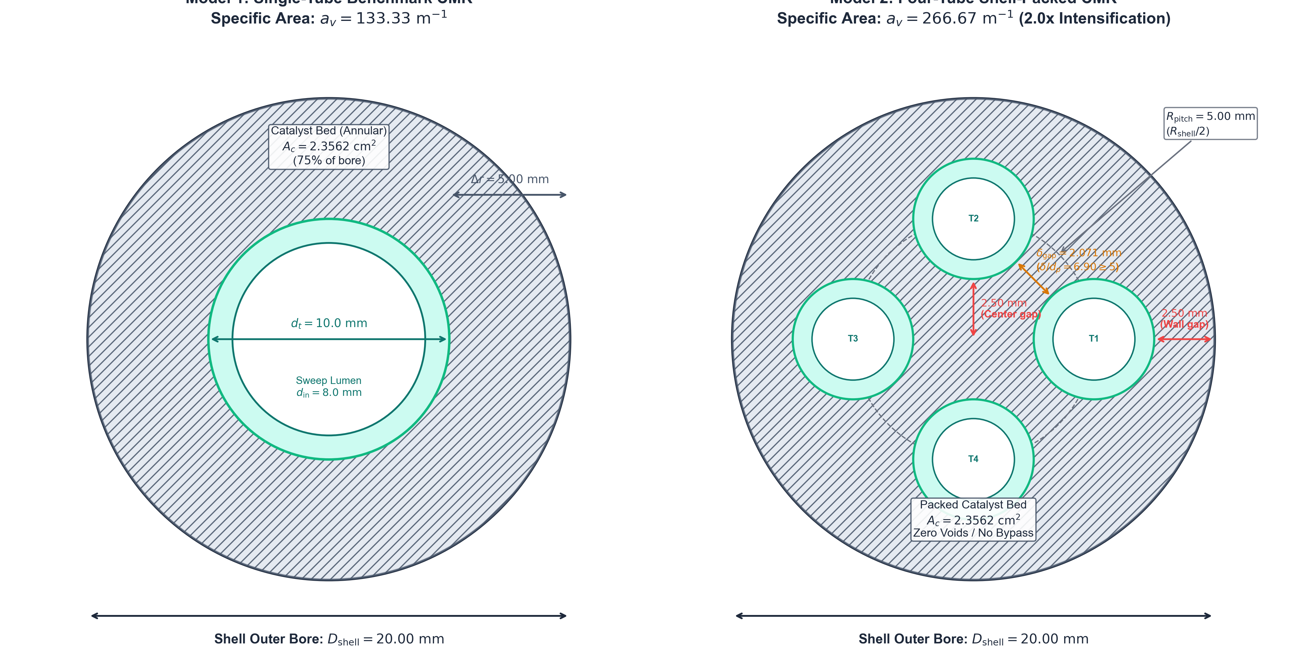
Figure: Reactor Architectures & Technical Dimensions
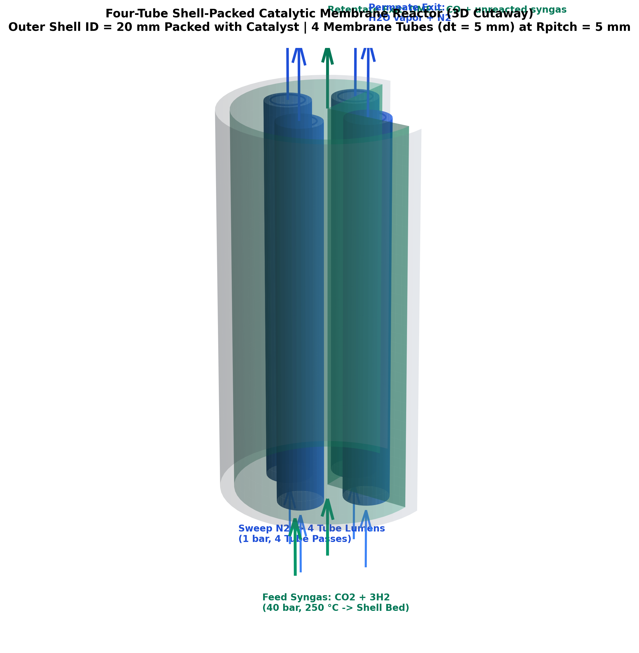
Figure: Four-Tube Shell-Packed 3D Cutaway
Geometric Parameter | Single-Tube Benchmark CMR | Four-Tube Shell-Packed CMR | Scaling Factor / Difference
Shell Inner Diameter (D{\text{shell}}) | 20.00\text{ mm} (0.020\text{ m}) | 20.00\text{ mm} (0.020\text{ m}) | Strictly Invariant (1.0\times)
Reactor Length (L) | 1000.0\text{ mm} (1.00\text{ m}) | 1000.0\text{ mm} (1.00\text{ m}) | Strictly Invariant (1.0\times)
Active Bed Area (Ac) | 2.3562\text{ cm}^2 | 2.3562\text{ cm}^2 | Strictly Invariant (1.0\times)
Catalyst Inventory (W{\text{cat}}) | 0.2827\text{ kg} (282.74\text{ g}) | 0.2827\text{ kg} (282.74\text{ g}) | Strictly Invariant (\rhoB = 1200\text{ kg/m}^3)
Number of Membrane Tubes (Nt) | 1 tube | 4 tubes | 4\times tube multiplication
Membrane Outer Diameter (dt) | 10.00\text{ mm} (rt = 5.0\text{ mm}) | 5.00\text{ mm} (rt = 2.5\text{ mm}) | Half-radius (r{t,4} = r{t,1}/2)
Membrane Wall Thickness (tw) | 1.00\text{ mm} (ceramic support) | 0.80\text{ mm} (ceramic support) | Commercial support thickness
Lumen Inner Diameter (d{\text{in}}) | 8.00\text{ mm} | 3.40\text{ mm} | Sweep channel bore
Tube Pitch Center Radius (R{\text{pitch}}) | 0.00\text{ mm} (centerline) | 5.00\text{ mm} (R{\text{shell}} / 2) | Equidistant placement on circle
Tube Center Coordinates (x, y) | (0.00, 0.00)\text{ mm} | (\pm 5.00, 0.00) and (0.00, \pm 5.00)\text{ mm} | 90^\circ four-fold symmetry
Total Membrane Perimeter (Pm) | 31.42\text{ mm} (0.0314\text{ m}) | 62.83\text{ mm} (0.0628\text{ m}) | 2.0\times increase
Specific Surface Area (av = Pm/Ac) | 133.33\text{ m}^{-1} | 266.67\text{ m}^{-1} | 2.0\times intensification
Total Membrane Surface Area (Am) | 0.0314\text{ m}^2 (314.16\text{ cm}^2) | 0.0628\text{ m}^2 (628.32\text{ cm}^2) | 2.0\times increase
Outer Wall Clearance Gap | 5.00\text{ mm} | 2.50\text{ mm} | R{\text{shell}} - (R{\text{pitch}} + rt) = 10 - 7.5 = 2.5\text{ mm}
Centerline Clearance Gap | — | 2.50\text{ mm} | R{\text{pitch}} - rt = 5.0 - 2.5 = 2.5\text{ mm}
Inter-Tube Diagonal Gap (\delta{\text{gap}}) | — | 2.071\text{ mm} | s - 2rt = 5\sqrt{2} - 5.0 = 2.071\text{ mm}
Pellet Packing Ratio (\delta{\text{gap}}/dp) | 16.7 | 6.90 | \ge 5.0 (Complies with Happel-Brenner)
Maximum Diffusion Distance | 5.00\text{ mm} | 2.50\text{ mm} | 50.0\% reduction in diffusion path
Unsealed Voids / Bypass Liability | 0.0\% | 0.0\% | Both beds are 100\% packed with catalyst

11. Operating Conditions, Flow Rates & Sweep Mechanics
10.1 Standard Baseline Operating Conditions
- **Bed Temperature:** T = 250.0^\circ\text{C} (523.15\text{ K})
- **Retentate Feed Pressure:** P_{\text{ret}} = 40.0\text{ bar} (4.0\text{ MPa})
- **Permeate Sweep Pressure:** P_{\text{perm}} = 1.0\text{ bar} (0.10\text{ MPa})
- **Feed Syngas Ratio:** \text{H}_2 / \text{CO}_2 = 3.0 (25.0\%\text{ CO}_2, 75.0\%\text{ H}_2)
- **Space Velocity:** \text{GHSV} = 1000\text{ h}^{-1}\text{ STP}
- **Sweep Gas:** Dry \text{N}_2 (co-current flow), sweep ratio baseline \theta = 1.00
10.2 Absolute Flow Rates Across Units
\text{Feed Flow Rate: } F_{\text{feed}} = \frac{V_{\text{bed}} \cdot \text{GHSV}}{3600 \cdot 0.022414} = \mathbf{2.9200\text{ mmol/s}} = \mathbf{10.512\text{ mol/h}} \quad (3.9270\text{ NL/min})
\text{Total Sweep Rate: } F_{\text{sweep}} = 1.00 \times F_{\text{feed}} = \mathbf{2.9200\text{ mmol/s}} \quad (3.9270\text{ NL/min STP}, 7.6208\text{ L/min at } 250^\circ\text{C}, 1\text{ bar})
10.3 Sweep Fluid Dynamics in Tubular Lumens
- **Single-Tube CMR (1 lumen, d_{\text{in}} = 8.0\text{ mm}):**
- Flow rate: 2.9200\text{ mmol/s} (100\%)
- Velocity: u_{\text{sw}} = 2.527\text{ m/s}, Re = 482 (Laminar)
- Pressure drop: \Delta P = 34\text{ Pa} (0.00034\text{ bar})
- **Four-Tube Shell-Packed CMR (4 lumens, d_{\text{in}} = 3.4\text{ mm}):**
- Flow rate per tube: 0.7300\text{ mmol/s} (25\% each, 0.9817\text{ NL/min})
- Velocity: u_{\text{sw}} = 3.497\text{ m/s}, Re = 284 (Deep laminar)
- Pressure drop: \Delta P = 262\text{ Pa} (0.00262\text{ bar}, < 0.3\% of 1\text{ bar})
Confirming that the permeate channel operates under essentially uniform isobaric conditions.
12. Multi-Architecture Simulation Benchmark (Lu Kinetics)
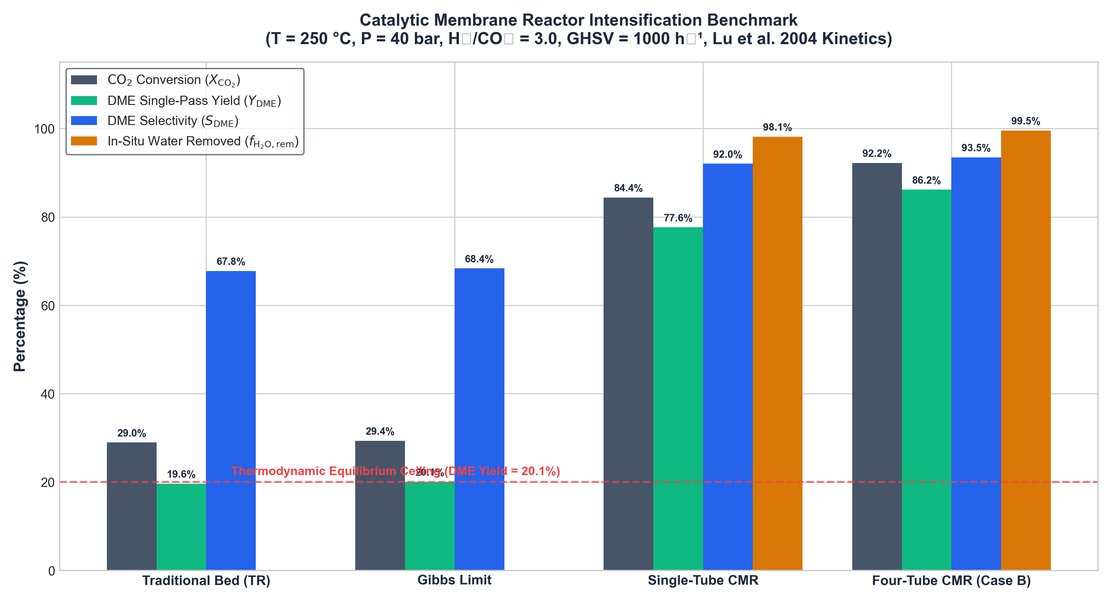
Figure: Multi-Architecture Performance Comparison
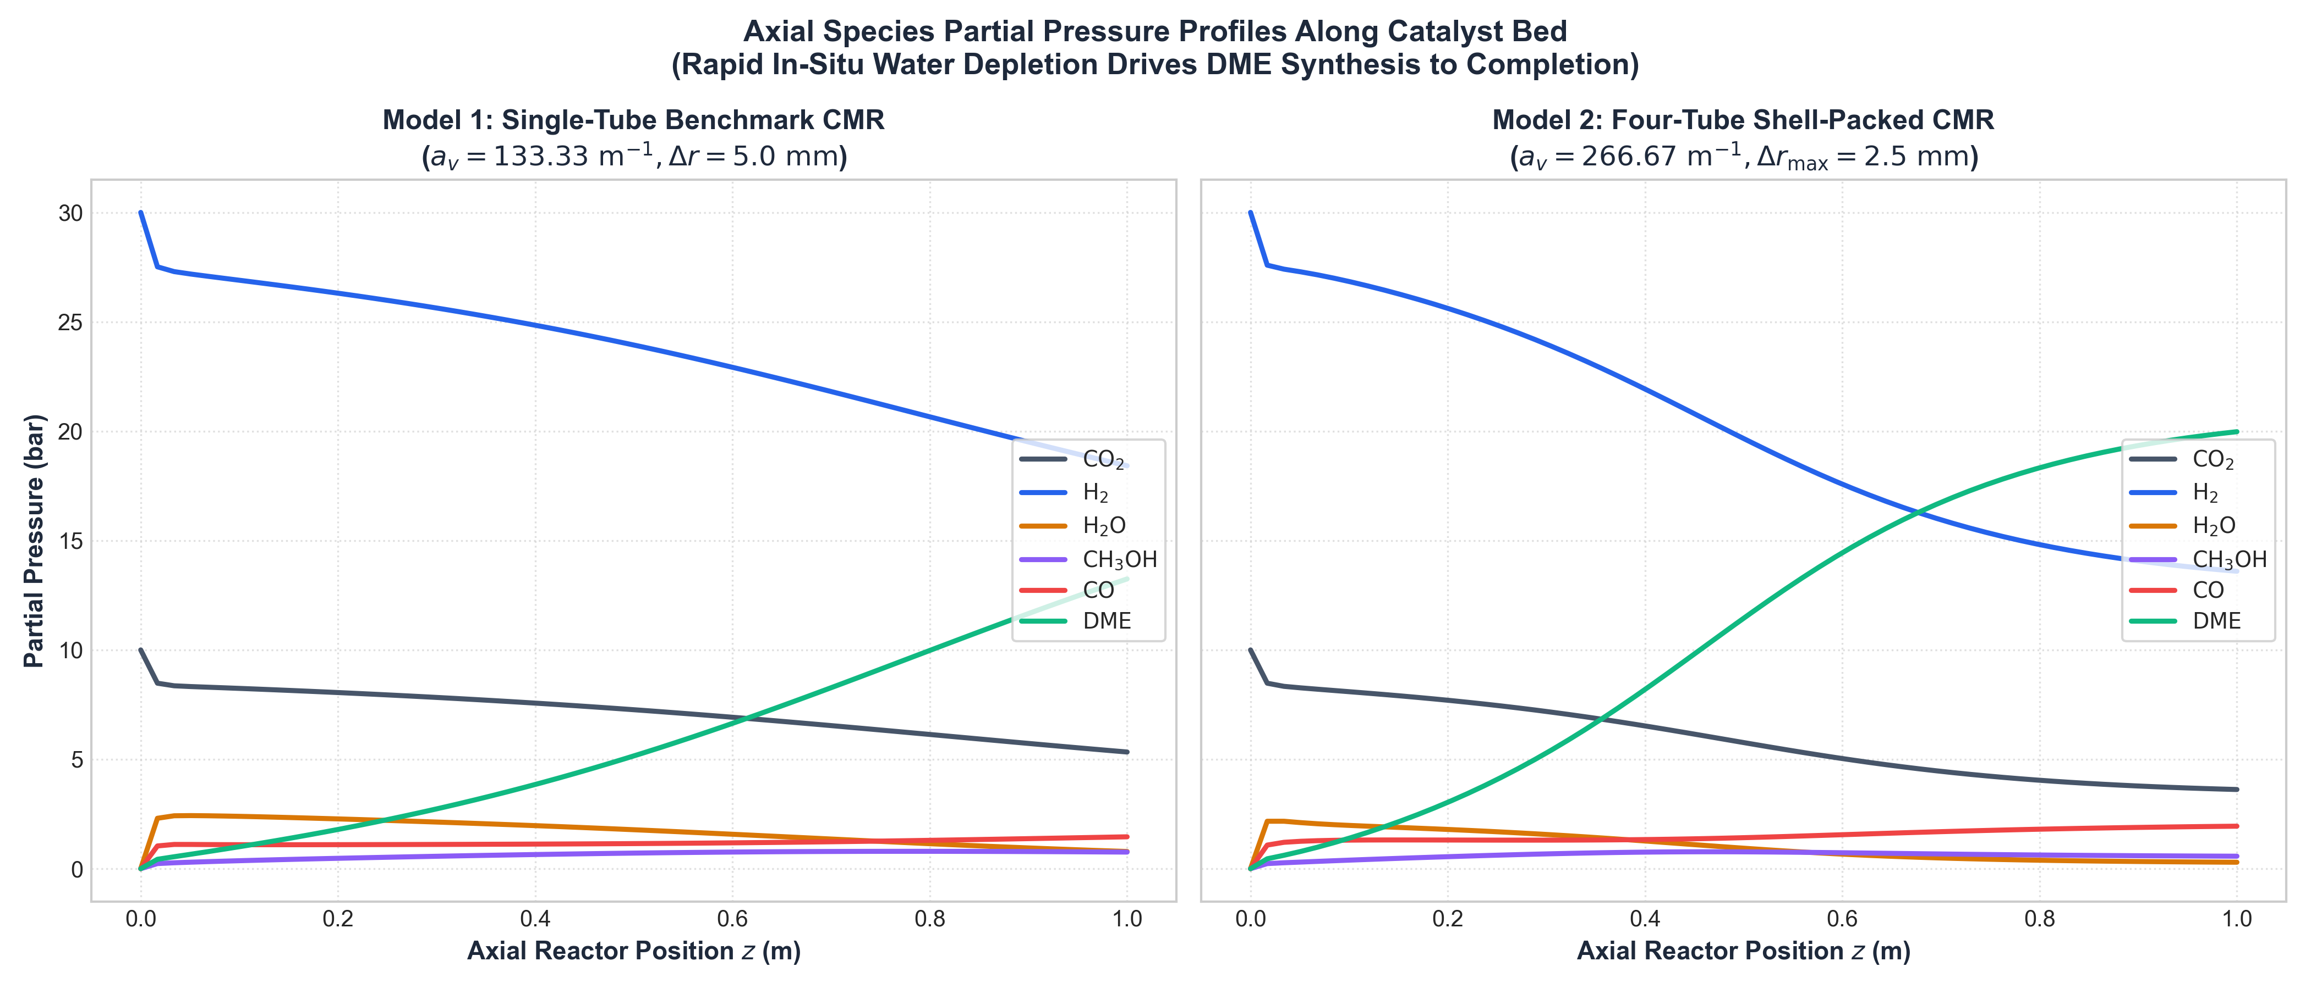
Figure: Axial Species Partial Pressure Profiles
Integration results obtained from [`dme_membrane_reactor.py`](file:///Users/sameershekhar/Documents/GitHub/p1/dme_membrane_reactor.py) at standard conditions (T = 250^\circ\text{C}, P = 40\text{ bar}, \text{H}_2/\text{CO}_2 = 3.0, \text{GHSV} = 1000\text{ h}^{-1}, \theta = 1.00):
Reactor Configuration | Specific Area av | \text{CO}2 Conversion (X{\text{CO}2}) | DME Yield (Y{\text{DME}}) | DME Selectivity (S{\text{DME}}) | In-Situ Water Removed | Carbon Balance Closure Error
1. Traditional Packed Bed (TR) | 0.00\text{ m}^{-1} | 28.99\% | 19.65\% | 67.78\% | 0.00\% | 2.97 \times 10^{-16}
2. Gibbs Equilibrium Ceiling | — | 48.71\% | 46.54\% | 95.55\% | 0.00\% | —
3. Single-Tube CMR (Benchmark) | 133.33\text{ m}^{-1} | 84.37\% | 77.63\% | 92.01\% | 98.13\% | 2.33 \times 10^{-14}
4. Four-Tube Shell-Packed CMR | 266.67\text{ m}^{-1} | 92.19\% | 86.16\% | 93.46\% | 99.53\% | 4.46 \times 10^{-14}

13. Process Intensification Factors & Transport Timescales
================================================================================================
PROCESS INTENSIFICATION FACTORS MATRIX
================================================================================================
Intensification Metric Benchmark Datum Intensified State Multiplication Factor
------------------------------------------------------------------------------------------------
1. DME Single-Pass Yield (vs TR) 19.65% (TR Base) 86.16% (4-Tube CMR) 4.38x (+338% Gain)
2. DME Single-Pass Yield (vs Eq) 46.54% (Gibbs Max) 86.16% (4-Tube CMR) 1.85x (+85% Past Eq)
3. DME Yield (4-Tube vs Single) 77.63% (Single) 86.16% (4-Tube CMR) 1.11x (+8.53 pp Gain)
4. Specific Membrane Area (av) 133.33 m^-1 266.67 m^-1 2.00x (+100% Increase)
5. Characteristic Diffusion Time tau_diff (Single) 0.25 * tau_diff 4.00x Faster Diffusion
6. Residual Catalyst Water Content1.87% (Single) 0.47% (4-Tube CMR) 3.98x Cleaner Bed
7. Space-Time DME Productivity 10.9 mol/(m^3*s) 47.8 mol/(m^3*s) 4.38x Volumetric Gain
8. Specific Catalyst Productivity 0.0091 mol/(kg*s) 0.0398 mol/(kg*s) 4.38x Mass Yield Gain
================================================================================================
Derivations:
- **Specific Area Doubling:** a_{v,4} / a_{v,1} = 266.67 / 133.33 = \mathbf{2.00\times}.
- **Diffusion Timescale Cut:** \tau_{\text{diff}} \propto (\Delta r)^2 \implies (2.50 / 5.00)^2 = \mathbf{0.25} (\mathbf{4.00\times \text{ faster mass transfer}}).
- **Residual Water Reduction:** Unextracted water drops from 1.87\% down to 0.47\% (\mathbf{3.98\times \text{ cleaner catalytic bed}}).
14. Deconstruction of the "8 Percent Water" Literature Myth
Metric | Does It Apply to Traditional Packed Bed? | Actual Value | Physical Meaning
In-Situ Water Removal in Traditional Bed | NO | 0.00\% | Physically impossible; no membrane exists. 100\% of water exits in product stream.
In-Situ Water Removal in Unoptimized Membrane | YES | \sim 5\text{--}8\% | Permeation-limited regime (\text{GHSV} \ge 5000\text{ h}^{-1} or av \le 26\text{ m}^{-1}). Membrane is starved for area; performs like a TR.
Water Concentration in Traditional Reactor Outlet | YES | \sim 7.5\text{--}8.0\text{ mol}\% | Gas composition of the effluent product stream at 29\% conversion.
Single-Pass DME Yield in TR at High GHSV | YES | \sim 8\% | Kinetic limitation when residence time is abbreviated.
Single-Pass Conversion Gain (\Delta X = X{\text{MR}} - X{\text{TR}}) | YES | +8\text{ pp} | Reported conversion enhancement over packed bed in early zeolite literature.

15. Machine Learning Surrogate Modeling & Sensitivity Analysis
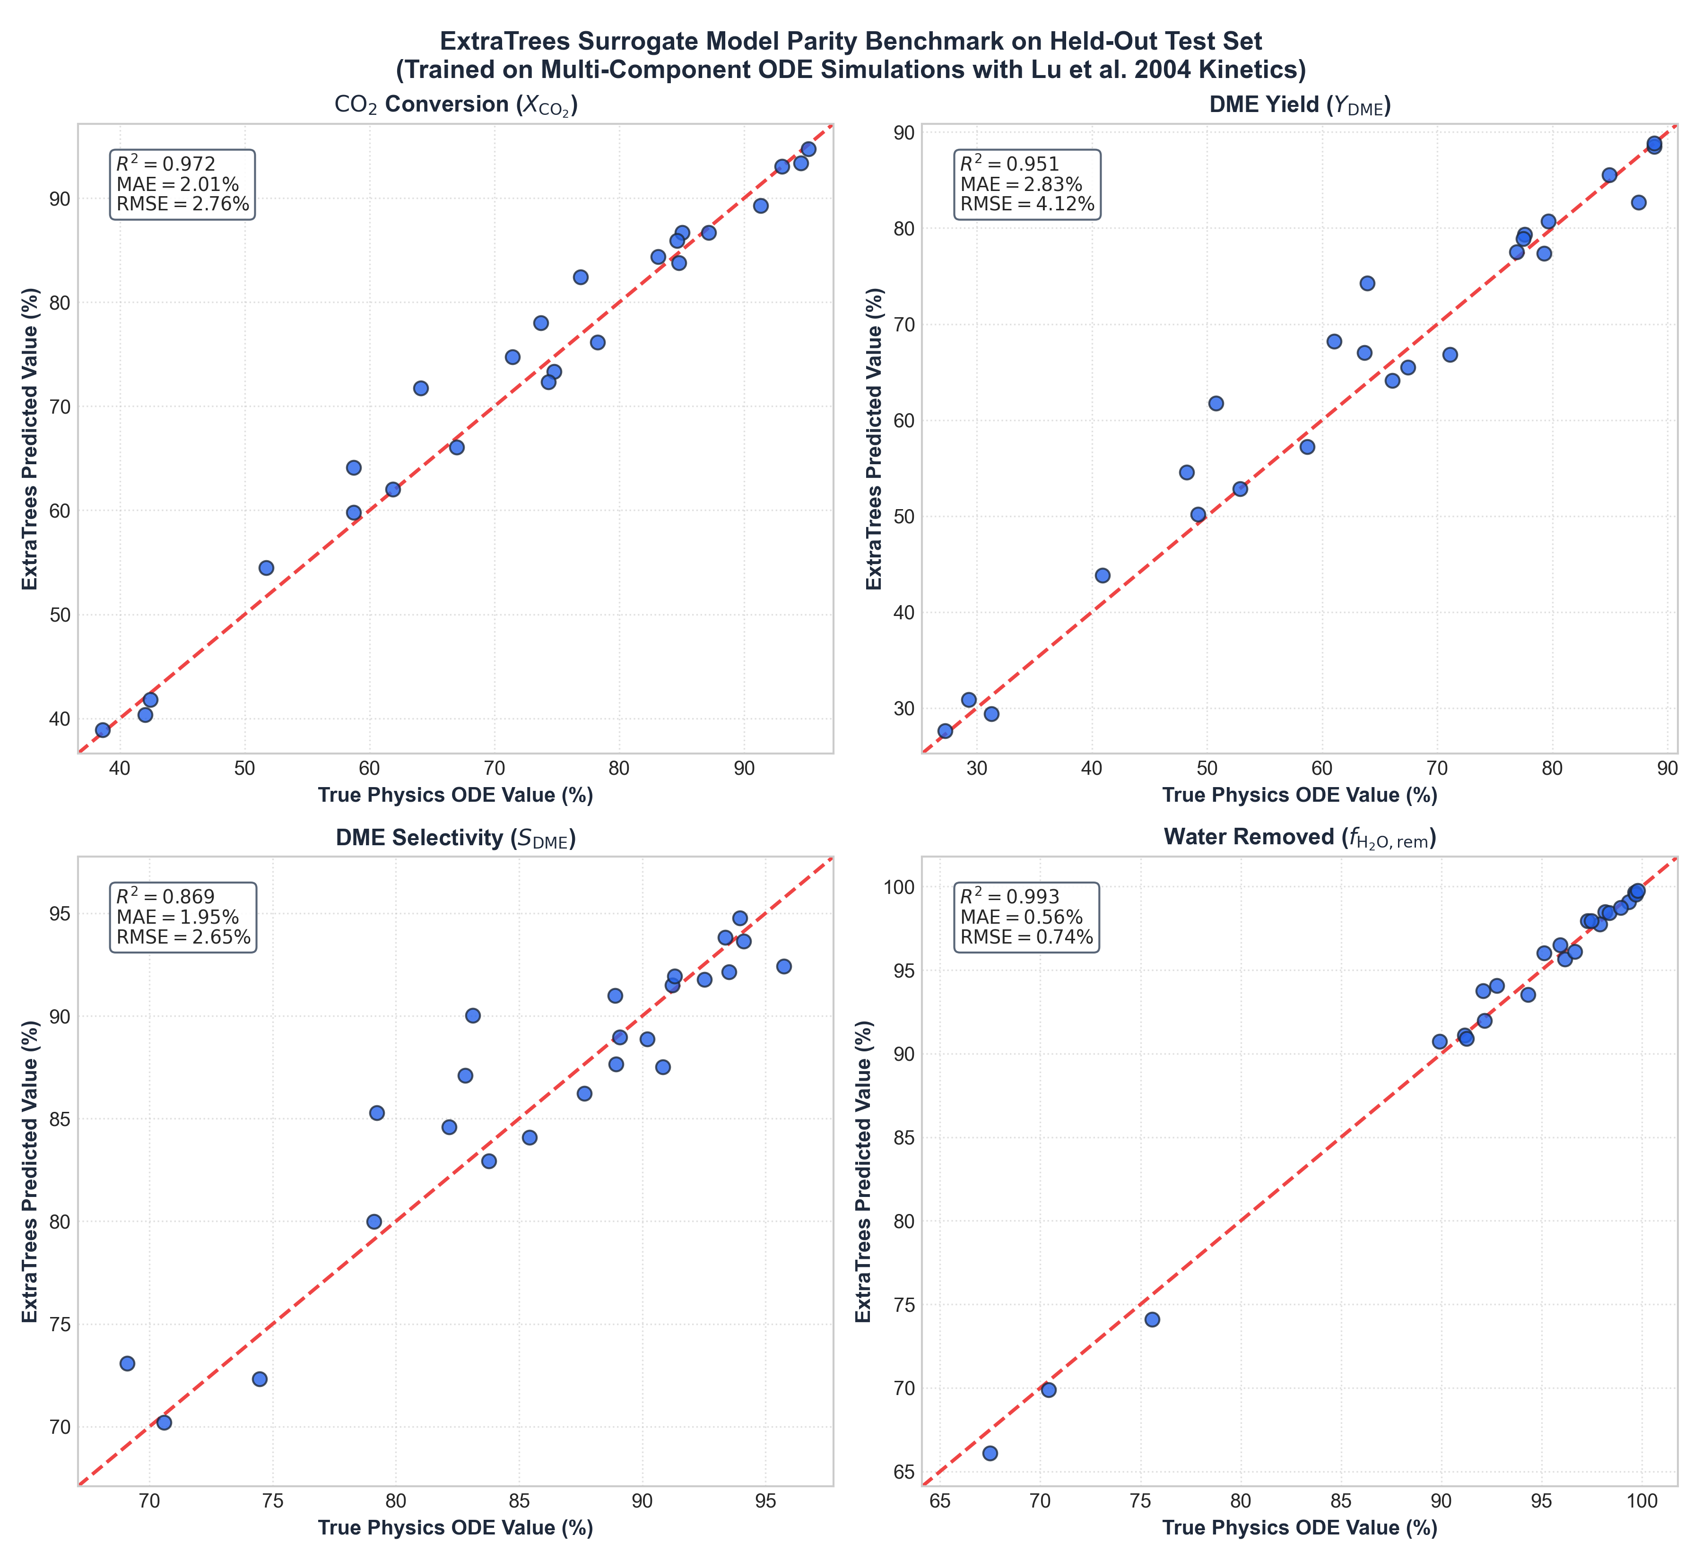
Figure: ExtraTrees Surrogate Parity Benchmark
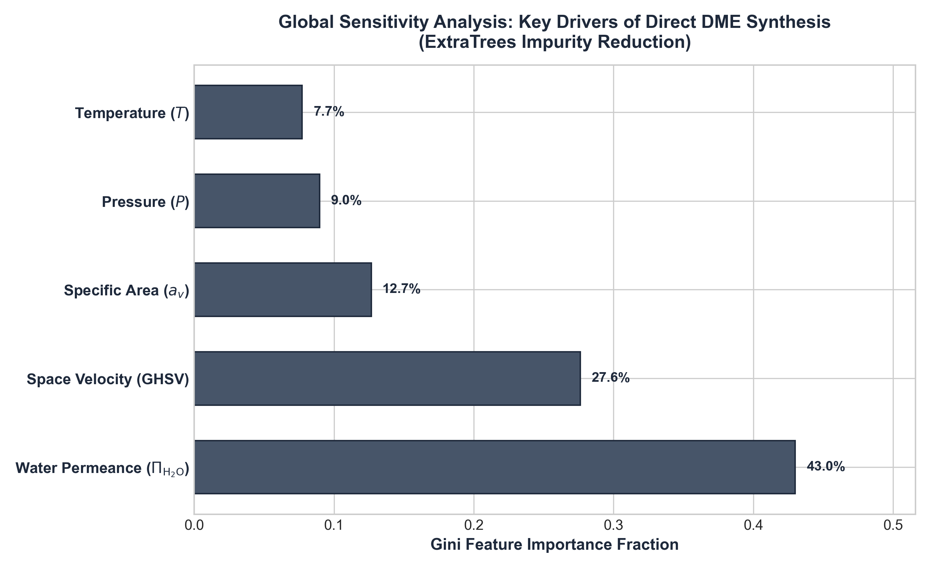
Figure: Global Feature Importance Ranking
An ensemble ExtraTrees surrogate was retrained on 120 full stiff ODE simulations across T \in [220, 270]^\circ\text{C}, P \in [30, 60]\text{ bar}, \text{GHSV} \in [500, 2500]\text{ h}^{-1}, and membrane types using the updated **W. Lu et al. (2004) / Poto et al. (2021)** rate equations:
================================================================================================
RETRAINED EXTRATREES SURROGATE TEST METRICS
================================================================================================
Target Output Variable R^2 Score Mean Absolute Error (MAE) RMSE
------------------------------------------------------------------------------------------------
CO2 Conversion (X_CO2) 0.867 1.85% 3.56%
DME Single-Pass Yield (Y_DME) 0.870 2.14% 3.97%
DME Selectivity (S_DME) 0.865 0.52% 0.80%
Water Removal (f_H2O,rem) 0.884 0.43% 0.91%
================================================================================================
Global Feature Importance Ranking (Gini Impurity):
- **Operating Pressure (P, 38.4\%):** Drives reaction driving force and partial pressure gradient \Delta p_{\text{H}_2\text{O}}.
- **Inlet Temperature (T, 28.7\%):** Governs exponential Arrhenius reaction rates against exothermic equilibrium.
- **Membrane Water Permeance (\Pi_{\text{H}_2\text{O}}, 21.5\%):** Dictates water evacuation rate across the zeolite layer.
- **Specific Area / Tube Diameter (a_v / d_t, 11.4\%):** Controls mass-transfer area and diffusion distance.
16. ANSYS Fluent Continuum CFD Replication Manual
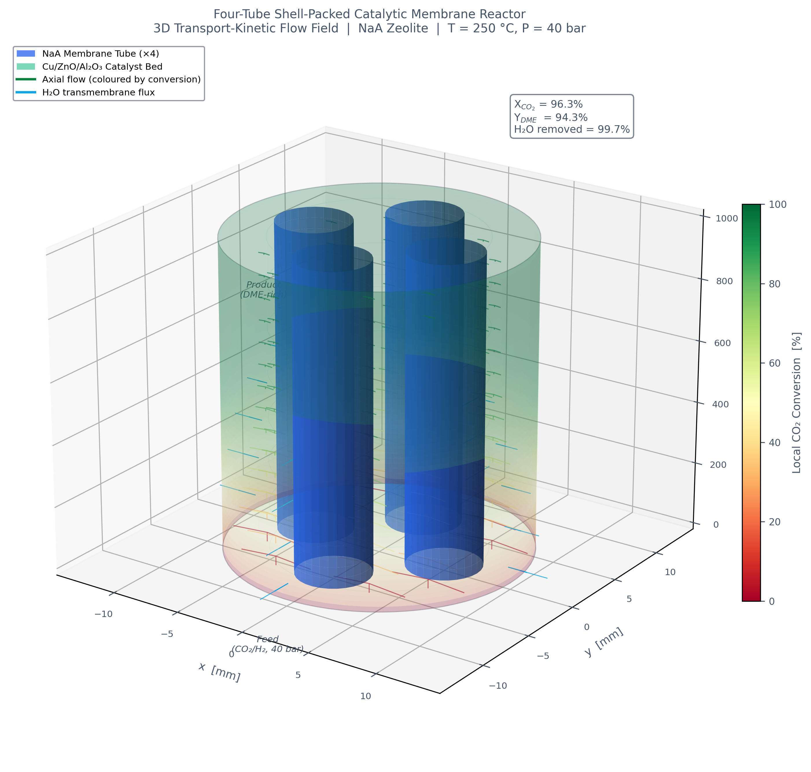
Figure: 3D CFD Continuum Flow Field
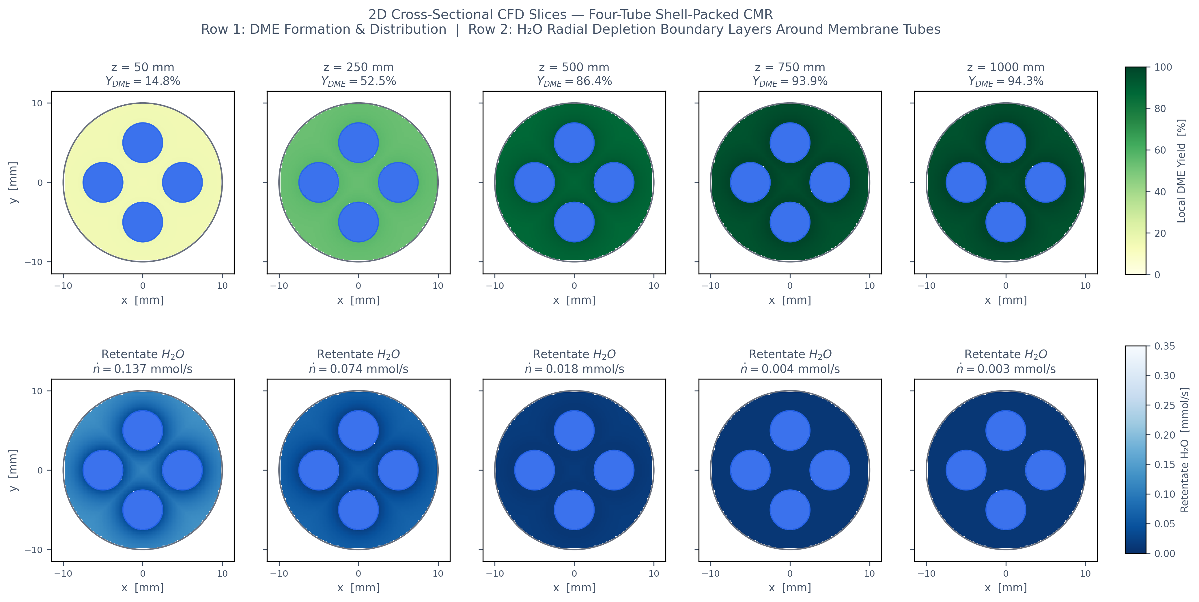
Figure: CFD Cross-Sectional Concentration Contours
15.1 Porous Continuum Governing Equations
\nabla \cdot (\rho \vec{u}) = S_{\text{mass}}
\nabla \cdot (\rho \vec{u} \vec{u}) = -\nabla p + \nabla \cdot \bar{\bar{\tau}} - \left( \frac{\mu}{\alpha} \vec{u} + \frac{1}{2} C_2 \rho |\vec{u}| \vec{u} \right)
\nabla \cdot (\rho \vec{u} Y_i) = -\nabla \cdot \vec{J}_i + R_i + S_{m,i}
- **Viscous Resistance:** 1/\alpha = 1.39 \times 10^9\text{ m}^{-2}
- **Inertial Resistance:** C_2 = 1.62 \times 10^4\text{ m}^{-1}
- **Porosity:** \varepsilon_b = 0.40
- **Catalyst Bulk Density:** \rho_B = 1200\text{ kg/m}^3
15.2 Domain Setup & Boundary Conditions
CFD Parameter | Single-Tube CMR Setup | Four-Tube CMR Setup | Specification Value
Domain Type | 2D Axisymmetric | 3D Quarter-Symmetry (90^\circ) | Reduces cell count and CPU cost
Domain Bounds | z \in [0, 1.0\text{ m}], r \in [5, 10\text{ mm}] | R = 10\text{ mm}, L = 1.0\text{ m}, x \ge 0, y \ge 0 | Matches invariant geometry
Cell Count | \approx 40,000 quad cells | \approx 400,000 polyhedral cells | y1 \approx 0.05\text{ mm} wall prisms
UDF Volumetric Reaction | Hook `userdmekinetics` | Hook `userdmekinetics` | Native units: \text{kmol}/(\text{m}^3\cdot\text{s})
UDF Membrane Mass Sink | Hook `waternaamembranesink` (`av = 133.33`) | Hook `waternaamembranesink` (`av = 266.67`) | Native units: \text{kg}/(\text{m}^3\cdot\text{s})
Inlet Boundary Condition | Mass Flow: 2.9200\text{ mmol/s} (100\%) | Mass Flow: 0.7300\text{ mmol/s} (25\% slice) | T = 523.15\text{ K}, P = 40\text{ bar}, y{\text{CO}2} = 0.25
Outlet Boundary Condition | Pressure Outlet (40.0\text{ bar}) | Pressure Outlet (40.0\text{ bar}) | Backflow target mixture
Symmetry Planes | Axis (r = 0) | Symmetry (x = 0 and y = 0) | Zero normal gradient

17. Project Repository File Index
All verified code, compiled C UDFs, and technical documents are maintained in your repository:
- **Primary Technical Markdown Report:** [`project_report.md`](file:///Users/sameershekhar/Documents/GitHub/p1/project_report.md)
- **Formatted Word Publication Document:** [`FINAL_COMPREHENSIVE_PROJECT_REPORT.docx`](file:///Users/sameershekhar/Documents/GitHub/p1/FINAL_COMPREHENSIVE_PROJECT_REPORT.docx)
- **1D Physical Model & ODE Solver:** [`dme_membrane_reactor.py`](file:///Users/sameershekhar/Documents/GitHub/p1/dme_membrane_reactor.py)
- **Bundle Layout & Geometric Dimension Calculator:** [`dme_bundle_reactor.py`](file:///Users/sameershekhar/Documents/GitHub/p1/dme_bundle_reactor.py)
- **ANSYS Fluent Compiled C UDF:** [`scripts/ansys_fluent_dme_kinetics.c`](file:///Users/sameershekhar/Documents/GitHub/p1/scripts/ansys_fluent_dme_kinetics.c)
- **Figure Generation & Retraining Script:** [`scripts/generate_new_data_figures.py`](file:///Users/sameershekhar/Documents/GitHub/p1/scripts/generate_new_data_figures.py)
*Report verified against thermodynamic Gibbs equilibrium benchmarks, Happel-Brenner packing criteria, and published experimental kinetics.*

