Artificial Intelligence
---------------------------
AI technology that allows computers or system to perform task that typically required Human Intelligence.

Ex
1. Pattern recognition
2. Speech Recognition, Siri Alexa, ChatGPT, Gemini
3. Image Analysis, Traffic challan via CCTV
AI > ML > Deep Learning > Gen AI

AI Sub domain is Machine Learning
ML is those algorithms that learn from data rather than programming.
Here Data is very important

Rule based system
Part of AI but not part of ML, work on programming rather than data.
Example
Classical Robotics
One A* algorithm used in Grass
Fuzzy Logics system used in AC, Fridge to programmed to provide some intelligence

Today’s Majority of AI is ML (Maps, Uber, Amazon, blink it)
Deep Learning sub domain of ML, very popular today
Inside DL we work with Neural Network
Created through machine and these networks inspired from Human Brain (have Neurons)
Gen AI subdomain of DL
Generative AI deal technology that can generate new text, images, audio, video
Machine Learning
ML is the process of teaching computers to learn patterns from data and make decision based on those patterns. ML works on algorithm that learn from data
Ex
Bank loan application
- Training (Learning from Data, create logic model) >> accept or reject
On basis of credit score, salary, education, collateral
- Inference or Making Prediction
New Applicant (use that logic model)
Analyse parameter, loan yes or no

Medical Field: Xray analysis, Cancer yes or no
Gamil: Mail is spam or no
Credit card fraud detection
Swiggy/Zomato delivery time prediction

ML algo vs Normal Computer algo
Normal Computer Algo
Input > (Logic) > Output

ML Algo
Input-Output > make logic (k/n model)
Now, New input > (model) > prediction out

ML Types
- Supervised Learning
- Unsupervised learning
- Reinforcement Learning

- Supervised Learning
Models learn from labelled data (Training data in form of table where input output both exists in well-structured manner)
In – out data both exists in well-structured manner
Input (X) have different column called features
Label output (Y)
Y = f(X) Function is stored in model to predict

Its solved 2 problem: Classification and Regression

Classification problem (fixed defined output, finite no of classification)
Based on input mapped to predefined categories/classes
Ex
Email > 2 category (Spam or not spam)
Loan > approved or not approved
Image classification > it will be cat or dog only
Further divided ->
- Binary classification: output 2 values
- Multiclass classification: more than 2 values
Ex. Sentiment analysis
“This is a bad day”
Positive, negative or neutral (3 different classes)

Handwritten digits (1-10) dataset to analyse user written value.
(10 different classes)
Some classification Algorithms
- Linear classifiers
- Logistic regression
- K-Nearest Neighbour (KNN)
- Support Vector Machine (SVM) > Relevance Vector Machine (RVM)
- Random Forest
- XG Boost

Regression problems
Models try to predict numerical value
Zomato delivery time: any time (based on old delivery data)
Stock price forecasting
Property price forecasting

X -> Y
X – independent variable
Y – dependent variable
Y = f(X) Function try to predict Relation b/w X and Y

Height (X) Weight (Y)
Y= f(X)
If X` as new data, then can produce Y`=f(X`)
Y=ax+b Straight line equation, a is slope(angle) of line, b is intercept
Line is function represent relationship b/w input and output values

Some Regression Algorithms
- Linear Regression
- Lasso Regression
- Multi-variate Regression

- Unsupervised Learning
Model learns from unlabelled data
Try to be grouped related data (make clusters) based on features (like data)
Ex
Huge News articles > Tech, Political, sports group (clusters)
When try to cluster, may some data be not part of any cluster called outliers or anomely
Very useful in finance, medical, cybersecurity
Ex. Cybersecurity analysing one website. Many user login but 1 user within 1 min login from 5 different city. This is something different from normal data k/a anomely data which our system detected.

Its solved 2 problem: Clustering and association

Clustering Problem
Unlabelled data converted in multiple clusters
Ex. Multiple news articles have Finance, tech, sports. Politics clusters.
2 types
- Partitional clustering problem

One data point must belong to only one cluster. Ex News Article.

- Hierarchical clustering problem

Single data point can belong to multiple clusters.
Ex. News Article of Taxation on Bitcoin in India
It may belong to politics cluster, finance cluster and tech cluster

Association Problems
Try to find relationship b/w different entities
Ex.
Market Basket Analysis
Amazon, Blink it suggests user to buy Milk when they added Bread in cart.
Ecom company suggest user what another item they should buy.
Suggestion on Amazon: “Item bought together”

Some Unsupervised Algorithms
K-means clustering
Hierarchical clustering
PCA (Principal Component Analysis)
DBSCAN (Density-Based Spatial Clustering of Applications with Noise)

- Reinforcement Learning

In RL, an agent learns to make decision by interacting with an environment, receiving rewards or penalties for its actions.
In home, to Pet Dog say sit, if done, provide some rewards or treats.
Here, agent (Model) learns (train) to make decision by interacting with environment. Then make some prediction. If wright, then rewards otherwise penalties.
Rewards: Feed +ve values to Agent
Penalties: Feed -ve values to Agent
Agent moto not to provide correct prediction. Its moto to maximize rewards.

Ex
To create a model who can be able to win in snake ladder Game.
On dice roll,
if snake encounter – penalty
If ladder encounter– rewards
Aim to maximize ladder climb to reach end point. To win Game.
Chess, Self driving car, Robotics

Some RL Algorithms
Q Learning
Deep Q Networks (DQN)
Policy Gradient Methods
Proximal Policy Optimization (PPO)

Mentioned above algorithm used with multiple tools
Python – Prog lang used to ML algo write, data process and prediction
Jupyter notebook - write python code, multiple libraries and modules used in ML
NumPy, pandas – for data preprocessing
Seaborn, matplotlib – data visualization
Scikit learn, XGBoost – libraries to train our ML models

DEEP Learning
Subset of ML in which study all about neural network
All previous learning called statistical ML Algo applied on structural data (tabular data)

On Unstructured data, statical ML not able to perform. So, Deep Learning take place
Ex. Multiple camera or Video recording, multiple YouTube video as input on YouTube, multiple images or audios, application chat messages these are not in fixed format k/a Unstructured data.

Human Face
DL able to extracts useful data from Raw data (Ex Human face)
By using Neural Networks is core of DL, inspired from Human brain neurons network

Neural Networks
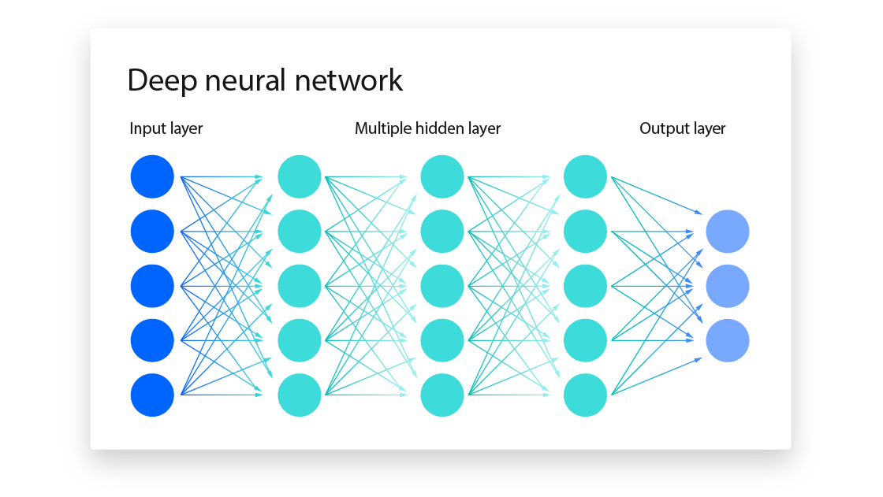
Each dot called neuron may have trillions of connections (hidden networks)

College CGPA calculation can be remodified with weightage adjustment on mid, end and class test weightage.
Weight parameter tells how important input value for output or for next neurons.
Adjustment (trail/error) on weight parameter to get prediction (output) as close to the expected value. To build neural network with high accuracy.

Now understand in depth process on Neural Network Training
Forward & Backward Propagation
Step 1. Forward – moving forward in NN, to make a guess/prediction based on input
Step 2, Backword – moving backward in NN, compare prediction with expected values then make adjustment (learning from mistakes)
Except input neurons, each one has own bias values (b)
Every neuron calculates some computation k/a weighted sum on each input from input neuron.
f [(x1.w1 + x2.w2 + x3.w3) + b] = value passed to next neuron/layer in network
f is activation function
ex. Sigmoid function, ReLU function.
This way every neuron makes some computation and passed final value to next layer. At end get final prediction called Forward Propagation.

Backward Propagation (Model Training)
Final prediction will compare to expected values (already have).
Calculate how much loss with loss function. Quantify how much inaccurate.
Now adjust/update bias and weight on hidden layer (Not for input layer as it was fixed)
Loss function to quantify loss then move from output layers to hidden layers k/a Backward Propagation

For each input, make forward and backward propagation then perform adjustments
To minimize Deviation calculated on loss function to get more correct prediction.
That’s why when Neural Network gets feed more data will able to produce more correct prediction.
Neural Network trained means weight and bias value figured out.
Now we can use models for new data.

Tools used
For Libraries we use
TensorFlow (from Google, more industrial nature) &
PyTorch (from Meta, more academic in nature) – simpler and more intuitive for beginner
Kaggle – use for different data set, its website has multiple data set required for statistical ML and DL algorithms.

Neural Network Architectures

- Feed Forward Neural Network (FNN)
- Recurrent Neural Network (RNN) -> Long short-term memory network (LSTM), advance version
- Convolutional Neural Networks (CNN)
- Transformers

Feed Forward Neural Network (FNN)
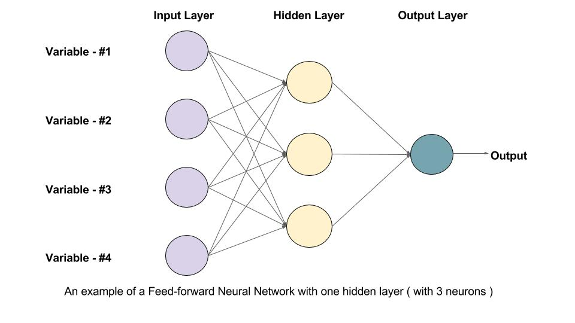
A trained Neural Network in which information flow in single direction for prediction and there are no loops, no cycles k/a FNN
These NN not good for sequential and time dependent data.
Used for simple prediction. Ex. Medical diagnosis, loan approval application.

Recurrent Neural Network (RNN)
Have special thing, Memory.
RNN remember information from previous steps that information used to influence the current steps output.
Here we can loopback to reuse the information.
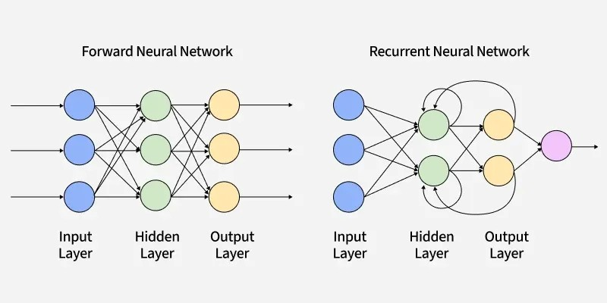

Used to sequential data where context matters.
Ex. text data (sequential data)
“Raj is happy”
Somebody happy.
Find context > Who is exactly happy?
Previous information required who is happy? Raj is a person who is happy.

Used in Language translation, speech recognition, stock prediction. Here we need old data to make some prediction.
Drawbacks: Good in sequences but bad in long term memory.

Long Short-Term Memory Networks (LSTM)
Advance version, for long term memory

Convolutional Neural Networks (CNN)
Specially used for images and videos
Data can be represented in Grid form.
Ex
A Black n White image, represent in 6x6 grid form
Computer read pictures as grid of pixels
CNN analyse image one small patch at once, see patterns regarding corner, edges, shapes so that they reduced input size then data processed in better optimised way.

Transformers
Basically, they are driving force behind GPT
GPT – Generative Pre-trained Transformers.
GPT behind scene use Transformers to interact with us.
Transformers designed to analysis sequential data without RNN
“The dog chased the cat because it was scared.”
Transformer see overall data instead of step-by-step analysis because of mechanism k/a attention.
Decide on overall data on which part required to put special focus.
For complete text derived multiple tokens, on basis of token compute attention.
Here, understand context and meaning easily in sequential data.
It – context
After analysing understand it basically related with dog.
Transformers give strong sense of the meaning and context behind the data.

Gen AI (Generative AI)
Here we generate new text, video, audio and images
Ex.
Text – GPT, Claude, Gemini, LLaMA
Images – Midjourney, DALL.E, Stable Diffusion
Audio – ElevenLabs, Bark, MusicGen
Videos – Sora, Runway, HeyGen
Code – Github Copilot, Code Llama, CodeWhisperer (from AWS)

NLP and LLMs
NLP – Natural Language Processing – domain of ML where we deal with languages,
Here we teach machine to understand, interpret and generate human language like Hindi, English, French

LLMs – Large Language Model - type of model to solve NLP task,
Have large data feed to trained them. They have lots of data to trained on.
Text – from multiple internet website, books, articles in huge
Parameters – weight, bias, neurons billions- trillions parameter used to train on
That’s why called Large LM
LLM is not single sufficient when we ready end user facing product.
In case of Open AI created ChatGPT uses RLHF (Reinforcement learning with human feedback)
When LLM produce output, then RLHF check and validate it should not hurt any rules, people centimes and laws by providing additional human feedback.

Another AI Branch – Computer Vision

Allow computer to see and interpret images like see as from human eye.
See images and videos (visual interpretation)
Through CNN
Ex. Face recognition, self-driving car

