**Abstract**

Agriculture is one of the major means to eradicate poverty in the world. It must feed close to 10 billion people by 2050. 65% of people in the world survive with the income from agriculture.

It is very crucial for economic growth, eradication of poverty, and global GDP improvements among the countries in the world.

Current system of food is lot more threating in nature - lot of water usage (70% of water in the earth is used for agriculture), lot of unsustainable pollution and waste. One-Third of food produced is wasted globally. Fresh produce, nutrition values of produce is always retained only when produce reaches consumer households or any form of consumer earlier than now. It takes closer to 24-48 hours for a produce to reach a market and then takes about 4-5 hours to reach a household or the place where it’s used for making dishes.

Food insecurity has led to poor diet leading to lot of diseases. Healthy diet is becoming more and more unaffordable to large section of society.

On the other hand, farmers struggle to make ends meet. If a farmer must survive, farming policies needs to change across world and needs a massive shift – policy should deliver fair prices and allow them to make a living that never put them at risk any time during their lifetime. When farmer do better, we all do better, and vice-versa. Farming is termed inelastic – with farmers and consumers not knowing the demand and supply for a given year. Parity pricing set by farmer is important to address pricing woes and that will benefit farmer and help consumer consume without additional middleman cost.

**Problem Statement**

In the current era, most of the agricultural products are sold by farmers to money lenders or traders. These private middlemen or traders dominate the agricultural marketing exploiting farmers due to lack of adequate marketing infrastructure or logistics to reach consumers directly.

Lot of constraints that results in poor farmers though they feed the entire world includes but not limited to:

* Too many middlemen / Traders
* Fragmented nature of market - Limited infra to handle farmers produce.
* Density regulated markets – Demand and supply varies from place to place and densely populated areas determine the cost of product mostly.
* High market fee /logistic charges
* High intermediation cost
* Limited rural credit facility for farmers
* Insufficient storage facility
* Malpractices in market – large gains for sampling almost half of produce, black marketing, hoarding etc.

The best way to address this is to ensure that a farmer friendly infrastructure is available that can help him/his family sell the produce to the nearby consumers to a comparatively higher cost than what a middleman provides.

For E.g. if a coconut we buy at house hold is Rs.40/-, then the farmer used to sell the same for Rs.8/ to a middleman (Fact studied recently) and almost Rs.32 is incurred by middle man for transport and logistics. But if there is an easy means for farmer to sell his produce directly to the consumers for say Rs.15 and let consumers in the neighboring location or same community pool in logistics cost which might not cost more than Rs.22 for a coconut. This is more of improving farmers economy and profit, beneficial to consumers with the satisfaction of knowing source of the produce and freshness of product.

**Existing solution**

There are lot of applications available all over the world to ensure farmers produce reaches consumers but must say these applications sells product at cost much more than a middleman charge. These models operate on profit by accumulating high quality produce with low quality one and selling the mix in the market, retail or wholesale. This results in farmers deprived of actual to be got post produce money for next cropping.

**Solution proposed**

Increasing value proposition for farmers produce is the idea of our hackathon project – **C**onnect**F**(armers)or**G**ood(CFG) . This includes following steps for a farmer to sell his produce and ensure sustainable living and eradicate poverty.

List of neighboring communities, colonies that can provide demand list for a week or 2 days minimum

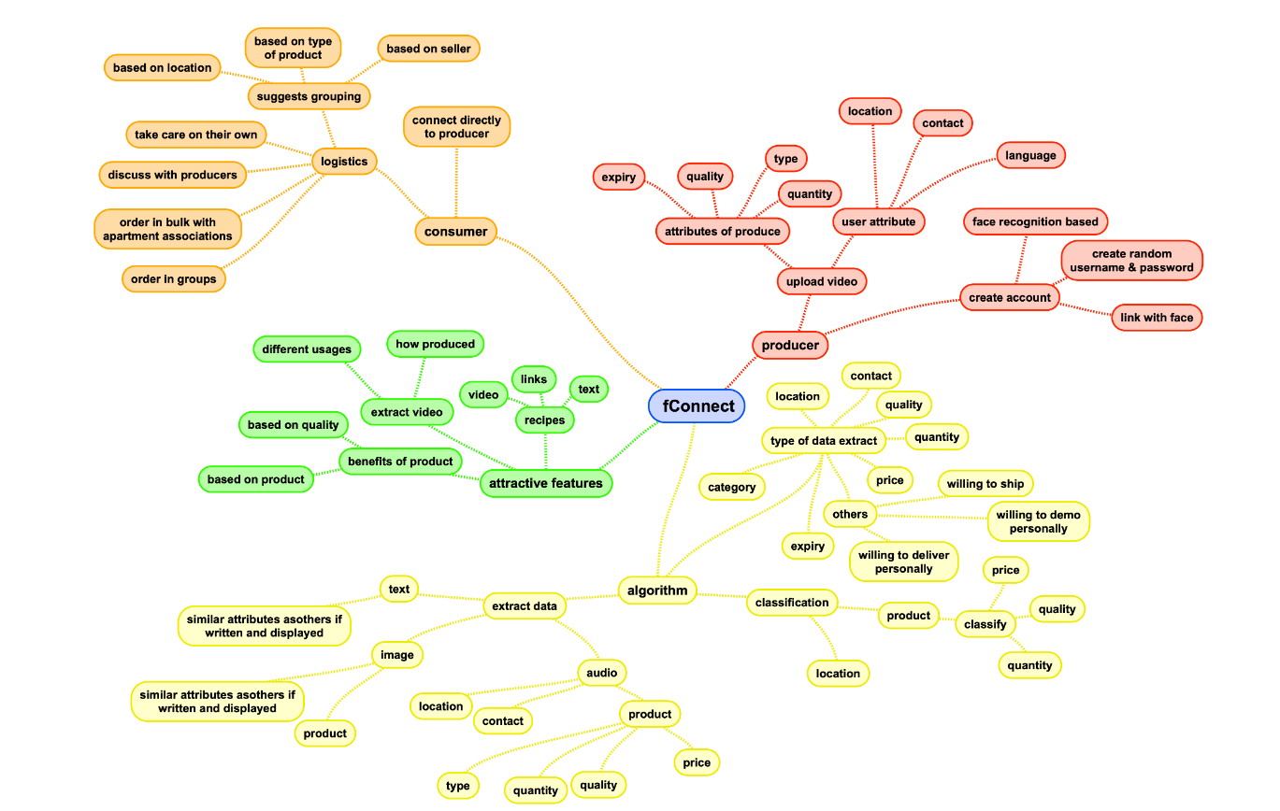

Fig 1: Use case scenarios for the solution

List of neighboring communities, colonies that can provide demand list for a week or 2 days minimum

Identify and register farmers to the CFG app, SMS or MMS facilities are also sufficient.

Let farmers decide the cost of their produce – provide potential help in developing a profit model initially.

Value chain proposition meetings to ensure not all farmers grow same produces all time.

Provide ways for farmers to leverage best farming practices – sustainable farming practices

Alternate income recommendations – live stocks – dungs can be used as manure, etc.,

Consumers in colonies., communities group together to ensure logistics on the way with benefit of sharing cost.

**Solution Detail**

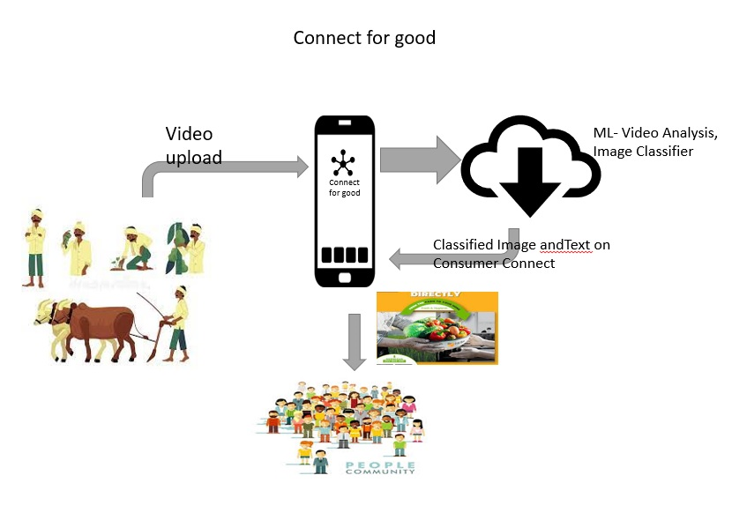

Fig 2: Solution workflow

**App Support**

* *Programming languages – Python,*
* *Machine Learning –Model – Pixel Lib , Audio bot*
* *IBM catalog – IBM Cloud Object Storage & IBM COS SDK for Python using IBM_boto3*
* *OS – Android Studio 4.2.1, Android SDK( 9.0,),SDK platform tools/SDK-tools -31.0.2/26.1.1*

**Future plans**

* Plans to integrate Groceries as part of the app
* Environment friendly farming practices and live sessions
* Share canceled orders or produce to the nearest needy.
* Lend loans to needy farmers with the community sharing corpus.
* Corpus to be used for sponsoring education of farmers kids till they stabilize as they start with CFG app.

**Advantages/Disadvantages**

* Limited / no middleman looting farmers anymore.
* Farmers will be able to determine the cost
* Best farming practices for sustainable living and greater food chain ability for future generation
* Right cost for right produce