CSCI 2720 (Term 1 2017-18) Programming Test (Full mark 30%) 2 hrs
- HTML and CSS [10%]
Without modifying p1.html, and only edit p1.css to produce an interface that meets the following requirements:

In wide-screen view where the screen width is at least 720 pixels
- Make the text of first and last list items bold (or looks bolder than the other list items). Your CSS should work for any type of lists, and list with any number of items.
- Set the width of the images inside <div id="container"> to 200 pixels while keeping their respective width to height ratio.
- Set the container to be as wide as the browser window.
- Layout the images inside <div id="container"> row by row and fit as many images as possible per row. Images that cannot fit in the current row should appear in the next row, and so on.
- There should be a 50 pixels horizontal gap between adjacent images on the same row. (Do not worry about the vertical gap and the gap between an image and the browser window.)

In narrow-screen view where the screen width is less than 720 pixels
- Make the text of all list items normal.
- Set the width of the images inside <div id="container"> to 400 pixels while keeping their respective width to height ratio.
- Layout the images inside <div id=”container”> vertically and show only one image per row. The image on each row should be centered.

Your solution should also work for p1a.html, and p1b.html.

If your solution involves modifying the HTML, you can only get at most 6 points for this problem.
- JavaScript DOM [10%]
p2.html is supposed to implement a UI that allows a user to add/remove a number to/from a list, and display the numbers in the list.

Let NUM be the number in the textfield.

Your objective is to modify p2.html so that
- Initially, the list is empty.
- When the “Push” button is clicked, append NUM to the end of the list if the list does not yet contain a value that is equal to NUM.
- When the “Pop” button is clicked, if there exists a value in the list that is equal to NUM, remove the value from the list.
- Whenever the list of numbers change, the list view is updated accordingly. (You can find the HTML code for the list view in p2.html.)

The following shows the view a list containing 5 numbers.
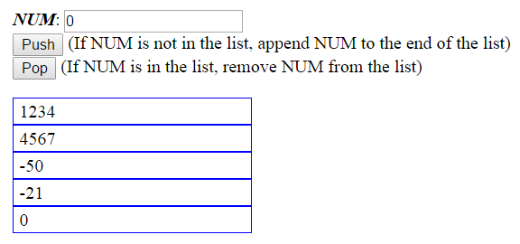
Note: You may assume the value in the text box is always a sequence of characters that represents a valid integer between -99999 to 99999.

- Ajax and Express (All files for this question are in folder “p3”)
Note: Part (b) is a more complicated version of (a). If your solution can handle the requirements in (b), we will assume your solution can handle the requirements in (a).

- [7%] Modify p3.html (contains client-side JS code) and p3.js (contains server-side JS code) so that when a user clicks the “Process” button,
- The client-side script will pass the string in the input text field, <input id=input>, to toIntArray() (a function defined in p3.html), and send the array of integers returned by toIntArray() via Ajax to the server. The script can expect an array in the response.

- The server-side script, upon receiving the Ajax request, will call customSort() (a function defined in p3.js) to sort the array of integers sent by the client, and return the sorted array in the response.

- The client-side script, upon receiving the sorted array returned by the server, will show the numbers in the arrays in reverse order (in any format) inside <div id=output>.

- [3%] Extend your solution in part (a) so that
- The server will create a session that will stay active for at least 10 minutes.
- The server-side script, upon receiving the Ajax request sent by the client, will return both the current and the previous sorted arrays. The previous sorted array is the sorted array returned to the client (that shares the same session) in the previous response. (If there is no previous sorted array, let the previous sorted array be an empty array)
- The client-side script, upon receiving the sorted arrays returned by the server, will show the numbers in both the arrays in reverse order (in any format) inside <div id=output>.

Between any two requests, the user can close the browser. You need to make sure your session can stay alive under such condition.

For this problem, you need install all the necessary modules like “express” yourself, and include the modules in your submission.

What to turn in?
Submit a ZIP file containing the p1, p2, p3 folders (which should contain also your solution) to Blackboard.

