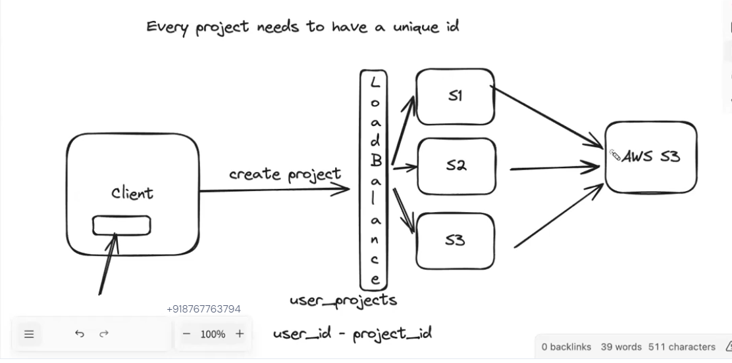

**Vertical Scaling**

* **Concept:**
  + Involves **increasing the capacity of a single server**.
  + Think of it like upgrading a car engine for more power instead of buying another car.
* **How it's done:**
  + **Adding more RAM:** Provides more memory for the server to handle increased workloads.
  + **Upgrading CPU:** Increases processing power to handle more requests concurrently.
  + **Increasing storage:** Provides more space for data, logs, and other files.
  + **Improving network bandwidth:** Allows for faster data transfer and communication.
* **Example:** Upgrading a server with a faster processor and more RAM to handle increased traffic to a website.

**Horizontal Scaling**

* **Concept:**
  + Involves **adding more servers** to your infrastructure to distribute the workload.
  + Think of it like adding more servers to a fleet of delivery trucks to handle increased orders.
* **How it's done:**
  + **Adding more servers:** Deploying additional servers to the network.
  + **Load balancing:** Distributing incoming traffic across multiple servers using a load balancer.
    - **Load balancers** can use various algorithms (e.g., round robin, least connections, least response time) to distribute traffic efficiently.
* **Example:** Adding more web servers to a cluster to handle a surge in website traffic during a sale.

**Load Balancing**

* **Purpose:**
  + Distributes incoming traffic across multiple servers in a horizontal scaling environment.
  + Prevents any single server from becoming overloaded.
  + Improves system performance, reliability, and availability.
* **Methods:**
  + **Round Robin:** Distributes requests evenly across all servers in a circular fashion.
  + **Least Connections:** Directs requests to the server with the fewest active connections.
  + **Least Response Time:** Directs requests to the server that has responded to previous requests the fastest.
  + **IP Hashing:** Directs requests from the same IP address to the same server.

**Key Considerations:**

* **Cost:** Vertical scaling can be more cost-effective initially, while horizontal scaling can become expensive as you add more servers.
* **Complexity:** Horizontal scaling introduces complexities such as server coordination, data synchronization, and maintaining consistency across multiple servers.
* **Scalability:** Horizontal scaling generally offers greater scalability potential as you can add an unlimited number of servers to handle increasing demand.
* **Fault Tolerance:** Horizontal scaling improves fault tolerance as the failure of one server does not necessarily bring down the entire system.

**In Summary:**

* **Vertical scaling** increases the capacity of individual servers.
* **Horizontal scaling** adds more servers to the system.
* **Load balancing** is crucial for effectively distributing traffic across multiple servers in a horizontally scaled environment.

The best scaling strategy depends on various factors, including the specific application, budget constraints, performance requirements, and scalability needs.