Add a Database to your Application

1 Go to DevOps Services at https://hub.jazz.net/ and SIGN IN.
2 Open the sample application rewillen | NodeJS_Simple_3.
Note: if you are working from a hardcopy type: https://ibm.biz/nodejs3 or EXPLORE for “rewillen”
3 Click on EDIT CODE
4 DEPLOY the Application and follow URL Link to the application. Refresh the application in the browser. * What happens? Both counters should be incremented. The counters should have the same value.
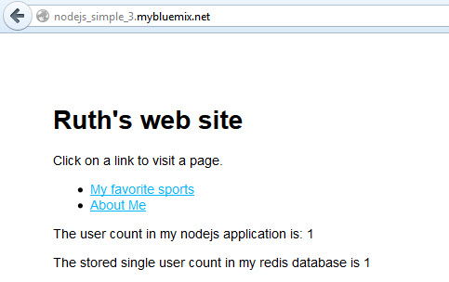

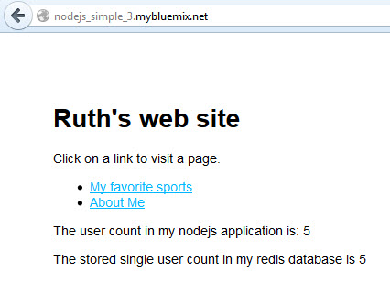
11 To manage your application, go to your application dashboard in Bluemix.
12 STOP your application.
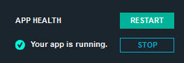
13 Click the START button
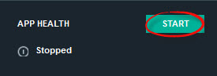
8 Follow the URL link again to the application running in a separate tab. * What happens to the count? The user count should be reset to 1 visit, but the database count should continue to increment across restarts.
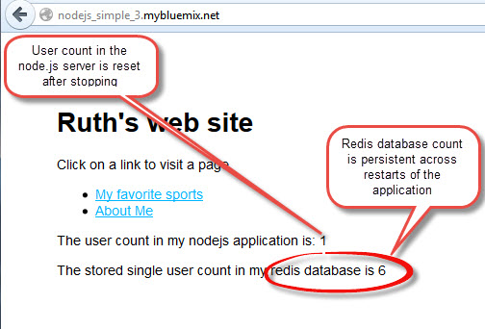
9 Return to the application dashboard in Bluemix where you can work with the application and the Redis Service.
10 In the Bluemix User Interface, Delete the deployed application and the Redis Service from Bluemix using the button in the top right corner, and then selecting “Delete App”.
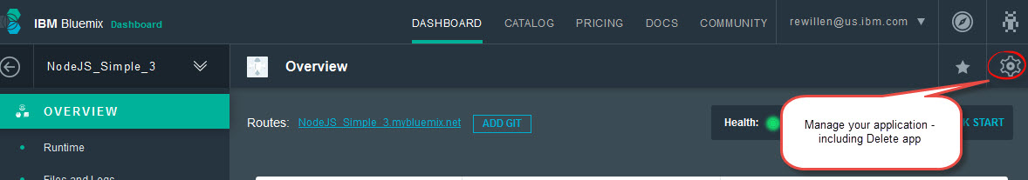
11 Be sure to select to delete the redis service.
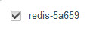
12 In DevOps Services, Re-DEPLOY the application. Follow the URL link again to the application running in a separate tab. *What happens? This time, the Redis database count should also be reset to 1.

