**Question 1.**

**You are given a dataset of a fictional e-commerce platform. The dataset includes tables for**

**users, products, orders, and order items. Design and write SQL queries to:**

**a. Find the top 5 customers by total spend in the last 30 days.**

**b. Find Most purchased product till date.**

From the given “SQL-Challenge.sql” file, I have created the table in MySQL workbench.

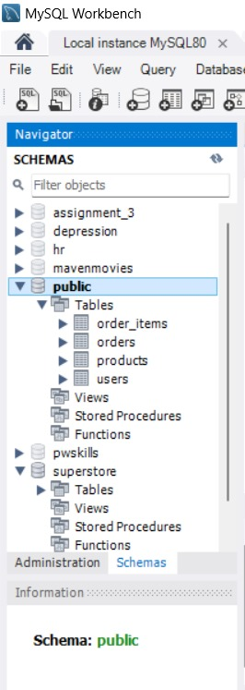

1. **Find the top 5 customers by total spend in the last 30 days.**

**CODE:**

SELECT

    u.user_id,

    u.username,

    SUM(o.total_amount) AS total_spend

FROM

    users u

JOIN

    orders o ON u.user_id = o.user_id

WHERE

    o.order_date >= DATE_SUB(NOW(), INTERVAL 30 DAY)

GROUP BY

    u.user_id, u.username

ORDER BY

    total_spend DESC

LIMIT 5;

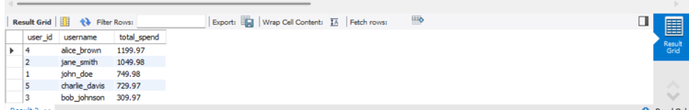**OUTPUT:**

**b. Find Most purchased product till date.**

**CODE:**

SELECT

    p.product_id,

    p.product_name,

    SUM(oi.quantity) AS total_quantity_sold

FROM

    products p

JOIN

    order_items oi ON p.product_id = oi.product_id

GROUP BY

    p.product_id, p.product_name

ORDER BY

    total_quantity_sold DESC

LIMIT 1;

**OUTPUT:**

