CANDLE CHARTS

One candle pattern

Hammer

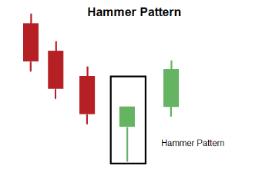
Hammer is a one candle pattern that occurs in a downtrend when bulls make a start to
step into the rally.
It is so named because it hammers out the bottom.
The lower shadow of hammer is minimum of twice the length of body.
Although, the color of the body is not of much significance, but a white candle shows slightly more bullish implications than the black body.
A positive day i.e. a white candle is required the next day to confirm this signal

Criteria
1. The lower shadow should be at least two times the length of the body.
2. There should be no upper shadow or a very small upper shadow.
3. The real body is at the upper end of the trading range. The color of the body is not
important although a white body should have slightly more bullish implications.
4. The following day needs to confirm the Hammer signal with a strong bullish day.

Signal enhancements
1. The longer the lower shadow, the higher the potential of a reversal occurring.
2. Large volume on the Hammer day increases the chances that a blow off day has
occurred.
3. A gap down from the previous day’s close sets up for a stronger reversal move provided
the day after the Hammer signal opens higher.

Pattern psychology
The market has been in a downtrend, so there is an air of bearishness. The price opens and
starts to trade lower. However, the sell-off is abated and market returns to high for the day as the bulls have stepped in. They start bringing the price back up towards the top of the trading range. This creates a small body with a large lower shadow. This represents that the bears could not maintain control. The long lower shadow now has the bears questioning whether the decline is still intact. Confirmation would be a higher open with yet a still higher close on the next trading day.

Hanging man

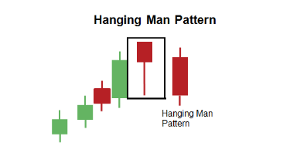

The hanging man appears during an uptrend, and its real body can be either black or white.
While it signifies a potential top reversal, it requires confirmation during the next trading
session. The hanging man usually has little or no upper shadow.

Inverted hammer
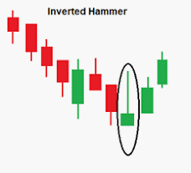

Description
Inverted hammer is one candle pattern with a shadow at least two times greater than the
body. This pattern is identified by the small body. They are found at the bottom of the decline which is evidence that bulls are stepping in but still selling is going on. The color of the small body is not important, but the white body has more bullish indications than a black body. A positive day is required the following day to confirm this signal.

Signal enhancements
1. The longer the upper shadow, the higher the potential of a reversal occurring.
2. A gap down from the previous day’s close sets up for a stronger reversal move.
3. Large volume on the day of the inverted hammer signal increases the chances that a
blow off day has occurred
4. The day after the inverted hammer signal opens higher.

Pattern psychology
After a downtrend has been in effect, the atmosphere is bearish. The price opens and starts to trade higher. The Bulls have stepped in, but they cannot maintain the strength. The existing sellers knock the price back down to the lower end of the trading range. The Bears are still in control. But the next day, the Bulls step in and take the price back up without major resistance from the Bears. If the price maintains strong after the Inverted Hammer day, the signal is confirmed.

Shooting star

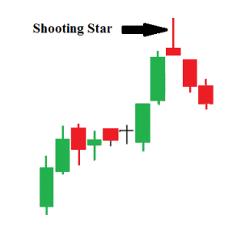
A small real body that gaps away from the large real body preceding it is known as star. It’s
still a star if the small real body does not overlap the preceding real body. The color
of the star is not important. Stars can occur at tops or bottoms.

Description
The Shooting Star is a single line pattern that indicates an end to the uptrend. It is easily
identified by the presence of a small body with a shadow at least two times greater than the
body. It is found at the top of an uptrend. The Japanese named this pattern because it looks
like a shooting star falling from the sky with the tail trailing it.

Signal enhancements
1. The longer the upper shadow, the higher the potential of a reversal occurring.
2. A gap up from the previous day’s close sets up for a stronger reversal move provided.
3. The day after the Shooting Star signal opens lower.
4. Large volume on the Shooting Star day increases the chances that a blow-off day has
occurred although it is not a necessity.

Pattern psychology
During an uptrend, the market gaps open and rallies to a new high. The price opens and trades
higher. The bulls are in control. But before the close of the day, the bears step in and take
the price back down to the lower end of the trading range, creating a small body for the day. This could indicate that the bulls still have control if analyzing a Western bar chart. However, the long upper shadow represents that sellers had started stepping in at these levels. Even
though the bulls may have been able to keep the price positive by the end of the day, the
evidence of the selling was apparent. A lower open or a black candle the next day reinforces
the fact that selling is going on.

Two candle patterns

Bullish engulfing

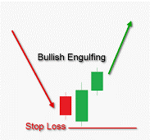

A “bullish engulfing pattern” consists of a large white real body that engulfs a small black
real body during a downtrend. It signifies that the buyers are overwhelming the sellers.

Description
The Engulfing pattern is a major reversal pattern comprised of two opposite colored bodies.
This Bullish Pattern is formed after a downtrend. It is formed when a small black candlestick
is followed by a large white candlestick that completely eclipses the previous day candlestick.
It opens lower than the previous day’s close and closes higher than the previous day’s open.

Criteria
1. The candlestick body of the previous day is completely overshadowed by the next day’s
candlestick.
2. Prices have been declining, even if it has been in short term.
3. The color of the first candle is similar to that of the previous one and the body of the
second candle is opposite in color to that first candle. The only exception being an engulfed
body which is a doji.

Signal enhancements
1. A small body being covered by the larger one. The previous day shows the trend was
running out of steam. The large body shows that the new direction has started with good
force.
2. Large volume on the engulfing day increases the chances that a blow off day has
occurred.
3. The engulfing body engulfs absorbs the body and the shadows of the previous day; the
reversal has a greater probability of working.
4. The probability of a strong reversal increases as the open gaps between the previous and
the current day increases.

Pattern psychology
After a decline has taken place, the price opens at a lower level than its previous day closing
price. Before the close of the day, the buyers have taken over and have led to an increase in the price above the opening price of the previous day. The emotional psychology of the trend has now been altered.

When investors are learning the stock market they should utilize information that has worked with high probability in the past.

Bullish Engulfing signal if used after proper training and at proper locations, can lead to highly profitable trades and consistent results. This pattern allows an investor to improve them probabilities of been in a correct trade. The common-sense elements conveyed in candlestick signals make for a clear and concise trading technique for beginning investors as well as experienced traders.

Bearish engulfing

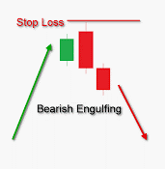

A “bearish engulfing pattern,” on the other hand, occurs when the sellers are overwhelming the buyers. This pattern consists of a small white candlestick with short shadows or tails followed by a large black candlestick that eclipses or “engulfs” the small white one.

Piercing

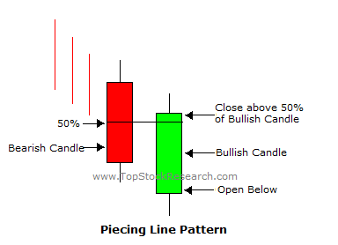

The bullish counterpart to the dark cloud cover is the “piercing pattern.” The first thing to
look for is to spot the piercing pattern in an existing downtrend, which consists of a long black candlestick followed by a gap lower open during the next session, but which closes at least halfway into the prior black candlestick’s real body.

Description
The Piercing Pattern is composed of a two-candle formation in a down trending market. With daily candles, the piercing pattern will often end a minor downtrend (a downtrend that lasts between six and fifteen trading days). The day before the piercing candle appears, the daily candle should have a large dark real body, signifying a strong down day.

Criteria
1. The downtrend has been evident for a good period.
2. The body of the first candle is black; the body of the second candle is white.
3. A long black candle occurs at the end of the trend.
4. The white candle closes more than halfway up the black candle.
5. The second day opens lower than the trading of the prior day.

Signal enhancements
1. The reversal will be more noticeable, if the gap down the previous day close is more.
2. The longer the black candle and the white candle, the more forceful the reversal.
3. The higher the white candle closes into the black candle, the stronger the reversal.
4. Large volume during these two trading days is a significant confirmation.

Pattern psychology
The atmosphere becomes bearish once a strong downtrend has been in effect. The price goes down. Bears may move the price even further but before the day ends the bulls enters and bring a dramatic change in price in the opposite direction. They finish near the high of the day.
The move has almost negated the price decline of the previous day. This now has the bears
concerned. More buying the next day will confirm the move. Being able to utilize information
that has been used successfully in the past is a much more viable investment strategy than
taking shots in the dark. Keep in mind, when you are given privileged information about stock market tips, where you are in the food chain. Are you one of those privileged few that get top-notch pertinent information on a timely manner, or are you one of the masses that feed into a frenzy and allow the smart money to make the profits?

Bearish harami

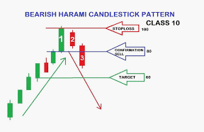

In up trends, the harami consists of a large white candle followed by a small white or black
candle (usually black) that is within the previous session’s large real body.

Description
Bearish Harami is a two-candlestick pattern composed of small black real body contained
within a prior relatively long white real body. The body of the first candle is the same color
as that of the current trend. The open and the close occur inside the open and the close of
the previous day. Its presence indicates that the trend is over.

Criteria
1. The first candle is white in color; the body of the second candle is black.
2. The second day opens lower than the close of the previous day and closes higher than
the open of the prior day.
3. For a reversal signal, confirmation is needed. The next day should show weakness.
4. The uptrend has been apparent. A long white candle occurs at the end of the trend.

Signal enhancements
1. The reversal will be more forceful, if the white and the black candle are longer.
2. The lower the black candle closes on the white candle, the more convincing that a
reversal has occurred, despite the size of the black candle.

Pattern psychology
The bears open the price lower than the previous close, after a strong uptrend has been in
effect and after a long white candle day. The longs get concerned and start profi t taking. The
price for the day ends at a lower level. The bulls are now concerned as the price closes lower.
It is becoming evident that the trend has been violated. A weak day after that would convince
everybody that the trend was reversing. Volume increases due to the profit taking and the
addition of short sales.

Bullish harami
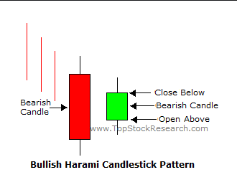
A candlestick chart pattern in which a large candlestick is followed by a smaller candlestick
whose body is located within the vertical range of the larger body. In downtrends, the harami consists of a large black candle followed by a small white or black candle (usually white) that is within the previous session’s large real body. This pattern signifies that the immediately preceding trend may be concluding, and that the bulls and bears have called a truce.

Description
The Harami is a commonly observed phenomenon. The pattern is composed of a two candle
formation in a down-trending market. The color first candle is the same as that of current
trend. The first body in the pattern is longer than the second one. The open and the close
occur inside the open and the close of the previous day. Its presence indicates that the trend is over.
The Harami (meaning “pregnant” in Japanese) Candlestick Pattern is a reversal pattern. The
pattern consists of two Candlesticks. The first candle is black in color and a continuation of
the existing trend. The second candle, the little belly sticking out, is usually white in color but that is not always the case. Magnitude of the reversal is affected by the location and size of the candles.

Criteria
1. The first candle is black in body; the body of the second candle is white.
2. The downtrend has been evident for a good period. A long black candle occurs at the end
of the trend.
3. The second day opens higher than the close of the previous day and closes lower than
the open of the prior day.
4. Unlike the Western “Inside Day”, just the body needs to remain in the previous day’s
body, where as the “Inside Day” requires both the body and the shadows to remain inside
the previous day’s body.
5. For a reversal signal, further confirmation is required to indicate that the trend is now
moving up.

Signal enhancements
1. The reversal will be more forceful if the black candle and the white candle are longer.
2. If the white candle closes up on the black candle then the reversal has occurred in a
convincing manner despite the size of the white candle.

Pattern psychology
After a strong down-trend has been in effect and after a selling day, the bulls open at a price higher than the previous close. The short’s get concerned and start covering. The price for the day finishes at a higher level. This gives enough notice to the short sellers that trend
has been violated. A strong day i.e. the next day would convince everybody that the trend
was reversing. Usually the volume is above the recent norm due to the unwinding of short
positions.
When the second candle is a doji, which is a candle with an almost non-existent real body,
these patterns are called “harami crosses.” They are however less reliable as reversal patterns as more indecision is indicated.

Three candle patterns

Evening star

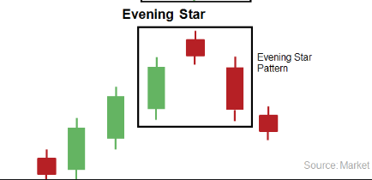

The Evening Star is a top reversal pattern that occurs at the top of an uptrend. It is formed
by a tall white body candle, a second candle with a small real body that gaps above the first
real body to form a “star” and a third black candle that closes well into the first session’s white real body.

Description
The Evening Star pattern is a bearish reversal signal. Like the planet Venus, the evening star represents that darkness is about to set or prices are going to decline. An uptrend has been in place which is assisted by a long white candlestick. The following day gaps up, yet the trading range remain small for the day. Again, this is the star of the formation. The third day is a black candle day and represents the fact that the bears have now seized control. That candle should consist of a closing that is at least halfway down the white candle of two days prior. The optimal Evening Star signal would have a gap before and after the star day.

Criteria
1. The uptrend should be apparent.
2. The body of the first candle is white, continuing the current trend. The second candle has
small trading range showing indecision formation.
3. The third day shows evidence that the bears have stepped in. That candle should close
at least halfway down the white candle.

Signal enhancements
1. Long length of the white candle and the black candle indicates more forceful reversal.
2. The more indecision the middle day portrays, the better probabilities that a reversal will
occur.
3. A gap between the first day and the second day adds to the probability of occurrence of
reversal.
4. A gap before and after the star day is even more desirable. The magnitude, that the
third day comes down into the white candle of the first day, indicates the strength of the
reversal.

Pattern psychology
The psychology behind this pattern is that a strong uptrend has been in effect. Buyers have
been piling up the stock. However, it is the level where sellers start taking profits or think the price is valued. The next day all the buying is being met with the selling, causing for a small trading range. The bulls get concerned and the bears start taking over. The third day is a large sell off day. If there is big volume during these days, it shows that the ownership has dramatically changed hands. The change of direction is immediately seen in the color of the bodies.

Morning star

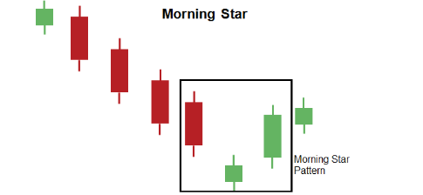

Description
The Morning Star is a bottom reversal signal. Like the planet Mercury, the morning star,
signifies brighter things – that is sunrise is about to occur, or the prices are going to go higher.
A downtrend has been in place which is assisted by a long black candlestick. There is little
about the downtrend continuing with this type of action. The next day prices gap lower on
the open, trade within a small range and close near their open. This small body shows the
beginning of indecision. The next day prices gap higher on the open and then close much
higher. A significant reversal of trend has occurred.
The makeup of the star, an indecision formation, can consist of several candle formations.
The important factor is to witness the confirmation of the bulls taking over the next day. That candle should consist of a closing that is at least halfway up the black candle of two days prior.

Criteria
1. Downtrend should be there.
2. The body of the first candle is black, continuing the current trend. The second candle is
an indecision formation.
3. The third day is the opposite color of the first day. It shows evidence that the bulls have
stepped in. That candle should close at least halfway up the black candle.

Signal enhancements
1. Long length of the black candle and the white candle indicates more forceful reversal.
2. The more indecision that the star day illustrates, the better probabilities that a reversal
will occur.
3. A Gap between the first day and the second day adds to the probability of occurrence of
reversal.
4. A gap before and after the star day is even more desirable.
5. The magnitude, that the third day comes up into the black candle of the first day, indicates
the strength of the reversal.

Pattern psychology
While a strong downtrend has been in effect, there is a large sell-off day. The selling continues, and bulls continue to step in at low prices. Big volume on this day shows that the ownership has dramatically changed. The second day does not have a large trading range. The third day, the bears start to lose conviction as the bull increase their buying. When the price starts moving back into the trading range of the first day, the sellers diminish, and the buyers seize control.

Doji

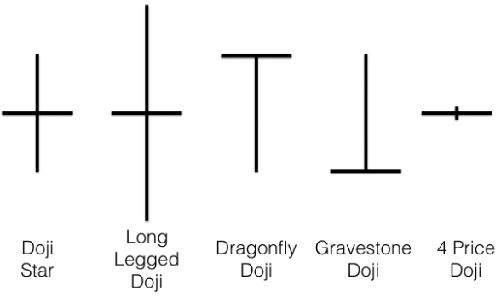

The Importance of the Doji
The perfect doji session has the same opening and closing price, yet there is some flexibility
to this rule. If the opening and closing price are within a few ticks of each other, the line could still be viewed as a doji.
How do you decide whether a near-doji day (that is, where the open and close are very close, but not exact) should be considered a doji? This is subjective and there are no rigid rules but one way is to look at a near-doji day in relation to recent action. If there are a series of very small real bodies, the near-doji day would not be viewed as significant since so many other recent periods had small real bodies. One technique is based on recent market activity.
If the market is at an important market junction or is at the mature part of a bull or bear move, or there are other technical signals sending out an alert, the appearance of a near-doji is treated as a doji. The philosophy is that a doji can be a significant warning and that it is better to attend to a false warning than to ignore a real one. To ignore a doji, with all its inherent implications, could be dangerous.
The doji is a distinct trend change signal. However, the likelihood of a reversal increases if
subsequent candlesticks confirm the doji’s reversal potential. Doji sessions are important
only in markets where there are not many doji. If there are many doji on a chart,
one should not view the emergence of a new doji in that market as a meaningful
development. That is why candlestick analysis usually should not use intra-day charts of less than 30 minutes. Less than 30 minutes and many of the candlestick lines become doji or near doji

Doji at tops
A Doji star at the top is a warning that the uptrend is about to change. This is especially true after a long white candlestick in an uptrend. The reason for the doji’s negative implications in uptrend is because a doji represents indecision. Indecision among bulls will not maintain the uptrend. It takes the conviction of buyers to sustain a rally. If the market has had an extended rally, or is overbought, then formation of a doji could mean the scaffolding of buyers’ support will give way.
Doji are also valued for their ability to show reversal potential in downtrends. The reason may be that a doji reflects a balance between buying and selling forces. With ambivalent market participants, the market could fall due to its own weight. Thus, an uptrend should reverse but a falling market may continue its descent. Because of this, doji need more confirmation to signal a bottom than they do a top.

