# Bamazon

Step 1: Open the command line and change directory to the directory location



Step 2: To access the application and view the inventory

type: node bamazoncustomer.js

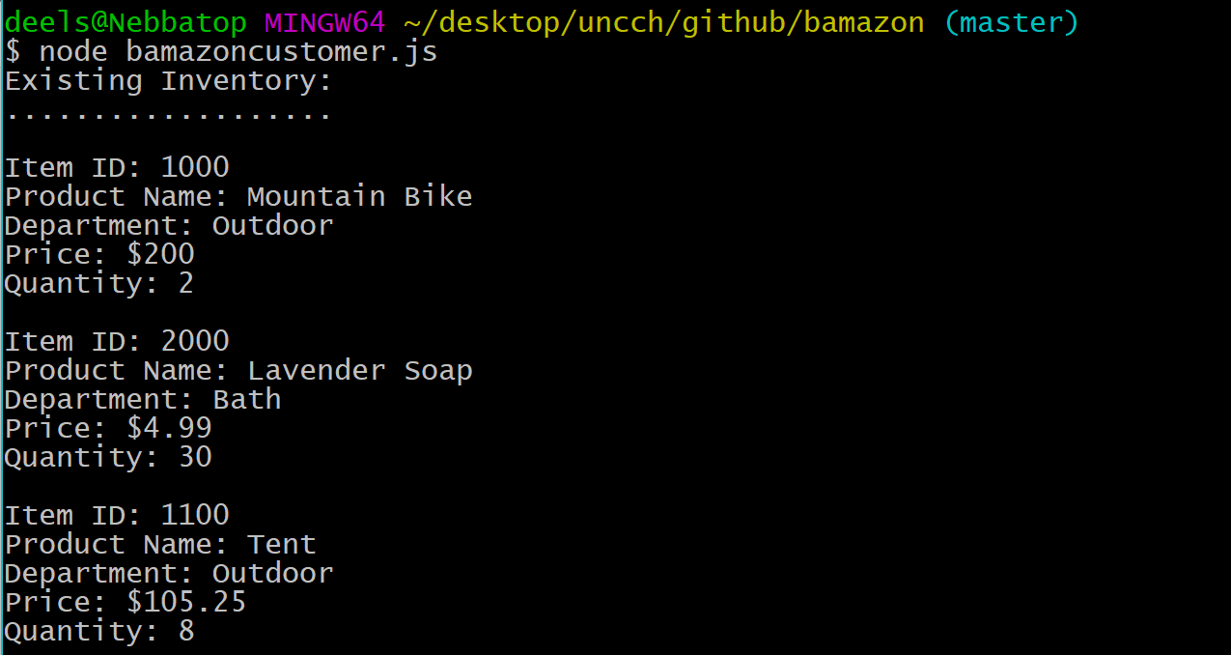

Step 3: Read the inventory. At the bottom, it will ask for the item id of the product you are interested in. Type the item id.



Step 4: It will ask you how many you need. Notice the quantity available is listed under the item. NOTE: If you ask for more than we have or enter the wrong item id then you will be told to change your order by starting from step 3.

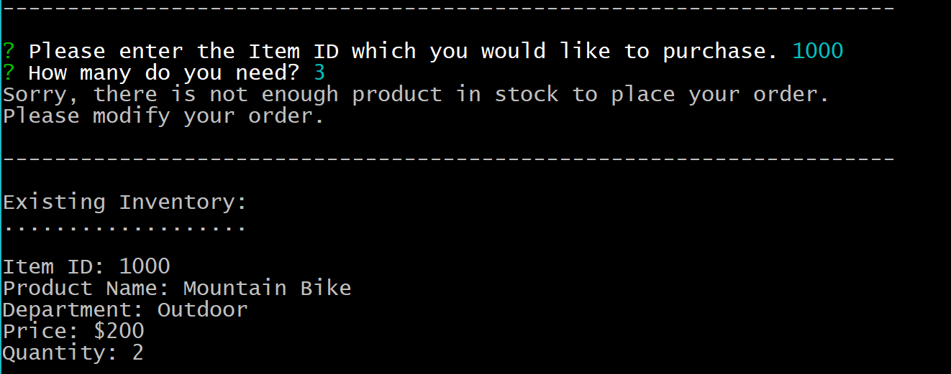

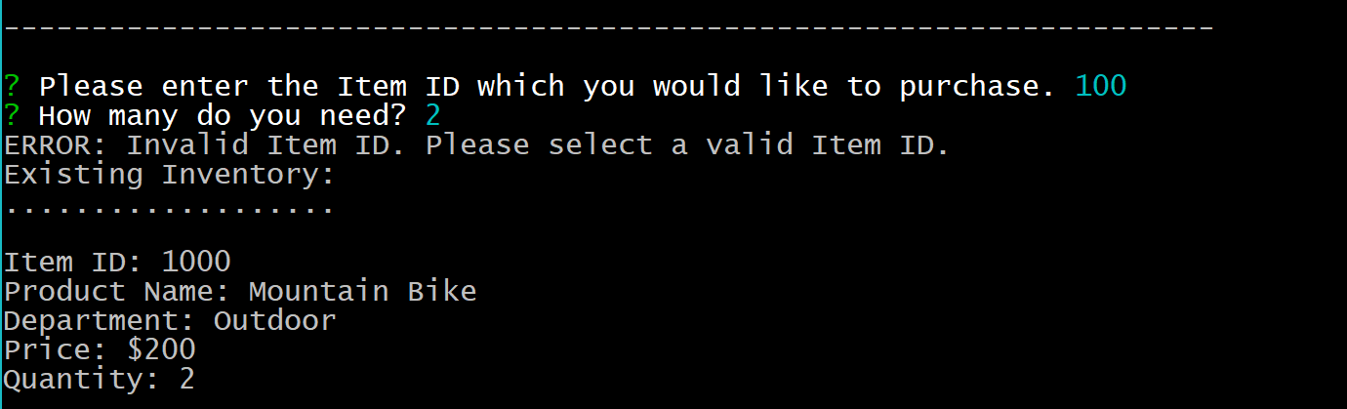

Step 4: If you enter a correct item id and a quantity we have in stock, then this message will tell you your order has been placed.

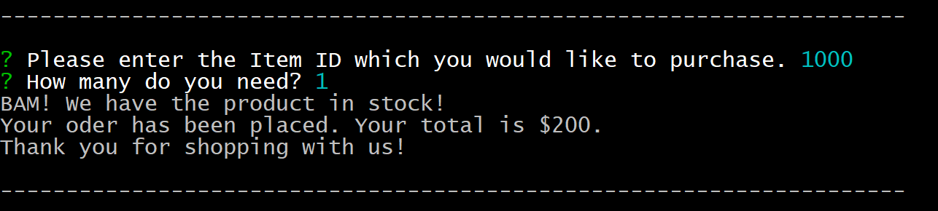

Step 5: Inventory list is kept current and updated as orders are placed. When we run the command “node bamazoncustomer.js” a second time the product has been removed from the inventory.

