INT375: DATA SCIENCE TOOLBOX: PYTHON PROGRAMMING

PROJECT REPORT
(Project Semester January - April 2026)

Air Quality Index (AQI) Analysis of India

Submitted by

Aniket Raj
Registration No. 12416201
Course Code: INT375

Under the Guidance of

Maneet kaur
Assistant Professor

Discipline of CSE/IT
Lovely School of Technology and Sciences
Lovely Professional University, Phagwara

CERTIFICATE

This is to certify that Aniket Raj bearing Registration No. 12416201 has completed INT375 project titled "Air Quality Index (AQI) Analysis of India" under my guidance and supervision. To the best of my knowledge, the present work is the result of his original effort and study.

Maneet Kaur
Designation: Assistant Professor
School of Technology and Sciences
Lovely Professional University, Phagwara, Punjab

Date: 19/04/26

DECLARATION

I, Aniket Raj, student of B.Tech (CSE) under CSE/IT Discipline at Lovely Professional University, Punjab, hereby declare that all the information furnished in this project report is based on my own work and is genuine. This work has not been submitted elsewhere for any other purpose.

Date: 19/04/26
Registration No. 12416201
Name: Aniket Raj

ACKNOWLEDGEMENT

I would like to thank my faculty Maneet kaur for their guidance throughout this project. I also thank Lovely Professional University for providing the resources needed to complete this work.

The dataset used in this project is the Air Quality Index data of India from the Central Pollution Control Board (CPCB). This project helped me apply the concepts I learned in INT375 practically.

TABLE OF CONTENTS

Sr. No. | Section | Page No.
1 | Introduction | 6
2 | Source of Dataset | 7
3 | Dataset Preprocessing | 8
4 | Objective 1 - Average Pollutant Levels | 10
5 | Objective 2 - Distribution of PM2.5 | 12
6 | Objective 3 - Outlier Detection | 14
7 | Objective 4 - Correlation Analysis | 16
8 | Objective 5 - Top Polluted States | 18
9 | Objective 6 - Hypothesis Testing | 20
10 | Objective 7 - Linear Regression (ML) | 22
11 | Conclusion | 24
12 | Future Scope | 25

1. Introduction
Air pollution is a serious problem in India. With growing industries and more vehicles on roads, the air quality in many cities has become worse. Air Quality Index (AQI) is a number used to tell people how clean or polluted the air is in a particular area.

This project analyzes AQI data of India. The dataset has pollutant readings from 263 cities across 30 states. The pollutants tracked are PM2.5, PM10, SO2, NO2, CO, NH3, and OZONE.

The main objectives of this project are:
- To load and explore the AQI dataset using Pandas.
- To find and handle missing values in the dataset.
- To calculate summary statistics like mean, median, and standard deviation.
- To visualize pollutant levels using bar charts and histograms.
- To find outliers using box plots and IQR method.
- To check correlation between pollutant columns using heatmap.
- To perform hypothesis testing (t-test) on PM2.5 and PM10.
- To build a linear regression model to predict pollutant_avg.

2. Source of Dataset


3. Dataset Preprocessing

3.1 Data Overview
After loading the dataset using Pandas, the shape was (3503, 11). The last_update column was in datetime format. All other columns had correct data types.

3.2 Missing Values
Three columns had missing values: pollutant_min, pollutant_max, and pollutant_avg. Each had 214 missing values which is about 6.1% of the total data. Since these are the main columns for analysis, rows with missing values were removed.

After removing null rows, 3289 rows remained for analysis.

3.3 Steps Done
- Loaded the dataset using pd.read_excel().
- Checked shape and data types using df.shape and df.dtypes.
- Checked missing values using df.isnull().sum().
- Dropped rows with null pollutant values using df.dropna().
- Verified cleaned dataset has no missing values.

4. Objective 1 - Average Level of Each Pollutant

General Description
This objective finds out which pollutant has the highest average level in India. A bar chart is plotted to compare average values of all 7 pollutants.

Analysis
The average pollutant levels were calculated by grouping the data by pollutant_id and finding the mean of pollutant_avg.

Visualization
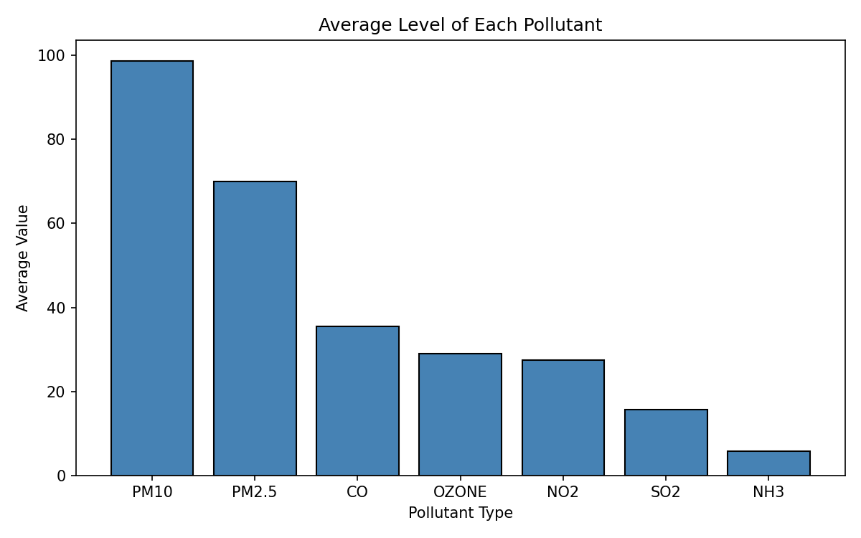
Figure 1: Average Level of Each Pollutant

Result
PM10 has the highest average level (98.72) among all pollutants. SO2 has the lowest average level. This shows that particle pollution (PM10 and PM2.5) is the biggest air quality problem in India.

5. Objective 2 - Distribution of PM2.5

General Description
This objective studies the distribution of PM2.5 pollutant values. A histogram is used to see how the PM2.5 readings are spread. Mean and median lines are also shown.

Analysis
PM2.5 data was filtered from the dataset. Mean and median were calculated. The histogram shows the frequency of different PM2.5 values.

Statistic | Value
Mean | 70.05
Median | 52.00
Std Dev | 53.21
Min | 1.00
Max | 306.00

Visualization
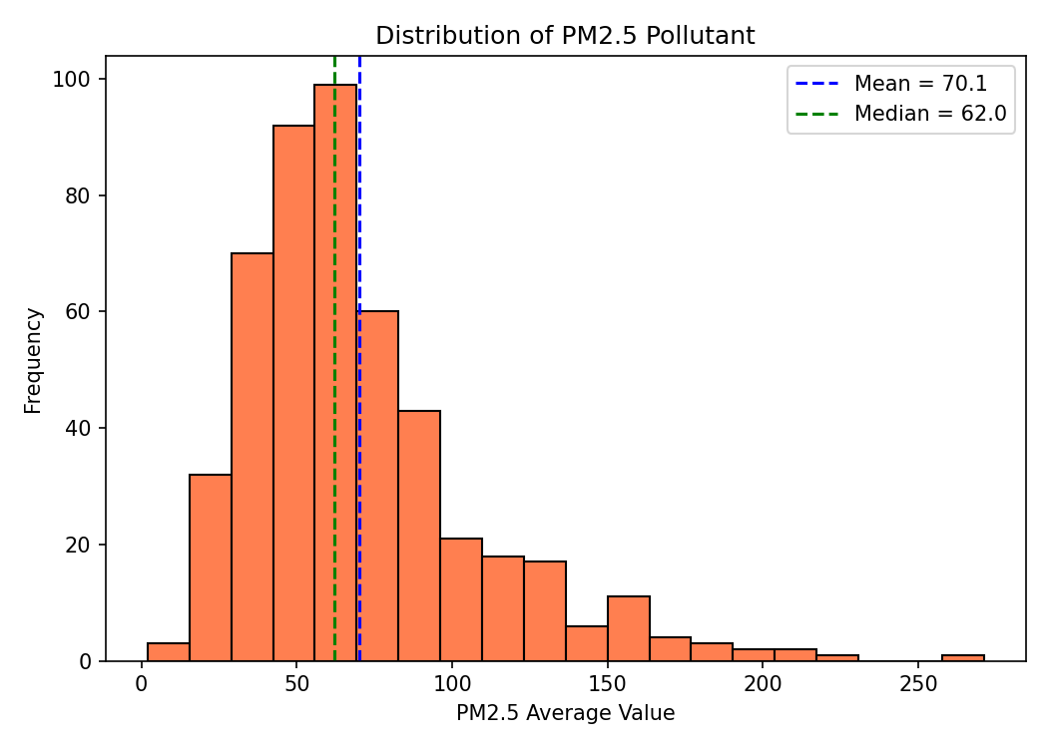
Figure 2: Distribution of PM2.5 Pollutant

Result
The mean (70.05) is higher than the median (52.00). This tells us the PM2.5 data is right-skewed, meaning most values are on the lower side but a few cities have very high PM2.5 levels.

6. Objective 3 - Outlier Detection using Box Plot

General Description
This objective detects outliers in pollutant_avg for each pollutant type. Box plots are used to visualize outliers. IQR method is also used to count them.

Analysis
Box plots were drawn for all pollutants. IQR (Inter Quartile Range) method was applied to count the outlier rows.

Visualization
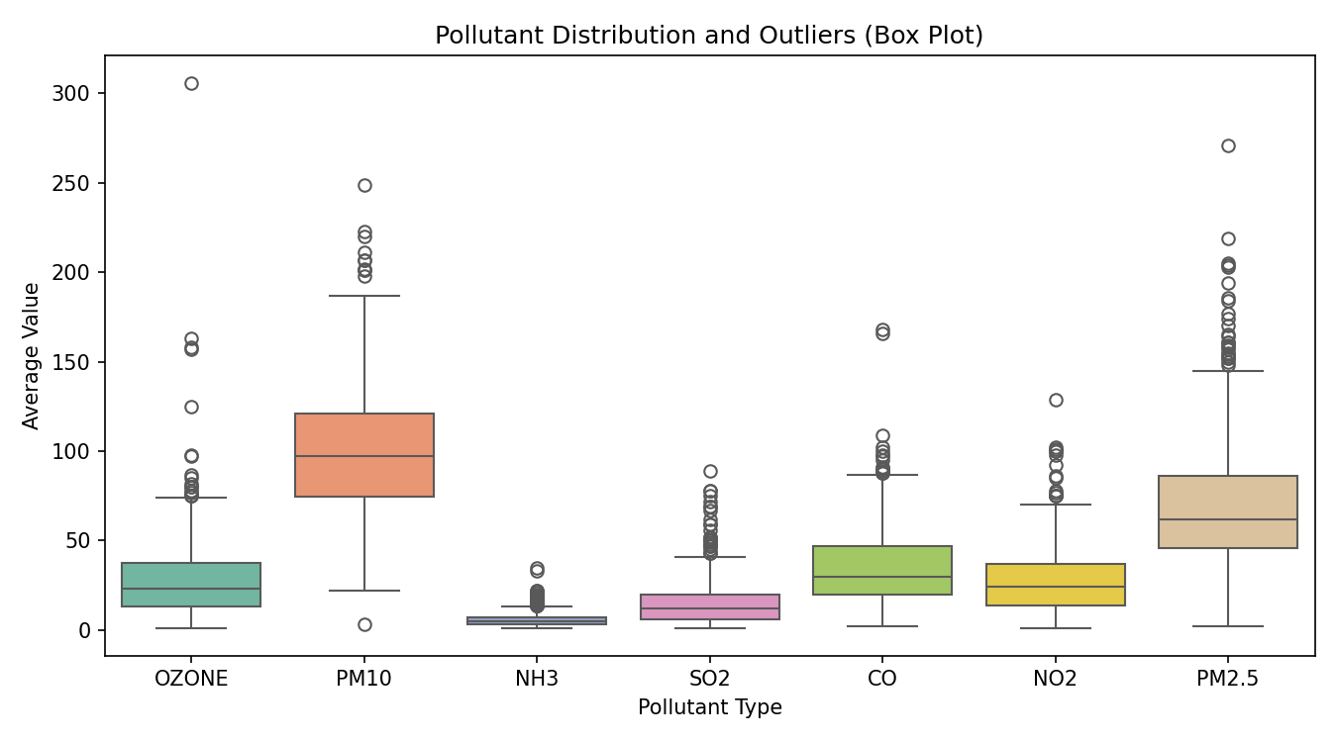
Figure 3: Box Plot - Outlier Detection by Pollutant Type

Result
119 rows were found as outliers using IQR method. PM10 and PM2.5 have the most outliers. These are cities with unusually high pollution levels, like Delhi and some industrial areas.

7. Objective 4 - Correlation Analysis

General Description
This objective checks the relationship between numerical columns in the dataset. A correlation heatmap is used to visualize how strongly two columns are related.

Analysis
Correlation matrix was calculated using df.corr(). Values close to 1 mean strong positive correlation and values close to 0 mean no relationship.

Column Pair | Correlation
pollutant_avg & pollutant_max | 0.87 (Strong)
pollutant_avg & pollutant_min | 0.86 (Strong)
pollutant_min & pollutant_max | 0.63 (Moderate)
latitude & pollutant_avg | 0.04 (Very Weak)
longitude & pollutant_avg | -0.11 (Weak)

Visualization
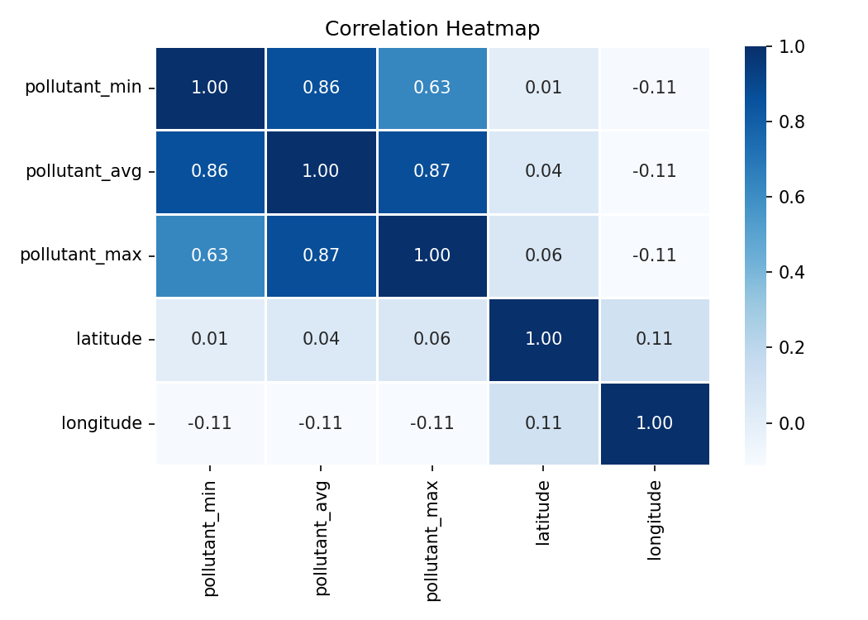
Figure 4: Correlation Heatmap

Result
pollutant_avg and pollutant_max have the highest correlation (0.87). Latitude and longitude have almost no correlation with pollution levels, which means location coordinates alone cannot predict pollution.

8. Objective 5 - Top 10 Most Polluted States

General Description
This objective finds the top 10 states in India with the highest average pollution levels. A horizontal bar chart is used to compare these states.

Analysis
Data was grouped by state and mean of pollutant_avg was calculated. The top 10 states were selected and sorted.

Visualization
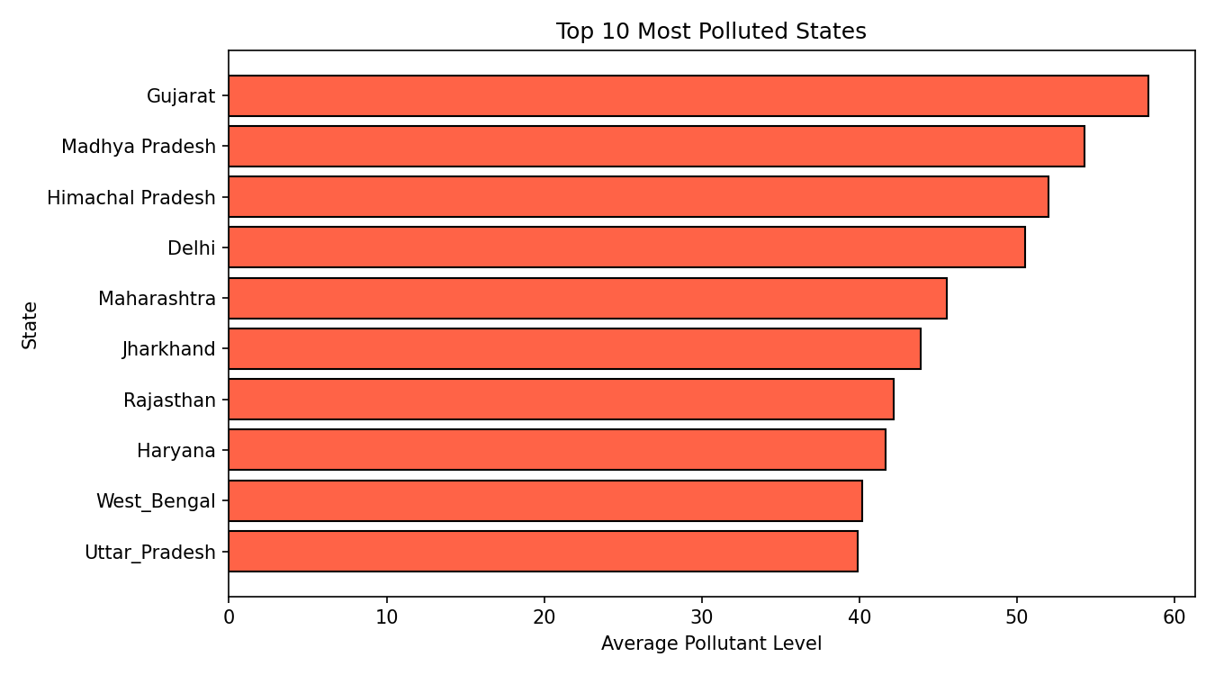
Figure 5: Top 10 Most Polluted States in India

Result
Gujarat and Delhi appear among the most polluted states. These are highly industrialized and densely populated areas. States like Maharashtra and Uttar Pradesh also show high pollution levels due to large number of vehicles and factories.

9. Objective 6 - Hypothesis Testing (t-test)

General Description
This objective compares PM2.5 and PM10 pollution levels using an independent samples t-test. We want to check if there is a significant difference between these two pollutants.

Hypothesis
- H0 (Null): There is no significant difference between PM2.5 and PM10 average levels.
- H1 (Alternate): There is a significant difference between PM2.5 and PM10 average levels.

Analysis Result
Statistic | Value
PM2.5 Mean | 70.05
PM10 Mean | 98.72
t-statistic | -11.8207
p-value | 0.000000
Significance Level (alpha) | 0.05
Decision | Reject H0

Result
Since p-value (0.000000) is less than 0.05, we reject the null hypothesis. This means there is a significant difference between PM2.5 and PM10 average levels. PM10 levels are significantly higher than PM2.5 in India.

10. Objective 7 - Linear Regression (Machine Learning)

General Description
This objective uses Linear Regression to predict the average pollutant level (pollutant_avg) using pollutant_min and pollutant_max as input features. This is a supervised machine learning model.

Steps Done
- Selected pollutant_min and pollutant_max as input features (X).
- Used pollutant_avg as the target variable (y).
- Split the data into 80% training and 20% testing using train_test_split.
- Trained a LinearRegression model from sklearn.
- Evaluated the model using R2 Score and Mean Squared Error.

Model Results
Metric | Value
R2 Score | 0.9117
Mean Squared Error (MSE) | 121.69
Training Data Size | 2631 rows
Testing Data Size | 658 rows

Visualization
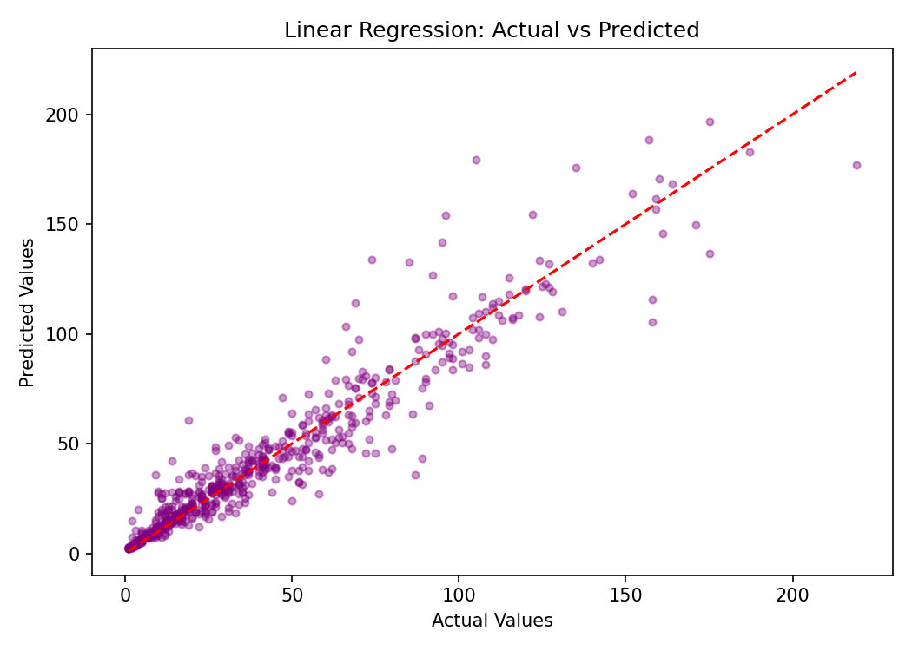
Figure 6: Linear Regression - Actual vs Predicted Values

Result
The model got an R2 score of 0.91 which means it can explain 91% of the variation in pollutant_avg. The points in the graph are close to the red line which shows the predictions are good. This confirms that pollutant_min and pollutant_max are strong predictors of pollutant_avg.

11. Conclusion
In this project, AQI data of India was analyzed using Python. The dataset had 3503 rows and 11 columns covering 30 states and 263 cities.

The main findings are:
- PM10 has the highest average pollution level (98.72) among all pollutants.
- The data is right-skewed, meaning most areas have low pollution but a few have very high levels.
- 119 outliers were found using the IQR method.
- pollutant_avg and pollutant_max are strongly correlated (0.87).
- Gujarat and Delhi are among the most polluted states in India.
- t-test showed that PM2.5 and PM10 levels are significantly different.
- Linear Regression model predicted pollutant_avg with 91% accuracy (R2 = 0.91).

This project helped me understand how to use Python for real-world data analysis and apply concepts from the INT375 syllabus.

12. Future Scope
- More ML models like Decision Tree or Random Forest can be tried to improve prediction accuracy.
- Time-series analysis can be done if historical data from multiple years is available.
- A city-level dashboard can be created using Power BI or Streamlit.
- Deep learning models can be used to predict future AQI levels.
- Analysis can be extended to include weather data like temperature and humidity

