INT375: DATA SCIENCE TOOLBOX: PYTHON PROGRAMMING
PROJECT REPORT
(Project Semester: January – April 2026)
Air Quality Index (AQI) Analysis of India

Submitted by
Aniket Raj
Registration No. 12416201
Course Code: INT375

Under the Guidance of
Ms. Maneet Kaur
Assistant Professor

Discipline of CSE/IT
Lovely School of Technology and Sciences
Lovely Professional University, Phagwara
April 2026

Certificate

This is to certify that Aniket Raj bearing Registration No. 12416201 has completed INT375 project titled "Air Quality Index (AQI) Analysis of India" under my guidance and supervision. To the best of my knowledge, the present work is the result of his original effort and study.

Ms. Maneet Kaur
Designation: Assistant Professor
School of Technology and Sciences
Lovely Professional University, Phagwara, Punjab
Date: 19/04/2026

Declaration

I, Aniket Raj, student of B.Tech (CSE) under CSE/IT Discipline at Lovely Professional University, Punjab, hereby declare that all the information furnished in this project report is based on my own work and is genuine. This work has not been submitted elsewhere for any other purpose.

Date: 19/04/2026
Registration No.: 12416201
Name: Aniket Raj

Acknowledgement

I would like to thank my faculty Ms. Maneet Kaur for her guidance throughout this project. I also thank Lovely Professional University for providing the resources needed to complete this work.

The dataset used in this project is the Air Quality Index data of India from the Central Pollution Control Board (CPCB). This project helped me apply the concepts I learned in INT375 practically.

Table of Contents

Sr. No. | Section | Page No.
1 | Introduction | 6
2 | Source of Dataset | 7
3 | Dataset Preprocessing | 8
4 | Objective 1 – Average Pollutant Levels | 10
5 | Objective 2 – Distribution of PM2.5 | 12
6 | Objective 3 – Outlier Detection | 14
7 | Objective 4 – Correlation Analysis | 16
8 | Objective 5 – Top Polluted States | 18
9 | Objective 6 – Hypothesis Testing | 20
10 | Objective 7 – Linear Regression (ML) | 22
11 | Conclusion | 24
12 | Future Scope | 25

Abstract

Air pollution is one of the most critical environmental challenges in India. This project presents a comprehensive data analysis of India’s Air Quality Index (AQI) using Python programming. The dataset contains pollutant readings from 263 cities across 30 states, covering seven major pollutants: PM2.5, PM10, SO2, NO2, CO, NH3, and OZONE. The study applies data preprocessing, exploratory data analysis, statistical methods, and machine learning to extract meaningful insights. A Linear Regression model achieved an R² score of 0.91, demonstrating strong predictive capability. The findings reveal that PM10 has the highest average pollution level, Gujarat and Delhi are among the most polluted states, and hypothesis testing confirms a statistically significant difference between PM2.5 and PM10 levels.

Keywords: Air Quality Index, AQI, PM2.5, PM10, Data Analysis, Python, Pandas, Linear Regression, Hypothesis Testing, Outlier Detection

1. Introduction

Air pollution is a serious problem in India. With growing industries and more vehicles on roads, the air quality in many cities has become worse. Air Quality Index (AQI) is a number used to tell people how clean or polluted the air is in a particular area.

This project analyzes AQI data of India. The dataset has pollutant readings from 263 cities across 30 states. The pollutants tracked are PM2.5, PM10, SO2, NO2, CO, NH3, and OZONE.

1.1 OBJECTIVES
- To load and explore the AQI dataset using Pandas.
- To find and handle missing values in the dataset.
- To calculate summary statistics like mean, median, and standard deviation.
- To visualize pollutant levels using bar charts and histograms.
- To find outliers using box plots and IQR method.
- To check correlation between pollutant columns using heatmap.
- To perform hypothesis testing (t-test) on PM2.5 and PM10.
- To build a linear regression model to predict pollutant_avg.

1.2 TOOLS AND TECHNOLOGIES
Library | Purpose
Pandas | Data loading, cleaning, and manipulation
NumPy | Numerical computations
Matplotlib | Bar chart, histogram visualization
Seaborn | Box plot and heatmap visualization
Scipy (stats) | Statistical hypothesis testing (t-test)
Scikit-learn | Linear Regression model

2. Source of Dataset

The dataset used in this project is the Air Quality Index (AQI) data of India, sourced from the Central Pollution Control Board (CPCB) of India. The data was accessed in Excel format (.xlsx) containing real-time pollutant readings from monitoring stations placed across different cities and states of India.

2.1 DATASET DESCRIPTION
Attribute | Details
File Format | Excel (.xlsx)
Total Rows | 3,503
Total Columns | 11
Cities Covered | 263
States Covered | 30
Pollutants Tracked | PM2.5, PM10, SO2, NO2, CO, NH3, OZONE

2.2 KEY COLUMNS
- pollutant_id — Type of pollutant (PM2.5, PM10, SO2, etc.)
- pollutant_min — Minimum recorded value
- pollutant_avg — Average recorded value (main analysis column)
- pollutant_max — Maximum recorded value
- state, city, station — Location information
- latitude, longitude — Geographic coordinates
- last_update — Timestamp of the reading

3. Dataset Preprocessing

3.1 DATA OVERVIEW
After loading the dataset using Pandas, the shape was (3503, 11). The last_update column was in datetime format. All other columns had correct data types.

3.2 MISSING VALUES
Three columns had missing values: pollutant_min, pollutant_max, and pollutant_avg. Each had 214 missing values which is about 6.1% of the total data. Since these are the main columns for analysis, rows with missing values were removed. After removing null rows, 3,289 rows remained for analysis.

Column | Missing Values | Percentage
pollutant_min | 214 | 6.1%
pollutant_avg | 214 | 6.1%
pollutant_max | 214 | 6.1%

3.3 STEPS DONE
- Loaded the dataset using pd.read_excel().
- Checked shape and data types using df.shape and df.dtypes.
- Checked missing values using df.isnull().sum().
- Dropped rows with null pollutant values using df.dropna().
- Verified cleaned dataset has no missing values.

4. Objective 1 – Average Level of Each Pollutant

4.1 GENERAL DESCRIPTION
This objective finds out which pollutant has the highest average level in India. A bar chart is plotted to compare average values of all 7 pollutants.

4.2 ANALYSIS
The average pollutant levels were calculated by grouping the data by pollutant_id and finding the mean of pollutant_avg. The groupby() function in Pandas was used to group data and compute mean values for each pollutant type.

4.3 VISUALIZATION
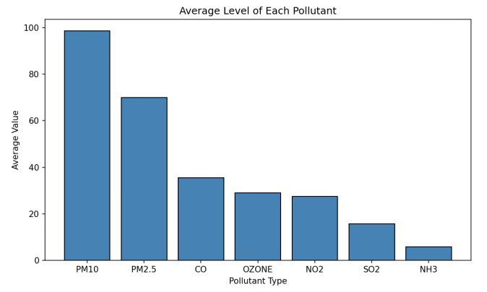
Figure 1: Average Level of Each Pollutant (Bar Chart)
4.4 RESULT
PM10 has the highest average level (98.72) among all pollutants. SO2 has the lowest average level. This shows that particle pollution (PM10 and PM2.5) is the biggest air quality problem in India.

5. Objective 2 – Distribution of PM2.5

5.1 GENERAL DESCRIPTION
This objective studies the distribution of PM2.5 pollutant values. A histogram is used to see how the PM2.5 readings are spread. Mean and median lines are also shown on the histogram.

5.2 ANALYSIS
Statistic | Value
Mean | 70.05
Median | 52.00
Std Dev | 53.21
Min | 1.00
Max | 306.00

5.3 VISUALIZATION
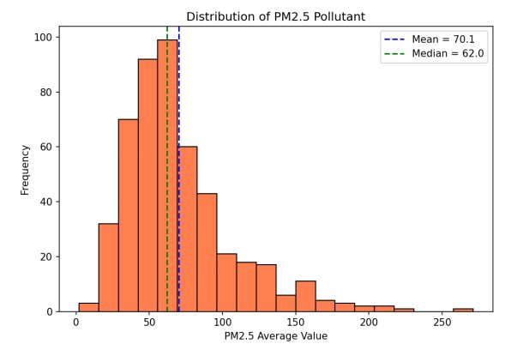
Figure 2: Distribution of PM2.5 Pollutant (Histogram with Mean & Median lines)
5.4 RESULT
The mean (70.05) is higher than the median (52.00). This tells us the PM2.5 data is right-skewed, meaning most values are on the lower side but a few cities have very high PM2.5 levels.

6. Objective 3 – Outlier Detection using Box Plot

6.1 GENERAL DESCRIPTION
This objective detects outliers in pollutant_avg for each pollutant type. Box plots are used to visualize outliers. The IQR (Interquartile Range) method is also used to mathematically count the outlier rows.

6.2 IQR METHOD
- Lower Bound = Q1 − 1.5 × IQR
- Upper Bound = Q3 + 1.5 × IQR
- Any value outside these bounds is considered an outlier.

6.3 VISUALIZATION
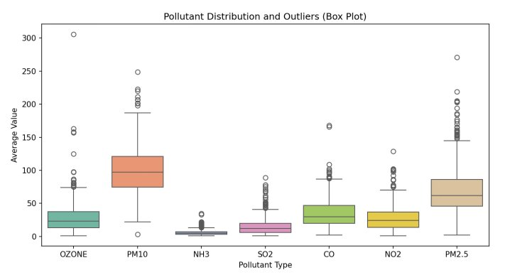
Figure 3: Pollutant Distribution and Outliers (Box Plot)
6.4 RESULT
119 rows were found as outliers using the IQR method. PM10 and PM2.5 have the most outliers. These are cities with unusually high pollution levels, like Delhi and some industrial areas.

7. Objective 4 – Correlation Analysis

7.1 GENERAL DESCRIPTION
This objective checks the relationship between numerical columns in the dataset. A correlation heatmap is used to visualize how strongly two columns are related to each other.

7.2 CORRELATION TABLE
Column Pair | Correlation | Strength
pollutant_avg & pollutant_max | 0.87 | Strong Positive
pollutant_avg & pollutant_min | 0.86 | Strong Positive
pollutant_min & pollutant_max | 0.63 | Moderate
latitude & pollutant_avg | 0.04 | Very Weak
longitude & pollutant_avg | -0.11 | Weak Negative

7.3 VISUALIZATION
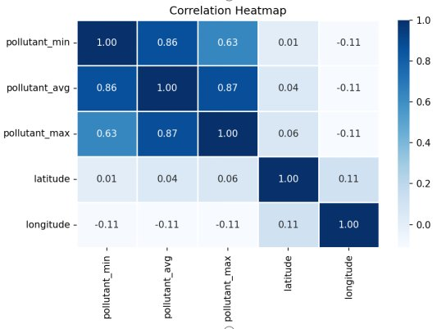
Figure 4: Correlation Heatmap
7.4 RESULT
pollutant_avg and pollutant_max have the highest correlation (0.87). Latitude and longitude have almost no correlation with pollution levels, which means location coordinates alone cannot predict pollution.

8. Objective 5 – Top 10 Most Polluted States

8.1 GENERAL DESCRIPTION
This objective finds the top 10 states in India with the highest average pollution levels. A horizontal bar chart is used to compare these states.

8.2 ANALYSIS
Data was grouped by state and mean of pollutant_avg was calculated. The top 10 states were selected and sorted in descending order.

8.3 VISUALIZATION
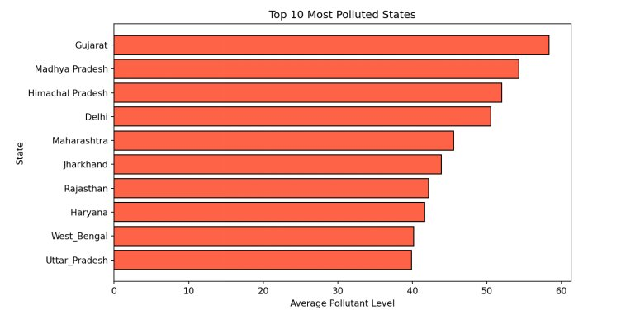
Figure 5: Top 10 Most Polluted States in India (Horizontal Bar Chart)
8.4 RESULT
Gujarat and Delhi appear among the most polluted states. These are highly industrialized and densely populated areas. States like Maharashtra and Uttar Pradesh also show high pollution levels due to large number of vehicles and factories.

9. Objective 6 – Hypothesis Testing (t-test)

9.1 HYPOTHESIS
- H₀ (Null): There is no significant difference between PM2.5 and PM10 average levels.
- H₁ (Alternate): There is a significant difference between PM2.5 and PM10 average levels.

9.2 ANALYSIS RESULTS
Statistic | Value
PM2.5 Mean | 70.05
PM10 Mean | 98.72
t-statistic | -11.8207
p-value | 0.000000
Significance Level (α) | 0.05
Decision | Reject H₀

9.3 RESULT
Since p-value (0.000000) is less than 0.05, we reject the null hypothesis. This means there is a significant difference between PM2.5 and PM10 average levels. PM10 levels are significantly higher than PM2.5 in India.

10. Objective 7 – Linear Regression (Machine Learning)

10.1 GENERAL DESCRIPTION
This objective uses Linear Regression to predict the average pollutant level (pollutant_avg) using pollutant_min and pollutant_max as input features. This is a supervised machine learning model.

10.2 STEPS DONE
- Selected pollutant_min and pollutant_max as input features (X).
- Used pollutant_avg as the target variable (y).
- Split the data into 80% training and 20% testing using train_test_split.
- Trained a LinearRegression model from sklearn.
- Evaluated the model using R² Score and Mean Squared Error.

10.3 MODEL RESULTS
Metric | Value
R² Score | 0.9117
Mean Squared Error (MSE) | 121.69
Training Data Size | 2,631 rows
Testing Data Size | 658 rows

10.4 VISUALIZATION
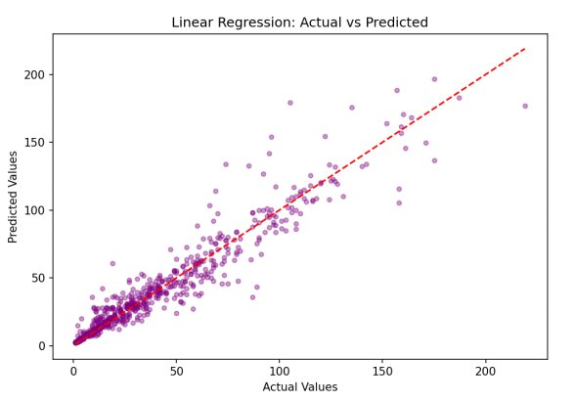
Figure 6: Linear Regression – Actual vs Predicted Values
10.5 RESULT
The model achieved an R² score of 0.91 which means it can explain 91% of the variation in pollutant_avg. The points in the scatter plot are close to the diagonal line which confirms that the predictions are accurate. pollutant_min and pollutant_max are strong predictors of pollutant_avg.

11. Conclusion

In this project, AQI data of India was analyzed using Python. The dataset had 3,503 rows and 11 columns covering 30 states and 263 cities. The following are the major findings:

- PM10 has the highest average pollution level (98.72) among all pollutants.
- The PM2.5 data is right-skewed — most areas have low pollution but a few have very high levels.
- 119 outliers were found using the IQR method, indicating extreme pollution events.
- pollutant_avg and pollutant_max are strongly correlated (0.87).
- Gujarat and Delhi are among the most polluted states in India.
- t-test showed that PM2.5 and PM10 levels are significantly different (p < 0.05).
- Linear Regression model predicted pollutant_avg with 91% accuracy (R² = 0.91).

This project helped in understanding how to use Python for real-world data analysis and apply concepts from the INT375 syllabus practically.

12. Future Scope

- More ML models like Decision Tree or Random Forest can be tried to improve prediction accuracy.
- Time-series analysis can be done if historical data from multiple years is available.
- A city-level dashboard can be created using Power BI or Streamlit.
- Deep learning models can be used to predict future AQI levels.
- Analysis can be extended to include weather data like temperature and humidity.

References

- [1] Centr Pollution Control Board (CPCB), Government of India — AQI Dataset. Available at: data.gov.in

