**Task 1: a.**

>touch 23341065_1.txt 23341065_2.txt 23341065_3.txt 23341065_4.txt

>mkdir Istiaque1 Istiaque2

>mv 23341065_1.txt 23341065_2.txt 23341065_3.txt Istiaque1

>cd Istiaque1

>cp 23341065_1.txt 23341065_2.txt ../Istiaque2

>cd ..

>mkdir Istiaque3

>cp -r Istiaque1 Istiaque3

>cd Istiaque3

>ls -l

>chmod -R go=rx *

>cd ..

>cd Istiaque2

>ls

>mv ../Istiaque3 ../ /**/Istiaque3 is already in root directory in this case.**

>rm ./*

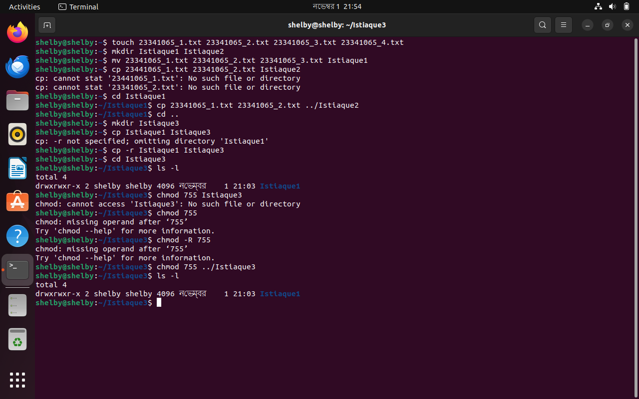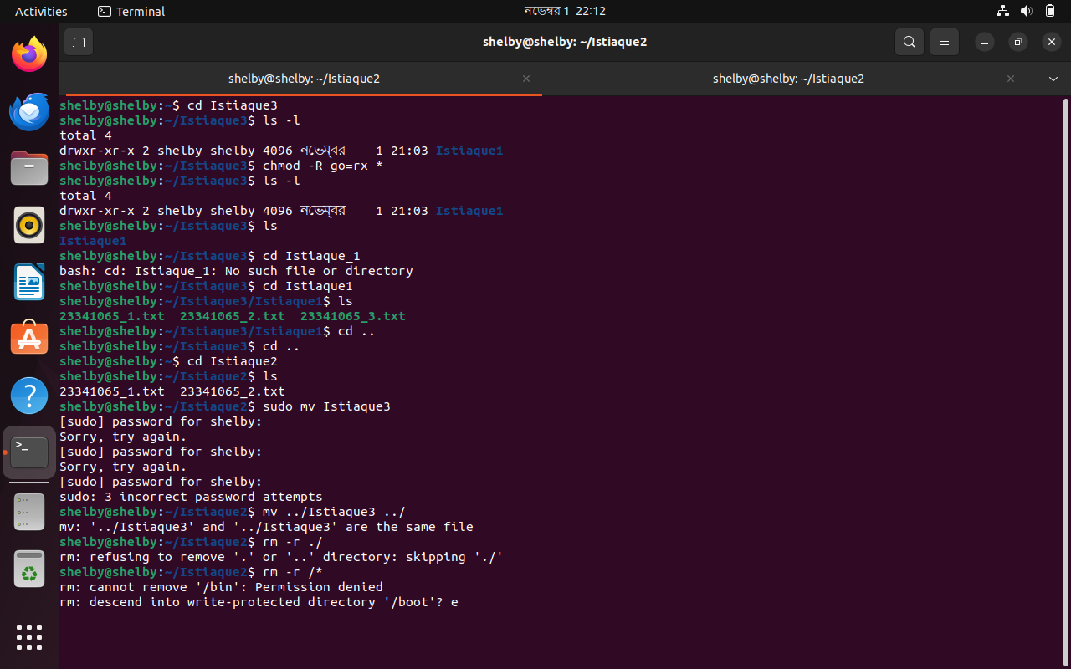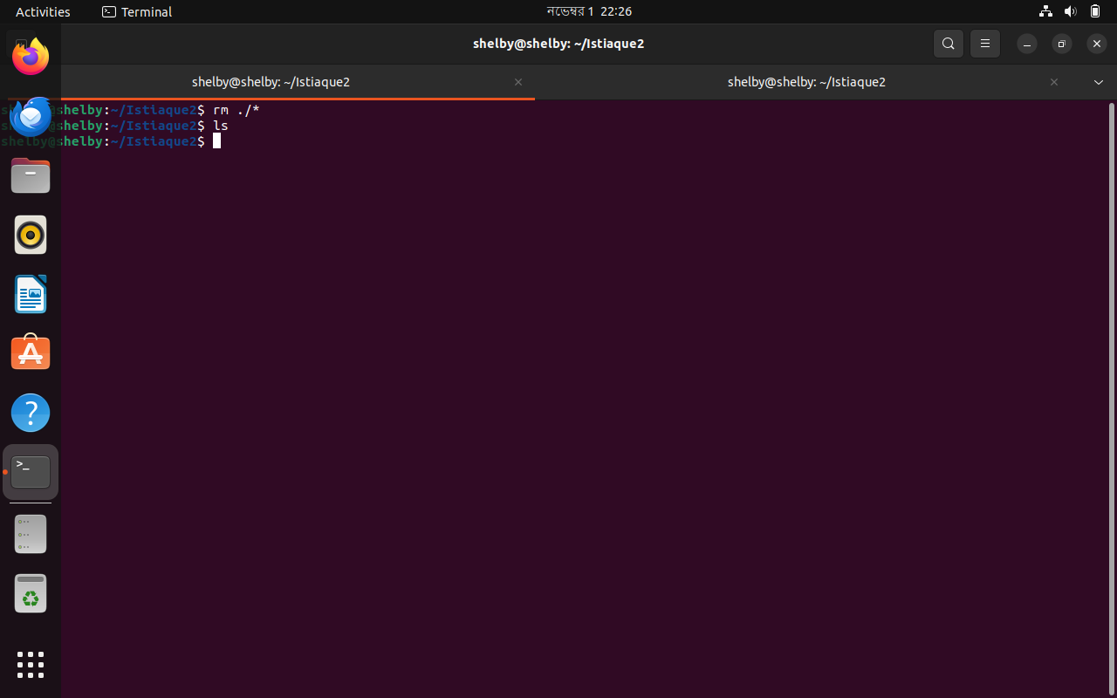

**Task 1: b.**

>echo "CSE321_Operating Systems_6" >> course.txt

>echo "CSE331_Automata and Computability_5" >> course.txt

>echo "CSE370_Database Systems_10" >> course.txt

>echo "CSE426_Advanced Algorithm_1" >> course.txt

>echo "MAT216_Linear Algebra_14" >> course.txt

>grep -c "CSE" course.txt

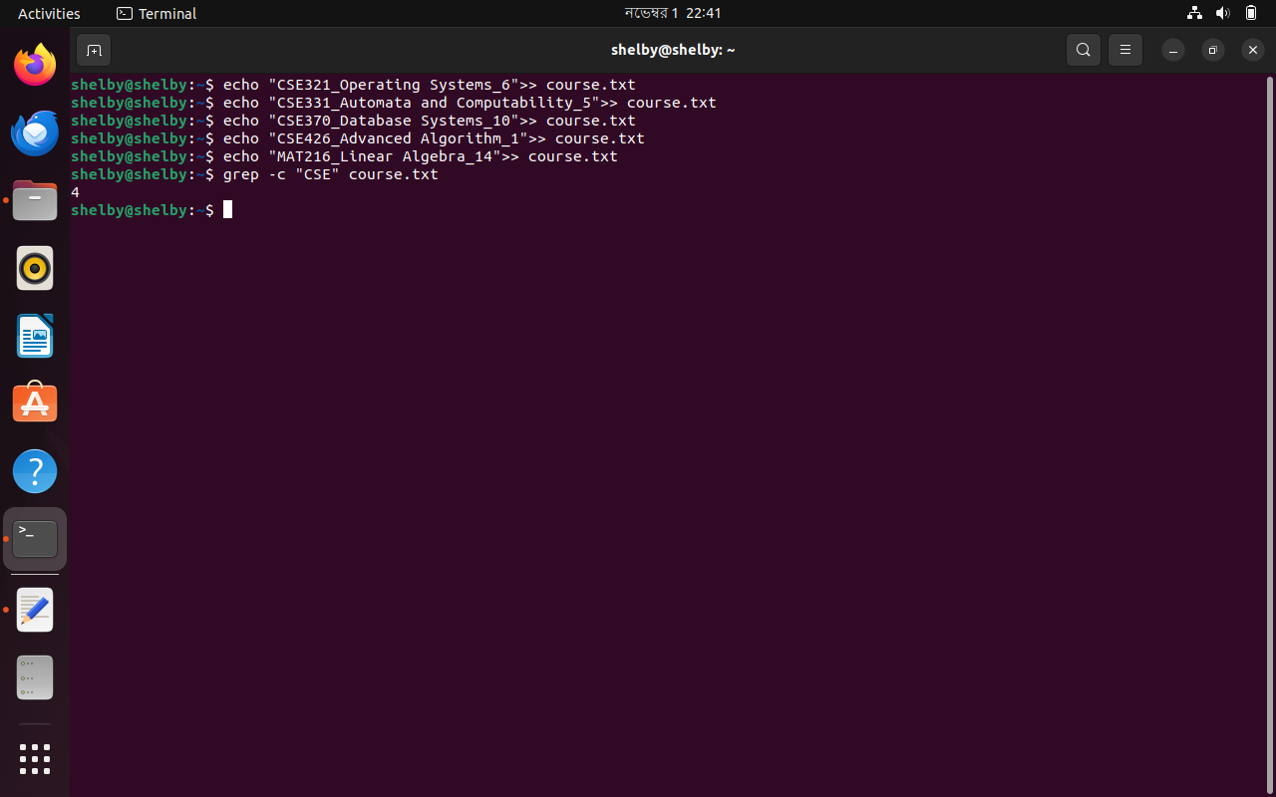

**Task 1: c.**

>ls -a /

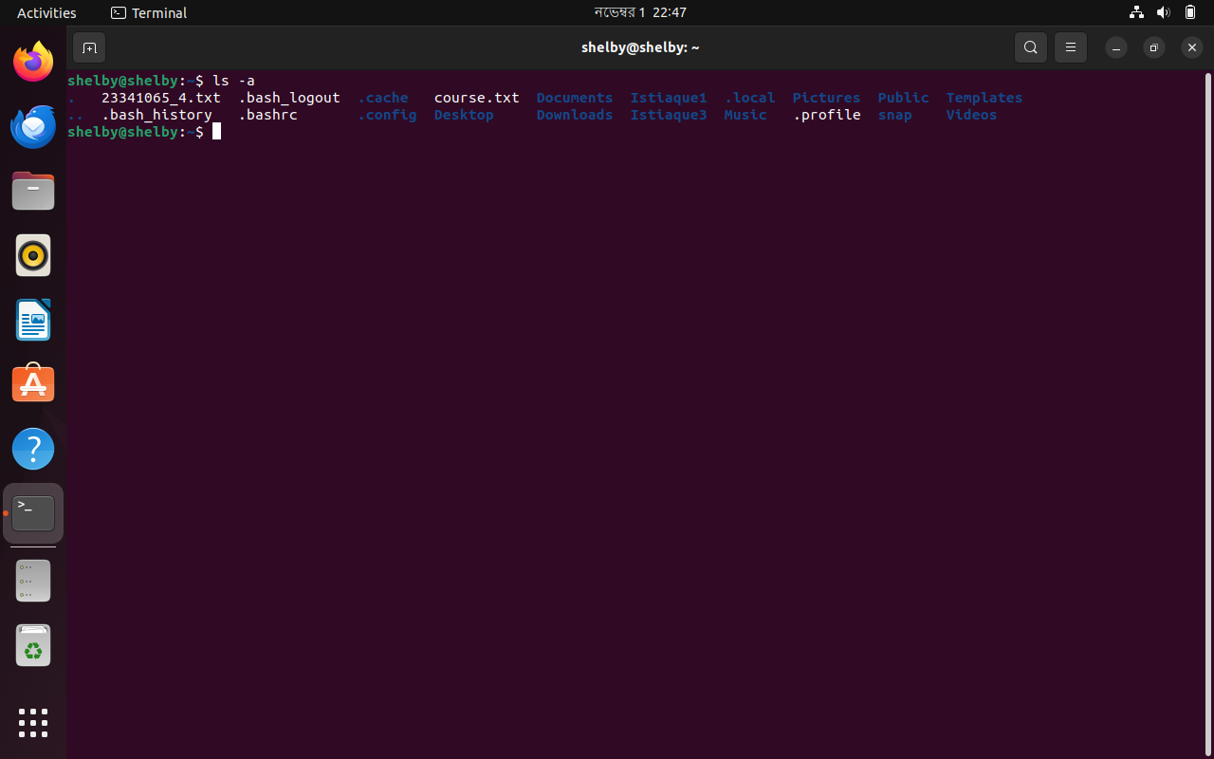

**Task 1: d.**

>sed -n '5,17p' a.txt

