COS 214 PRACTICAL 4
TaskForge
Hierarchical Construction Work Processing
Team member 1 | u25038967 – Shelby Bodenstein
Team member 2 | u25405064 – Lwandiso George
Team member 3 | u25270665 – Prince Tamiru
GitHub repository | GitHub Link

1. System Description and Domain
TaskForge is a construction work-management system that organises a project as a recursive hierarchy. A Phase contains Rooms, and Rooms contain individual Tasks. The same WorkItem abstraction is used for both groups and leaves, allowing the client to treat a single task and an entire project section uniformly.
The system supports two independent traversal behaviours over the same hierarchy: CostReportIterator performs a full depth-first traversal of all nodes, while ActiveTaskIterator currently performs a task-focused leaf traversal by selecting objects whose getChildCount() is zero. Tasks also have a lifecycle that changes their valid behaviour at runtime, and optional responsibilities can be stacked dynamically using decorators such as UrgentDecorator and SpecialistDecorator.
Two runtime scenarios tie the patterns together. RushOrderDayScenario drives a task through inspection and rework, demonstrates invalid state transitions, then replaces a plain task in a Room with a stacked decorated WorkItem. ChangeOrderScenario modifies the project hierarchy at runtime by adding an Emergency Repair Bay.

1.1 Main Runtime Hierarchy
- Level 1: constructionPhase : Phase (root composite)
- Level 2: serverRoom : Room and officeRoom : Room (nested composites)
- Level 3: individual Task leaves such as Install Raised Flooring, Run Cat6 Network Cabling and Carpet Tiling
- Runtime additions: floorTiling and a decorated fixtureInstall are added to serverRoom during the rush-order scenario.

1.2 Core Behaviour
- Recursive cost calculation: Phase and Room sum the costs of their children.
- Traversal is separated from storage: main.cpp does not retrieve the complete children vector for iteration.
- State-dependent task operations reject invalid lifecycle actions without a giant central switch statement.
- Decorators preserve the WorkItem interface, so a decorated task remains usable anywhere an undecorated WorkItem is expected.
- Ownership is explicit and recursive, supporting clean polymorphic destruction.

2. Complete UML Class Diagram
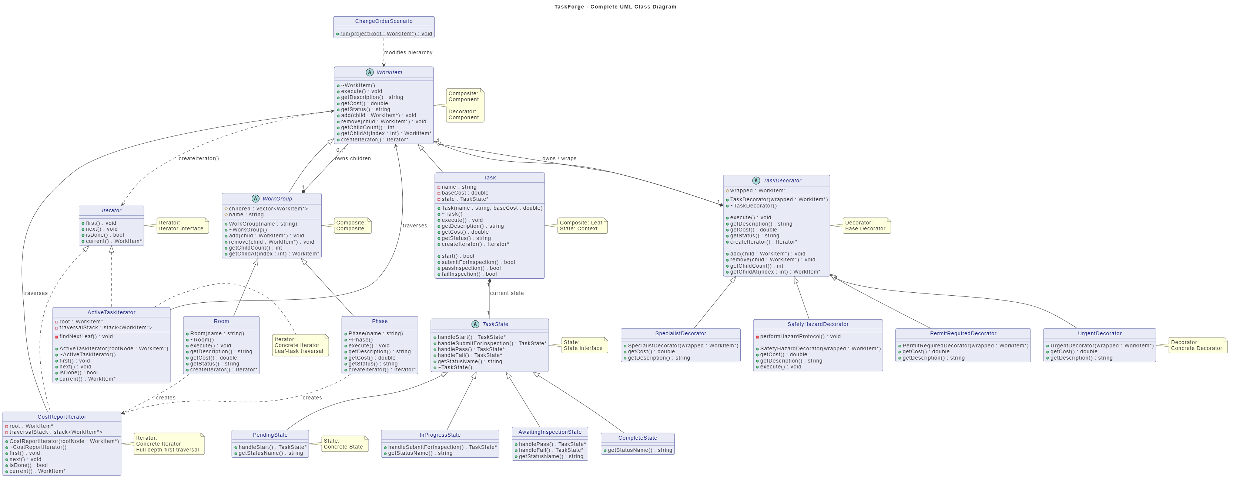
Figure 1. Complete class diagram showing the four GoF patterns and their ownership relationships.
Notation: hollow triangle = inheritance; filled diamond = ownership/composition; dashed dependency = traversal/reference relationship.

3. GoF Participant Mapping
Pattern | GoF Participant | TaskForge Class(es) | Role in the System
Composite | Component | WorkItem | Common interface for individual tasks, groups and decorators.
Composite | Composite | WorkGroup | Stores and owns child WorkItem pointers; provides add/remove/child access.
Composite | Concrete Composite | Phase, Room | Concrete grouping objects that execute children and aggregate cost.
Composite | Leaf | Task | Individual unit of work with no children.
Iterator | Iterator | Iterator | Traversal interface: first, next, isDone and current.
Iterator | Concrete Iterator | CostReportIterator | Own stack; depth-first traversal over every hierarchy node.
Iterator | Concrete Iterator | ActiveTaskIterator | Own stack; structurally filters traversal to leaf WorkItems.
State | Context | Task | Delegates lifecycle transition decisions to its current TaskState.
State | State | TaskState | Defines default handlers that return the current state for invalid actions.
State | Concrete States | PendingState, InProgressState, AwaitingInspectionState, CompleteState | Implement the valid state transitions for the task lifecycle.
Decorator | Component | WorkItem | The same abstraction used by decorated and undecorated objects.
Decorator | Decorator | TaskDecorator | Owns and forwards to one wrapped WorkItem.
Decorator | Concrete Decorators | UrgentDecorator, SpecialistDecorator, SafetyHazardDecorator, PermitRequiredDecorator | Add cost, description changes and/or execution responsibilities at runtime.

3.1 Pattern Collaboration
The four patterns are not isolated demonstrations. Composite creates the recursive WorkItem structure; Iterator traverses that structure without exposing the vector used by WorkGroup; State controls lifecycle behaviour inside Task leaves; and Decorator allows a Task to gain extra runtime responsibilities while remaining a WorkItem that can be inserted back into a Room.

3.2 Design and Ownership Rationale
- WorkGroup owns its children. WorkGroup::~WorkGroup() recursively deletes every child, so deleting the root Phase destroys the entire composite hierarchy.
- WorkGroup::remove() erases a pointer without deleting it. This is deliberate: RushOrderDayScenario removes fixtureInstall before transferring ownership to a decorator chain.
- Task owns exactly one TaskState. On a valid transition the old state is deleted and replaced; on an invalid action the state object returns itself and no replacement occurs.
- TaskDecorator owns the wrapped WorkItem. Stacked decorators therefore form an ownership chain: Room owns the outer decorator, which owns the next decorator, which owns the underlying Task.
- Each iterator owns a separate traversal stack. Two iterator objects can therefore be positioned independently over the same hierarchy.

4. UML Object Diagram
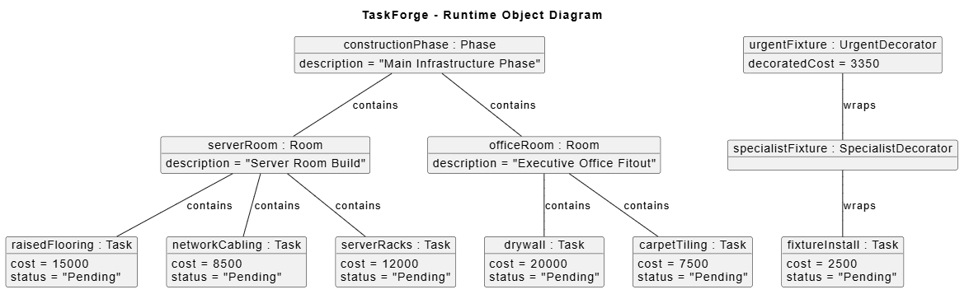
Figure 2. Meaningful runtime portion of the hierarchy after RushOrderDayScenario and before the change order.
At this point the original five tasks contribute R63 000. The rush-order scenario adds floorTiling (R900) and fixtureInstall wrapped by SpecialistDecorator (+R1 200) and UrgentDecorator (+R750), giving the decorated fixture a total cost of R3 350 and the project a total of R67 250. floorTiling is Completed after its rework/inspection cycle, while the underlying fixture task remains Pending.

5. UML State Diagram
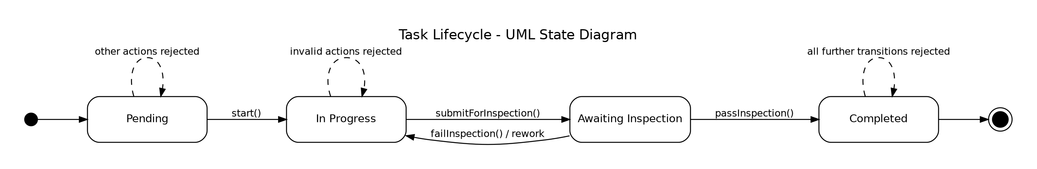
Figure 3. Lifecycle of a Task and the valid transitions implemented by the concrete TaskState classes.
A new Task begins in PendingState. start() moves it to InProgressState; submitForInspection() moves it to AwaitingInspectionState. A failed inspection returns the task to InProgressState for rework, while a passed inspection moves it to CompleteState. All unsupported actions are rejected because the base TaskState handlers return this, leaving the current state unchanged.

6. Activity Diagram 1 - Full Project Cost Traversal
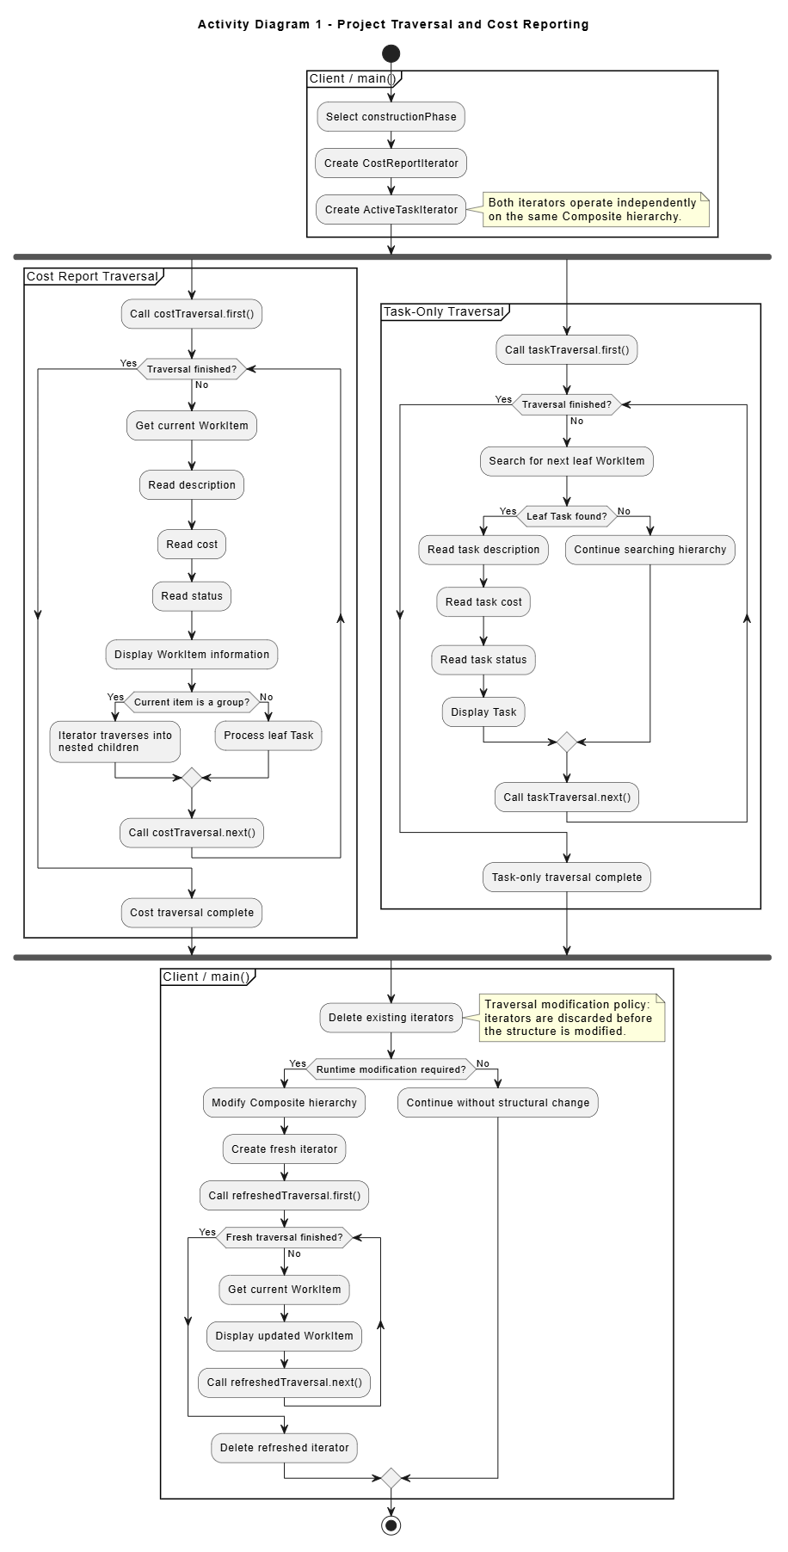
Figure 4. Full traversal is visible as a loop rather than being hidden behind a single process-all action.

7. Activity Diagram 2 - Rush Order Lifecycle and Decoration
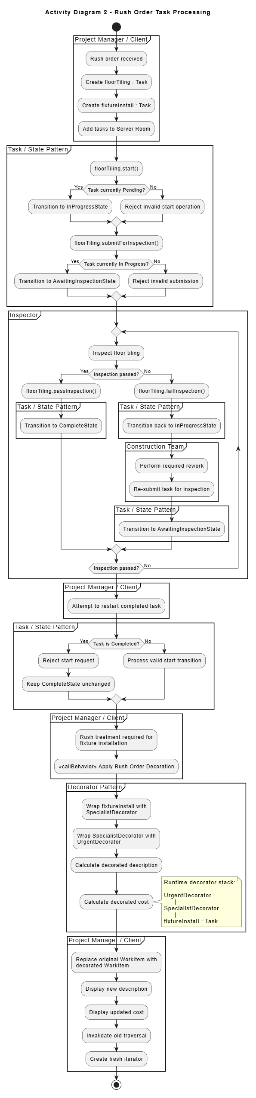
Figure 5. Swimlane activity showing state-dependent behaviour, rework loop, invalid transitions and stacked decoration.

8. Activity Diagram 3 - Independent Traversals and Runtime Modification
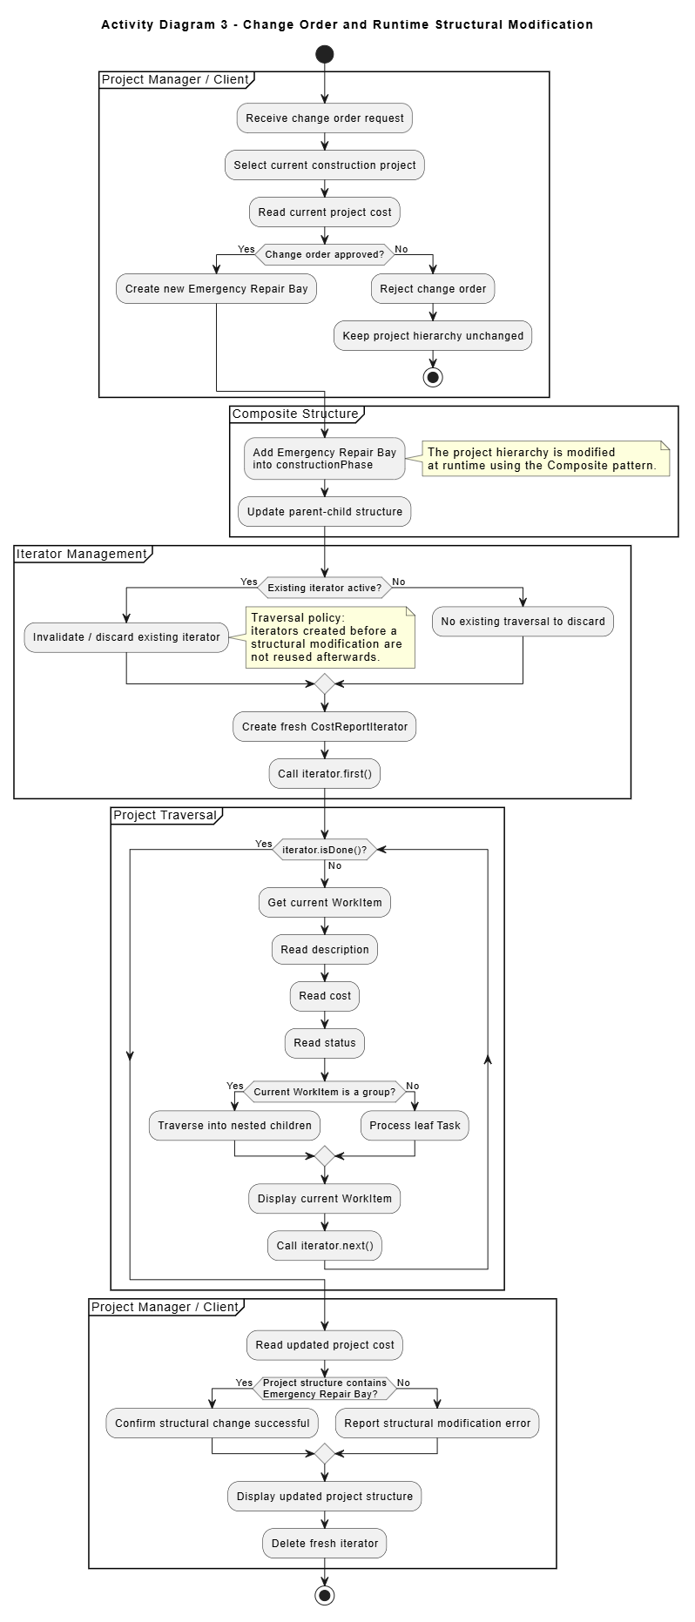
Figure 6. Fork/join and called activities used to show independent reporting workflows and controlled runtime modification.

9. Traversal-Modification Policy and Important Design Decisions

9.1 Policy for Modifying a Structure During Traversal
TaskForge uses an explicit iterator-invalidation policy. Existing iterators are destroyed before a structural modification is performed. After the hierarchy has changed, a new iterator is created if traversal must continue.
- Reason: both concrete iterators maintain stacks of raw WorkItem pointers representing their current traversal state.
- If an item were removed and deleted while an iterator still stored its address, the stack could contain a dangling pointer.
- If a group were expanded before a new child was added, a live traversal could also miss that new item depending on its current position.
- Deleting the old iterator and creating a fresh one makes the policy safe, simple and predictable for the client.

9.2 Two Independent Traversals
CostReportIterator and ActiveTaskIterator each contain their own std::stack<WorkItem*>. The integrated main creates both over constructionPhase at the same time, advances only the cost traversal, and then shows that the task traversal is still positioned independently. This directly demonstrates that traversal state is not stored in the Composite itself.

9.3 ActiveTaskIterator Selection Rule
Despite its class name, the current implementation uses a structural leaf-selection rule rather than checking the Task lifecycle state: findNextLeaf() accepts any WorkItem for which getChildCount() == 0. In the current hierarchy these leaves are Tasks (or decorated Tasks), so the iterator serves as the second, task-focused traversal behaviour.

9.4 Decorator Ownership Transfer
Before fixtureInstall is decorated, RushOrderDayScenario removes it from targetRoom. This is essential because the Room must no longer own the bare pointer once SpecialistDecorator takes ownership of it. The outer UrgentDecorator is then added to the Room. This prevents double deletion and makes the ownership chain unambiguous.

10. GDB Investigation and Genuine Bug

10.1 Meaningful GDB Investigation - Task State Transition
A useful GDB investigation is to stop inside Task::start() during the rush-order scenario and step into PendingState::handleStart(). This demonstrates that behaviour is delegated to the current state object and that a new InProgressState is returned only for a valid transition.
gdb ./taskforge
set print object on
break Task::start
run
step
backtrace
next
finish
next
continue
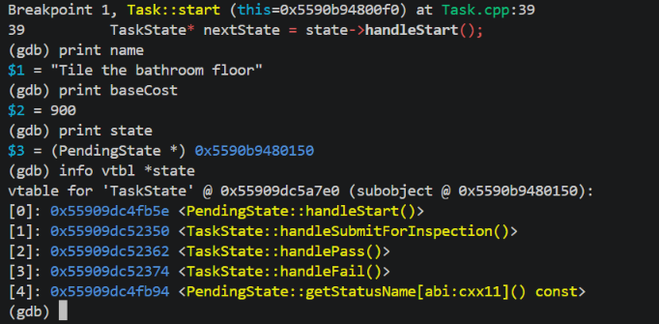
Suggested explanation under the screenshot: the breakpoint enters Task::start(); the call is delegated through state->handleStart(); PendingState creates an InProgressState; Task deletes the old state and stores the new state. Repeating the same idea on an invalid transition shows the handler returning the same pointer, so the state remains unchanged.

10.2 Genuine Development Bug - Case-Sensitive Header Name
A genuine integration bug occurred in WorkGroup.cpp when the implementation included "Workgroup.h" while the actual file was named "WorkGroup.h". This can appear to work on a case-insensitive Windows filesystem but fails in the Linux Docker environment.
Symptom | Docker/Linux compilation reports that Workgroup.h cannot be found.
Cause | Header-name capitalisation did not match the actual WorkGroup.h filename.
Correction | Changed the include to #include "WorkGroup.h".
Engineering lesson | Building inside the required Linux container exposed a portability bug that the host environment could mask.
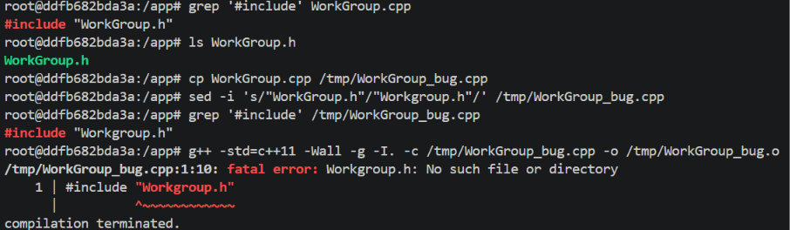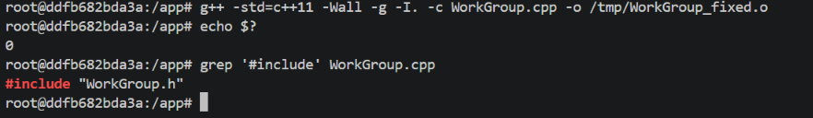

11. Valgrind and Docker Evidence

11.1 Valgrind
The final executable is checked using the leak-check command required by the practical. The recursive ownership policy means that deleting constructionPhase should delete every Room, Task, TaskState and decorator chain that remains in the hierarchy.
valgrind --leak-check=full --show-leak-kinds=all ./taskforge
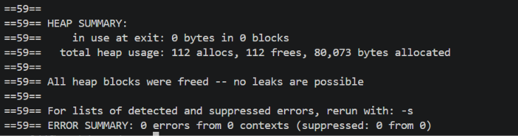

11.2 Docker Build and Reproduction
The Docker environment is based on Ubuntu and installs g++, make, gdb and valgrind so the marker can compile, run and investigate the project without host-specific dependencies.
docker build -t taskforge .
docker run --rm taskforge
# interactive investigation
docker run --rm -it --entrypoint /bin/bash taskforge
make clean && make
gdb ./taskforge
valgrind --leak-check=full --show-leak-kinds=all ./taskforge
The Makefile compiles all .cpp files with -std=c++11 -Wall -g and produces the required executable named taskforge.

12. GitHub Workflow Reflection and Team Contribution

12.1 Repository
GitHub Link

12.2 Workflow Reflection
The work was divided amongst the three members evenly. The coding was split in half between Lwandiso and Prince while Shelby debugged the code and made the PDF as well as the diagrams.

13. Design-to-Code Traceability
Diagram / Requirement | Implementation | Traceable Code Location
Recursive part-whole hierarchy | Phase -> Room -> Task using WorkItem/WorkGroup | main.cpp; WorkGroup.h/.cpp; Phase.cpp; Room.cpp
Full traversal | Depth-first stack traversal of every node | CostReporterI.cpp; Phase::createIterator(); Room::createIterator()
Second traversal | Leaf-only task-focused traversal | ActiveTaskIterator.cpp::findNextLeaf()
Independent iterators | Separate stack per concrete iterator | CostReportIterator::traversalStack; ActiveTaskIterator::traversalStack; main.cpp
State lifecycle | Pending -> In Progress -> Awaiting Inspection -> Completed / rework | Task.cpp; PendingState.cpp; InProgressState.cpp; AwaitingInspectionState.cpp; CompleteState.cpp
Invalid transitions | Default TaskState handlers return this | TaskState.cpp and Task transition methods
Stacked decorators | Specialist then Urgent wrapping fixtureInstall | RushOrderDayScenario.cpp; TaskDecorator.cpp
Runtime structure change | Add Emergency Repair Bay | ChangeOrderScenario.cpp
Ownership cleanup | Recursive child/state/wrapped-object deletion | WorkGroup::~WorkGroup(); Task::~Task(); TaskDecorator::~TaskDecorator()

