**Prince William Sound Profiler Communication Module**

ECE 4873 Senior Design Project

Aquanauts

Dr. Mick West

Dr. Robert Campbell (if applicable)

Shayna Seidel, EE, sseidel7, [sseidel7@gatech.edu](mailto:sseidel7@gatech.edu)

Jim O’Donnell, CmpE, jodonnell3, [jodonnell3@gatech.edu](mailto:jodonnell3@gatech.edu)

Shelby Crisp, CmpE, scrisp3, [scrisp3@gatech.edu](mailto:scrisp3@gatech.edu)

Jason Lee, EE, slee3117, [slee3117@gatech.edu](mailto:slee3117@gatech.edu)

Ruben Quiros, CmpE, rquiros6, [rquiros6@gatech.edu](mailto:rquiros6@gatech.edu)

Timothy Pierce, EE, tpierce31, [timrpierce31@gatech.edu](mailto:timrpierce31@gatech.edu)

Submitted

2/17/21

**Table of Contents**

**Executive Summary** 3

1. **Introduction** ……………………………………………………………………….. 5
2. **Project Description and Goals** ……………………………………………………. 7
3. **Technical Specification** ……………………………………………………………. 9
4. **Design Approach and Details** …………………………………………………….. 10
   1. Design Approach ……………………………………………………………... 10
   2. Codes and Standards …………………………………………………………. 15
5. **Project Demonstration** …………………………………………………………….. 17
6. **Schedule, Tasks, and Milestones** ………………………………………………… 18
7. **Marketing and Cost Analysis** …………………………………………………….. 20
   1. Marketing Analysis …………………………………………………………... 20
   2. Cost Analysis …………………………………………………………………. 20
8. **Current Status** …………………………………………………………………….. 22
9. **Leadership Roles** ………………………………………………………………….. 23
10. **References** …………………………………………………………………………. 24

**Appendix** ……………………………………………………………………………. 26

**Executive Summary**

The goal of this project is to design a new communications module for an existing underwater profiler. This module will be able to send data from a data-collecting profiler in the Prince William Sound to the researchers working on it. The current transfer of information necessitates a biweekly data transfer on site of the profiler, which is 4 hours offshore in the Prince William Sound. By designing a new communications module, data will be transferred once every 24 hours without the need for onsite download. This module will need to surface in the sound and communicate wirelessly to shore in an environment with few options for long range transfer of data. The profiler currently uses low bandwidth cellular data to send minimal information every 24 hours. The added module shouldn’t take up too much battery life, and should include an interface between existing sensors that are necessary to surface in the profiler. The expected cost is $183.78.

**Nomenclature**

**AMP:** Autonomous Moored Profiler

**BOM**: Bill of Materials

**CmpE**: Computer Engineer

**EE**: Electrical Engineer

**PWS**: Prince William Sound

**Prince William Sound Profiler Communication Module**

**1. Introduction**

In the aftermath of the 1989 Exxon Valdez oil spill in Prince William Sound, an Autonomous Moored Profiler (AMP) has been used (since 2013) to collect data on PWS’s environmental recovery [1]. Although originally manufactured by Sea-Bird Scientific, the profiler is no longer available. The current profiler in PWS continues to monitor the environmental recovery of PWS but requires numerous updates and improvements. This is why the Aquanauts team is requesting $400 of funding to create a data transmission module for a profiler in Prince William Sound. This module will be able to surface and send data from the profiler sensors to the ocean scientists. This functionality will save energy thus reducing the maintenance frequency while giving scientists more information on a regular basis. The current cost estimate for parts for this module is $183.78, however, the total project will cost more when PCB printing and components that are unaccounted for are taken into account.

Currently, scientists must visit the profiler approximately every two weeks to charge the battery. These maintenance visits are when data from the sensors is collected. Making frequent maintenance trips to the profiler is inefficient, and can become delayed or even dangerous due to weather conditions. Saving battery life and accessing sensor data remotely would greatly enhance the profiler's usage. Developing a smaller module to surface, as opposed to the entire large platform, would save battery life and decrease maintenance visits. This module would also use the nearby 3G cell tower to transmit data to the ocean scientists so they could access it without making a trip to the profiler.

This module will require a separate smaller winch to ascend to the surface. However, the Aquanaut’s focus is on the module itself and mainly its software and electrical hardware components. This will involve connecting all sensors to the module and a centralized microcontroller, and designing a method for the module to transmit data when at the surface. There are multiple constraints that must be taken into account for this design. Due to the nature of the profiler, designs must withstand the water, pressure, temperature, and harsh storms of PWS. These requirements will be factored into the design. Once design is complete, a combination of simulations and physical tests will be conducted to demonstrate the module’s capabilities. The verification will be videos for use at the Spring 2021 Senior Design Expo. The rest of this report will go into greater detail on the specifics of designing and validating this module.

**2. Project Description, Customer Requirements, and Goals**

The Aquanauts team proposes a new sensor module in addition to the overall profiler assembly to address four of the customer’s main requirements: improved data transfer from the profiler’s remote location, extended battery life of the overall profiler, updated central data storage, and extended profiling capabilities. The new module will address these requirements in the following ways:

1. Revamp the method of communication to improve data transfer volume and speed by offering a higher baud rate than the existing 9600 baud, and utilize the available 3G cell tower nearby.
2. Use a smaller integrated winch to release the sensor module to the water’s surface when broadcasting data, thus saving critical battery life by eliminating the need to surface the full profiler on a daily basis via the anchoring winch.
3. Relocate the full array of sensors to a smaller and less invasive module. This will allow the potential for profiling in both the up and down directions of movement. Currently, the profiler does not collect data while moving downward to prevent profiling water that has washed through the large 6 ft. by 2 ft. profiler assembly. This “washed-through” water is not representative of the environment around the profiler.
4. Provide a modern data storage unit and processor for aggregation of data, replacing the outdated and no longer produced Persistor module.

Success and stakeholder acceptance will be measured by benchmarking performance of the new module versus current-state performance. Notably, current-state data transfer is every 10th data point amounting to around 200kb of data with the majority of communication representing an “alive” signal that indicates whether the profiler is still functioning. Battery life is estimated between 3 weeks and 1 month, with the majority of power drain resulting from the anchoring winch. The project’s internal stakeholder is Dr. West, while the external stakeholder is Dr. Campbell and his team in Alaska.

**Table 1. Stakeholder 2x2**

|  |  |
| --- | --- |
| Internal Stakeholders | External Stakeholders |
| Dr. West, Aquanauts | Dr. Campbell |

Constraints are minimal. The intent of the long-term project with the research team is to design a new profiler as the existing profiler is no longer manufactured. The Aquanauts goal is to provide an ideal sensor and communication subsystem to address the research team’s requirements, rather than consider integration with other existing systems. Considerations will include data transfer rate, low power consumption, environmental survivability of the components in terms of temperature and pressure in a very cold underwater environment, and appropriate storage capacity to accommodate profiling data.

**Table 2. QFD Chart**

|  |  |  |  |  |  |
| --- | --- | --- | --- | --- | --- |
|  | **Long-Range Communication** | **Centralized Data Storage and Processing** | **Extended Battery Life** | **Extended Profiling Capability** | **Total** |
| **Form Factor** | 2 | 4 | 10 | 10 | 26 |
| **Power Consumption** | 4 | 4 | 10 | 7 | 25 |
| **Environmental Conditions** | 10 | 10 | 2 | 2 | 24 |
| **Total** | 16 | 18 | 22 | 19 |  |

1. **Technical Specifications**

**Table 3. Technical Specifications**

|  |  |  |
| --- | --- | --- |
| **Specification** | **Min** | **Max** |
| Functional Temperature | -5 C | 30 C |
| Functional Depth | N/A | 100m |
| Total Power Consumption | 9 Vdc, 1.01 A (** Missing min amp info for RBR Brevio) | 14 Vdc, 1.67 A (**Missing max amp info for RBR Brevio) |
| Communication Range (Approx) | 100m (Operating depth + realistic estimate of surface buoy distance) | 8000m (Nearest cell tower, approximately 5 mi.) |
| Communication Frequency | GSM 850 MHz for remote 3G compatibility (869.2 – 893.8 MHz)  **Other available frequencies**: E-GSM 1900 MHz, DCS 1800 MHz, PCS 1900 MHz | |

The specifications listed in Table 3 indicate the foundational requirements of the integrated system, including functional temperature, depth, power consumption, communication range, and communication frequency. All defined sections are equally important as they encompass environmental considerations for the underwater and highly remote locale, power consumption considerations in terms of saving critical battery life, and communications requirements for improved data transfer. The minimum power consumption is determined from the highest minimum operating voltage of all sensors, and maximum power consumption is determined from the lowest maximum operating voltage of all sensors. Minimum communication range is an approximation based on the operating depth of the profiler to a theoretical buoy containing additional communication equipment, and maximum communication range is from the profiler’s location to the nearest cell tower 5 miles (~8000 meters) away. The communication frequency, GSM 850 MHz, is the standard frequency used in data transfer to 3G cell towers.

1. **Design Approach and Details**
   1. **Design Concept Ideation, Constraints, Alternatives, and Tradeoffs**

The current design concept for this project is to have a central processor which will interface between the different sensors used by the profiler. The processor will store sensor data in a central place as well as interface with a cellular communication module to send the data out while profiling.

**4.1.1 Smaller module**

The current Prince William Sound profiler completely surfaces through the use of a winch. The winch is the greatest power draw and necessitates a large battery. One concept to conserve energy is to utilize a smaller module that surfaces to profile without surfacing with the battery. Through the use of a second winch, the large battery can remain at a lower depth, only needing to surface for charging. Since a smaller winch is used, less power will be expended. This smaller module will need to house the profiling sensors as well as a module for data transmission.

A constraint of a smaller module is the ability for it to withstand strong currents and storm conditions in the sound. The current profiler is sometimes overtaken by currents and is unable to surface and therefore cannot send a signal to indicate that it’s still working. When this occurs, the profiler needs to be checked on, which is a dangerous task especially under storm conditions. The sturdiness and surfacing abilities of the smaller module must be taken into account. If the separation of a smaller module from the profiler causes more issues when it comes to surfacing, the benefits of having a smaller module will be negated.

A few alternatives to the smaller module would be keeping the design as is and losing power saving capabilities, or having a buoy sitting at the surface to transmit messages. With the use of a buoy, the profiler would be able to stay submerged and use the buoy as a relay point for information. This would solve the problem of currents keeping the profiler from surfacing and allow for seamless communications with the shore. The buoy itself could have a solar powered battery so it doesn’t draw additional power from the profiler and therefore will not need to be serviced frequently. We decided against the use of a buoy because of the short lifespan previous buoys have had when utilized in the Prince William Sound. Previous buoys used by Dr. Campbell in the Prince William sound have only lasted around three weeks due to high boat traffic as well as strong weather conditions. Having to replace the buoy on a monthly basis would negate the benefits of using a buoy.

**Table 4. Smaller Module Tradeoffs**

|  |  |
| --- | --- |
| Tradeoffs for Smaller module use | |
| Pros | * Less power used * Safer than buoy use |
| Cons | * Added complexity * May not surface properly - no signal sent |

**4.1.2 Data Transmission**

A data transmission module is a main focus for this project. Different concepts were considered, including satellite transmission for data, cellular telemetry and radio transmission. Cellular data is what is currently utilized for transmitting information from the profiler to shore. Using cellular data will make the most sense for application of this project. Since cellular data is currently utilized, it will be more ideal for use in testing as opposed to radio transmission and satellite transmission. There is a cellular tower near the sound that can support 3G communications.

While cellular data is useful to utilize, the constraint of inability to send data without surfacing still comes into play. Satellites would require a buoy and therefore a signal would persist even under harsher conditions. However, upon further inspection, satellites would be beyond the budget of this project and not many companies support satellite communication at such a remote location. Viasat, one of the larger and more affordable companies to offer satellite transmission, doesn’t immediately offer transmission to the sound [2]. Radio transmission is another option to explore, but would require testing and setup in the sound that would be hard to reproduce offsite.

**Table 5. Cellular Data Tradeoffs**

|  |  |
| --- | --- |
| Tradeoffs for Cellular data usage | |
| Pros | * In use currently * Easier to test |
| Cons | * Doesn’t work if the module doesn’t surface * May have lower speeds than other alternatives |

**4.1.3 Centralized Sensors**

In order to successfully collect and store data as well as control the sensors and communications module, a central processor will be necessary. While there is one currently in use, it is no longer being produced. The plan for this project is to replace the old processor with one that is newer and can run a lightweight version of ubuntu in order to interface with some of the sensors.

One constraint to keep in mind are the conditions that this electronic component will be working under. The processor will be functioning at low temperatures and high pressure in an underwater environment. Special care needs to be taken to keep it in a waterproof enclosure and make sure any wiring or exposed pieces are protected.

An alternative would be to keep the current processor. Since it is no longer being produced and uses outdated software, it would be close to impossible to test the integration of sensors and communication modules. If any damage were to occur with the current processor, it would be harder to replace than something like an arduino or raspberry pi which are still in production.

**Table 6. Updating Central Storage Tradeoffs**

|  |  |
| --- | --- |
| Tradeoffs for Updating central storage | |
| Pros | * Old processor no longer in production * Can update software |
| Cons | * Added cost * Old processor still working and in use |

* 1. **Preliminary Concept Selection and Justification**

**4.2.1 Smaller Module to Save Battery Life**

After reviewing documentation and discussing the AMP needs with Dr. West and Dr. Campbell, the Aquanauts decided to design a module to ascend to the surface. One motivation for this was saving battery life. The profiler is rather large (diameter: 78.75 cm, length 212cm) [3] and uses much of the battery life to visit the surface. Since profiling occurs while travelling up the water column to the surface, this module must house the sensors needed for profiling. The module itself will need to be waterproof and sealed adequately to protect the electronics inside. The module will require a smaller winch to send the module to the surface and then back to the AMP. The module will also need to be connected to the power supply (currently the battery). This can be accomplished using a long cable with adequate protection/sleeving. The Aquanauts focus is moreso on the technology that will go inside this module and less on the mechanical aspects of this module.

**4.2.2 Centralized Sensors**

Currently, data from the sensors is stored in a central location using ASCII text. The main storage unit is a Persistor which is outdated and no longer produced. A new microcontroller must be chosen to accommodate the sensors on the module, cellular data transmission, expandable memory, and ease of programming. The sensors the microcontroller needs to interface with are: SBE 49 FastCAT CTD Sensor, RBR Brevio, Seabird Eco FLNTU, SBE 63 Optical Dissolved Oxygen Sensor, Aanderaa Oxygen Optode, and Seabird SUNA V2 Nitrate Sensor. The current plan is to use an Arduino Mega. This is best suited for this project because it has many pins to accommodate the sensors, expandable pin modules can be added if needed, there are multiple kits already developed for using cell data with Arduino, Arduino uses a C style language, and several Aquanauts have prior experience with Arduino. If an error occurs that makes the Arduino Mega no longer viable for the necessary functions, there are other models of Arduino and other microcontrollers such as Raspberry Pi that would be researched as replacements.

**4.2.3 Data Transmission**

When the module is at the surface, data from the sensors will be transmitted. Currently when the profiler surfaces, a nearby 3G cell tower is used to send minimal information. Due to availability and cost, the Aquanauts plan is to continue to use this cell tower for the increased data transmission. If this method ends up not being viable, there are backup methods such as satellite that can be further explored. The Aquanauts have selected the Arduino GSM 1400 Cellular Kit [4]. This kit is specifically designed to use the GSM/3G network which this module will be using. There are multiple attachments that can be used with an Arduino for cell data connection if there are issues with this kit.

* 1. **Engineering Analyses and Experiment**

The Aquanauts team will perform simulations for both hardware and software for experiments on our design. The three Computer Engineers will be tasked with simulating the system in software, with programs and libraries that will operate on the final product. Once the three Electrical Engineers have designed the PCB, they will be in charge of performing tests on the hardware to make sure it will safely operate under certain power conditions. Power consumption can be monitored to determine how much power this module will be consuming. This is an important step as power should be saved using a smaller module.

In the next phase, the software and hardware teams will be able to test the overall system. In other words, we will perform experiments to make sure that the processing unit is able to send data through the new communication system. This will involve the use of real data that Dr. Campbell has collected. The Aquanauts will also ideally have access to real sensors which can be connected and used to simulate how the current profiling system works. This will prove that the current electronics will work with a new communication system and a centralized data processing unit.

* 1. **Codes and Standards**

The relevant codes and standards include the following:

* IP69K: The IP (Ingress Protection) Code is an international standard that rates a product’s protection against intrusions by water and foreign particles. The 6 represents solid particle protection and the 9K represents the moisture protection. IP69K is rated as "dust tight" and protected against complete, continuous submersion in water [5].
  + The new modules that we introduce must be able to operate in continuous submersion.
* The Research Vessel Safety Standards (RVSS) appendix states that the tension in the rope must be monitored at the operator’s station with a resolution of a certain frequency depending on the factor of safety [6].
  + The rope of the winch must be able to meet the tension requirements with the addition of new modules.

# 802.15.4-2020 - IEEE Standard for Low-Rate Wireless Networks: The standard provides for ultra low complexity, ultra low cost, ultra low power consumption, and low data rate wireless connectivity among inexpensive devices, especially targeting the communications requirements of what is now commonly referred to as the Internet of Things [7].

1. **Project Demonstration**

To validate the specifications of the Prince William Sound Profiler Communication Module, a combination of software simulations, demonstration video, and a physical prototype with available components used to model the profiler will be used. Additionally, remote communication tests will be performed and software simulations will be used to validate the communication abilities of the communication module.

For the virtual senior design expo, the project demonstration will include the following: simulation results presented in a descriptive manner with important data highlighted to show that requirements have been met, a scaled down prototype of the profiler communication module to show how the system works, and video to provide demonstrations that can not be performed during the expo.

1. **Schedule, Tasks, and Milestones:**

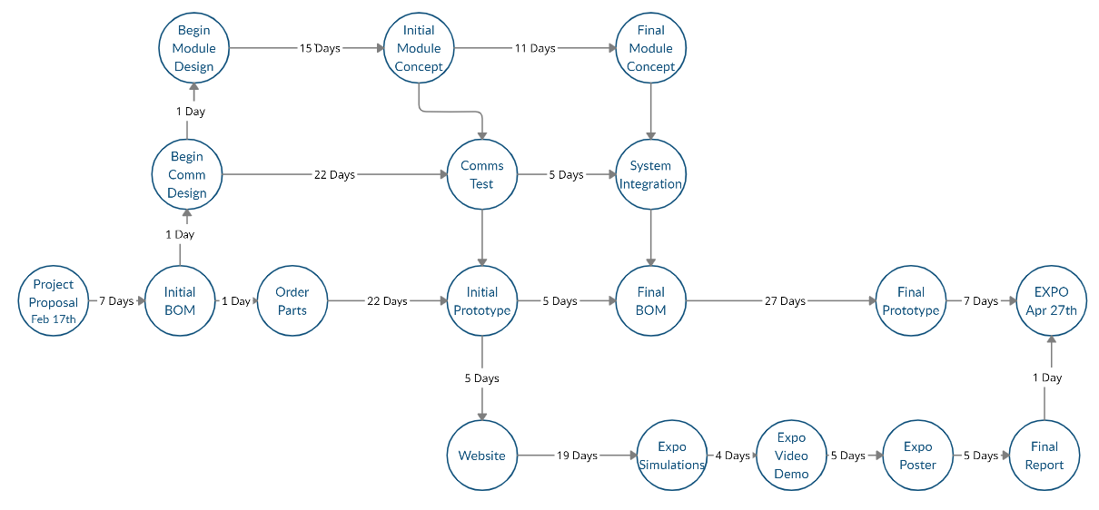**Figure 1.** PERT Chart showing the expected timeline for module development

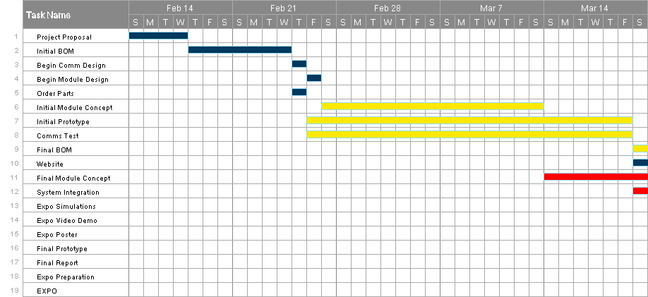**Figure 2.** Gantt chart for February 14th to March 20th showing a timeline of project phases and their estimated difficulty. Purple indicates low difficulty, yellow indicates medium difficulty, and red indicates high difficulty.

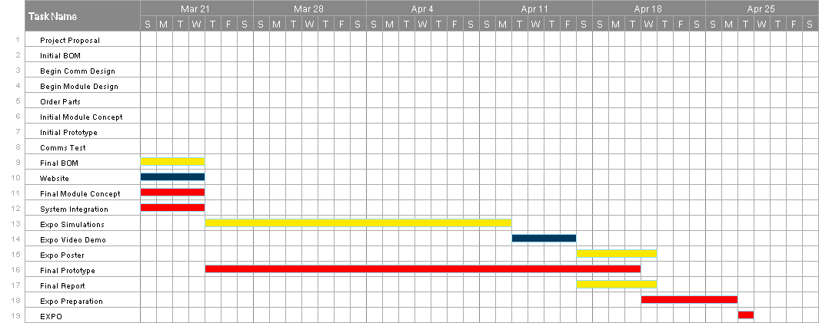**Figure 3.** Gantt chart for March 21st to April 27th showing a timeline of project phases and their estimated difficulty. Purple indicates low difficulty, yellow indicates medium difficulty, and red indicates high difficulty.

The PWS profiler communication module will take advantage of pre-existing technology to upgrade a well documented profiler. Because our team is using established technology, our chance of success is not reliant on technological breakthroughs. The factor that has the largest chance of preventing success is falling behind schedule and hitting unexpected roadblocks. With the PERT chart and the Gantt chart establishing a timeline for the project, these roadblocks will be minimized. Considering the above factors, the team’s chance of finishing the project a week before the expo is 95%.

1. **Marketing and Cost Analysis**
   1. **Marketing Analysis**

The proposed communication module will be a newly designed long range wireless communication unit that will be an addition to a Sea Bird Thetis profiler currently deployed in the Prince William Sound. What is currently in use for external communications is an RS-232 100 Mbps serial to IP ethernet device. This sends a signal when the profiler itself surfaces.

There are some products that boast wireless communications without the necessity to leave the water. DSPComm has a line of underwater acoustic modems [8]. They are manufactured to be used underwater and can transmit a signal up to 3km away. Our product will not need to have such a long underwater range, as it can surface to transmit.

Another similar product on the market is the MarineLabs CoastScout. This long range communication buoy is a self-contained and self-powered buoy that is capable of transmitting 5MB wirelessly. The CoastScout is its own data collection device that collects weather and water data and sends it to a remote server. Our device differs from the CoastScout because instead of collecting its own data and sending it, it will be sending data that was collected by the underwater Thetis profiler. Additionally, the communication module will rely on power from the Thetis profiler battery instead of solar power.

* 1. **Cost Analysis**

Currently, the group spends approximately three hours a week for meetings. These meetings are held to discuss the current status and the future goals of the project. Half of these meetings are held with our supervisor, Dr. West. This opportunity allows the group to receive feedback and produce an improved approach to the goal. Although the group works on reports and other documents during the meeting, some members may spend up to an additional hour adding to the report. Once the goals and the scope of the project have been solidified, each member will spend approximately eight hours a week to complete the tasks that were assigned. This time will still include the times spent for the meetings and the report documentation, but it will also be composed of times used to design the new components that the group aims to produce.

**Table 7. Expected Costs**

|  |  |  |  |  |  |
| --- | --- | --- | --- | --- | --- |
| Part | Quantity | Manufacturer | Retailer | Price per Item | Total |
| Arduino Mega 2560 | 1 | Arduino | Arduino | $40.30 | $40.30 |
| Arduino SIm MKR GSM 1400 Cellular Kit | 1 | Arduino | Newegg | $119.69 | $119.69 |
| PRO Plus SD Card 32GB | 1 | Samsung | Amazon | $9.99 | $9.99 |
| MKR SD Proto Shield | 1 | Arduino | Arduino | $13.80 | $13.80 |

1. **Current Status**

As of the time of submission of this proposal, it is estimated that the Aquanauts have completed about 20 percent of their project. Up to this point, the Aquanauts have a general design idea, but have not built anything yet. The design process will take place in the next phase.

The overall task of this project is to create a new communication system for the underwater profiler, which will be a major upgrade to the original system. Sub-tasks are listed below:

1. Designing a new centralized storage for all of the data in the profiler - IN PROGRESS
2. Designing a system that will send the data to the research facility over a cellular connection - IN PROGRESS
3. Designing software programs for the two components listed above - INCOMPLETE
4. Create a full BOM - IN PROGRESS
   1. Order parts - INCOMPLETE
5. Project proposal and presentation - IN PROGRESS
6. **Leadership Roles**
7. Group Leader: Jim O’Donnell

* Main speaker and scheduling coordinator

1. Expo Coordinator: Shayna Seidel

* In charge of making sure the team is aware of all requirements for the expo

1. Financial Advisor: Seungju Jason Lee

* Responsible for keeping track of receipts and handling reimbursements

1. Webmaster: Ruben Quiros

* Responsible for managing the team’s website

1. Documentation Coordinator: Timothy Pierce

* In charge of maintaining and submitting documentation on behalf of the group

1. Tech lead: Shelby Crisp

* Host and manager of the git repository

1. **References**
2. R. W. Campbell, P. L. Roberts, and J. Jaffe, “Prince William Sound Plankton Camera: a profiling in situ observatory of plankton and particulates,” *OUP Academic*, 24-Mar-2020. [Online]. Available: https://academic.oup.com/icesjms/article/77/4/1440/5811106. [Accessed: 17-Feb-2021].
3. Admin, “How it Works: The technology behind satellite internet,” *Viasat.com*. [Online]. Available: https://www.viasat.com/about/newsroom/blog/how-it-works-the-technology-behind-satellite-internet/. [Accessed: 18-Feb-2021].
4. S.-B. S. USA, “Thetis Autonomous Moored Profiler Datasheet,” *Sea-Bird Scientific*. [Online]. Available: https://www.seabird.com/systems/thetis-profiler/family-downloads?productCategoryId=54627869948. [Accessed: 17-Feb-2021].
5. *ARDUINO SIM - MKR GSM 1400 Cellular Kit*. [Online]. Available: https://store.arduino.cc/usa/sim-bundle. [Accessed: 17-Feb-2021].
6. H. H. A. K. A. www.crazyhamster.co.uk, *IP Ratings Explained - know your enclosure Ingress Protection ratings*. [Online]. Available: https://www.enclosurecompany.com/ip-ratings-explained.php. [Accessed: 17-Feb-2021].`
7. “Winch and wire regulations,” *Scripps Institution of Oceanography*. [Online]. Available: https://scripps.ucsd.edu/ships/planning/winch-and-wire. [Accessed: 17-Feb-2021].
8. “802.15.4-2020 - IEEE Standard for Low-Rate Wireless Networks,” *IEEE Xplore*. [Online]. Available: https://ieeexplore.ieee.org/document/9144691/metrics#metrics. [Accessed: 18-Feb-2021].
9. “Products,” *Underwater Wireless Modem and Communication Devices*, 05-Feb-2021. [Online]. Available: http://www.dspcommgen2.com/products/. [Accessed: 18-Feb-2021].
10. Xylem, *Aanderaa Oxygen Optode 4531*. Xylem, Bergen, Norway, 2020. Datasheet. https://www.aanderaa.com/productsdetail.php?Oxygen-Optodes-2
11. Xylem, *Aanderaa Oxygen Optode 4835*. Xylem, Bergen, Norway, 2020. Datasheet. https://www.aanderaa.com/productsdetail.php?Oxygen-Optodes-2
12. RBR, *RBRBrevio C.T.D.* RBR, Ottawa, Ontario, 2019. Datasheet. https://rbr-global.com/products/standard-loggers/rbrbrevio
13. Seabird, *ECO FLbb Fluorometer and Scattering Meter*. Seabird, Bellevue, WA, 2021. Datasheet. https://www.seabird.com/combination-sensors/eco-flntu/family?productCategoryId=54758054352
14. Seabird, *SBE 49 FastCAT CTD Sensor*. Seabird, Bellevue, WA, 2015. Datasheet. https://www.seabird.com/profiling/sbe-49-fastcat-ctd-sensor/family?productCategoryId=54627473793&brParentId=54627473767
15. Seabird, *SBE 63 Optical Dissolved Oxygen Sensor*. Seabird, Bellevue, WA, 2014. Datasheet. https://www.seabird.com/oxygen-sensors/sbe-63-optical-dissolved-oxygen-sensor/family?productCategoryId=54627869933
16. Seabird, *SUNA V2 UV Nitrate Sensor*. Seabird, Bellevue, WA, 2017. Datasheet. https://www.seabird.com/nutrient-sensors/suna-v2-nitrate-sensor/family?productCategoryId=54627869922

**Appendix**

|  |  |  |  |  |  |  |  |  |
| --- | --- | --- | --- | --- | --- | --- | --- | --- |
| **Sensor** | **Min Voltage** | **Max Voltage** | **Min Amps** | **Max Amps** | **Min Temp** | **Max Temp** | **Max Depth** | **Notes** |
| Aandera Optode 4531 (RS-232) | 5 Vdc | 30 Vdc | 0.16 mA + 40 mA/S | 100mA | -5 C | 30 C | 100m | RS-232 output format |
| Aandera Optode 4531 (Analog) | 7 Vdc | 30 Vdc | 0.16 mA + 40 mA/S | 100mA | -5 C | 30 C | 100m | Analog output format |
| Aandera Optode 4835 | 5 Vdc | 14 Vdc | 0.16 mA + 48 mA/S | 100mA | -5 C | 40 C | 300m | RS-232 output format |
| RBR Brevio | 4.5 V | 30 V | ??? | ??? | -5 C | 35 C | 750m (Plastic), 6000m (Titanium) | RS-232 output format |
| Searbird ECO FLbb Fluorometer | 7 Vdc | 15 Vdc | 140 µA | 60 mA | ??? | ??? | 600m | RS-232 output format, 19200 baud |
| Seabird SBE 49 FastCAT CTD Sensor | 9 Vdc | 24 Vdc | 350 mA (9V), 285 mA (12V), 180 mA (19V) | 750 mA (Turn-on transient) | -5 C | 35 C | 350m (Plastic), 7000m (Titanium) | RS-232 output format |
| Seabird SBE 63 Dissolved Oxygen Sensor | 6 Vdc | 24 Vdc | 35 mA | 35 mA | 0 C | 30 C | 600m (Plastic), 7000m (Titanium) | RS-232 output format |
| Seabird SUNA V2 UV Nitrate Sensor | 8 Vdc | 18 Vdc | 625 mA (12V) | 625 mA (12V) | 0 C | 35 C | 500m | Serial data output, assuming RS-232 |
|  |  |  |  |  |  |  |  |  |
| **mA/S is milliamps per sampling interval in seconds | |  | **Total min amps (mA)** | **Total max amps (mA)** | **Overall Min Temp** | **Overall Max Temp** | **Overall Max Depth** |  |
|  |  |  | 1010.62 | 1670 | 0 C | 30 C | 100m |  |