**Prince William Sound Profiler**

ECE 4873 Senior Design Project

Aquanauts

Dr. Mick West

Dr. Robert Campbell (if applicable)

Shayna Seidel, EE, sseidel7, [sseidel7@gatech.edu](mailto:sseidel7@gatech.edu)

Jim O’Donnell, CmpE, jodonnell3, [jodonnell3@gatech.edu](mailto:jodonnell3@gatech.edu)

Shelby Crisp, CmpE, scrisp3, [scrisp3@gatech.edu](mailto:scrisp3@gatech.edu)

Jason Lee, EE, slee3117, [slee3117@gatech.edu](mailto:slee3117@gatech.edu)

Ruben Quiros, CmpE, rquiros6, [rquiros6@gatech.edu](mailto:rquiros6@gatech.edu)

Timothy Pierce, EE, tpierce31, [timrpierce31@gatech.edu](mailto:timrpierce31@gatech.edu)

**Table of Contents**

**Executive Summary** …………………………………………………………………... 3

1. **Introduction** ……………………………………………………………………….. 5
2. **Project Description and Goals** ……………………………………………………. 7
3. **Technical Specification** ……………………………………………………………. 9
4. **Design Approach and Details** …………………………………………………….. 10
   1. Design Concept Ideation, Constraints, Alternatives, and Tradeoffs …………. 10
   2. Preliminary Concept Selection and Justification …………………………….. 12
   3. Engineering Analysis and Experiments …………………………………….... 17
   4. Codes and Standards …………………………………………………………. 17
5. **Project Demonstration** …………………………………………………………….. 19
6. **Schedule, Tasks, and Milestones** ………………………………………………… 23
7. **Marketing and Cost Analysis** …………………………………………………….. 25
   1. Marketing Analysis …………………………………………………………... 25
   2. Cost Analysis …………………………………………………………………. 26
8. **Current Status** …………………………………………………………………….. 27
9. **Leadership Roles** ………………………………………………………………….. 28
10. **References** …………………………………………………………………………. 29

**Appendix** ……………………………………………………………………………. 31

**Executive Summary**

The goal of this project was to design a new communications system for an existing underwater profiler. This allows a data-collecting profiler in the Prince William Sound to send the collected data to researchers. The current transfer of information necessitates a biweekly data transfer on site of the profiler, which is 4 hours offshore in the Prince William Sound. With the newly designed communications module, data will be transferred once every 12 hours without the need for onsite download. This module needs to surface and communicate wirelessly to the shore in an environment with few options for long range transfer of data. The profiler currently uses low bandwidth cellular data to send minimal information every 12 hours. The new system should not take up too much battery life, and should include an interface between existing sensors that are necessary to surface in the profiler. The total cost for this project was $354.85.

**Nomenclature**

**AMP:** Autonomous Moored Profiler

**BOM**: Bill of Materials

**CmpE**: Computer Engineer

**EE**: Electrical Engineer

**PCB**: Printed Circuit Board

**PWS**: Prince William Sound

**Prince William Sound Profiler Communication Module**

**1. Introduction**

In the aftermath of the 1989 Exxon Valdez oil spill in Prince William Sound, an Autonomous Moored Profiler (AMP) has been used (since 2013) to collect data on PWS’s environmental recovery [1]. Although originally manufactured by Sea-Bird Scientific, the profiler is no longer in production. The current profiler in PWS continues to monitor the environmental recovery of PWS, but requires numerous updates and improvements. This is why the Aquanauts team created a data transmission system for the profiler in Prince William Sound. This system is able to send data from the profiler sensors to the ocean scientists and give the scientists the flexibility to individually control sensors. This functionality will give scientists more information on a regular basis. The total cost for this project was $354.85.

Currently, scientists must visit the profiler approximately every two weeks to charge the battery and manually collect data. Making frequent maintenance trips to the profiler is inefficient, and can become delayed or even dangerous due to weather conditions. Remote access to sensor data would greatly enhance the profiler's usage. Data transmission would require using the nearby 3G cell tower to transmit data to the ocean scientists so they could access it without making a trip to the profiler.

The current system has all the sensors on a single relay system such that sensors cannot be individually controlled. Certain sensors cannot collect data as the profiler travels downward, so all sensors are off during this time. A new relay system that can control sensors individually would allow more flexibility for data collection and increase the amount of data collected.

This design involved connecting all sensors to the new switching board and a centralized microcontroller, and designing a method for the system to transmit data when at the surface. There were multiple constraints that had to be taken into account for this design. Due to the nature of the profiler, designs must withstand the extreme pressure, temperature, and storms of PWS. The system must also fit inside a 3.937 inch diameter capsule. These requirements were factored into the design. Once the design was complete, a combination of simulations and physical tests were conducted to demonstrate the module’s capabilities. The verification was a video and presentation used at the Spring 2021 Senior Design Expo. The rest of this report will go into greater detail on the specifics of designing and validating this system.

**2. Project Description, Customer Requirements, and Goals**

The Aquanauts team proposed a new sensor module in addition to the overall profiler assembly to address three of the customer’s main requirements: improved data transfer from the profiler’s remote location, extended battery life of the overall profiler, and updated central data storage. The new module addresses these requirements in the following ways:

1. Revamp the method of communication to improve data transfer volume and speed by utilizing the available 3G/4G cell tower nearby.
2. Provide physical infrastructure and software capability to turn individual sensors on and off on a schedule, thus saving critical battery life.
3. Provide a modern microprocessor and data storage unit for aggregation and processing of data, replacing the outdated and no longer produced Persistor module.

Success and stakeholder acceptance will be measured by benchmarking performance of the new module versus current-state performance. Notably, current-state data transfer is every 10th data point amounting to around 200kb of data, with the majority of communication representing an “alive” signal that indicates whether the profiler is still functioning. Battery life is estimated between 3 weeks and 1 month, with the majority of power drain resulting from the anchoring winch. The project’s internal stakeholder is Dr. West, while the external stakeholder is Dr. Campbell and his team in Alaska.

**Table 1. Stakeholder 2x2**

|  |  |
| --- | --- |
| Internal Stakeholders | External Stakeholders |
| Dr. West, Aquanauts | Dr. Campbell |

Constraints are minimal. The intent of the long-term project with the research team is to design a new profiler as the existing profiler is no longer manufactured. The Aquanauts’ goal is to provide an ideal sensor and communication subsystem to address the research team’s requirements, rather than consider integration with other existing systems. Considerations include data transfer rate, low power consumption, environmental survivability of the components in terms of temperature and pressure in a very cold underwater environment, and appropriate storage capacity to accommodate profiling data.

**Table 2. QFD Chart**

|  |  |  |  |  |  |
| --- | --- | --- | --- | --- | --- |
|  | **Long-Range Communication** | **Centralized Data Storage and Processing** | **Extended Battery Life** | **Extended Profiling Capability** | **Total** |
| **Form Factor** | 2 | 4 | 10 | 10 | 26 |
| **Power Consumption** | 4 | 4 | 10 | 7 | 25 |
| **Environmental Conditions** | 10 | 10 | 2 | 2 | 24 |
| **Total** | 16 | 18 | 22 | 19 |  |

1. **Technical Specifications**

**Table 3. Technical Specifications**

|  |  |  |
| --- | --- | --- |
| **Specification** | **Min** | **Max** |
| Functional Temperature | -5 C | 30 C |
| Functional Depth | N/A | 60m |
| Total Power Consumption for Sensors | 12 V DC, 480 mA (** Missing min amp info for SBE 16plus V2) | 12 V DC, 1.1 A (**Missing max amp info for SBE 16plus V2) |
| Communication Range (Approx) | 8000m (Nearest cell tower, approximately 5 mi.) | N/A |
| Communication Protocols | 3G, 4G, FTP/SFTP | |

The specifications listed in Table 3 indicate the foundational requirements of the integrated system, including functional temperature, depth, power consumption, communication range, and communication frequency. All defined sections are equally important as they encompass environmental considerations for the remote underwater locale, power consumption considerations in terms of saving critical battery life, and communications requirements for improved data transfer. The minimum power consumption is determined from the highest minimum operating voltage of all sensors, and maximum power consumption is determined from the lowest maximum operating voltage of all sensors. Minimum communication range is an approximation based on the operating depth of the profiler to a theoretical buoy containing additional communication equipment, and maximum communication range is from the profiler’s location to the nearest cell tower 5 miles (~8000 meters) away. 3G and 4G are the fastest available communication protocols using the nearby cellular tower.

1. **Design Approach and Details**
   1. **Design Concept Ideation, Constraints, Alternatives, and Tradeoffs**

The current design concept for this project is to have a central processor which will interface between the different sensors used by the profiler. The processor will store sensor data in a central place as well as interface with a cellular communication module to send the data out while profiling.

**4.1.1 Power Switching Functionality**

In order to have the capability to control individual sensors, a power switching system needed to be designed. The system currently used in PWS has all the sensors on a single relay so they are all turned on and off together. To control sensors separately, they must each have their own power switch.

Using optocouplers for each sensor was initially considered, but no optocouplers with a high enough current rating and low enough price were found. Next, solid state relays were considered for their long term reliability, but similarly to the high current optocouplers, solid state relays are expensive. Finally, MOSFETs were considered because all of the sensors use DC power. MOSFETs were chosen for their ease of implementation as well as their low price. Each sensor has a corresponding MOSFET that when conducting, connects the ground lead of the sensor to ground and allows the sensor to receive the necessary voltage and draw the needed current.

**Table 4. Switching Board Tradeoffs**

|  |  |  |
| --- | --- | --- |
| Tradeoffs for Power Switching Board | | |
| Pros | * Individual control of sensors | |
| Cons | * A new board had to be designed * Components for board had to be purchased | |

**4.1.2 Data Transmission**

Data transmission is a main focus for this project. Different concepts were considered, including satellite transmission for data, cellular telemetry and radio transmission. Cellular data is what is currently utilized for transmitting information from the profiler to shore. Using cellular data made the most sense for application of this project. Since cellular data was already being utilized, it was more ideal for use in testing as opposed to radio transmission and satellite transmission. There is a cellular tower near the sound that can support 3G/4G communications.

While cellular data is useful to utilize, the constraint of inability to send data without surfacing still comes into play. Satellites would require a buoy and therefore a signal would persist even under harsher conditions. However, upon further inspection, satellites were beyond the budget of this project and not many companies support satellite communication at such a remote location. Viasat, one of the larger and more affordable companies to offer satellite transmission, doesn’t immediately offer transmission to the sound [2]. Radio transmission is another option to explore, but would require testing and setup in the sound that would have been hard to reproduce offsite.

**Table 5. Cellular Data Tradeoffs**

|  |  |  |
| --- | --- | --- |
| Tradeoffs for Cellular data usage | | |
| Pros | * In use currently * Easier to test | |
| Cons | * Doesn’t work if the module doesn’t surface * May have lower speeds than other alternatives | |

**4.1.3 Centralized Sensors**

In order to successfully collect and store data as well as control the sensors and communications module, a central processor was necessary. The one already in use, a Persistor, is no longer being produced. Multiple microcontrollers were considered such as Arduino Mega and multiple Raspberry Pi models. Ultimately a Raspberry Pi model 3B was selected. This model of Raspberry Pi uses the least power while offering Linux compatibility to support well-known communication protocols like FTP/SFTP/SCP as well as the Sixfab Cellular Kit.

This PCB and microcontroller must fit inside the capsule and be able to function at low temperatures and high pressure in an underwater environment.

An alternative would be to keep the current processor. Since it is no longer being produced and uses outdated software, it would be close to impossible to test the integration of sensors and communication modules. If any damage were to occur with the current processor, it would be harder to replace than something like an Arduino or Raspberry Pi which are still in production.

**Table 6. Updating Central Storage Tradeoffs**

|  |  |  |
| --- | --- | --- |
| Tradeoffs for Updating central storage | | |
| Pros | * Old processor no longer in production * Can update software * Compatible with cellular kit | |
| Cons | * Added cost * Old processor still working and in use | |

* 1. **Preliminary Concept Selection and Justification**

**4.2.1 Power Switching Functionality**

After discussing the power requirements with Dr. West and Dr. Campbell, the Aquanauts decided to design a PCB that allowed for the sensors to be turned on and off individually using MOSFETs. Currently, the profiler lacks individual sensor power control and all sensors must be turned on at the same time. Individual sensor power control will allow the profiler to collect data on its descent. The ability to turn on only the needed sensors will conserve battery life.

The selected power switches for sensor control are FQP30N06L power MOSFETs. These power MOSFETs were chosen for their high power dissipation capabilities and their ease of implementation. The chosen MOSFETs are capable of dissipating 79W of power which far exceeds the power draw of any of the onboard sensors. The maximum power draw of any of the individual sensors is 11.25W which is low enough to not require the use of heat sinks on the MOSFETs.

To convert the voltage to usable DC levels for both the sensors and the Raspberry Pi, two DC-DC Buck converters were used to buck the voltage from the onboard 30V 1.5kWHr battery. All four sensors currently on the profiler have voltage ranges that include 12V so this was the selected voltage for conversion. A Mean Well 18-36V to 12V power converter was used that is capable of outputting 30W - significantly more than the maximum power draw of all four sensors. To buck the voltage to usable levels for the Raspberry Pi, a Traco Power 12W, 5.1V output buck converter was used.

There are currently four sensors on the profiler, but a total of six MOSFET switches were added to allow more sensors to be added in the future. To control the MOSFETs, a separate GPIO pin from the Raspberry Pi was connected to the gate of each MOSFET. The GPIO pin from the Raspberry Pi was set to 3.3V to trigger the MOSFET and supply the connected sensor with 12V. To protect the sensors in case of a voltage or current spike, a fuse specified for the power requirements of each sensor was added.

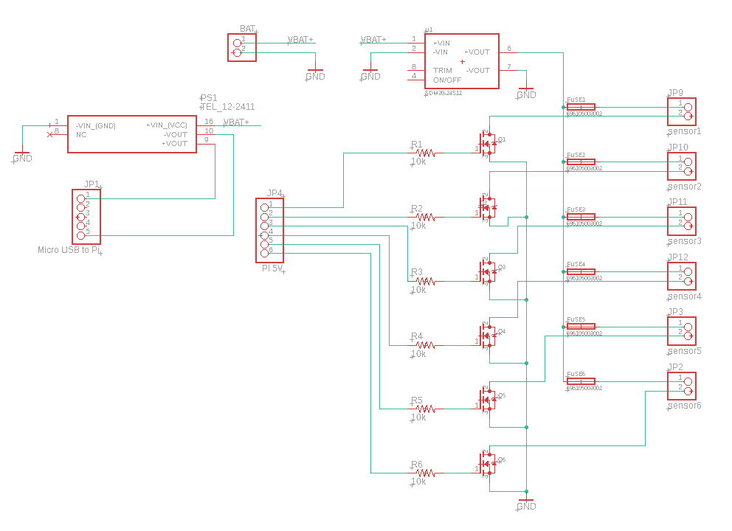

**Figure 1.** Eagle schematic showing the layout for the MOSFET sensor switching board

Once the schematic was completed, the PCB was designed with several constraints in mind. Each trace on the PCB is rated for 2.5A which is greater than the highest current draw of a sensor by more than a factor of 1.5. The PCB was also designed to fit in a vacuum sealed tube suitable for keeping electronics dry under water. The diameter of the tube is 100mm or 3.937in and the dimensions of the PCB are 3.5 inches by 3.9 inches. When creating the layout of the PCB, thermal and ease of use considerations were taken into account. The components that generate the most heat, the DC-DC converters and the MOSFETs, were spaced out as much as possible while also keeping the PCB within size constraints. Additionally, the MOSFET, fuse, resistor, and pin header for each individual sensor were grouped together in order to make identifying blown fuses and their corresponding sensor easier.

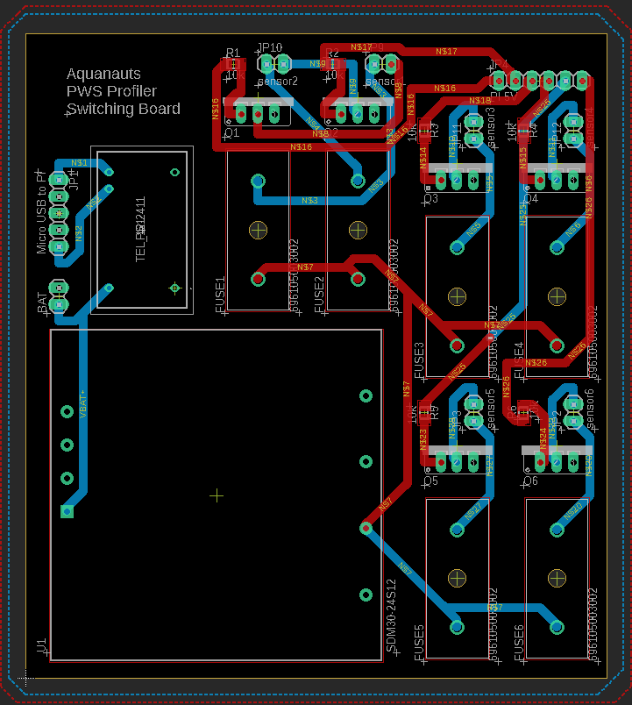

**Figure 2.** The final MOSFET sensor switching board PCB layout. The dimensions of the board are 3.9 inches (from top to bottom) by 3.5 inches (from left to right)

**4.2.2 Centralized Sensors**

Currently, data from the sensors is stored in a central location using ASCII text. The main storage unit is a Persistor which is outdated and no longer produced. A new microcontroller must be chosen to accommodate the sensors on the module, cellular data transmission, expandable memory, and ease of programming. The sensors the microcontroller needs to interface with are: SBE 49 FastCAT CTD Sensor, RBR Brevio, Seabird Eco FLNTU, SBE 63 Optical Dissolved Oxygen Sensor, Aanderaa Oxygen Optode, and Seabird SUNA V2 Nitrate Sensor. A Raspberry Pi 3B was used to replace the Persistor. This was best suited for this project because it has many pins to accommodate the sensors, expandable pin modules can be added if needed, and there are multiple kits already developed for using cell data with a Raspberry Pi. Raspberry Pi’s run using a limited version of Ubuntu. This would give our team easy access to a multitude of preexisting data transmission commands. The Pi 3B can run these commands without the excessive power draw of the Pi 4.

**4.2.3 Data Transmission**

When the module is at the surface, data from the sensors will be transmitted. Currently when the profiler surfaces, a nearby 3G cell tower is used to send minimal information. Due to availability and cost, the Aquanauts plan is to continue to use this cell tower for the increased data transmission. The Aquanauts have selected the Sixfab 4G LTE Cell Hat. This kit is specifically designed to interface with 4G cellular towers which are currently being utilized in the sound. This kit is comprehensive, which was an attractive feature for our team in testing, but in the future a more whittled down version could be used. While 5G was considered, the 4G cellular tower was just installed in the Prince William Sound, and the likelihood that 4G would become obsolete any time soon is unlikely.

* 1. **Engineering Analyses and Experiment**

The Aquanauts team performed simulations for both hardware and software for experiments on our design. The three Computer Engineers were tasked with simulating the system in software, with programs and libraries that operate on the final product. When the three Electrical Engineers designed and fabricated the PCB, they were in charge of performing tests on the hardware to make sure it could safely operate under the required power conditions. Power consumption was monitored to determine how much power the overall module would consume.

In the following phase, the software and hardware teams were able to test the overall system. The team performed experiments to make sure that the processing unit was able to send data through the new communication system. This involved the use of real data that Dr. Campbell has collected. Unfortunately, the team did not have access to neither the battery nor the sensors. As a result, a 2 W resistor was used to simulate the sensor, and a DC power supply was used to simulate the battery. This proved that the current electronics worked with a new communication system and a centralized data processing unit.

* 1. **Codes and Standards**

The relevant codes and standards include the following:

* IMT-2000: Offers the capability of providing value-added services and applications for frequencies between 400 MHz and 3 GHz [6].
  + Adds compatibility feature with existing systems such as 2G
  + Makes 3G systems affordable
* 802.15.4-2020 - IEEE Standard for Low-Rate Wireless Networks: The standard provides for ultra low complexity, ultra low cost, ultra low power consumption, and low data rate wireless connectivity among inexpensive devices, especially targeting the communications requirements of what is now commonly referred to as the Internet of Things [7].

1. **Project Demonstration**

To validate the specifications of the Prince William Sound Profiler communication system and sensor switching board, a series of both software and hardware tests were performed. Testing the communication system used the Raspberry Pi 3b, the Raspberry Pi cellular kit, the Samsung Evo SSD, and the custom printed circuit board. A DC-DC buck converter on the PCB was used to lower the battery-level voltages to 5.1V to power the Raspberry Pi. The Raspberry Pi was connected to the PCB, and the SSD and Sixfab cellular kit were connected to the Raspberry Pi. Using a remote FTP server hosted off campus, the communication module was tested by executing a shell script on the Raspberry Pi, which sent sample data files to the FTP server through a wireless connection.

For the validation of the sensor switching system on the custom PCB, both software simulations and hardware tests were performed. First, a single MOSFET switching circuit was simulated using LTSpice to verify that the chosen design could power the sensor by providing 12V and then turn off the sensor by providing 0V. To simulate the sensor, a 75Ω, 2W resistor was used to draw a current of about 160mA.

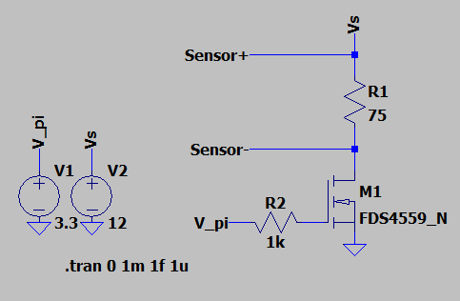

**Figure 3.** LTSpice schematic for a single MOSFET sensor switch when the Raspberry Pi sends a 3.3V signal to turn the sensor on

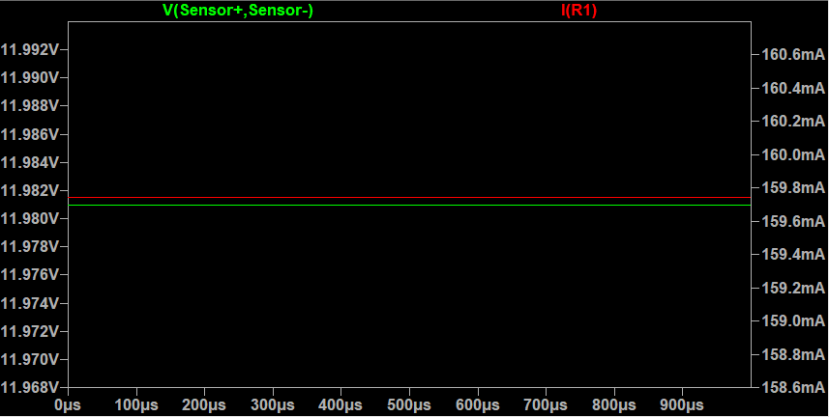

**Figure 4.** LTSpice transient simulation results showing 12V and 160mA being supplied to the 75Ω resistor simulating a sensor

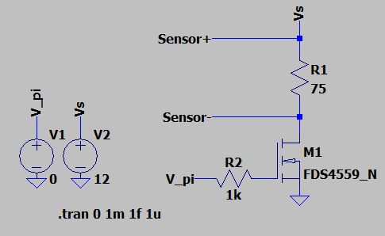

**Figure 5.** LTSpice schematic for a single MOSFET sensor switch when the Raspberry Pi sends a 0V signal to turn the sensor off

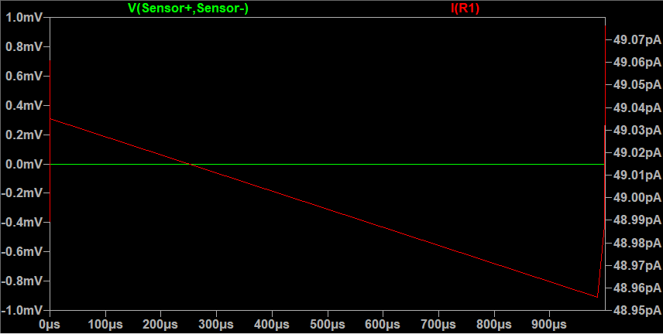

**Figure 6.** LTSpice transient simulation results showing 0V and nearly 0mA being supplied to the 75Ω resistor simulating a sensor

Once the custom PCB with the sensor switching system was complete, hardware tests were performed to verify that the switching system worked as intended. The Raspberry Pi was hooked up to the PCB and a 75Ω, 2W resistor was wired to the output of the MOSFET switching system. The voltage across the resistor and the current through the resistor were measured using a digital multimeter. When the Raspberry Pi supplied 3.3V to the gate of the MOSFET, the voltage across the resistor was 12V and the current through the resistor was 160mA. When the Raspberry Pi supplied 0V to the gate of the MOSFET, the voltage across the resistor was reduced to 0V and the current across the resistor was reduced to 0mA, effectively turning the “sensor” off.

When the design aspect of the project was complete, results were prepared and presented at the Spring 2021 Senior Design Capstone Expo. A poster was created to show an overview of the system that was designed, and a project video was created to present motivations for this project and demonstrate the system.

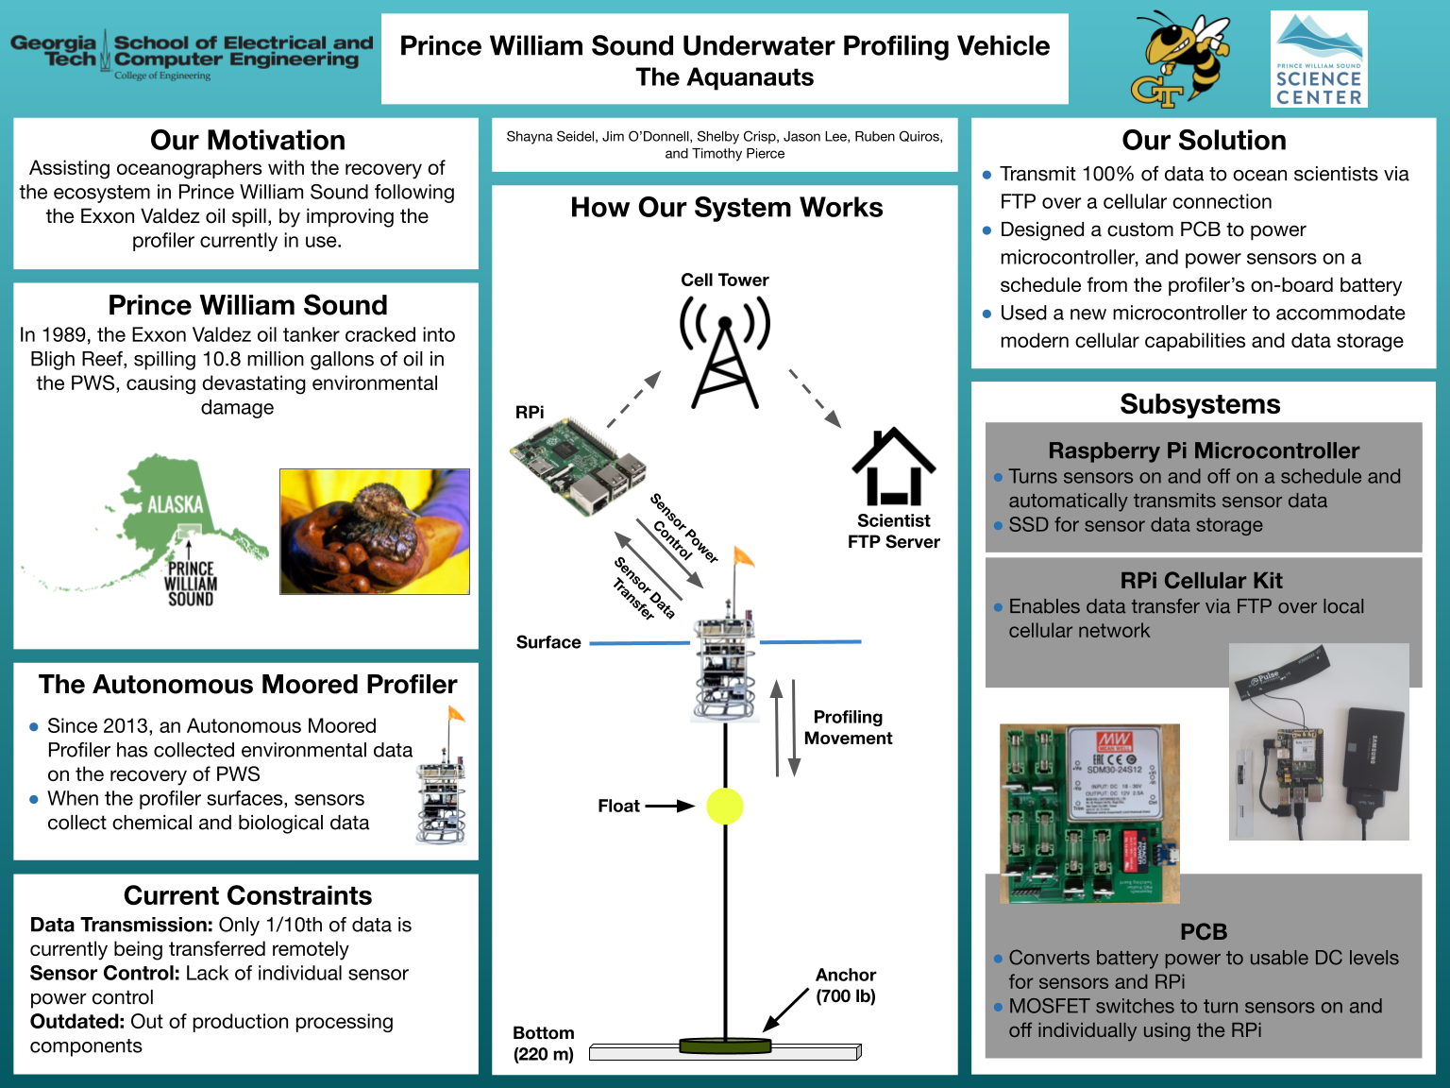

**Figure 7.** Senior Design Capstone Expo Poster with background information of the project and an overview of the designed system

1. **Schedule, Tasks, and Milestones:**

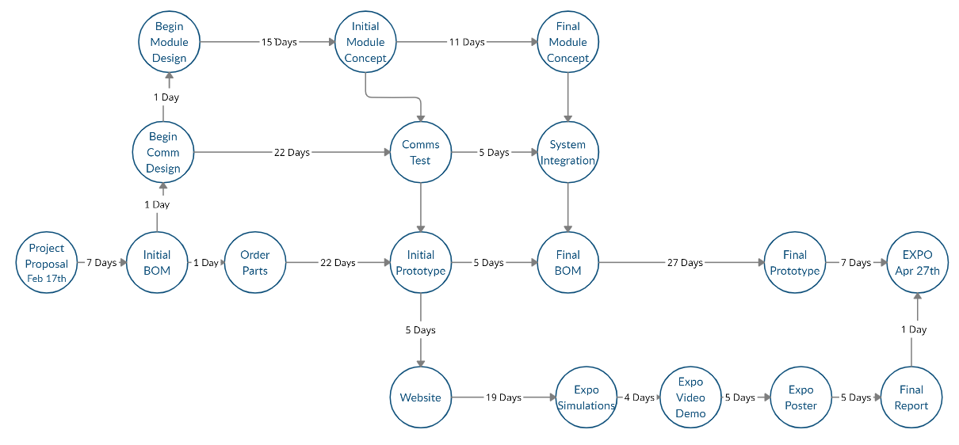**Figure 8.** PERT Chart showing the expected timeline for module development

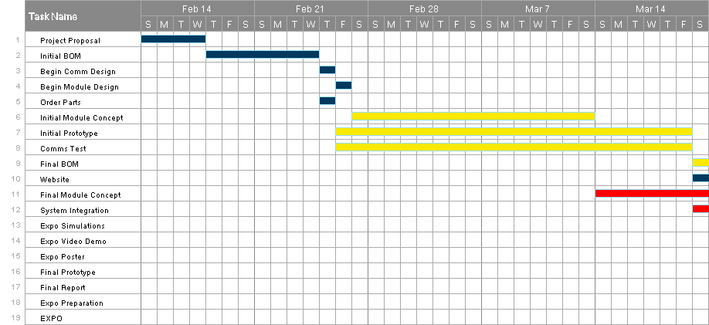**Figure 9.** Gantt chart for February 14th to March 20th showing a timeline of project phases and their estimated difficulty. Purple indicates low difficulty, yellow indicates medium difficulty, and red indicates high difficulty.

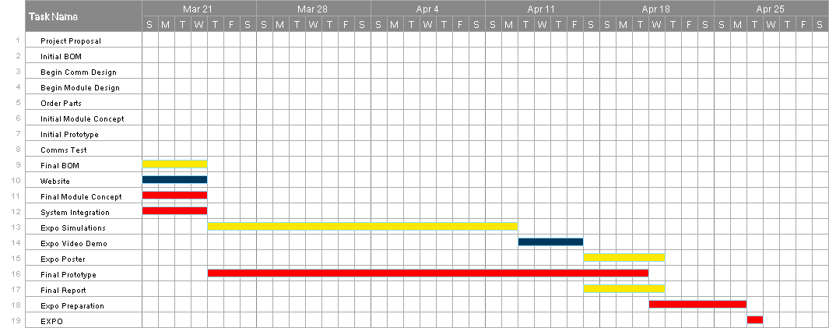**Figure 10.** Gantt chart for March 21st to April 27th showing a timeline of project phases and their estimated difficulty. Purple indicates low difficulty, yellow indicates medium difficulty, and red indicates high difficulty.

At the start of the project, the chance of successful project completion by April 27th was determined to be 95%. The project utilized pre existing technology and did not rely on any significant technological breakthroughs. The completion of the project did not directly follow the outlined timeline in the PERT chart and Gantt charts. Much more time was dedicated to initial product research and design. Because more time was devoted to designing the system for this project, less time was needed for the final prototype and integration of the system. Additionally, significantly less time was needed for expo preparation. After a successful Senior Design Capstone Expo, the goal was met and the project was officially completed by the deadline.

1. **Marketing and Cost Analysis**
   1. **Marketing Analysis**

The proposed communication module is a newly designed long range wireless communication unit that will be an addition to a Sea Bird Thetis profiler currently deployed in the Prince William Sound. What is currently in use for external communications is an RS-232 100 Mbps serial to IP ethernet device. This sends a signal when the profiler itself surfaces.

There are some products that boast wireless communications without the necessity to leave the water. DSPComm has a line of underwater acoustic modems [8]. They are manufactured to be used underwater and can transmit a signal up to 3km away. Our product does not need to have such a long underwater range, as it can surface to transmit.

Another similar product on the market is the MarineLabs CoastScout. This long range communication buoy is a self-contained and self-powered buoy that is capable of transmitting 5MB wirelessly. The CoastScout is its own data collection device that collects weather and water data and sends it to a remote server. Our device differs from the CoastScout because instead of collecting its own data and sending it, it will be sending data that was collected by the underwater Thetis profiler. Additionally, the communication module will rely on power from the Thetis profiler battery instead of solar power.

* 1. **Cost Analysis**

**Table 7. Costs**

|  |  |  |  |  |  |
| --- | --- | --- | --- | --- | --- |
| **Part** | **Manufacturer** | **Retailer** | **Price per Item** | **Quantity** | **Part Total** |
| Raspberry Pi 3B | Raspberry Pi | Amazon | 37.99 | 1 | 37.99 |
| Raspberry Pi 4G/LTE Cellular Modem Kit | Sixfab | Sixfab | 109 | 1 | 109 |
| Sixfab Connect Sim | Sixfab | Sixfab | 2 | 1 | 2 |
| SAMSUNG PRO Plus SDHC Full Size SD Card 32GB | Samsung | Amazon | 9.99 | 1 | 9.99 |
| MKR SD PROTO SHIELD | Arduino | Arduino | 13.8 | 1 | 13.8 |
| USB 3.0 SATA III Hard Drive Adapter Cable, SATA to USB Adapter Cable | SKL Tech | Amazon | 7.99 | 1 | 7.99 |
| SAMSUNG 870 EVO 250GB 2.5 Inch SATA III Internal SSD | Samsung | Amazon | 39.99 | 1 | 39.99 |
| 30 W DC/DC Converter | Mean Well USA | Digi-Key | 26.71 | 1 | 26.71 |
| FQP30N06L | ON Semiconductor | Digi-Key | 1.22 | 6 | 7.32 |
| USB to Serial RS232 Adapter | SIIG | Amazon | 49.85 | 1 | 49.85 |
| 12 W DC/DC Converter | Traco Power | Digi-Key | 28 | 1 | 28 |
| PCB | JLC PCB | JLC PCB | 14.8 | 1 | 14.8 |
| 500 mA Fuse | Bel Fuse Inc | Digi-Key | 0.234 | 5 | 1.17 |
| 1A Fuse | Bel Fuse Inc | Digi-Key | 0.224 | 5 | 1.12 |
| 5x20 mm Fuse Holder | Würth Elektronik | Digi-Key | 0.64 | 8 | 5.12 |

|  |
| --- |
| **Total** |
| **354.85** |

1. **Current Status**

The overall task of this project was to create a new communication system for the underwater profiler, which will be a major upgrade to the original system. Sub-tasks are listed below:

1. Designing a subsystem that collects data from all sensors on the profiler - COMPLETE
   1. Design and manufacture a PCB to control sensors individually and power the microcontroller - COMPLETE
2. Designing a subsystem that will send the data to the research facility over a wireless connection - NEARLY COMPLETE
   1. Testing the ability to send files over WiFi - COMPLETE
   2. Testing the ability to send files over a cellular connection - INCOMPLETE.

* Due to time constraints at the end of the semester and troubleshooting issues, we were unable to complete testing of the AT command set with our cellular HAT. We have included as much information as we were able to gather, and the process is detailed nearly in full in the User Manual. This would be a good place for a future team to continue research and testing.

1. Create a full BOM - COMPLETE
   1. Order parts - COMPLETE
2. Project proposal and presentation - COMPLETE
3. **Leadership Roles**
4. Group Leader: Jim O’Donnell

* Main speaker and scheduling coordinator

1. Expo Coordinator: Shayna Seidel

* In charge of making sure the team is aware of all requirements for the expo

1. Financial Advisor: Seungju Jason Lee

* Responsible for keeping track of receipts and handling reimbursements

1. Webmaster: Ruben Quiros

* Responsible for managing the team’s website

1. Documentation Coordinator: Timothy Pierce

* In charge of maintaining and submitting documentation on behalf of the group

1. Tech lead: Shelby Crisp

* Host and manager of the git repository

1. **References**
2. R. W. Campbell, P. L. Roberts, and J. Jaffe, “Prince William Sound Plankton Camera: a profiling in situ observatory of plankton and particulates,” *OUP Academic*, 24-Mar-2020. [Online]. Available: https://academic.oup.com/icesjms/article/77/4/1440/5811106. [Accessed: 17-Feb-2021].
3. Admin, “How it Works: The technology behind satellite internet,” *Viasat.com*. [Online]. Available: https://www.viasat.com/about/newsroom/blog/how-it-works-the-technology-behind-satellite-internet/. [Accessed: 18-Feb-2021].
4. S.-B. S. USA, “Thetis Autonomous Moored Profiler Datasheet,” *Sea-Bird Scientific*. [Online]. Available: https://www.seabird.com/systems/thetis-profiler/family-downloads?productCategoryId=54627869948. [Accessed: 17-Feb-2021].
5. *ARDUINO SIM - MKR GSM 1400 Cellular Kit*. [Online]. Available: https://store.arduino.cc/usa/sim-bundle. [Accessed: 17-Feb-2021].
6. H. H. A. K. A. www.crazyhamster.co.uk, *IP Ratings Explained - know your enclosure Ingress Protection ratings*. [Online]. Available: https://www.enclosurecompany.com/ip-ratings-explained.php. [Accessed: 17-Feb-2021].`
7. “About mobile technology and IMT-2000,” *International Telecommunication Union.* [Online]. Available: https://www.itu.int/osg/spu/imt-2000/technology.html. [Accessed: 17-Feb-2021].
8. “802.15.4-2020 - IEEE Standard for Low-Rate Wireless Networks,” *IEEE Xplore*. [Online]. Available: https://ieeexplore.ieee.org/document/9144691/metrics#metrics. [Accessed: 18-Feb-2021].
9. “Products,” *Underwater Wireless Modem and Communication Devices*, 05-Feb-2021. [Online]. Available: http://www.dspcommgen2.com/products/. [Accessed: 18-Feb-2021].
10. Xylem, *Aanderaa Oxygen Optode 4531*. Xylem, Bergen, Norway, 2020. Datasheet. https://www.aanderaa.com/productsdetail.php?Oxygen-Optodes-2
11. Xylem, *Aanderaa Oxygen Optode 4835*. Xylem, Bergen, Norway, 2020. Datasheet. https://www.aanderaa.com/productsdetail.php?Oxygen-Optodes-2
12. RBR, *RBRBrevio C.T.D.* RBR, Ottawa, Ontario, 2019. Datasheet. https://rbr-global.com/products/standard-loggers/rbrbrevio
13. Seabird, *ECO FLbb Fluorometer and Scattering Meter*. Seabird, Bellevue, WA, 2021. Datasheet. https://www.seabird.com/combination-sensors/eco-flntu/family?productCategoryId=54758054352
14. Seabird, *SBE 49 FastCAT CTD Sensor*. Seabird, Bellevue, WA, 2015. Datasheet. https://www.seabird.com/profiling/sbe-49-fastcat-ctd-sensor/family?productCategoryId=54627473793&brParentId=54627473767
15. Seabird, *SBE 63 Optical Dissolved Oxygen Sensor*. Seabird, Bellevue, WA, 2014. Datasheet. https://www.seabird.com/oxygen-sensors/sbe-63-optical-dissolved-oxygen-sensor/family?productCategoryId=54627869933
16. Seabird, *SUNA V2 UV Nitrate Sensor*. Seabird, Bellevue, WA, 2017. Datasheet. https://www.seabird.com/nutrient-sensors/suna-v2-nitrate-sensor/family?productCategoryId=54627869922

**Appendix**

|  |  |  |  |  |
| --- | --- | --- | --- | --- |
| **Sensors** | **Min Voltage** | **Max Voltage** | **Min Current (mA)** | **Max Current (mA)** |
| SBE 16plus V2 | 9 | 28 | N/A | N/A |
| SBE 43 | 6.5 | 24 | 2.5 | 9.23 |
| SUNA Nitrate Sensor | 8 | 18 | 416.67 | 937.5 |
| Echo Fluorometer | 7 | 15 | 60 | 140 |