**CHATBOT DEPLOYMENT USING IBM CLOUD WATSON ASSISTANT**

**DEVELOPMENT PART 1:**

**Step 1:** Go t**o** IBM **cloud’s** login page and create an account to access the the resources that is present in it.

If you don't have an IBM Cloud account, sign up for one or Log in to your IBM Cloud account and navigate to the IBM Watson Assistant service.

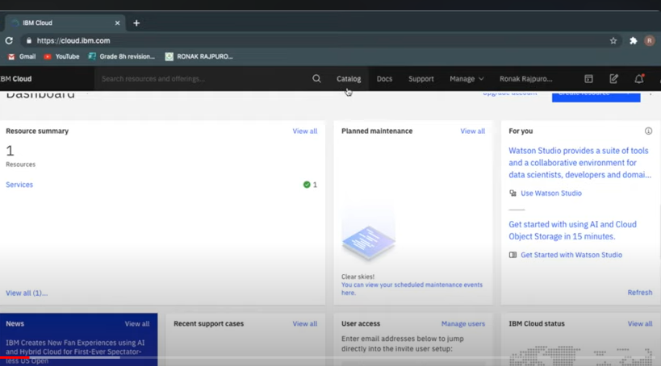

**Step2:** Next click on the **catalog** menu which is present on the left most corner of the web page.

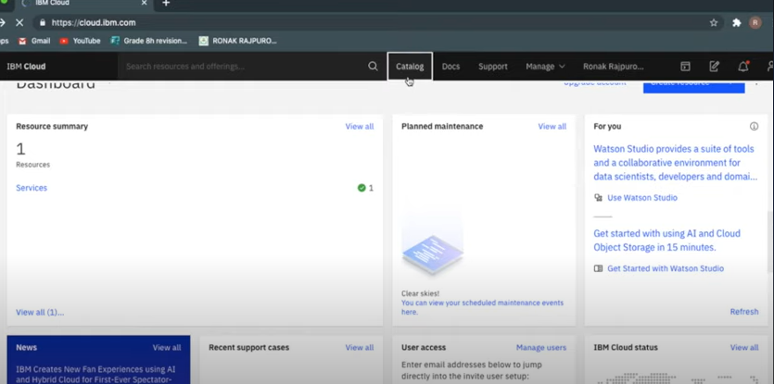

**Step 3:** Click and move forward to **Watson assistant** tab.

Click "Create assistant."

Give your assistant a name and, optionally, a description.

Click "Create assistant."

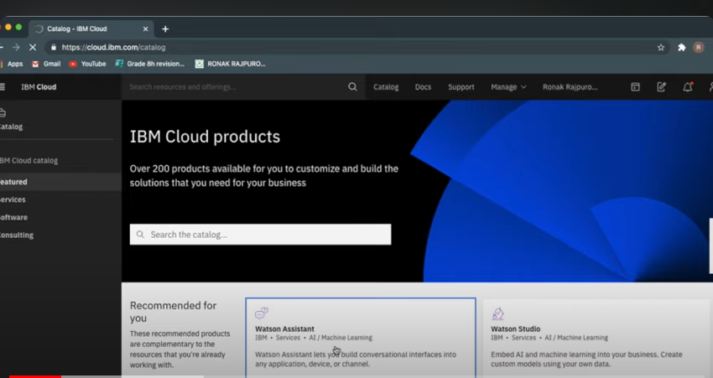

**Step 4:** Move on to **Resource list** menu and slide towards to **Services** menu item to access other services from IBM Watson assistant.

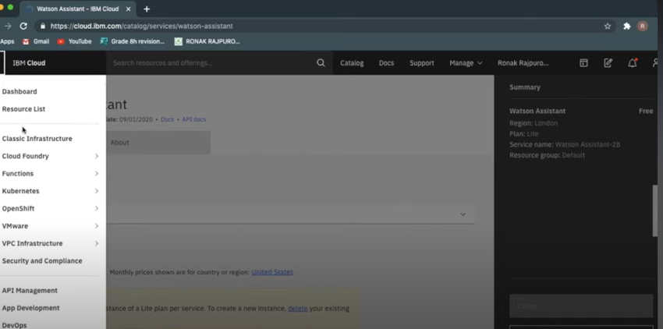

**Step 5:** Press **launch Watson assistant** button which will be displayed in blue.From step 5 actual deployment of chatbot takesplace.

When you launch Watson Assistant, it becomes available for use by your intended users. Launching Watson Assistant typically involves deploying the chatbot to a specific channel or platform, such as a website, messaging platform, or mobile app. Once launched, users can interact with the chatbot through the designated channel. The chatbot will use the trained models and dialog flows you have created in Watson Assistant to understand user inputs and provide appropriate responses. It can answer questions, provide information, or assist with specific tasks based on its programming and training. Launching Watson Assistant allows users to engage in conversations with the chatbot, receive automated assistance, and potentially resolve their queries or complete tasks without human intervention. It can help streamline customer support, provide information, or offer personalized recommendations, depending on how it has been configured and trained. It's important to continuously monitor and evaluate the performance of the chatbot after launching to ensure it is meeting user needs and expectations. Regular updates and improvements may be necessary based on user feedback and evolving requirements.

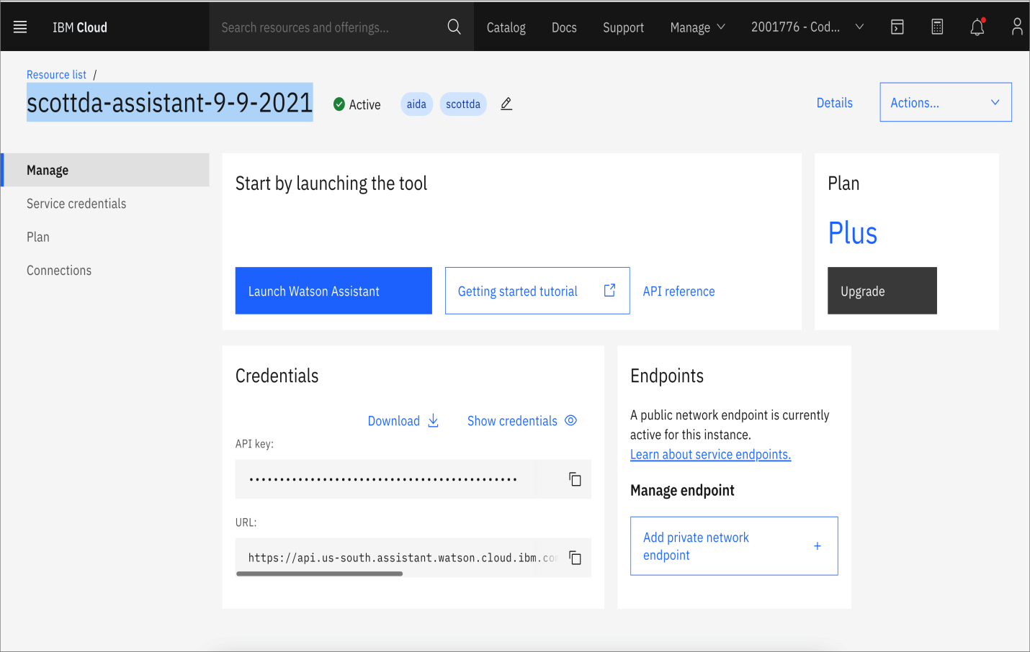

**Step 6:** Name your Watson assistant with your service.

When you name a Watson Assistant service, it is simply a way to identify and differentiate that specific instance of the Watson Assistant service within your IBM Cloud account. The name you provide does not have any direct impact on the functionality or behavior of the Watson Assistant itself. Naming the Watson Assistant service helps you easily identify and manage multiple instances of Watson Assistant if you have more than one. It can be useful when you are working with multiple projects or clients and want to keep them organized. Once you have named the Watson Assistant service, you can access and work with it through the IBM Cloud dashboard or API using the provided name. It is important to note that the actual chatbot or assistant you create within the Watson Assistant service will have its own separate name, which you can define during the assistant creation process.

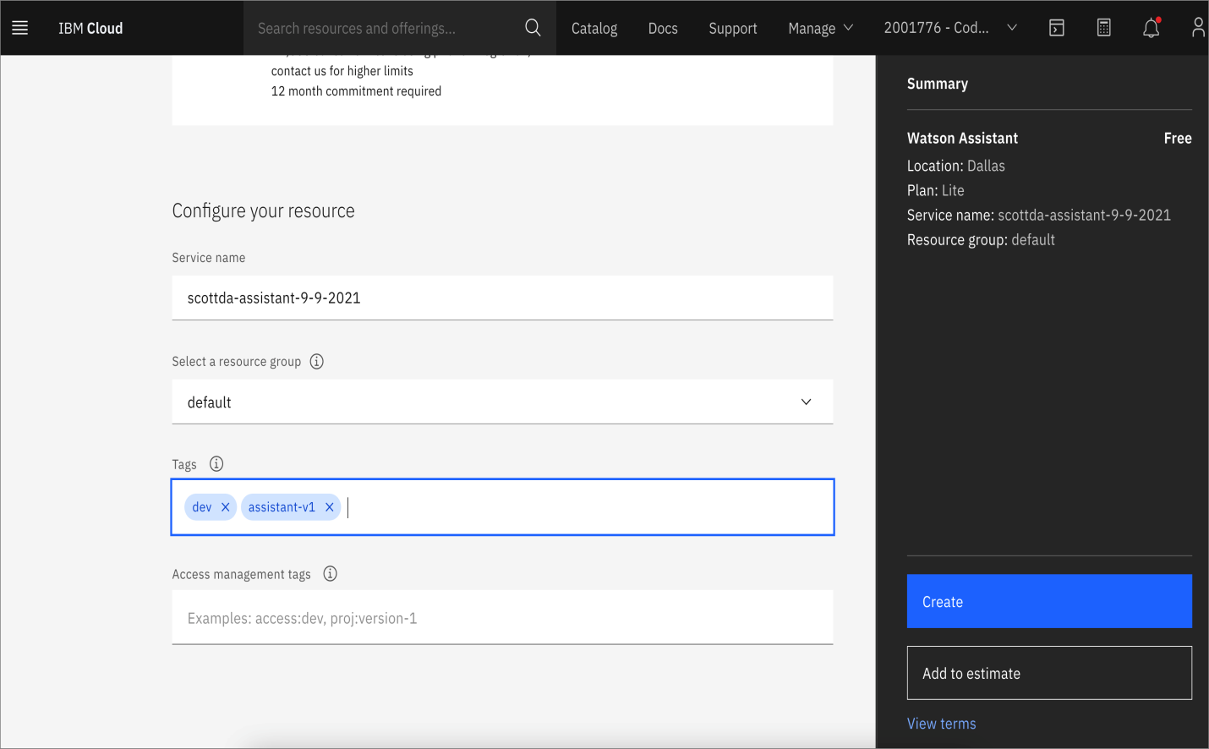

**Step 7: Enable preview link** to use that to deploy it in the targeted or intended website.

When you enable the preview link in Watson Assistant, it allows you to test and preview your chatbot before deploying it to production or making it available to end-users. Enabling the preview link generates a unique URL that you can use to access and interact with your chatbot in a testing environment.

Here's what happens when you enable the preview link:

**Testing environment:** The preview link provides you with a dedicated testing environment where you can interact with your chatbot. This allows you to simulate conversations and test the behavior and responses of your chatbot.

**Real-time changes:** Any changes you make to your chatbot, such as updating dialog flows, adding intents, or modifying responses, will be reflected in the preview link. This allows you to see the impact of your changes in real-time.

**Collaboration:** The preview link can be shared with other team members or stakeholders, allowing them to review and provide feedback on the chatbot's functionality and behavior.

**Iterative development:** By using the preview link, you can iterate and refine your chatbot based on feedback and testing results. This helps ensure that your chatbot meets the desired requirements and provides a satisfactory user experience.

It's important to note that the preview link is not meant for production use or to be shared with end-users. It is solely intended for testing and preview purposes. Once you are satisfied with the performance of your chatbot, you can deploy it using the appropriate channels or integration methods to make it available to your intended audience.

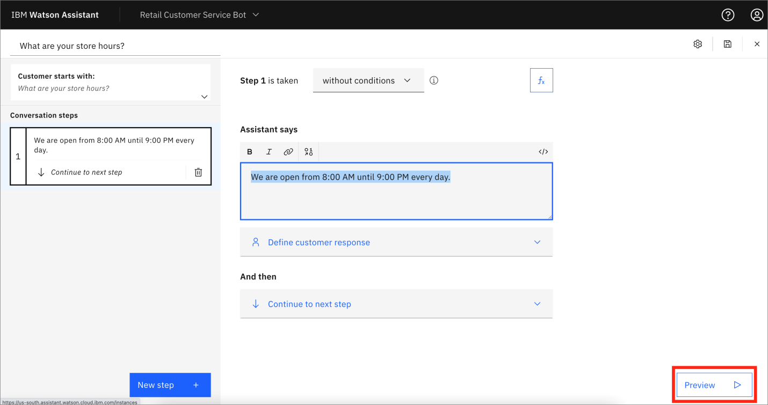

**Step 8:** Finally click **create assistant** button.Now the skeleton of chatbot is created.

When you create an assistant in Watson Assistant, you are essentially setting up the foundation for your chatbot.

Here's a brief overview of what happens:

**Name and configuration:** You provide a name for your assistant and configure any additional settings, such as the language and time zone.

**Skill creation:** A default skill is automatically created for your assistant. A skill represents the conversational capabilities of your chatbot.

**Dialog flow creation:** Within the skill, you can create a dialog flow that defines how your chatbot interacts with users. This includes defining intents (user intentions), entities (relevant information), and dialog nodes (steps in the conversation).

**Training and testing:** You can train your assistant by providing example user inputs and mapping them to intents and entities. This helps the chatbot understand and respond accurately. You can also test your assistant to ensure it is functioning as expected.

**Integration and deployment:** Once your assistant is built and tested, you can integrate it with various channels like websites, messaging platforms, or mobile apps. This allows users to interact with your chatbot. You can deploy your assistant to make it available for users.

Throughout the process, you have access to the Watson Assistant tooling, which provides a user-friendly interface for creating and managing your chatbot. It also offers features like analytics and version control to help you monitor and improve the performance of your assistant over time.

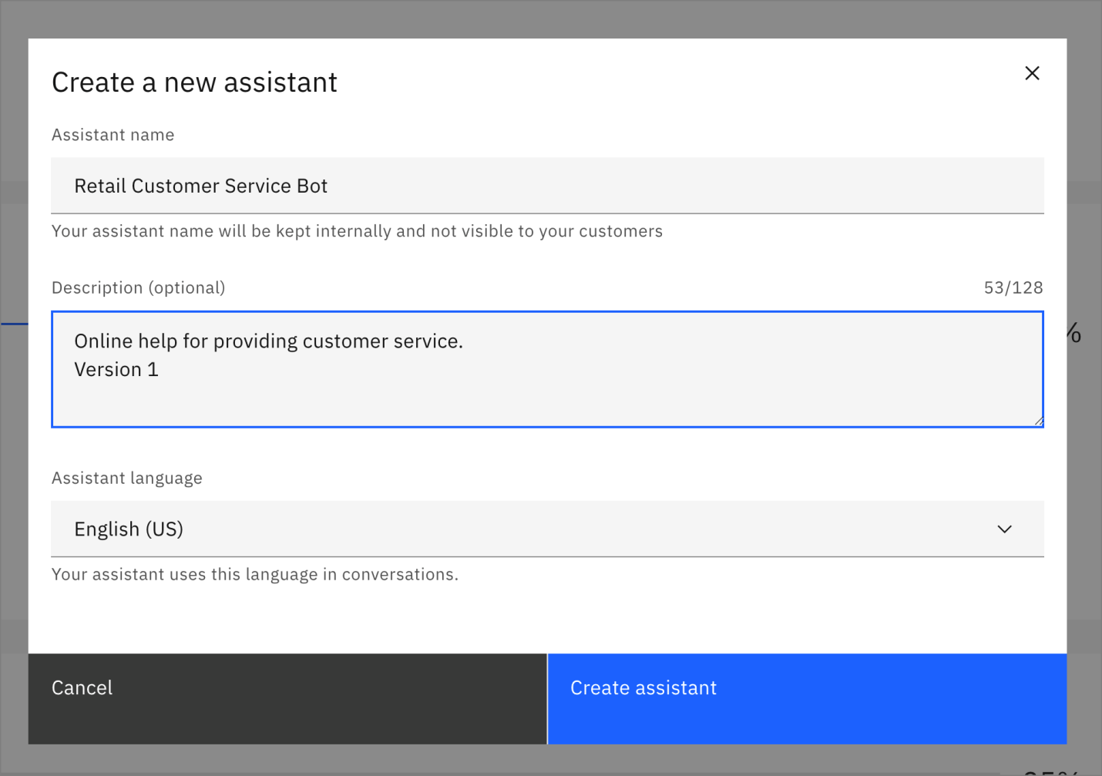

**Step 9:** Go to **add catalog skill** tab to create entities and intents.

TO CREATE INTENTS:

In the Watson Assistant UI, click on the Skills tab.

Choose the skill you want to work with or create a new one ->Navigate to the Intents tab ->Click Create Intent. Provide a name for the intent and a brief description ->You'll then be prompted to provide example user inputs.

These are phrases or sentences users might say that relate to this intent.

TO CREATE ENTITIES:

From within the skill, navigate to the Entities tab.

Click Create Entity. Name your entity and give it a description.Next, you can add values to your entity.

For instance, if your entity is 'color', values could be 'red', 'blue', 'green', etc.

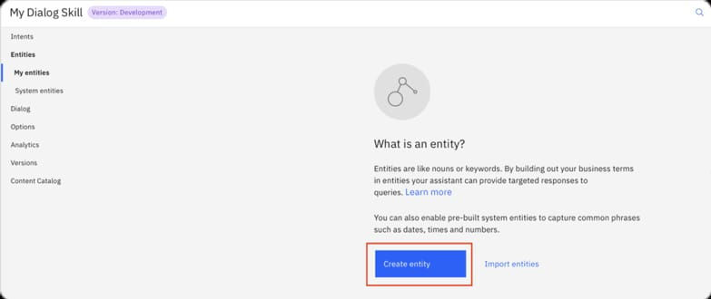

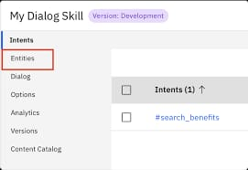

**Step 10:** By clicking on the **create skill** tab a page will be displayed,which contains the name of created IBM Watson assistant.

SKILL NAME: This is typically a unique identifier for the specific capability or set of capabilities that the skill provides. For example, if you're building a banking chatbot, you might have skills like "AccountBalance" CONFIGURATION& DETAILS: You may see other information related to the configuration or specifics of that skill. This could include things like intents, entities, or the dialogue flow, which are critical components of how the chatbot understands and responds to user input. TRAINING DATA : Depending on the configuration, you might have the ability to upload or input training data, which helps to improve the accuracy and effectiveness of the chatbot in recognizing and handling specific user queries TEST AND DEPLOY.: There's likely an option to test your skill in a sandbox or similar environment. Once satisfied, you can deploy the skill so that it's accessible to users.

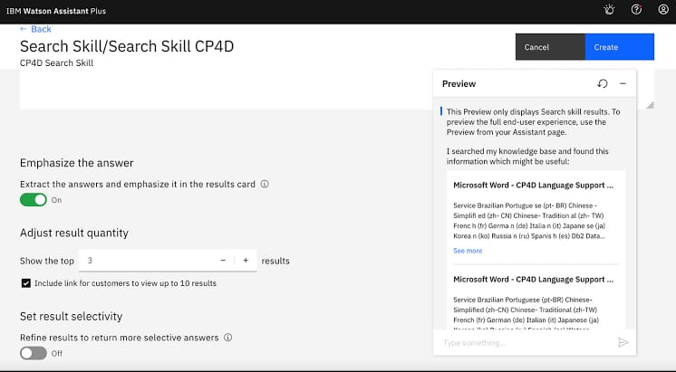

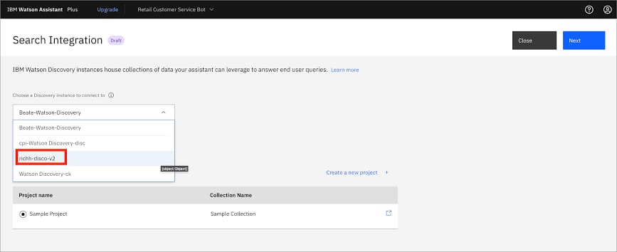

**Step 11:** Go to the page was viewed in step 10 and add the intents and entities by giving the message templates for the intended websites .

