Optimal Dispatch of Integrated Electricity-gas System With Soft Actor-critic Deep Reinforcement Learning
QIAO Ji¹, WANG Xinying^{1*}, ZHANG Qing², ZHANG Dongxia¹, PU Tianjiao¹
(1. China Electric Power Research Institute; 2. North China Electric Power University)
Key words: integrated electricity-gas system; optimal dispatch; uncertain sources and loads; deep reinforcement learning; soft actor-critic

The integrated electricity-gas system is one of the most promising approaches to improve the power utilization efficiency and renewable sources accommodation capacity in the future. The optimal dispatching of multi-energy flow is one of the core technologies to realize the efficient operation of integrated energy system.
This paper proposes a reinforcement learning method based on the framework of soft actor-critic for optimizing the operation of integrated electricity-gas energy system. The agent adaptively learns the control strategies through its interaction with the power system. The parameters of deep neural networks of the reinforcement learning model are gradually updated to maximize the cumulative reward of the agent. The action and state space, reward approach, neural network structures and training process are carefully designed. This proposed approach is able to take continuous control actions of the multi-energy flow system and flexibly deal with the complicated stochastic problem with uncertain wind power, photovoltaic power, electric and gas loads.
To increase the exploration ability of the agent, the maximum entropy framework is used. The objective function of the reinforcement learning agent is
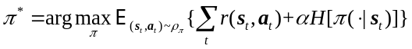 (1)
where 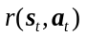 is the reward at each step, s_{t} is the state of the system, a_{t} is the action of the agent, is the action strategy, H is the entropy term and α is the temperature coefficient. The schematic diagram is shown in Fig. 1.

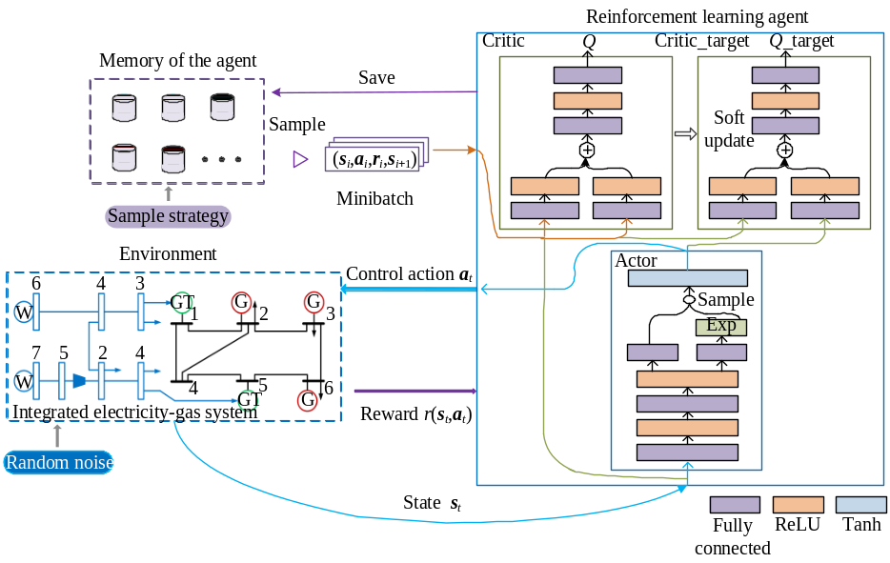
Fig. 1 Reinforcement learning for optimal dispatch of integrated electricity-gas systems

Compared to traditional method, the proposed method is able to adaptively learn the probability distribution of the renewable sources and power loads and has better optimization results. The presented model can avoid converging on local optimum too early and decrease the error caused by the discretization of the actions. The reinforcement learning agent is able to produce control strategy immediately with on need for retraining. Moreover, the model-free model can be easily applied to systems with different configurations and multi-time scales. The results on the two IEGS systems show that the proposed method can generate reasonable dispatching strategies to reduce the operation costs of the IEGS systems and increase the renewable sources accommodation with the coupling units and storages.

