WorkshopPLUS – Power Apps for Power User 1 Day

Module 2: Starting with connectors, screens, and controls

Student Lab Manual

**Conditions and Terms of Use**

Microsoft Confidential

This training package is proprietary and confidential, and is intended only for uses described in the training materials. Content and software is provided to you under a Non-Disclosure Agreement and cannot be distributed. Copying or disclosing all or any portion of the content and/or software included in such packages is strictly prohibited.

The contents of this package are for informational and training purposes only and are provided "as is" without warranty of any kind, whether express or implied, including but not limited to the implied warranties of merchantability, fitness for a particular purpose, and non-infringement.

Training package content, including URLs and other Internet Web site references, is subject to change without notice. Because Microsoft must respond to changing market conditions, the content should not be interpreted to be a commitment on the part of Microsoft, and Microsoft cannot guarantee the accuracy of any information presented after the date of publication. Unless otherwise noted, the companies, organizations, products, domain names, e-mail addresses, logos, people, places, and events depicted herein are fictitious, and no association with any real company, organization, product, domain name, e-mail address, logo, person, place, or event is intended or should be inferred.

**Copyright and Trademarks**

© 2020 Microsoft Corporation. All rights reserved.

Microsoft may have patents, patent applications, trademarks, copyrights, or other intellectual property rights covering subject matter in this document. Except as expressly provided in written license agreement from Microsoft, the furnishing of this document does not give you any license to these patents, trademarks, copyrights, or other intellectual property.

Complying with all applicable copyright laws is the responsibility of the user. Without limiting the rights under copyright, no part of this document may be reproduced, stored in or introduced into a retrieval system, or transmitted in any form or by any means (electronic, mechanical, photocopying, recording, or otherwise), or for any purpose, without the express written permission of Microsoft Corporation.

For more information, see Use of Microsoft Copyrighted Content at

<http://www.microsoft.com/en-us/legal/intellectualproperty/Permissions/default.aspx>

DirectX, Hyper-V, Internet Explorer, Microsoft, Outlook, OneDrive, SQL Server, Windows, Microsoft Azure, Windows PowerShell, Windows Server, Windows Vista, and Zune are either registered trademarks or trademarks of Microsoft Corporation in the United States and/or other countries. Other Microsoft products mentioned herein may be either registered trademarks or trademarks of Microsoft Corporation in the United States and/or other countries. All other trademarks are property of their respective owners.

Contents

Lab 2: Configuring screens and controls 5

Exercise 1: Rename the screen 6

Exercise 2: Add a header containing the app name and signed-in user’s name 7

Exercise 3: Save the Application 11

# Lab 2: Configuring screens and controls

**Introduction**

In this lab, you will start to design in Power Apps by renaming the screen and adding headers.

**Objectives**

After completing this lab, you will be able to:

* Rename screens in Power Apps Studio.
* Add and manipulate the label control in Power Apps Studio.

**Prerequisites**

Ensure you are using the “Incognito” or “InPrivate” browsing session of your modern browser.

Additionally, use the latest version of [Microsoft Edge](https://support.microsoft.com/en-us/help/4501095/download-the-new-microsoft-edge-based-on-chromium) (aka Edge Chromium) for the best performance.

**Estimated time to complete this lab**

15 mins

**Scenario**

The organization wishes to build apps using the PowerApps platform to take advantage of **No Code/Low Code** application development in the cloud. As part of this effort, you are required to use PowerApps Studio and manipulate different screens and controls.

## Exercise 1: Rename the screen

In this task, you will rename **Screen1** to **MainScreen**.

1. Select the screen by clicking the **Screen1** tile in the left navigation bar.
2. Click on “**…**” next to **Screen1** (or right-click **Screen1**) and select the **Rename** option.

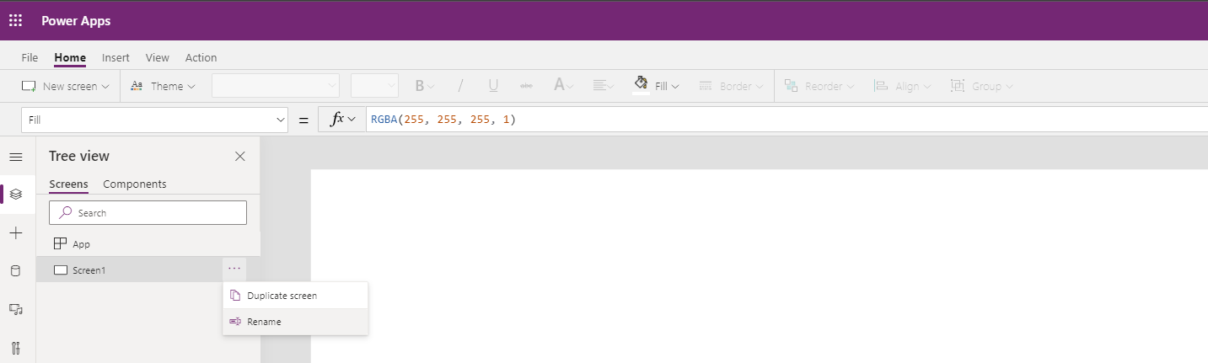

1. Change the name to **MainScreen.**

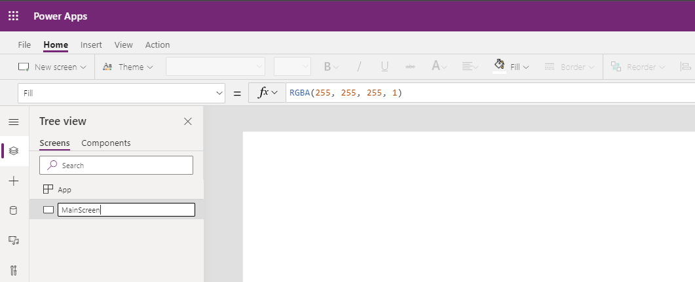

**Note**: You can also rename the screen by clicking on the screen name in the right pane and selecting the **edit** icon.

***Tip****: It is good practice to rename screens and controls as you create them, so they are easier to locate as you work with formulas that reference different controls.*

## Exercise 2: Add a header containing the app name and signed-in user’s name

1. Select the **Insert** tab in the ribbon and then select **Label** to add a text label.

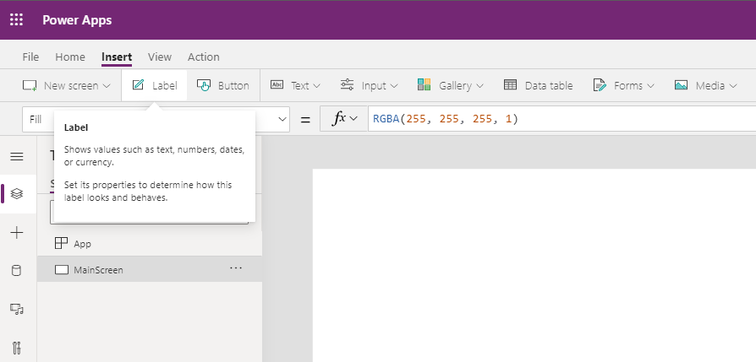

1. Rename the label from **Label1** to **HeaderLabel** (see the previous task on renaming controls).

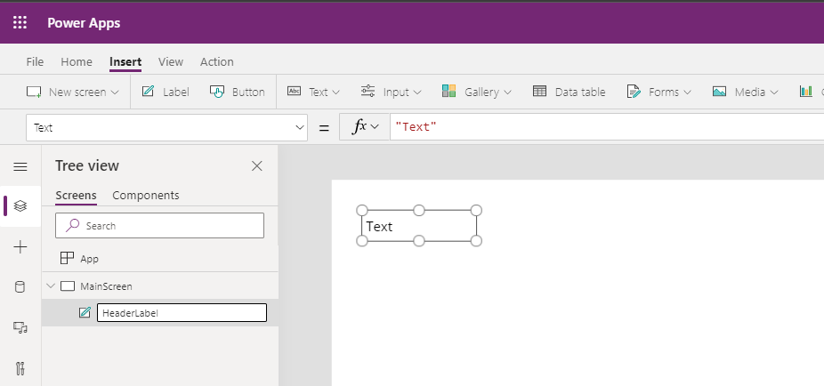

1. Select **Text** from the property drop-down list and enter **Device Ordering App** in the formula bar. You can also type directly in the label.

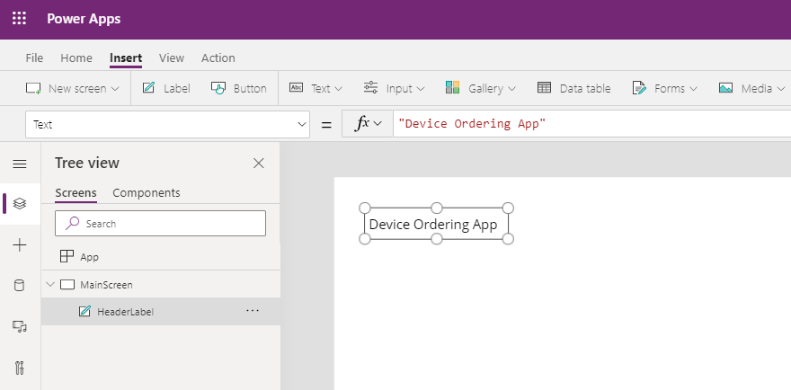

**Note**. You can change the text in the Properties pane on the right-hand side, as well:

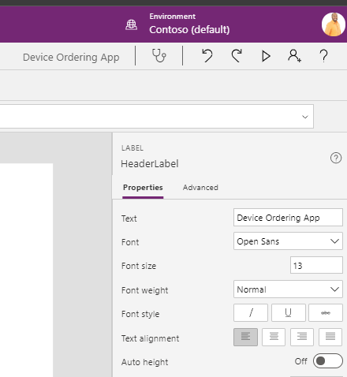

1. Resize the label such that its width is the width of the screen (e.g. 1366), and its height is a reasonable size for a header (e.g. 80). You can resize the label either by dragging the corners of the label or by adjusting its size in the right-hand pane.

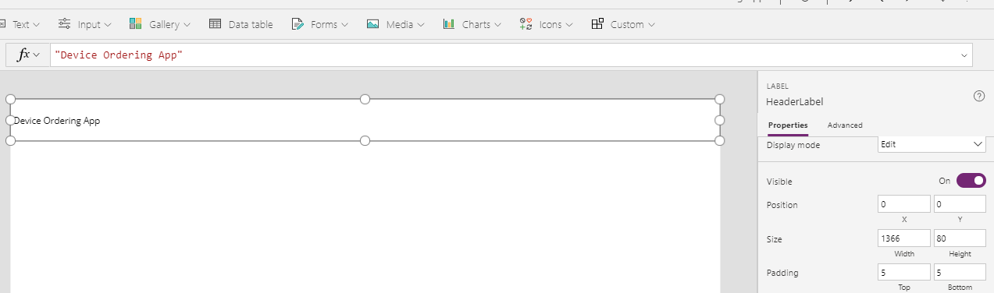

1. Select the **Home** tab and set the **Align** option in the ribbon to **Center**.

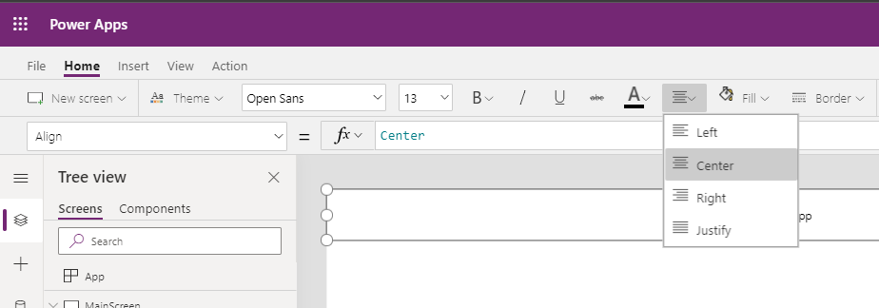

1. Change **Font** color to white and **Fill** color to blue.

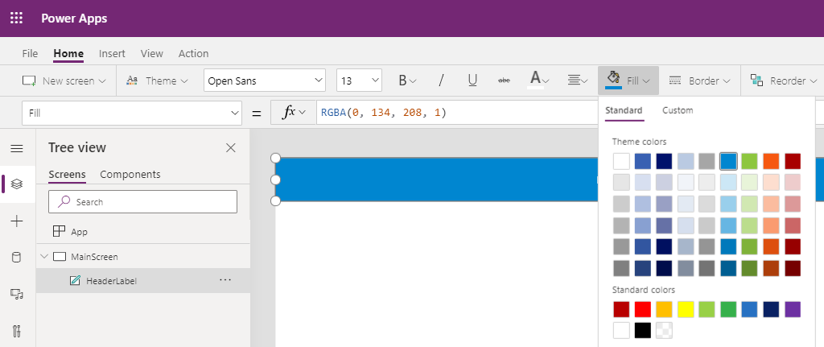

Change the font size to **24**.

***Tip****: You can also use the formula bar above or the* ***Advanced***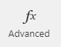 *tab on the far right of the screen to enter specific values or formulas for any property on a control.*

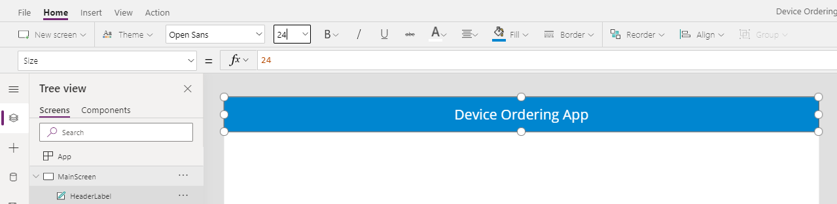

1. From the Insert tab, select **Label.** You will use this label to display the signed-in user’s name**.**

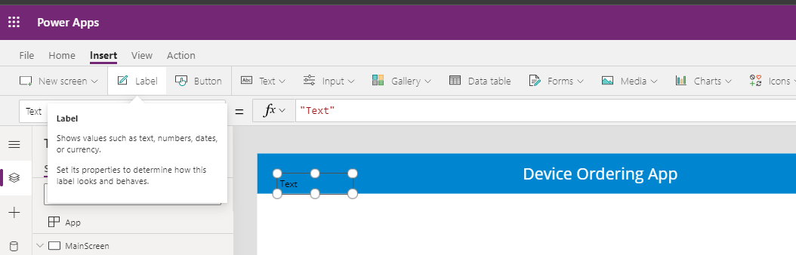

1. Drag the label to the far-right side of the screen and center the label vertically to be in line with the header text. You can use the purple alignment markers, as shown below.

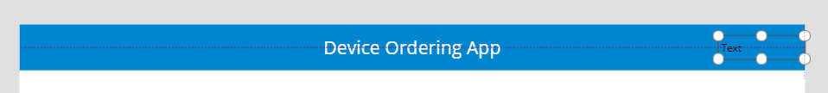

1. Rename the label to **UserLabel**.
2. Change the value of the **Text** field to: "Hello, " & User().FullName

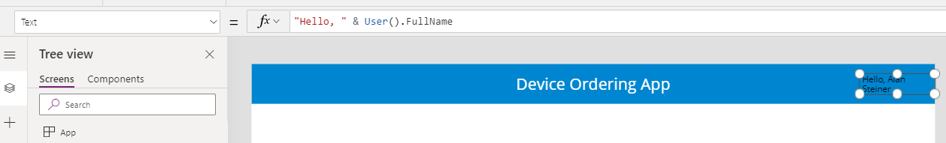

***Note****: All functions in Power Apps are case sensitive. As you start typing “User,” you will see a drop-down of available choices. It's a good idea to pick from the autocomplete options. You will also notice help text at the top showing the required parameters; in this case, it requires no input parameters.*

1. Right-justify the text in the label by selecting the **Align** option in the **Home** tab on the ribbon.
2. Change the **Color** to white.
3. If necessary, widen the label, so the text doesn’t wrap.
4. Change the **PaddingRight** property from **5** to **20**. You can do this quickly using the properties pane on the right-hand side.

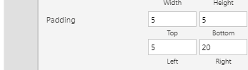

**Note:** The **User()** function in PowerApps allows you to retrieve the email, full name, and picture for the currently logged in user. App users will always be logged in with their business or school account (Azure Active Directory (AAD) credentials), so this information will always be available for any Power Apps app.

## Exercise 3: Save the Application

In this task, you will save an initial version of the app. It is good practice to keep saving app updates at regular intervals.

**Note:** After the initial save, Power Apps will autosave every two minutes.

1. First, you will check if there are any errors. Click on the **App checker** icon .

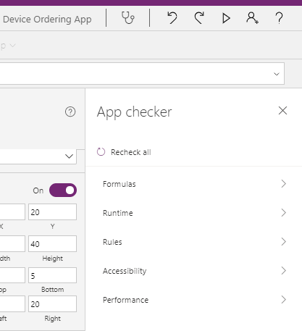

1. Go to the **File** Menu à **Settings**

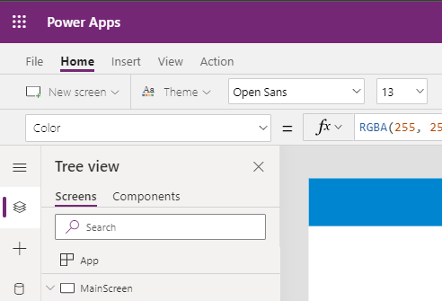

1. Change the name of your app.
2. Customize the app icon – choose a background color and icon.

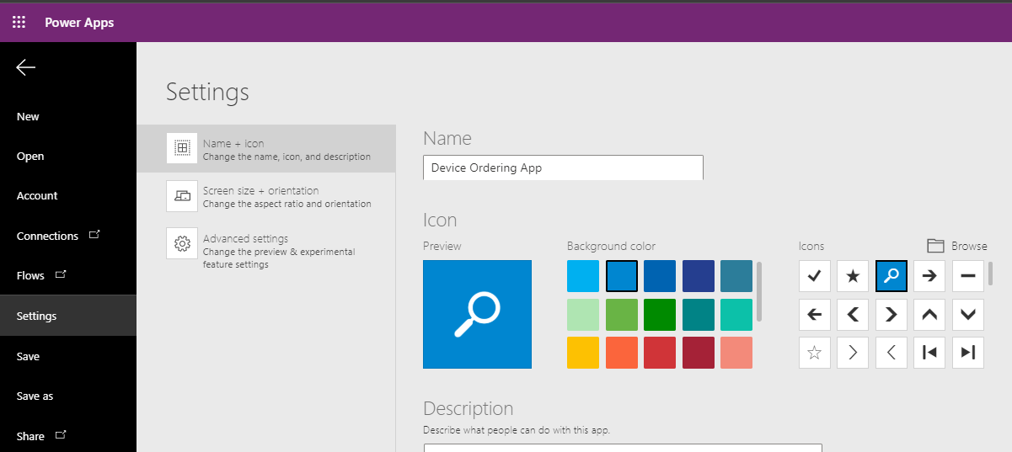

5. Select the **Screen size + orientation** tab to view the available screen orientation and aspect ratio settings. For this app, we will leave it at the default setting of **Landscape** with **16:9** aspect ratio.

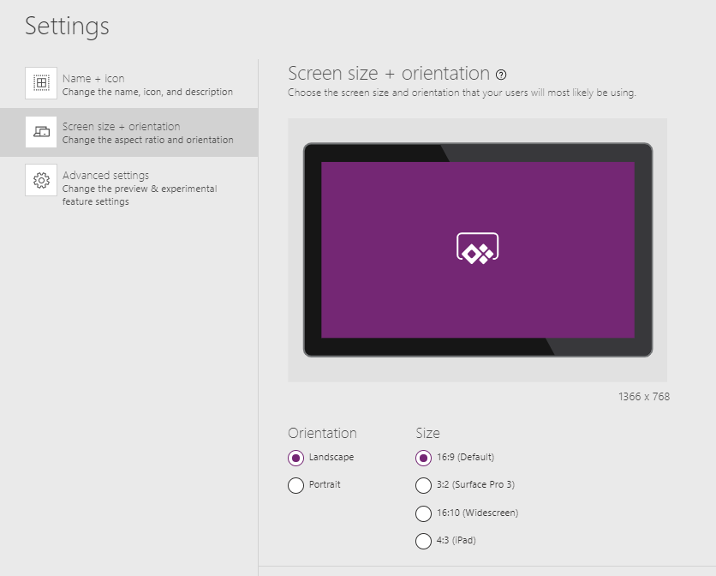

1. Select **The cloud** and click on **Save**.

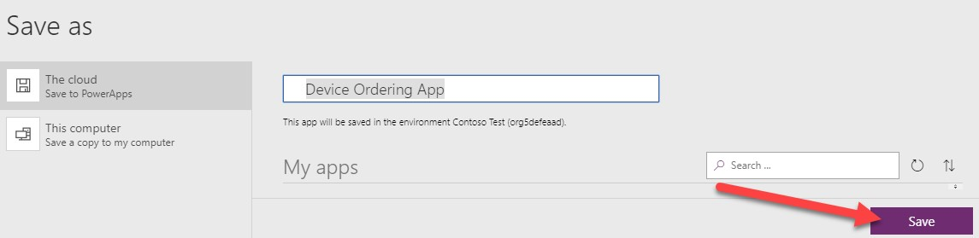

1. After the app is saved, click the back arrow on the top left to get back to the Studio.

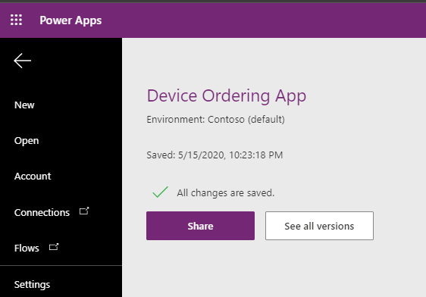

***Tip:*** *In Power Apps, when you save a version of your app, the first version is published by default and available to everyone you share the app with. Subsequent saves are only visible to the app maker in the Studio. You must explicitly publish it for all app users to get the update. For more details on saving, publishing, and sharing apps, see:* [*https://docs.microsoft.com/en-us/powerapps/maker/canvas-apps/share-app*](https://docs.microsoft.com/en-us/powerapps/maker/canvas-apps/share-app)