**Origins of Heavy Elements: The r-Process**

Sheldon Wasik

**Abstract**

Around half of the high mass (A > 26) elements are created from the rapid neutron-capture process, or r-process. The origins of this process are an active area of nuclear astrophysics research. The criteria for these high mass nuclei include of high temperatures (>1GK), densities of at least 1022 cm-3, and about 100 neutron captures per second. This criterion provides initial conditions to theoretical models to compare against the element abundances in the universe and gravitational wave observations. In this paper, major studies from the 60-year problem of the origin of the heavy elements (via the r-process) are laid out in detail. These results yield r-process elements produced by core-collapse supernovae, black holes, and neutron star-neutron star mergers. The nuclear astrophysics field has worked diligently on this problem, and it remains an ongoing field of research composed of a variety of concentrations.

**1. Introduction**

There are 94 naturally occurring elements in the universe, many of which make up our everyday life. The most common, hydrogen and helium, came about billions of years ago from the Big Bang. The remaining elements, also called metals, are created by stars. Most of the lower mass elements (mass number, A < 26) are created in massive star’s cores by the process of nuclear fusion. (Frebel et al. 2018). Examples of these elements are oxygen, which we need every day to breathe, and carbon, which is in a variety of essential items. As we move down and across the periodic table, the elements start to become more massive. About half of these high mass elements (A > 26) are created via the slow neutron-capture process, or s-process. This process occurs over thousands of years and occurs in massive stars that are very luminous but cool in retrospect (AGB stars) (Cseh et al. 2018). The s-process is a large area of study in the nuclear astrophysics’ world but is a topic for another paper. This paper is going to focus on the remaining region of nucleosynthesis, the r-process.

The rapid neutron-capture process, or r-process, makes up the remaining half of high mass elements. All the sources of the r-process are not entirely known but is an active area of research. With the help of observed distributions of elements in the known universe, as well as computational advances, we can however determine the most likely prospects. To do this, countless studies in the nuclear astrophysics field about the r-process are brought together in this paper. The findings are laid out as following. In section 2, this paper is going to walk through the physics of the r-process, as well as the necessary environment for this to take place. Section 3 is going to present the observational data of heavy elements created by the r-process. Recent and on-going theoretical models that display high mass element distributions will be laid out in Section 4. Ultimately, Section 5 will combine all these ideas together and propose the most likely candidates of the r-process.

**2. Rapid Neutron-Capture Process**

**2.1 Reactions**

The r-process can best be explained by rapid, consecutive neutron captures. Neutron capture is where a nucleus of an atom takes in a free neutron:

AX + 1n → A+1X’ (1)

Note that we see a conservation of nucleons, charge, and leptons. Neutron capture can happen due to the neutral charge of a neutron; therefore, it will not be repelled by the positive nucleus. The quicker neutrons are captured by a nucleus, the greater the mass will be of the resulting nucleus. This is because of the properties of a neutron, which will decay into a proton, electron, and an antineutrino in about 15 minutes. This type of decay is known as beta minus decay:

ZX → Z+1X’ + e− + ve (2)

Until the neutrons start decaying into protons, the atomic number of the element’s nucleus capturing the free neutrons stays the same, while its mass number is increasing. The mass number continues growing until rapid neutron capture is no longer achievable, most of the time due to the neutron density decreasing (discussed in Section 2.2). The resulting nucleus thus has a large mass number relative to the atomic number, as the protons have remained constant. These values cause the “new” nucleus to be extremely unstable.

Unstable nuclei will spontaneously decay into stable nuclei by weak interactions. When there are vastly more neutrons than protons, beta minus decay occurs (described above). This results in the neutron rich nuclei to “create” protons in exchange for neutrons, thus creating a new element. An example of this is platinum decaying into gold, something we have all learned to love and appreciate:

78Pt → 79Au + e− + ve (3)

Note, once again, that there is conservation, and we see a release of an electron and an antineutrino. This spontaneous decay occurs over and over until the limit of the neutron drip line is reached (Wanajo et al. 2010). This results in a variety of new elements from different masses instead of the same elements over and over.

**2.2 r-Process Environment**

Like stated before, rapid neutron capture can only occur in very specific environments. The temperatures must be high for the particles to move at fast enough speeds to have numerous captures, in fact about 100 captures per second. The accepted value of temperature in the nuclear astrophysics community for this criterion is T > 109 K. Second, to have enough neutron captures before decay takes over, the densities must be substantial. The exact value is debated, but the value of at least 1022 cm-3 is referenced a lot for theoretical models (Xu et al 2018). It is important to note that the cross section of nuclei and neutrons are important in these criteria and that there are some inconsistencies with them if they are known at all. When these conditions are met, the r-process can continue. Once either one of these conditions fails however, successive neutron captures are not able to occur, and beta decay takes over, where we see our new element formation.

**3. Observational Element Distribution (Abundance Peaks)**

The early ideas of the r-process came from the elements around us. It was easy to determine that low mass elements were created with nuclear fusion, but as for high mass elements, not so much. In 1956, H.C. Urey and Hans Seuss conducted an observational study to determine the abundances of each element in the solar system (Seuss and Urey 1956). In retrospect, this seems like a small sample size, but with the argument of an isotropic universe, these results will be used for years to come. In this study, Seuss and Hans found that the element abundances peaked in 3 main mass number, A, regions of 82, 130, and 196. The distribution of Seuss and Hans’ work can be seen by the triangle labels (marked solar) from Figure 1.

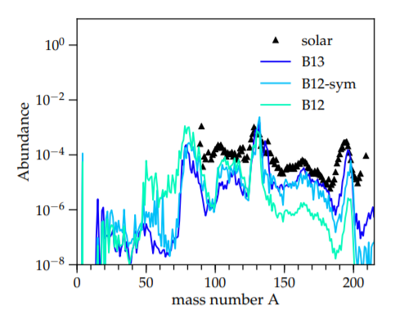

Figure 1: “Fractional abundance pattern as a function of mass number A for models B13, B12-sym and B12. Blue, light blue, and light green show models B13, B12-sym, and B12, respectively, for a constant neutrino luminosity of Lve = 1052 erg s-1 for both electron and electron antineutrinos in the nuclear reaction network calculation. Black markers indicate the solar abundance pattern scaled to match the second r-process peak (A = 135) for simulation B13. Model B13 reproduces the solar abundance pattern reasonably well, while model B12-sym underproduces third r-process peak (A = 195) material by more than an order of magnitude. In model B12, all nuclei beyond the second r-process peak are reduced in abundance by a factor of ∼ 100” (Mösta et al. 2017)

This sparked discussions on where these elements (and how much of them) are coming from, and more importantly, how one can prove it. Many of the leading hypotheses claimed that the high mass elements originated from either the Big Bang or fusion in star cores. However, only a year later, E.M. Burbridge, G.R. Burbridge, W.A Fowler, and F. Hoyle conducted a study by the name of “Synthesis of the Elements in Stars”, or better known as B2FH, that proved those hypotheses wrong (Burbridge et al. 1957).

In B2FH, the authors analyzed the data from Urey and Seuss, and claim the idea of the s-process and r-process, taking a focus on the peaks of the r-process. They note the masses, indicating that the nuclei originate from beta decay from the magic number of neutron number, N, 50, 82, and 126. Relevant nuclei at these magic numbers can be seen in table 1.

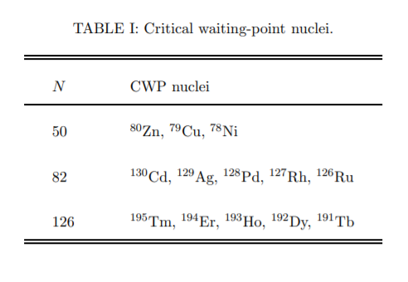Table 1: Critical waiting point nuclei based off the neutron number, N. These are nuclei you would tend to see near the r-process peaks. (Xu et al. 2018)

The greatest abundances occur at these values because of the properties of stable nuclei wanting to have complete shells of nucleons. Nuclear physics yields these magic shell numbers defined above and can be followed intensely through B2FH’s work. This paper kicked off the study of the r-process in the nuclear astrophysics’ community. With observed data from Urey and Seuss, as well as new theoretical ideas as to how some of the heaviest elements are formed, the next area of research for the r-process was to determine possible locations in the universe. This though, was no easy task, and due to the lack of technology, was disagreed up upon for a couple decades. This resulted in no real push in the r-process research, other than general ideas with no real way to test them until advances in technology.

**4. Theoretical Studies**

**4.1 Technological Advances**

In general, things are limited by what you can perform on them. In the case for a theoretical nuclear astrophysics problem, computing power is very important. When the r-process “problem” started, there was no such thing as running a model to determine a related feature. This limited what could be tested and even theorized. The 1980’s and 1990’s brought computing power in ways that could never be imagined. Computers allowed a new world of theoretical physics. Since then, the technological advances have exponentially increased. Where it used to take days, or even weeks, to model a simplified star, the most complex stars can now be modeled in a fraction of that time on some of the most powerful machines (with some exceptions of course). This allows for not only more complex models to be performed, but more models in general. Technology has allowed the people from all over the world working with the r-process to be more creative than ever, creating better studies by the year.

**4.2 Core-Collapse Supernova Studies**

The main goal of current studies surrounding the r-process in the nuclear astrophysics’ community is revolved around the sites at which the element creation occurs. There are many experiments out there that observe or derive nuclear physics properties used in r-process calculations – like cross sections, densities at high temperatures, etc. – but that is a topic for a different paper, as it is a field in and of itself. The r-process problem, even 60 years later, utilizes the solar abundance of each element found by H.C. Urey and Hans Seuss. To determine where these elements come from, studies of all kinds have been performed to try and “fit” these observed quantities with theoretical models, in hopes to provide more convincing results of astrophysical r-process sites.

*4.2.1 Early Supernova models of Woosley et al. (1994)*

Core-collapse supernovae (type II) are thought to be at the center of the r-process due to their extreme conditions and their physical properties that occur in the event, specifically electron capture. Electron capture is where a proton rich nucleus absorbs an inner electron, resulting in a creation of a neutron and electron neutrino, as seen by equation 4:

p + e - → n + ve (4)

These weak reactions resulting in a neutron is promising for the r-process because it needs an extreme count of neutrons in a small area. One of the first papers released on the origins of heavy element nucleosynthesis had a focus the core-collapse supernovae, “The r-process and neutrino-heated supernova ejecta” (Woosley et al. 1994). Still being in the early stages of computational models, the authors decided to model the remnants of a 20 M☉ progenitor star that had collapsed, which they claimed was the most realistic model attempted yet. The theoretical model was then compared to the observational solar abundances of Käppeler, Beer, and Wisshank (Käppeler et al. 1989) which is ideally a more refined solar abundance distribution than Seauss and Urey (1956). The results were astonishing, as seen in Figure 2, or better described in words by Woosley:

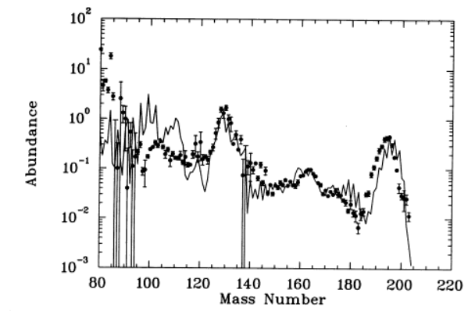“We find that the last 10-4 M☉ ejected, especially that material which escapes more than 5 seconds after core collapse agrees remarkably well with the observed solar r-process abundances.”

Figure 2: Nuclei abundances of Woosley et al. 1994. This model shows the remnant abundances of a 20 M☉ progenitor that underwent a core collapse supernova. The model is compared to the solar abundances of Käppeler et al. 1989. Note that both sets of data are normalized to the abundance of 129Xe.

These results were one of the first results, if not the first, that directly compared computational models with the solar abundances that were found via observation. The study was able to claim that a core collapse supernova is a promising site for the r-process. The authors in this paper were also able to reproduce the ejecta from the most recent observed supernova of SN 1987A, which was incredibly exciting at the time. By just glancing at Figure 2 though, we are missing over half the story, the flaws. Near the lower mass in Figure 2, specifically between a mass number of 80 and 120, the abundance is not accurate. This result is shown to be inaccurate by the nuclei of 88Sr, 89Y, and 90Zr, respectively. Woosley et al. does address these errors, elaborating that the abundance is about two orders of magnitude more than what it should be, and that they most likely came from the first second of the multidimensional evolution. Near the beginning of the computational astrophysics era though, these were promising results of a potential r-process site, though not completely correct. It demonstrated that theory can be guided by observations and that creativity can be rewarded. This was just the start of the journey to find the possible sources of half the heavy elements we see today.

*4.2.2 The “weak” r-process in core-collapse supernova*

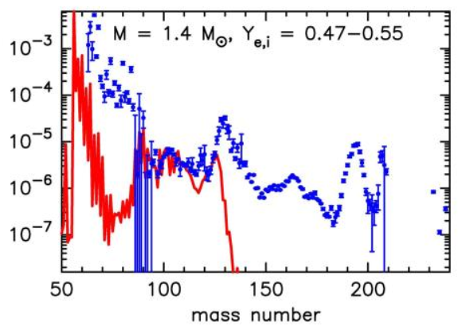 As the r-process problem advanced, so did the results of future studies. S. Wanajo and Y. Ishimaru carried out a very similar study in 2005 to Woosley et al. (1994). Wanajo and Ishimaru however, guided their study behind recent spectroscopic observations of extremely metal-poor stars in Galactic Halo. They claim that this result yields that a core collapse supernova is responsible, as the r-process takes place in neutrino winds from a 1.4 M☉ neutron star (left over from a core collapse supernova) and producing the elements that are being observed. The results yielded that only a very specific range of heavy nuclei are created in this region, which the authors deem the “weak” r-process. This can bee seen by Figure 3 below.

Figure 3: The abundances as a function of mass number, for both the abundances of HD 122563 (Galactic Halo) in S. Wanajo and Ishimaru (2005) and the scaled solar abundances of Käppeler et al. 1989. This Galactic Halo remnant maps very well to the observed data between mass number 90 and 120. (Wanajo and Ishimaru 2005).

The authors of this r-process site study conclude with the results that neutrino winds from 1.4 M☉ are likely the origins of the “weak” r-process (defined as A=90-120), thus tracing element production back to core-collapse supernovae once again. Wanajo and Ishimaru suggest that this neutron star most likely came from a 10-20 M☉ progenitor, and that larger mass nuclei may come from more massive progenitors or a different astrophysical site.

**4.3 Black Hole Studies**

With the results from Woosley et al. (1994) and Wanajo and Ishimaru (2005), nuclear astrophysicists needed to take a different approach on the mysterious r-process. They knew the criteria for the problem and what needed to be produced, as well as a very strong background on the core-collapse supernovae findings. All the necessary computational tools were available, and it was becoming practical to test more theories, whether it be a more massive star or a different astrophysical source.

*4.3.1 The r-Process in Black Hole Winds*

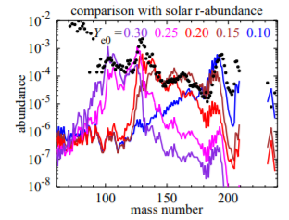In 2010, just five years after the Wanajo and Ishimaru paper made a strong statement that a different astrophysical site may be necessary for r-process nuclei greater than a mass number of 120, S. Wanajo and H.T. Janka tested that theory. In their paper “The r-Process in Black Hole Winds” Wanajo and Janka modeled black hole winds based on spherically symmetric, general relativistic proto-neutron star winds. They used a central black hole mass of 4 M☉, or an accreting black hole which comes from a 30 M☉ progenitor. The authors made a lot of conservative approximations, such as radius, outflow, etc. It is important to note this to show how many free parameters need to go into a problem of this caliber. The results of nucleosynthesis are examined at various low electron fractions (Ye), which is also treated as a free parameter, to try and get a better fit to observational data while keeping the physical properties realistic. Wanajo and Janka find that lower Ye produce nuclei consistent with the third r-process peak (A=196), whereas larger Ye produce a better fit near lower mass nuclei. This is seen by Figure 4 and provides a very probable r-process site since it can produce elements on separate ends of the spectrum with only varying one free parameter (to all reasonable values).

Figure 5: “Mass-averaged nucleosynthetic yields for various initial electron fractions (lines), which are compared with the solar r-process distribution (dots).” (Wanajo and Ishimaru 2010)

In their study, Wanajo and Ishimaru found that the black hole winds create the most entropy at its innermost regions. This not only demonstrates that the black hole winds are a possible source, but its near cousins of neutron star binaries and black hole-neutron star binaries could contribute to the creation of high mass elements. With the promising results of black hole winds based on various Ye values, it may not be far fetched that some of the most interesting sites in the universe may be a location of the r-process.

*4.3.2 Neutron Star Merger Remnants Around Black Holes*

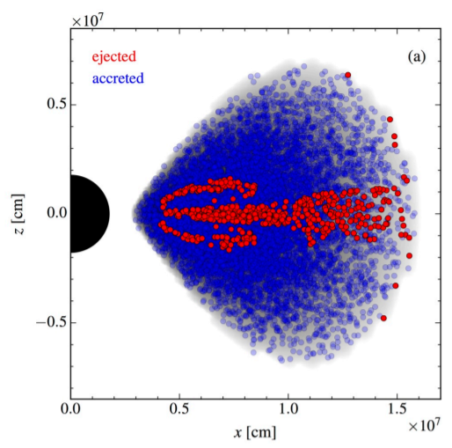 There has yet to be an astrophysical location that all nuclides of the r-process are created. The general community has speculation whether there even is one, or if all the possible candidates come together to produce what we see in the universe. Before the consensus on that however, M.R, Wu, R. Fernandez, G. Martinez-Pinedo, and B.D Metzger had other ideas. In their 2016 paper, “Production of the entire range of r-process nuclides by black hole accretion disc outflows from neutron star mergers” the authors model the nucleosynthesis in NS merger remnant accretion disks around black holes. They use the FLASH3 code, only one of the numerous astrophysics codes, as well as a handful of estimated parameters to gather results. Just like in Wanajo and Ishimaru (2010), Ye values are closely monitored to keep an emphasis on neutron rich areas. For nuclei to collide and produce higher mass elements, there must be an ejecta of mass (neutrons specifically). Wu et al. (2016) demonstrates what this looks like in Figure 6. The authors estimate that, at this source (a highly spinning black hole), the total ejected masses can range from a few percent to around 20% of the initial disc mass.

Figure 6: “initial density field (grey) and particle distribution in model S-def. Particles that reach a distance of 2 × 109 cm from the BH are considered to be ejected (red), with most of the remainder being accreted (blue)” (Wu et al. 2016). Note the parameter needed to define this.

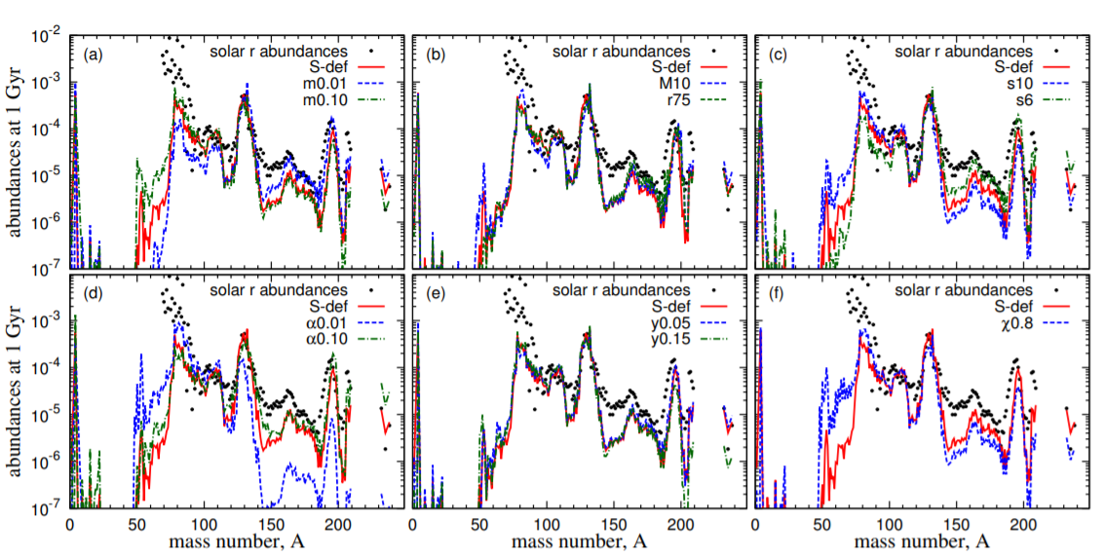Even at the lower bound of that range, with how massive these objects are, there is enough matter to produce the environment needed for the r-process to occur. In fact, that is exactly what was found in this study, as demonstrated by Figure 7.

Figure 7: “Dependence of average disc outflow abundances on disc mass (a), BH mass and disc radius (b), initial entropy (c), viscosity parameter (d), initial electron fraction (e), and BH spin (f). Note that the Solar system r-abundances are scaled to match the second peak abundances of S-def model.” (Wu et al. 2016).

Though numerous models are performed, each with their own complications, the main take away from this study is the abundance spike at A=132 significantly matches that of the solar r-abundance when the black hole’s disk outflow is fully convective, which is a relatively reasonable scenario (though not all the time). To add, this source is an excellent producer of r-process elements in the lower mass range (A<130), referred to before as the “weak” r-process nuclei. Lastly, the study indicates that the black hole disks struggle to consistently produce high mass (A>130) nuclei, stating that the models depend too much on the free parameters, specifically the type and magnitude of the angular momentum transport process. The authors do debunk the model significance to the entropy of the black hole disks and claim it as a less significant parameter, unlike the importance of Ye.

In Wu et al. (2016), the authors do an extensive study of the Ye to understand why the second r-process peak is normally produced in theoretical models, and why the third is not. While analyzing how Ye impacts the ejecta mass, the paper captures a gaussian-like distribution. As seen in Figure 8 (left panel), Ye peaks just under 0.25. In previous studies, as well as this study, the models with a Ye of 0.2 to 0.3 convincingly produce the second r-process peak (A=130), whereas models with a Ye of around 0.1 to 0.2 begin to produce the mysterious third r-process peak. This low Ye is incredibly difficult to reach for extended period of times resulting in a computational hurdle. The “weak” r-process elements tend to be created by the remaining values. In the same figure, but now on the right panel, we can see a distribution of a neutron-seed ratio. The neutron-seed ratio is a representation as to how many

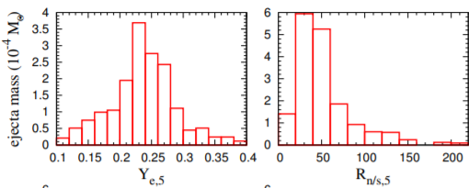

Figure 8: Ejecta mass as a function of Electron Fraction (Ye) – Panel 1. Note the gaussian-like distribution. Ejecta mass as a function of neutron-seed – Panel 2. This value represents the order of high mass element creation. (Wu et al. 2016)

neutrons can be captured on a starting nucleus before beta decay occurs. We see a positively skewed histogram, representing lower mass nuclei are more likely, based on this data. Lastly, Wu et al. (2016) encourage future problems to investigate the initial parameters, stating that different reasonable configurations may lead to the understanding of a wider range of r-process elements. These results confirm the black hole as a possible point of origin of the r-process, as well as demonstrate that high energy mergers, specifically NS-NS mergers, may be the next source of importance in the complex problem.

**4.4 Observed r-Process in Neutron Stars**

The r-process problem has evolved into one of the most complex areas of research. There are numerous fields of expertise that combine their works into what is being studied today. Theory has been joined with observations and old studies have been referenced in the mix with the groundbreaking efforts we see around us. As the r-Process problem continues to grow, recent detections from the most impressive machines on Earth have started to shed some light on high mass elements. The groundbreaking way to detect massive events in the universe is through gravitational waves. Gravitational wave astronomy is relatively new and studies the disturbances in spacetime, galled gravitational waves, usually from the most massive events in the universe, such as NS-NS mergers or black holes. The largest project in this field is the LIGO-VIRGO collaboration, which consists of two gravitational wave observatories halfway across the world from each other. The science behind how this worldwide project works is complex and can be read about in more detail (<https://www.ligo.caltech.edu/page/what-is-ligo>). In the importance of the r-process problem, LIGO and VIRGO were able to observe a NS-NS merger in 2017, which was named GW170817. This allowed telescopes from all around the world to be pointed at this event, leading to a wide range of data on the merger. Since then, various studies have been released, analyzing data for nuclear physics, mass distributions, and even high mass nucleosynthesis, specifically the r-process elements. This, to this date, remains the first and only observed event that produces the elements of the r-process.

*4.4.1 Implications of GW170817 of the r-Process*

Two years after the observation of the NS-NS merger in GW170817, Daniel Siegel released his findings in a paper (Siegel et al. 2019). Siegel displays the data for the NS-NS merger, indicating that is a significant amount of radioactive high mass nuclei (A < 140) and non-radioactive high mass range nuclei (A > 140). Like shown in Wu et al. (2016) Siegal argues that the heaviest elements have been created in outflows in the accretion disk. The study takes a focus on the origins of the r-process and compares resulting nuclei abundances with a collapsar process and a NS process. His findings are riveting. Daniel Siegel, even with this first and only r-process observation, claims that core-collapse supernovae are still the prime origin of high mass creation, with his reasoning in the following:

“Compared to NS mergers, collapsars arguably better satisfy existing constraints on heavy r-process nucleosynthesis, such as constraints from 244Pu, Eu enrichment in dwarf galaxies, the rate-yield constraints from the total galactic r-process content, and the respective event rate constraints. The collapsar scenario also bypasses and solves a number of problems that afflict merger-only enrichment models for the Galactic r-process in various environments, both at low and high metallicities.”

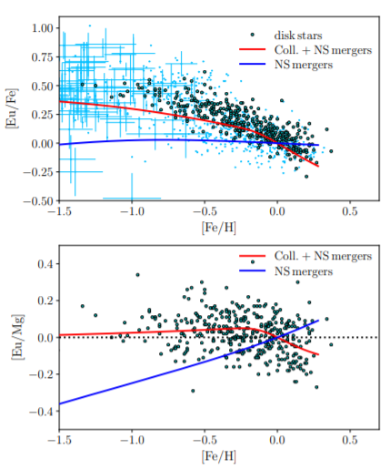Siegel’s claim is based of observed data, which is to be taken with a grain of salt (due to systematic bias) but is greatly backed up by the results obtained - shown in Figure 9.

Figure 9: Observed specific abundances as a function metallicity for observed data in the SAGA database (<http://sagadatabase.jp/>). For each panel, the NS merger models and the combination of collapsar and NS mergers are plotted. We see a better dependance on the combined properties, indicating the r-process does not likely come from only one source (Siegel 2019)

This does not disregard any studies so far but rather is an attempt to truncate the r-process problem into more refined subsections.

*4.4.2 Reexamination of the GW071807 Spectroscopy*

Astrophysical data, especially from a NS-NS merger detected by LIGO-VIRGO, can be overwhelming and sometimes needs more than a single look. That is exactly what was done by Darach Watson and colleagues in the letter “Identification of strontium in the merger of two neutron stars” (Watson et al. 2019). The first time the GW170817 spectroscopy data was studied, the consensus that there were radioactive heavy elements, but with no prominent elements, was declared. However, after reexamination, Watson et al (2019) found traces of strontium (Sr). The authors claim this is significant due to the nature of where Sr is usually observed in distant galaxies, which is with high mass r-process elements. This could potentially show that the creation of the lower mass Sr in an event yields the creation of high mass elements (specifically Ba) in the same area. The results of this study neither prove nor disprove any r-process origin studies in the past, it only creates more convincing data to eventually solve the complications of the r-process problem.

*4.4.3 Future Works*

The implications with technology are growing by the day and scientists are becoming more creative with how to use it. Computational models are growing, labs are generating data that was deemed as impossible before, the physical input parameters are being narrowed down, and tools for observation are becoming more useful. All these implications are going to be used in future studies for the r-process. The James-Webb Space Telescope (JWST) is going to create a new frontier of observed astrophysical objects. Improvements to LIGO and VIRGO are going to create more sensitive studies. The FRIB at Michigan State University is going to allow more nuclear physics calculations to lead the computational models in the right direction.

Currently, there are ongoing core-collapse supernovae simulations (to study the r-process) being run in 3-D on some of the world’s most powerful supercomputers. 3-D collapsars are a challenge in and of itself today, taking up to months to model the event of just one star. This is important in determining the high mass nuclei because there are asymmetric properties in stars that are a challenge to produce in 1-D and 2-D, such as magnetic fields and convection. These 3-D models can then be compared to previous models to determine what input parameters will be needed in the future, so less expensive models can persist with accurate results. These models, in joint with revolutionary observational tools in the near future, could very well lead the nuclear astrophysics community to the 60-year-old problem of the origin of the heavy elements via the r-process.

**5. Discussion of Likely r-Process Sites**

Throughout this paper numerous studies have been laid out, starting in the 1950’s with the kickoff of the r-process all the way up to the present. Usually as problems get worked on, they slowly tend to get solved. This has not been the case of the mysterious r-process problem, but rather, the problem has grown in scale. The heavy mass elements were first thought to come from nuclear fusion inside the stars core. With the addition of solar abundances in 1956, the theories behind the r-process changed quickly. Information presented over the decades leads us to believe that over half of the heavy elements come from not just one, but a variety of sources. The evidence is compelling for core-collapse supernovae (CCSNe) and black holes as an astrophysical site based on computational models. The recent observation of spectroscopy in a NS-NS merger displays another possible source. Therefore, the r-process origin is becoming clear to have more than just one answer. We are, however, not near the end of the problem. With our, at least three, origins of the r-process (CCSNe, black holes, NS-NS merger), the exact abundances from each are still unknown. Computational models have guided the sites of the heavy elements this far, and it is believed by many that it will, with the help of observations, determine the element abundance of heavy nuclei once and for all.

**6. Conclusion**

Element formation is a complex problem in the astrophysics world. It involves a great deal of nuclear physics, star death, computational knowledge, etc. There is one group of high mass nuclei (mass number, A, > 26), known as the r-process elements, that has an unknown origin in the universe. The theory of rapid neutron-capture, or r-process, was derived decades ago (Burbridge et al. 1957) after element abundances were observed in the solar system (Seuss and Urey 1956). The r-process is defined as rapid, consecutive neutron captures before beta decay is spontaneously able to occur. For high mass elements to be created via this process, temperatures need to be extremely high (1 GK), densities need to be at least 1022 cm-3, and close to 100 neutron captures need to happen every second. This specific criterion has been at the center of a search for the astrophysical sites of high mass elements.

Studies throughout the past 60 years have yielded numerous, very exciting results. We see from Woosley et al. (1994) that matching computational models with observational data can lead to promising results. Even with a few flaws in the study, it could be shown that core-collapse supernovae produce high mass elements at 2 of the 3 r-process peaks, which occur at A=82,130,196 (with respective neutron number, N, of 50, 82, 126). Future CCSNe studies provide more data on the topic and point to other astrophysical sources as possible r-process sites. Near the turn of the decade, black holes were studied intensely. Wanajo and Janka (2010) demonstrated that black holes, at both the upper and lower limits of ejecta, can emit the mass required for the r-process to take place. They produce an intensive Ye study that shows low values can produce elements at the third r-process peak and vice-versa. Utilizing constraints on the initial conditions in this study yielded results that have never been seen before and provided great direction for future studies. Most recently, LIGO and VIRGO detected a NS-NS merger, providing a perfect opportunity for spectroscopy of another theorized r-process site. GW170817 overperformed and conveyed high mass radioactive nuclei (A < 140) and non-radioactive nuclei (A > 140) were produced. This resulted in yet another origin of the heavy elements via the r-process.

Over the past several decades, advances in technology has significantly benefited the nuclear astrophysics’ studies. New telescopes, national labs, and computational power have all made it possible to approach the origins of the r-process. In the coming years, 3-D CCSNe models will provide more information, as well as the latest nuclear astrophysics properties produced by FRIB and the JWST. As for what we have now, based off theoretical models and observations, the origins of the r-process are CCSNe, black holes, and NS-NS mergers.

**References**

Burbridge, K.M, Burbridge, G.R., Fowler, W.A., Hoyle, F. Synthesis of the Elements in Stars.

1957. https://journals.aps.org/rmp/pdf/10.1103/RevModPhys.29.547

Cseh, B., M. Lugaro, M., D’Orazi, V., de Castro, D.B., Pereira, C.B., Karakas, A.I.,

Molnár, L., Plachy, E., Szabó, R., Pignatari, M., Cristallo, S. The s Process in

AGB Stars as Constrained by a Large Sample of Barium Stars. 2018.

https://arxiv.org/pdf/1810.01788.pdf

Darach Watson, D., Hansen, C.J., Selsing, J., Koch, A., Malesani, D.B., Andersen, A.C., Fynbo,

J.P.U., Arcones, A., Bauswein, A., Covino, S., Grado, A., Heintz, K.E., Hunt, L.,

Kouveliotou, C., Leloudas, G., Levan, A., Mazzali, P., Pian, E. Identification of

Strontium in the Merger of Two Neutron Stars. 2019.

https://arxiv.org/pdf/1910.10510.pdf

Frebel, A., Beers, T.C. The Formation of the Heaviest Elements. 2018.

<https://physicstoday.scitation.org/doi/10.1063/PT.3.3815>

Kappeler, F., Beer, H., Wisshak, K S-Process Nucleosynthesis-Nuclear Physics and the

Classical Model. 1989. https://iopscience.iop.org/article/10.1088/0034-4885/52/8/002/pdf

Mösta, P., Roberts, L., Halevi, G., Ott, C.D., Lippuner, J., Haas, R., Schnetter, E. r-Process

Nucleosynthesis from Three-Dimensional Magnetorotational Core-Collapse Supernovae.

2017. <https://arxiv.org/pdf/1712.09370.pdf>

SAGA Database – Stellar Abundances for Galactic Archaeology Database. sagadatabase.jp/.

Siegel, D. GW170817—the first observed neutron star merger and its kilonova: implications for

the astrophysical site of the r-process. 2017. <https://arxiv.org/pdf/1901.09044.pdf>

Seuss, H.E. and Urey, H.C. Abundances of the Elements. 1956.

<https://journals.aps.org/rmp/abstract/10.1103/RevModPhys.28.53>

Wanajo, S., Ishimaru, Y. The ‘weak’ r-process in core-collapse supernovae. 2005

<http://articles.adsabs.harvard.edu/cgi-bin/nph-iarticle_query?bibcode=2005IAUS..228..435W&db_key=AST&page_ind=0&plate_select=NO&data_type=GIF&type=SCREEN_GIF&classic=YES>

Wanajo, S. and Janka, H.T. The r-Process in Black Hole Winds. 2010.

<https://arxiv.org/pdf/1006.2277.pdf>

Wanajo, S. and Janka, H.T. The r-Process in The Neutrino-Driven Wind from a Black-Hole

Torus. 2018. <https://arxiv.org/pdf/1006.2277.pdf>

Wehmeyer, B., Frohlich, C., Cote, B., Pignatari, M., Thielemann, F.K. Using Filed Supernovae

to Constrain the Galactic r-Process Element Production. 2019.

<https://arxiv.org/pdf/1908.05617.pdf>

What Is LIGO? Caltech. www.ligo.caltech.edu/page/what-is-ligo.

Woosley, S., Wilson, J., Mathews, G., Hoffman, R., Meyer, B. The r-Process and Neutrino-

Heated Supernova Ejecta. 1994. <http://adsabs.harvard.edu/full/1994ApJ...433..229W>

Wu, M.R., Fernandez, R., Martinez-Pinedo, G., Metzger, B.D. Production of

the Entire Range of r-Process Nuclides by Black Hole Accretion Disc Outflows from

Neutron Star Mergers. 2016. <https://arxiv.org/pdf/1607.05290.pdf>

Xu, X.D., Sun, B., Niu, Z.M., Li, Z., Qian, Y.Z., Meng, J. Reexamining the temperature and

neutron density conditions for r-process nucleosynthesis with augmented nuclear mass

models. 2018. <https://arxiv.org/pdf/1208.2341.pdf>