Report on the variation of Covid-19 Case types on population of different Country Regions.

Authors: Shellah Nsubuga, Joyce Adee, Atim Sarah, Annet Balinabyo.

**Abstract**

Since December 2019, COVID-19 has evolved to become a pandemic and resulted in, according to the WHO as of May 31, 2021, 170 million cases and 3.5 million deaths.

The COVID-19 pandemic has had profound effects on health care and other societal systems, as well as the global economy. As is the case in most humanitarian emergencies, poorer developing nations have taken the hardest hits, and disadvantaged groups, particularly people living in poverty and subject to marginalization and exclusion, have suffered the most.

We address how Covid-19 case types varied on the population of different country regions across the globe. Our results based on the Covid-19 Case dataset suggest that relatively high populations in different countries across the globe were highly affected by the different case types; deaths and confirmed cases.

The results of the study basing on the dataset will be beneficial to medical personnel who would want to know how different regions were affected by covid-19.

**Introduction**

This is a report on *the variation of Covid-19 Case types on population of different Country Regions.*

COVID-19, the respiratory disease caused by severe acute respiratory syndrome coronavirus 2 (SARS-CoV-2) was first reported in Wuhan, China in late December 2019

On January 30, 2020, SARS-CoV-2 was declared a public health emergency of international concern, having spread to multiple countries outside of China By March 11, 2020, it was declared a global pandemic, with approximately 118,000 confirmed cases and nearly 4300 deaths on all continents except Antarctica

The COVID-19 pandemic is a catastrophe taking an enormous toll on humanity disrupting lives and livelihoods. The scale and severity of COVID-19 is unprecedented. Different regions have been affected unequally by COVID-19.

In a fast-evolving pandemic it is not a simple matter to identify the countries that are most successful in making progress against Covid-19. For a comprehensive assessment, *w*e based our attention on specific country regions driven by the following questions;

* How many new cases are being confirmed each day?
* How many cases have been confirmed since the pandemic started?
* How is the number of cases changing?
* How many deaths from COVID-19 have been reported?
* Is the number of deaths rising or falling?
* How does the death rate compare to other countries?

We are more interested in knowing how different covid-19 case types varied in different country regions. Basing on the Covid-19 Case dataset, we analyse the cases that were involved in different regions across the globe.

**Data**

Our main interest is in knowing how different covid-19 case types varied on population in different country regions. Basing on the Covid-19 Case dataset, we analyse the cases that were involved in different regions across the globe.

We used numerical data variable of Confirmed cases, Deaths and Population 2019 based on our dataset.

We investigated the data on confirmed cases, deaths and the population 2019 of different regions across the globe.

**The following table shows the descriptive statistics for our covid\_19 data set.**

|  |  |  |  |  |  |
| --- | --- | --- | --- | --- | --- |
| Variables | mean | median | Standard deviation | Minimum  (Afghanistan)  (High-income) | Maximum (Zimbabwe)    (Upper\_middle\_income) |
| Population density 2018 | 2.096 | 8.395 | 6.423 | 2.041 | 7952.998 |
| Mortality Rate | 2.552 | 2.004 | 2.807 | 0.000 | 28.916 |
| GDP\_2019 | 5.037 | 4.732 | 2.061 | 429016605.2 | 21400000000000.0 |
| GDP\_per\_ca p\_2019 | 2.218 | 1.475 | 2.203 | 782.817 | 121292.739 |
| Avg temp | 1.851 | 2.185 | 8.180 | -5.1 | 28.290 |
| Normalised cases | 5.142 | 2.313 | 7.289 | 0.000 | 0.044 |
| Normalised death | 1.256 | 3.815 | 2.078 | 0.000 | 0.001 |
| Population\_2 019 | 4.177 | 9.758 | 1.495 | 33860 | 1397715000 |
| Deaths | 5.453 | 2.280 | 2.108 | 0 | 204486 |
| Confirmed  cases | 1.799 | 1.338 | 7.728 | 19 | 7078039 |

This means that death has the highest mean with 5.453 and the lowest being normalised deaths with 1.256

The variable with the highest standard deviation is Avg temp with 8.180 (average temperature) and the variable with the lowest standard deviation is population with 1.495.

The country with the highest covid\_19 Confirmed cases is Zimbabwe which is 7078039 a middle-income country

The country with the lowest covid\_19 Confirmed cases is Afghanistan which is 19.

**The following table shows the descriptive statistics for population 2019, death and confirmed cases as our chosen variables**.

|  |  |  |  |  |  |
| --- | --- | --- | --- | --- | --- |
|  | Mean | Median | Standard deviation | Minimum | Maximum |
| Population\_2019 | 41767618.132 | 9758033.0 | 149477394.325 | 33860 | 1397715000 |
| Death | 5435.187 | 228.0 | 21079.534 | 0 | 204486 |
| Confirmed cases | 179868.121 | 13379.5 | 772821.589 | 19 | 7078039 |

Visualizing our chosen variables

a)

b)

c)

d

)

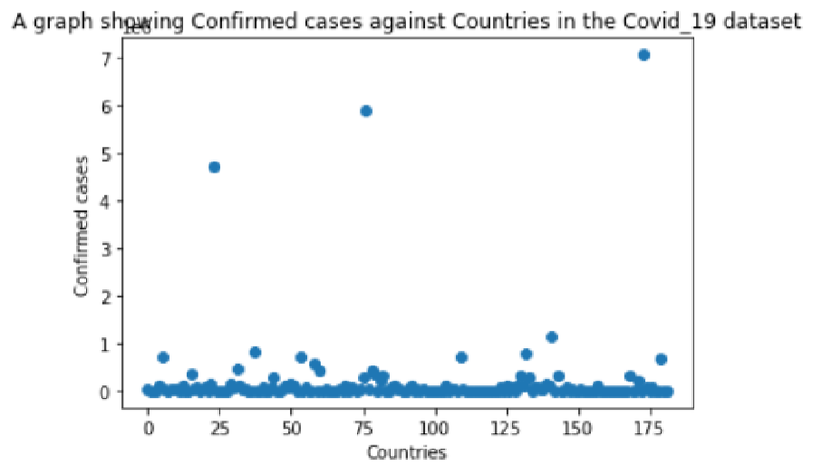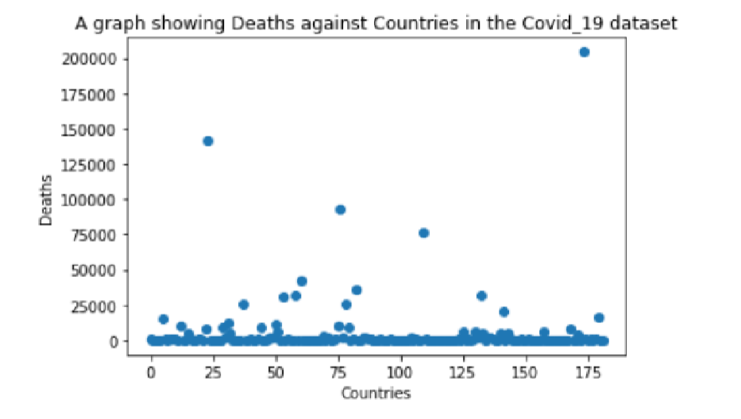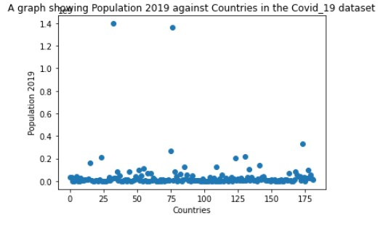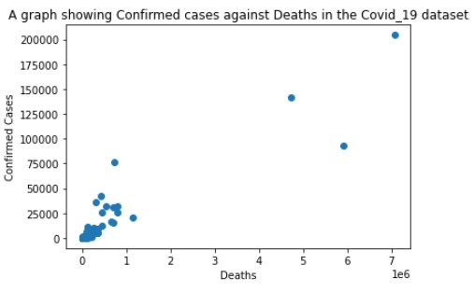

**e) f)**

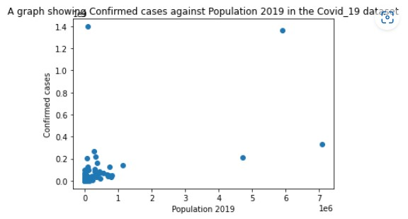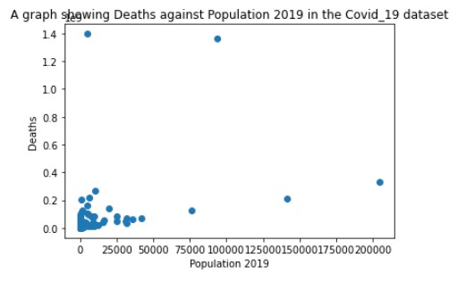

**Description of the data according to the user variables;**

* Population 2019
* Confirmed cases
* Deaths

1. The number of confirmed cases is very high in countries between 150 and 175. Basing on the scatter graph of confirmed cases against the population 2019, there is a positive relationship because as the population increases, the confirmed cases are also increasing due to related factors of heavy population in different regions across the globe.
2. Deaths are very high in low income countries. With the variation of deaths and population 2019, the number of deaths increases as the population increases especially in high income countries. In low income countries across the globe, there were relatively low deaths rates though they had relatively high population.
3. Basing on our analysis population is relatively many countries across the globe. Population does not rely on the income group of the countries.
4. Variation of confirmed cases and deaths shows that as the confirmed cases increase, the deaths also relatively increase in some regions across the globe. The deaths rates relatively decrease in some regions though there are high confirmed cases.

**Model**

We want to regress the population 2019 by the deaths of Covid-19 because with our analysis, we realised that most countries across the globe suffered relatively high death rates. There was a relatively positive relationship between the Population 2019 and the deaths.

Basing on the results, Deaths are very high in low income countries. With the variation of deaths and population 2019, the number of deaths increases as the population increases especially in high income countries. In low income countries across the globe, there were relatively low deaths rates though they had relatively high population.

We perform a hypothesis test on the chosen variables:

* Population 2019
* Deaths

Under the null hypothesis, High-income countries across the globe incur the most deaths and confirmed Covid-19 cases since they attract a large population. For our data, in low-income countries across the globe, there were relatively low death rates though they had a relatively high population.

This provides sufficient evidence for rejecting the null hypothesis as we conclude that the covid-19 case types have no statistically significant association with the population and the economy of different countries across the globe.

We perform a simple linear regression model after combining the actual values and the predicted values as shown using the scatter plot below.

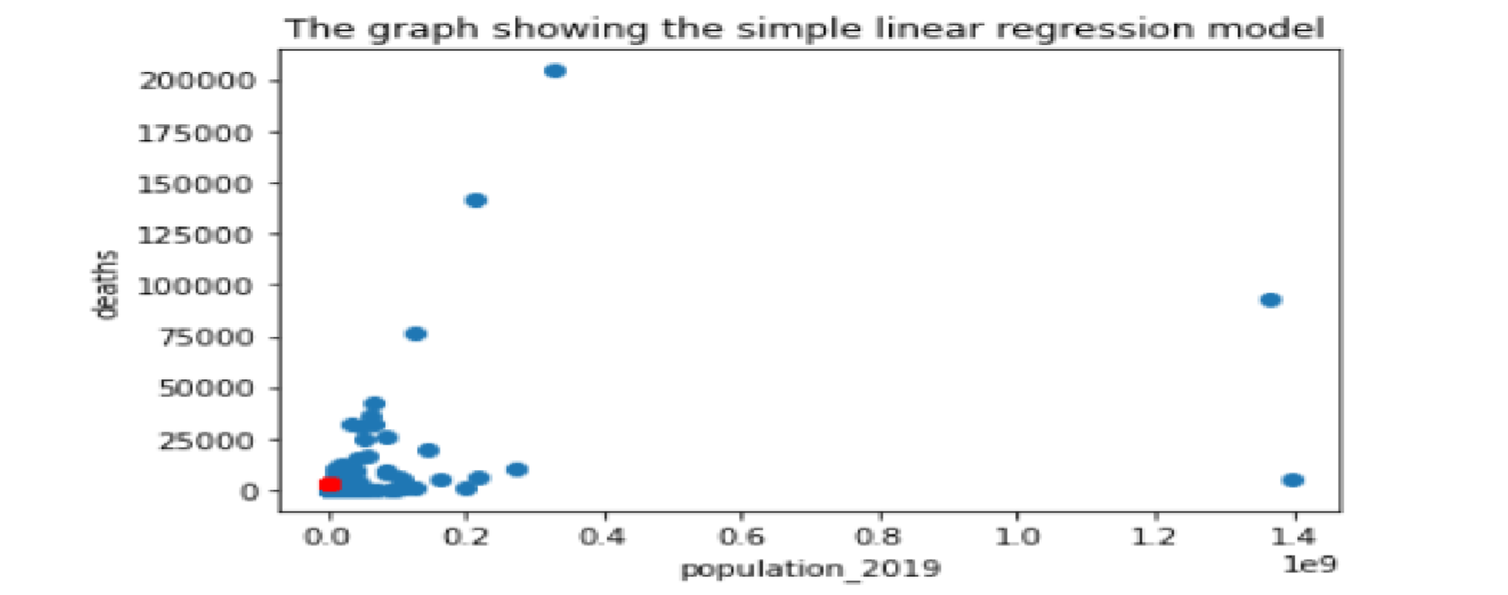

With the predicted values in red color and actual values in blue color, the plot shows a relatively perfect regression coz our model is not over predicted with no outliers and predicted values in line with the actual values at the starting point.

The table below shows the results of the summary of the used variables of population 2019 and deaths.

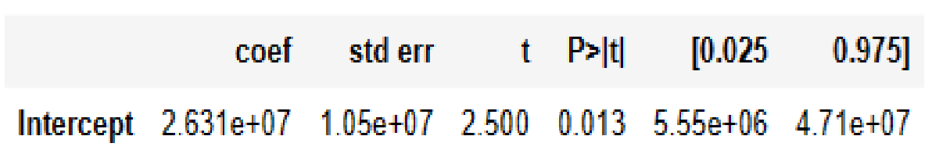

Basing on the results, the summary includes the difference in sample means of 14.15 the p-values have been appropriately rounded and the 5% confidence intervals around the difference in means. Here we 95% certain that the true difference between population 2019 and deaths is somewhere between 19.80 and 21.09..

The efficiency, accuracy, and consistency of the data assume that the square matrix  of the errors is correctly specified.

The condition number is large, 10.09. This might indicate that there are strong multicollinearity or other numerical problems.

**Conclusion**

We have analysed the relationship between the population of different countries across the globe and the different Covid -19 case types. Using a linear regression model, we arrived to the conclusion, that relatively high population in different countries across the globe where highly affected by the different case types; deaths and confirmed cases. Changing the model specification does not seems to have a significant effect on the parameter of interest.

The results of the study basing on the dataset will be beneficial to medical personals who would want to know how different regions were affected by covid-19.

**References**

1. Chan JF, To KK, Tse H, Jin DY, Yuen KY. Interspecies transmission and emergence of novel viruses: lessons from bats and birds. Trends Microbiol. 2013 Oct;21(10):544-55.
2. World Health Organization. *Coronavirus Disease (COVID-19)* (2020). Available online at: <https://www.who.int/news-room/commentaries/detail/transmission-of-sars-cov-2->.
3. Chen N, Zhou M, Dong X, Qu J, Gong F, Han Y, et al. Epidemiological and clinical characteristics of 99 cases of 2019 novel coronavirus pneumonia in Wuhan, China: a descriptive study. *The Lancet.* (2020) 395:507–13. doi: 10.1016/S0140-6736(20)30211-7
4. Cao W, Fang Z, Hou G, Han M, Xu X, Dong J, et al. The psychological impact of the COVID-19 epidemic on college students in China. *Psychiatry Res.* (2020) 287. doi: 10.1016/j.psychres.2020.112934
5. Pieh C. O.', Rourke T, Budimir S, Probst T. Relationship quality and mental health during COVID-19 lockdown. *PLoS ONE.* (2020) 15:e0238906. doi: 10.1371/journal.pone.0238906
6. UNHCR (2020) ‘Uganda: UNHCR COVID-19 response’, bi-monthly update. UNHCR: Uganda. Available at: https://reliefweb.int/report/uganda/uganda-unhcr-covid-19-response-bi-monthly-update21-july-20 (accessed 22 October 2020).
7. Olayinka O, Ogunleye O, Basu D, et al. (2020) 'Response to the Novel Corona Virus (COVID-19) pandemic across Africa: Successes, challenges and implications for the future', Health and wellbeing, Glasgow. Available at: www.frontiersin.org/articles/10.3389/phar.2020.01205/full/utm (accessed 25 September 2020).
8. GoU (2020h) ‘The Public Health (Control of COVID-19) Rules, 2020 Arrangement of Rules’, Ministry of Health: Kampala. Available at: www.health.go.ug (accessed 22 October 2020).
9. GoU (2014) ‘National Population and Housing Census’, Uganda Bureau of Statistics: Kampala. Available at: www.ubos.org (accessed 22 October 2020).

[https://towardsdatascience.com/simple-explanation-of-statsmodel-linear-regression-model-summary-35961919868b#:~:text=Covariance%20type%20is%20typically%20nonrobust,with%20respect%20to%20each%20other](https://towardsdatascience.com/simple-explanation-of-statsmodel-linear-regression-model-summary-35961919868b" \l ":~:text=Covariance%20type%20is%20typically%20nonrobust,with%20respect%20to%20each%20other" \t "_blank)