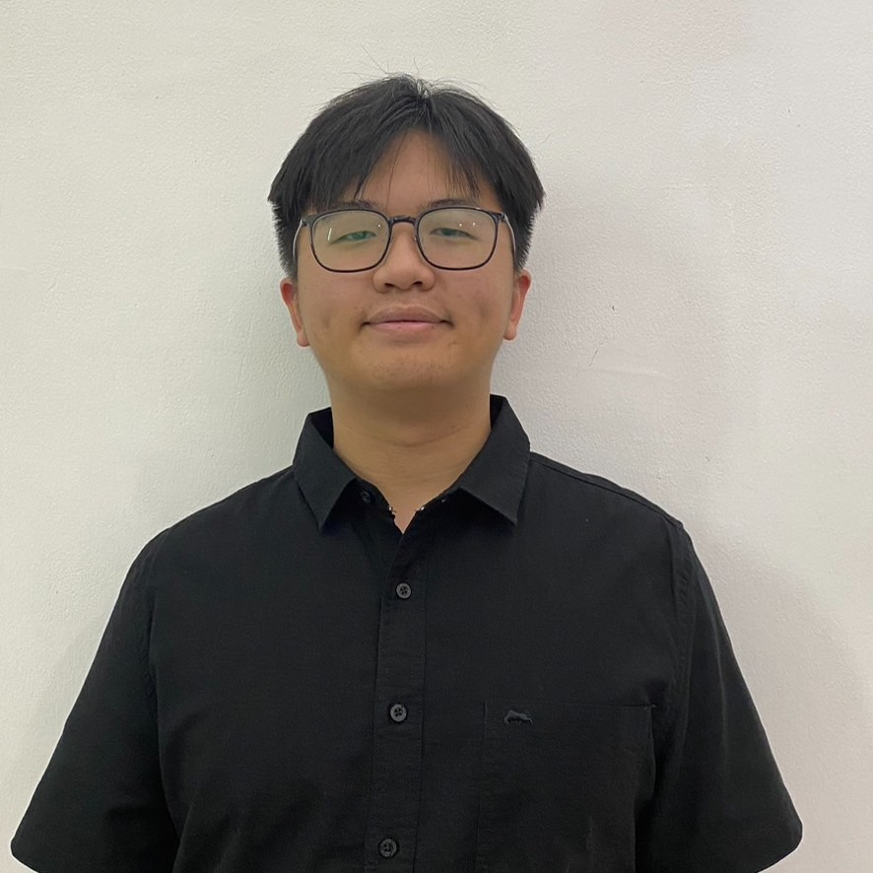CHARLES WIJAYA

081938363287 | [charleswijaya04@gmail.com](mailto:charleswijaya04@gmail.com) | https://[www.linkedin.com/in/charles-wijaya-653955285/](http://www.linkedin.com/in/charles-wijaya-653955285/) Dukuh Kupang Timur XV / 60

I am a Data Science and Analytics student at Petra Christian University with expertise in data analysis, machine learning, and software development. I have experience in processing, analyzing, and visualizing data using programming languages such as Python, SQL, and R. Additionally, I have experience in application development using backend frameworks like Laravel and Node.js, as well as frontend frameworks like React, Vue.js, Tailwind, and Bootstrap. I am passionate about continuously learning and developing innovative solutions in the fields of data and technology.

# Work Experiences

**Petra Christian University** Jul 2023 - Present

*Assistant Lecturer*

I am deeply appreciative of the chance to serve as an Assistant Lecturer at Petra Christian University. In this role, I have actively contributed by supporting faculty members in teaching students who face difficulties in certain subjects. By providing additional guidance, I aim to help students overcome their challenges and enhance their understanding of the material. This collaborative effort not only supports the teaching staff but also enriches the students' learning experience, ultimately contributing to their academic success.

**Petra Christian University** Jul 2024 - Present

*Lab Assistant*

I work as a lab assistant at Universitas Kristen Petra, where my primary responsibilities include managing the laboratory and handling administrative tasks to support academic activities. In this role, I ensure that all lab equipment functions properly and is ready for use, while also helping maintain a conducive learning environment. Additionally, I assist lecturers with administrative tasks such as preparing course materials, tracking student attendance, and assisting in report preparation. Through this role, I have developed skills in management, coordination, and improving operational efficiency in the lab.

# Education Level

**UK Petra - Jl. Siwalankerto No.121-131, Siwalankerto, Kec. Wonocolo, Surabaya, Jawa Timur 60236**

*Bachelor Degree in Petra Christian University, 3.97/4.00*

# Organisational Experience

Jul 2022 - Jul 2026 (Expected)

**Informatics Rally Games and Logic 2024 - Surabaya** Feb 2024 - Nov 2024

*Coordinator of IT Division*

I have also been instrumental in coordinating the development of both the website and the game to be used for the event. My responsibilities included overseeing the design and functionality of the website to ensure it meets the needs of the event and facilitates effective communication with participants. Additionally, I contributed to the creation of an engaging and interactive game that complements the training objectives. By managing these projects, I aimed to enhance the overall event experience, making it more interactive and accessible for all attendees. My involvement in these tasks underscores my commitment to delivering a well-organized and impactful event.

**Servant Leadership Training Petra Christian University - Surabaya** Dec 2023 - Feb 2024

*Coordinator of IT Division*

Servant Leadership Training is a key event designed to prepare new students for their roles in future organizational activities and committee work. As part of my contribution to the Servant Leadership Training, I have played an active role in coordinating and assisting with the development of the event's website. This site is designed to provide clear and organized information to participants, including the event schedule, training materials, and other important details. The website aims to enhance communication between the organizers and participants, making the training experience more efficient and professionally managed

**Epiclair PCU** Nov 2023 - Jun 2024

*Member of IT Division*

Epiclair PCU is an exciting competition designed to test the skills of students in both sports and the arts. This event brings together talented individuals to showcase their abilities in a variety of disciplines, offering a platform for them to shine and compete at their best. As part of the organizing team, I have contributed to the development of the event's website, specifically focusing on the registration process. My role involved creating a user-friendly and efficient registration system to ensure a smooth and seamless experience for all participants.

**BEM 2023 - Surabaya** Jul 2023 - Jul 2024

*Member of Information System Department*

BEM (Badan Eksekutif Mahasiswa) is an organization dedicated to fostering the growth of students at Petra Christian University and overseeing extracurricular activities within PCU. I am honored to have been entrusted with the role of member of Information Systems within the BEM organization. Our mission, within the Information Systems department, is to develop systems that facilitate both internal and external activities of the organization. For instance, this involves creating websites to streamline bureaucratic processes within our university and enhancing administrative tasks within the organization.The Information Systems team within BEM will be utilizing frameworks for both backend and frontend development, specifically Laravel and ReactJS.

**Informatics Rally Games and Logic 2023** Feb 2023 - Nov 2023

*Member of IT Game Division*

Informatics Rally Games and Logic 2023, a dynamic competition where participants have the chance to play and enjoy a variety of games developed by students. In this event, students have created and developed their own games using platforms

like Unity, showcasing their creativity and technical skills. As a contributor to this initiative, I have developed one of the featured games, focusing on delivering an engaging and innovative gaming experience.