STRUCTURE TASK

LAB-1A: Structure Modeling Basics

Objective
After This Lab Students will be able to Place Linear members, Place Member system with Frame connections, use Copy / Paste command, place split and place assembly connections.
Note: Use the grid system to help you place the structural members. Though not absolutely necessary, grids help in the modeling process by providing SmartSketch intersection points at which structural members can be placed. You may also want to make a relationship with gridlines so that if a gridline is moved, everything associated with that gridline will move also.

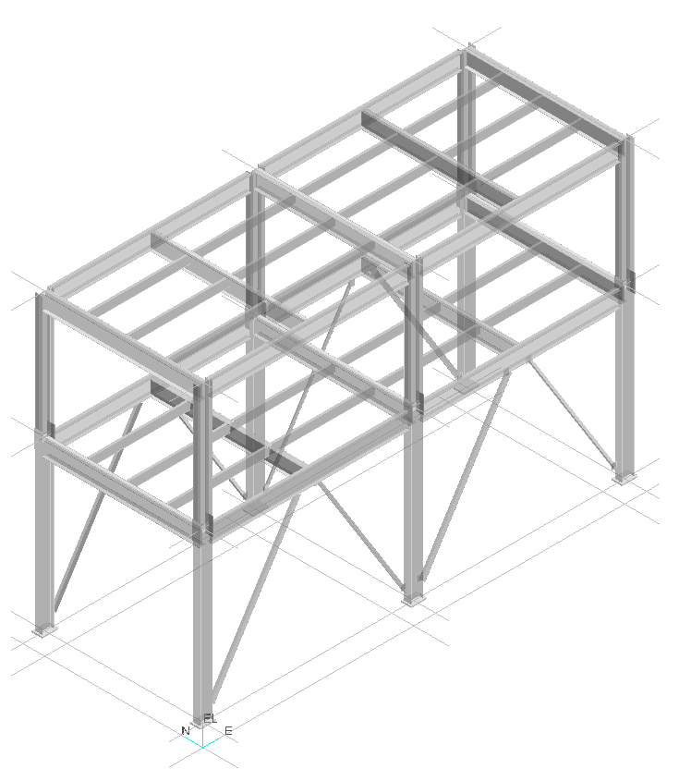

Placing Columns / Splits / beams
- Open or create a session file and define an appropriate filter for your workspace
- Go to the Structure Task environment. Make sure the Active Permission Group is set to Structure
- Select the place linear member system command. Use the views shown in figure 1 to place the appropriate support columns and beams.
- System displays the place linear member system smart step ribbon bar.
- Use the ribbon bar and set the active member parameters as follows:

Connection: By Rule
Type Category: Column
Type: Column
Section Name: W14x53
Cardinal point: 5
Angle: 0 deg
System: Area2->Unit 2 -> Structural -> Columns.

- Place the first column end at the grid intersections Elevation 2’ 1”.
- Place the second column end at the grid intersections Elevation 30’ 0”
- Repeat the above steps to place the other support column.
Select Place Split command
- Split Status: By Rule
- Select the 18’-0” Elevation Plane in the Workspace Explorer or the Ruler
- Select the members to split and click Finish.
- Choose the Select command and change the Locate Filter to Split Connections. To see the connection highlighted, move your cursor over the split
- Select Place Member Command
- For Beams use the Ribbon Bar to set active properties as
Connection: By Rule
Type Category: Beam
Type: Beam
Section Name: W18x40
Cardinal point: 8
Angle: 0 deg
System: Area2->Unit 2 -> Structural -> Beams.

Note: The next step is to place the first two beams at elevation 18 ft and elevation 0 ft. Beams are placed by selecting and lock constraint on to the column and then locate point-on any grid line passing through that column. Beams can also be placed by selecting Frame connection of Supporting members.
- Place Beams at Elevation 18’ and 30’
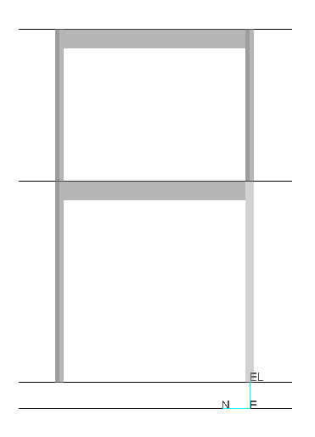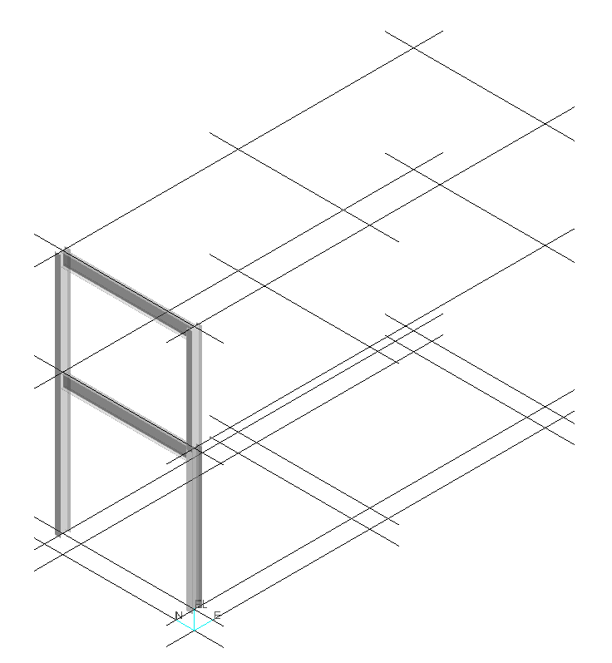
Figure 1 – Elevation and Isometric View of the Structure Unit 2 System
- Set the select filter to Member System
- Select all the members
- Select Copy
- Select paste
- Re-establish all the relation ship with East Plane locations 20’ 0” and 40’ 0”. See figure 2. Make sure to select the appropriate objects to re-establish the connection in the Paste Special Dialog box.

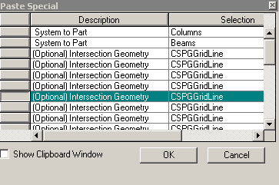

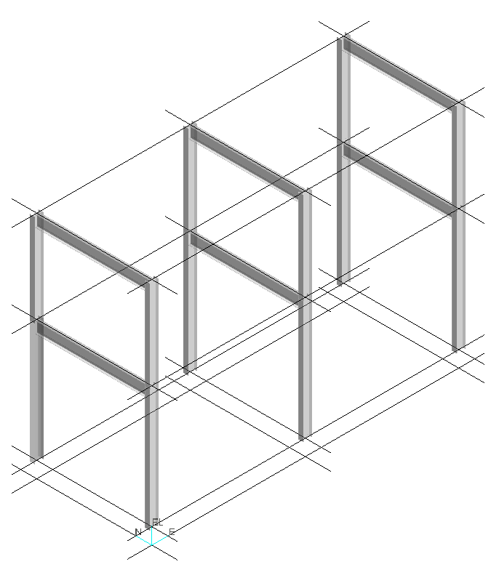
Figure 2 –Isometric View of the Structure Unit 2 System
Placing Perimeter Beams:

- Select Place member command to place beams as shown in figure 3. Use following properties for perimeter beams:

Connection: By Rule
Type Category: Beam
Type: Beam
Section Name: W18x40
Cardinal point: 8
Angle: 0 deg
System: Area2->Unit 2 -> Structural -> Beams.

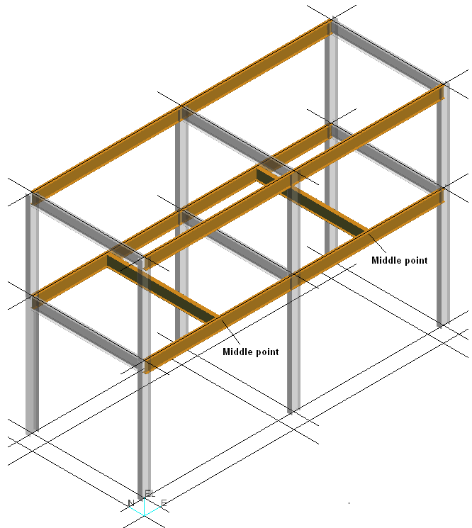

Figure 3 –Isometric View of the Structure Unit 2 System
Placing Intermediate Beams for the first floor frame
- Select the place framing member command. Use the view shown in Figure 4 to place the structural members.
- Use the Place Framing Member ribbon bar to set the active member parameters as follows:
Fit Mode: By Count
Count: 3
Connection: By Rule
Type Category: Beam
Type: Beam
Section Name: C10x15.3
Cardinal point: 8
Angle: 0 deg
System: Area2->Unit 2 -> Structural -> Horizontal Braces

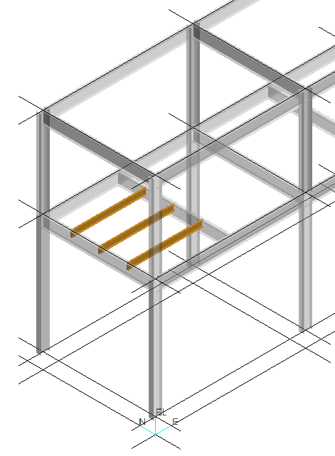
Figure 4 –Isometric View of the Structure Unit 2 System

- Continue using the Place Framing Members command by selecting Supporting Member2 to place framing members as shown in Figure 5.
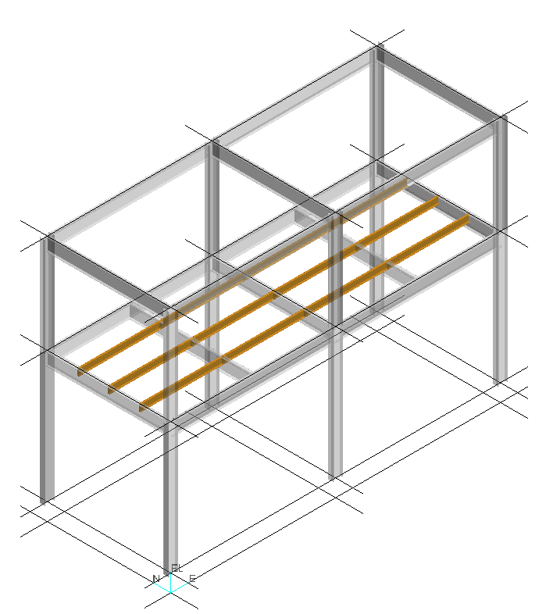
Figure 5 –Isometric View of the Structure Unit 2 System

Intermediate Beams for the second floor frame

- To place the intermediate beams for the second floor frame at elevation 30 ft, Use the Copy/Paste command to place all the intermediate members for the first floor frame at elevation 30 ft. See Figure 6. Make sure to select the appropriate objects to re-establish the connection in the Paste Special Dialog box.

Hint: Set the select filter to Member System to select 14 members.
Only 7 related object need to re-establish the connections.
Use the Paste command once.

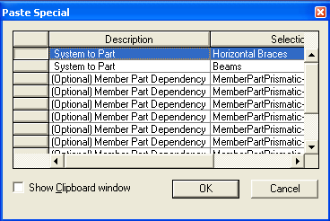

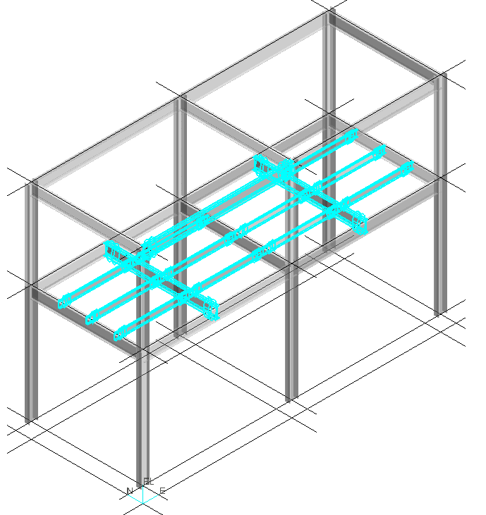
Figure 6 –Isometric View of the Structure Unit 2 System

Your View should now resemble the following graphic:

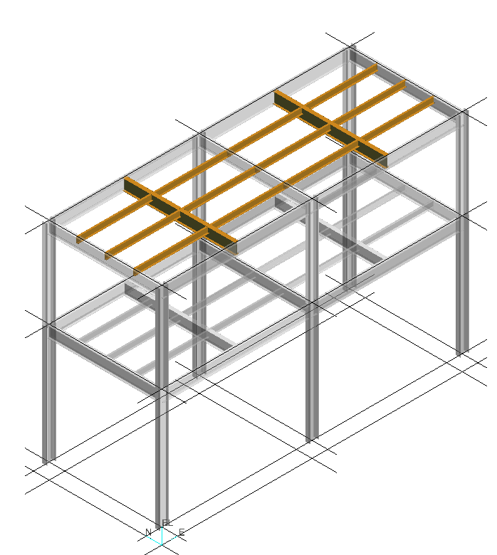

Placing Vertical Braces
- Select the Place Bracing command.
- Use the Place Bracing ribbon bar to set the active member parameters as follows:

Bracing Type: Chevron
Connection: By Rule
Type Category: Brace
Type: Vertical Braces
Section Name: L4x4x1/4
Cardinal point 5
Angle: 0 deg
System: Area2->Unit 2 -> Structural ->Vertical Braces
- Select the first column (as in figure 7)
- Select the second column
- Select the Beam
- Select Finish
- Place all vertical braces shown in figure 7

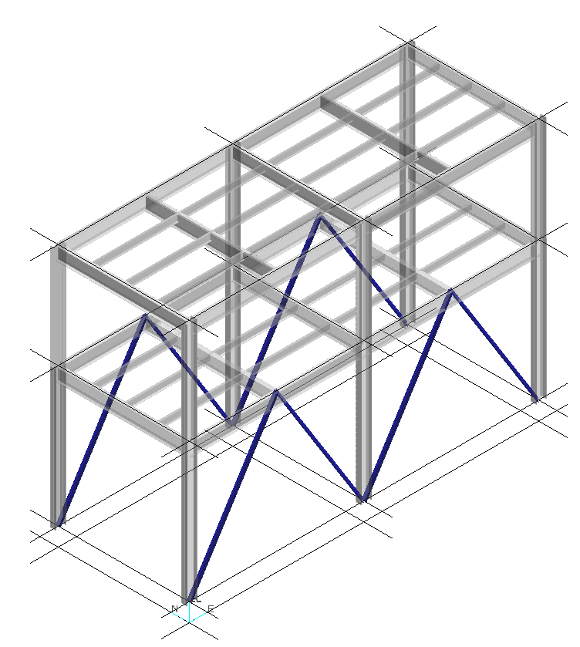
Figure 7 –Isometric View of the Structure Unit 2 System

Placing Assembly Connections
- Set the select filter to Frame Connections and use the select fence option to select all frame connections located in the building
- Select the Assembly connection command to open the ribbon bar
- Make sure the check box by rule is checked
- Place all assembly connections in System: Area2->Unit 2 -> Structural -> Assembly Connections
- Select Accept command
- Select Finish

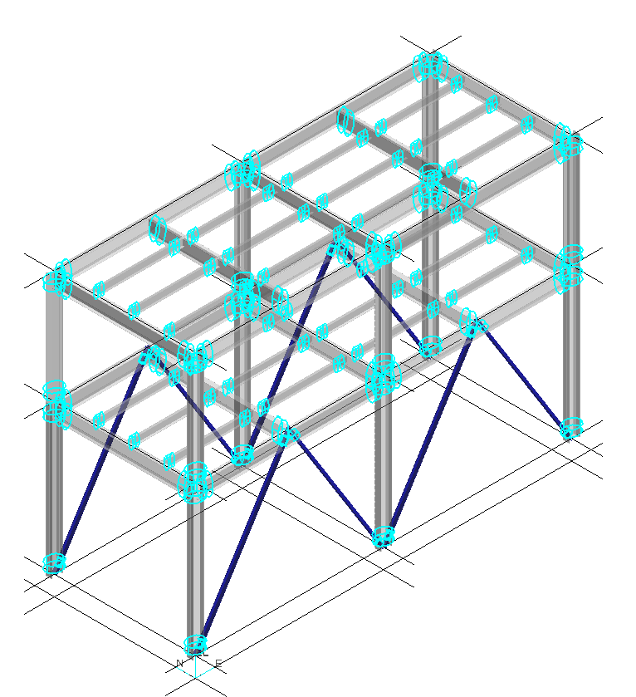

- Verify all assembly connections are properly created.

Your View should now resemble the following graphic:

