CLIFFSIDE- EXPORTING SP3D ITEMS TO MICROSTATION 3D

- In Drawings and Reports task create a folder for Microstation dgn exports. E.g. “DGN”
- Right click the new folder and select “New”
- In add component form that appears select Microstation 3D DGN and OK
- Rename the component that appears to reflect the target contents. E.g. The name of the piping system to be exported or the name of the eqp item(s) to be exported
- For this example, we’ll extract a piping system XX. Right click on XX and select setup
- In the Setup form select seed file “mdlsdz”
- In the Style pulldown select “Orthographic\3D to DGN Piping Only” (Shaw style)
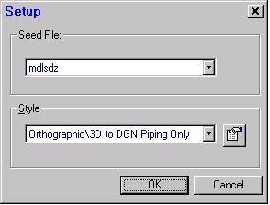
- Switch Tasks to Space Management
- Make sure that the active workspace shows the piping system (or any other graphic items) to be sent to Microstation 3D dgn
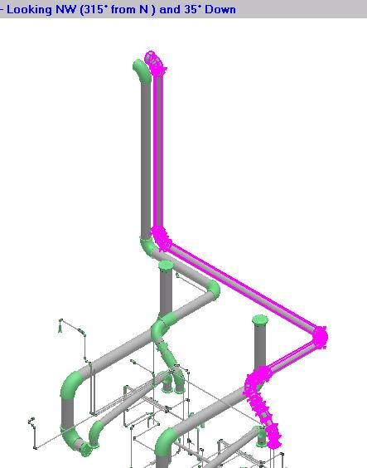
- A Plant filter named 4-EXPORT_TO_DGN is available for editing in order to find the item(s) for export. User can access it using Tools>Select by Filter.
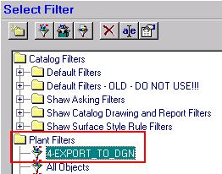Edit this filter definition as needed (System and if desired Object Type tabs) to select items for export. This is a required step, as this filter will determine what graphic items to include from within the volume to be defined next.
- From side bar menu select “Place Drawing Volume by Selection” command (third from the bottom)
- Under Drawing Type select more…
- Navigate the volume drawing type form that appears to the drawing component created in step 4 above
- Under Space Folder select more…
- Select the Database button and then select 120631>00>65>Dewatering>DW_Piping and OK
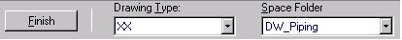
- The system prompts to “Select object(s)…” Select the opposite ends of the item(s) for export. A volume will be displayed showing the extents of the volume to be exported to dgn
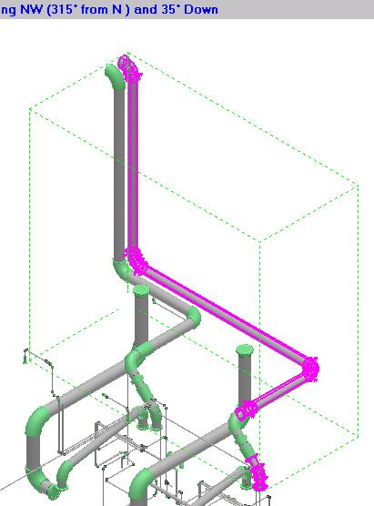
- Select Finish to commit the volume to the database.
Note that the volume may enclose other unrelated graphic items. The filter defined in step 10 above “4-EXPORT_TO_DGN” will take care of excluding these extra items from the Microstation dgn output file
- Return to the Drawings and Reports task
- Right click on the DGN folder created in step 1 above and select “Create Drawings”
- Select the drawing definition containing the export; in this example it was named XX in the previous steps
- Right click XX and select Update Now
NOTE: Microstation will be opened during the export process. Don’t close it or interact with it, it will close automatically when process completes
- Double click the output file once update completes and it appears with a green check mark on it. Use the Microstation Fit-all command to review the contents
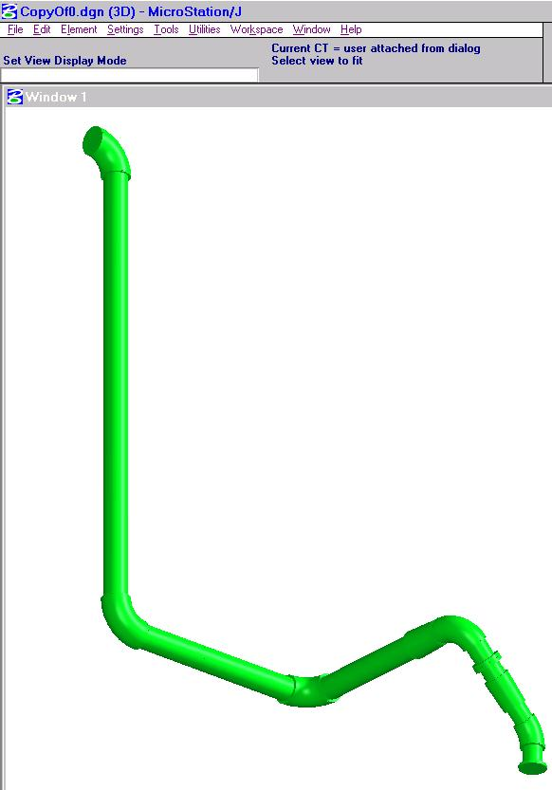 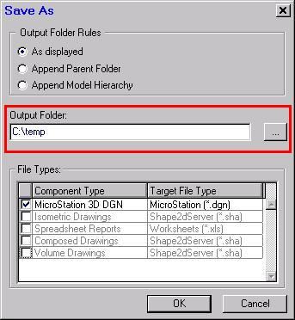
- This Microstation output is stored in the database. To generate a file to send to other disciplines right click on the output file, e.g. XX, and select Save As…
- Use the … button to select the output folder for the 3D dgn file and OK. System will confirm that 1 document was saved
Note: This example focused on piping from DW area. Simply change filter 4-EXPORT_TO_DGN and the volume creation process to select other piping from anywhere in the model. You’ll need to request a view style specific to a discipline from CAE for eqp, str or elec exports. Currently only “Orthographic\3D to DGN Piping Only” view style is ready for use.

