The piping has female EndPrep at port 1 and male port at port 2 with a specified flow direction from port 1 to port 2. This means that there should be a female port at the start point and a male port at end point.

Insert a Tee45deg in the vertical run as shown below. The horizontal run ends on the centerline from the Tee and has ports as expected.
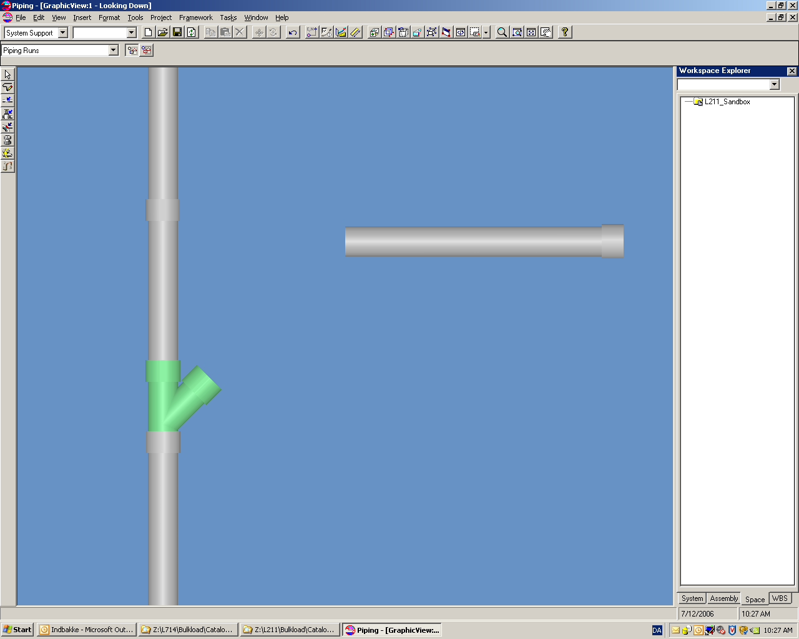
Continuing the horizontal run down to but not connected to the branch port creates a 45 deg elbow and a pipe part with ports as expected.
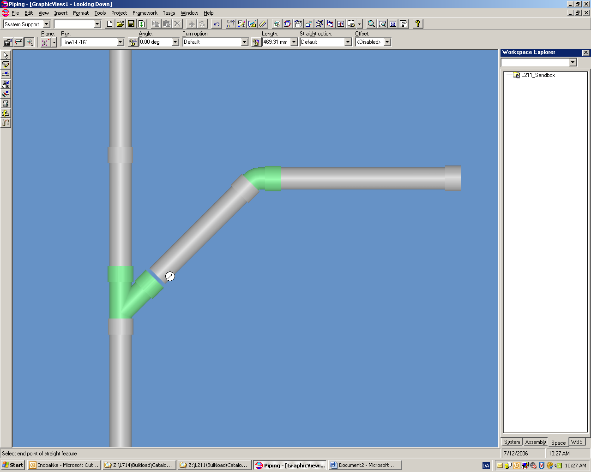
Connecting the horizontal run to the Tee branch port….
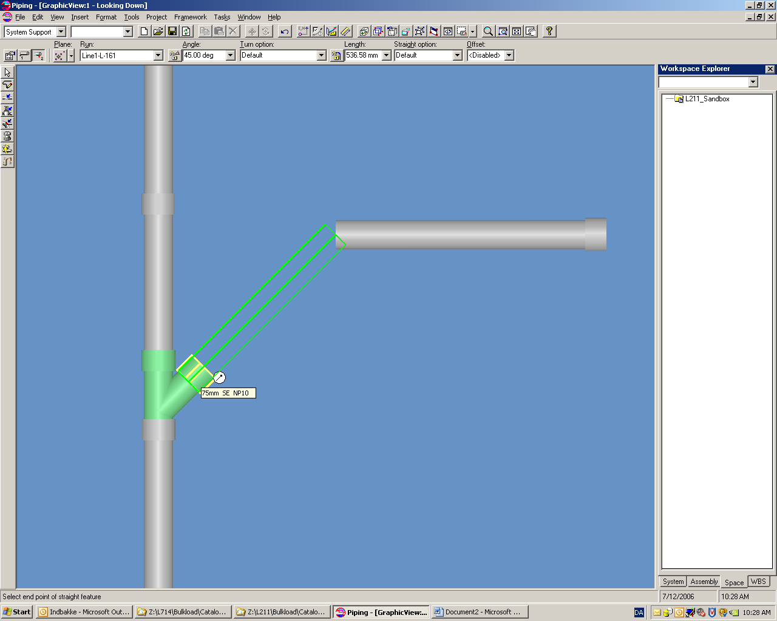
reverses the piping parts but not on the elbow on the branching run. The flow direction has no influence on this behavior.
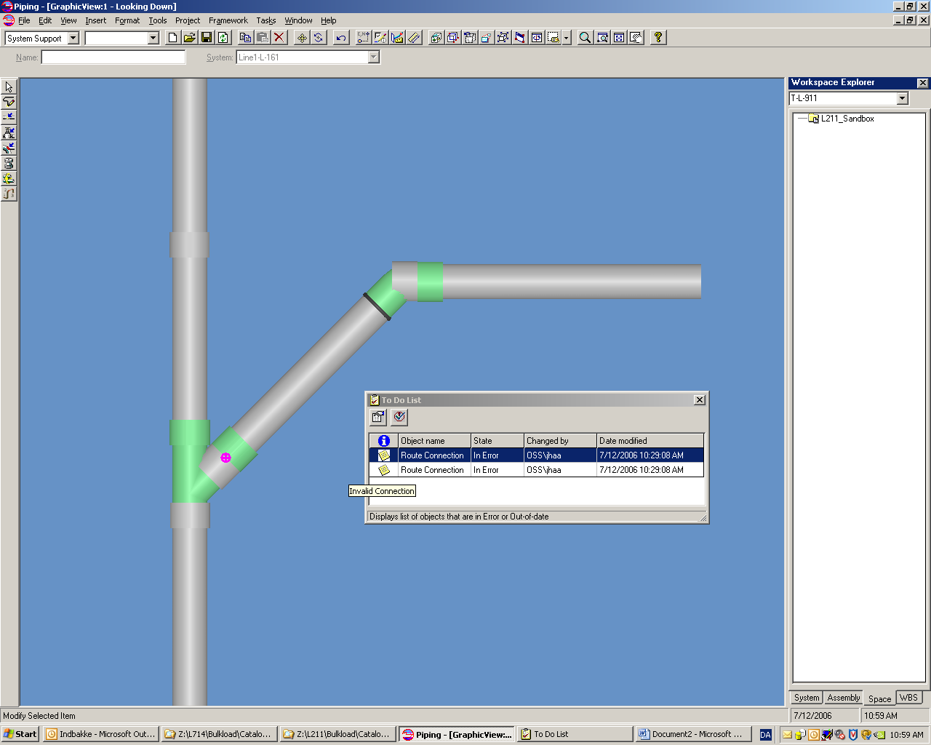

The female-female connections go to the ToDo list.

