Piping with different EndPrep at port 1 and 2 often has a specific flow direction. In this case the piping is specified with a female port and a male port. The flow direction is defined by inlet at the female port and outlet at the male port.

Creating a pipe run using this pipe definition and inserting a 45 deg Tee works fine. The Tee and the sleeves on the parts are correct according to the flow direction.
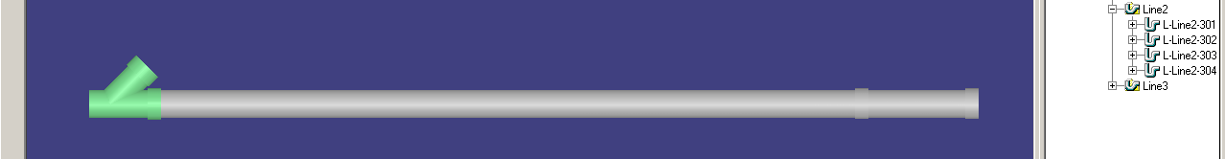

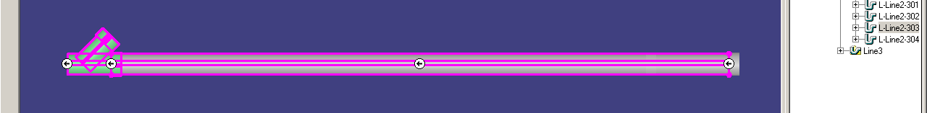

If the flow direction is changed the sleeves are moved (correct).
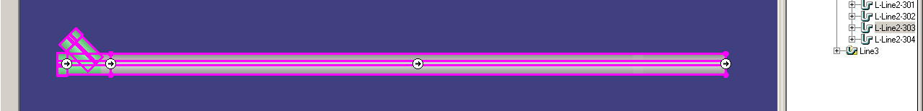

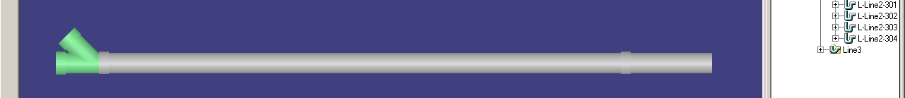
It is however not in all cases the sleeves on the piping parts are moved correct when the flow direction is changed.
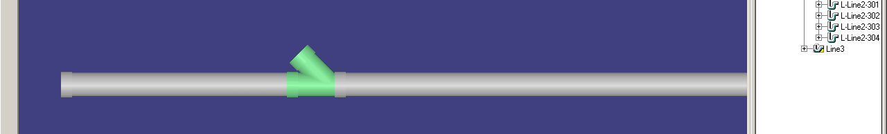

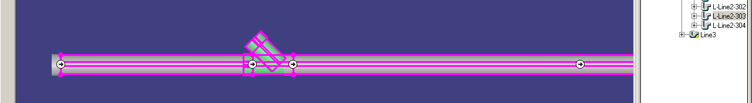

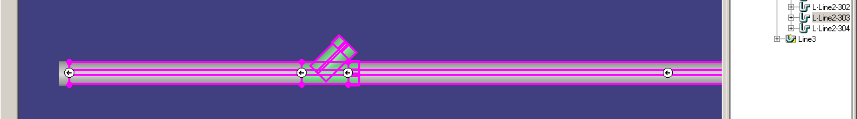

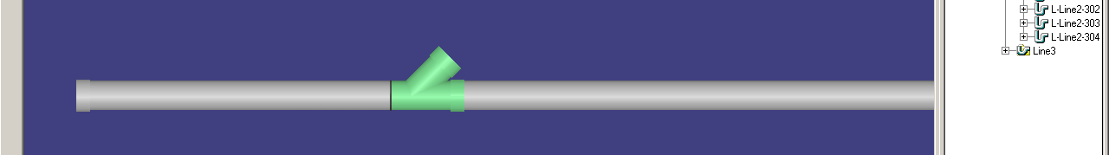

The sleeves on the first straight feature (from where the run was created) on the pipe run are not updated correct.

