PIPE SUPPORTS ORTHO REVISION
VIEW REVISION
After extraction, the supports drawings may be annotated, and the views orientation can be revised. If such is the case, the Update command must be used for the orientation revision to take effect. Manual annotations will be preserved if placed in the Default layer.
- Edit the support ortho just extracted, change the Iso view orientation to Southwest.
  - Open the drawing for edit
  - Window-in to the iso view of the support
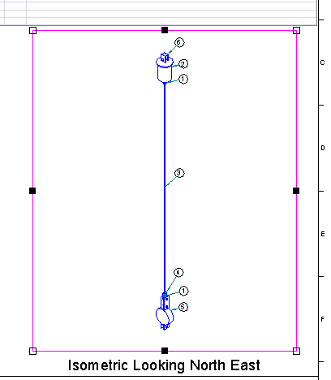
  - Right-click the iso view’s frame and select Properties
  - Change the view’s orientation to Looking Southeast and OK
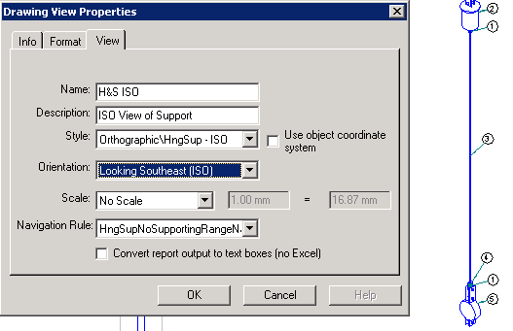
  - Save and exit the support drawing
  - Right click the drawing just revised and select Update Now
  - Once the update completes, enter the drawing and verify that the orientation was revised successfully
  - Select View>Background Sheets from the main menu
  - Edit the name of the view to “Isometric Looking South East” (double click the label to enter edit mode)
WARNING: Running Update Now again on this drawing will reset this label back to “North East”, as this label comes from a template. Shaw templates will not have this orientation hard-coded, but Intergraph templates will.
  - Select View>Working Sheets to return to the active drawing
  - Save and exit the support drawing
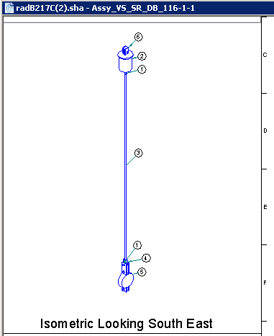

TITLE BLOCK REVISION
To add title block information to the drawing, the information must be saved to the database first. Then the update-now command will take that information and add it to the drawings. This is advantageous in that the user will only enter a set of initials and dates once, for example, which in turn will automatically be propagated to all drawings in a hierarchy, whether a handful or hundreds of them.
- Populate the title block with initials, dates, and miscellaneous information.
  - To modify title block properties, in the Management Console right click U01 and select Properties. In there, set properties common to all drawings under U01.
  - Under the Title Area tab set Company Name, Desc1, Desc2, Title1 and Title2 to any desired values.
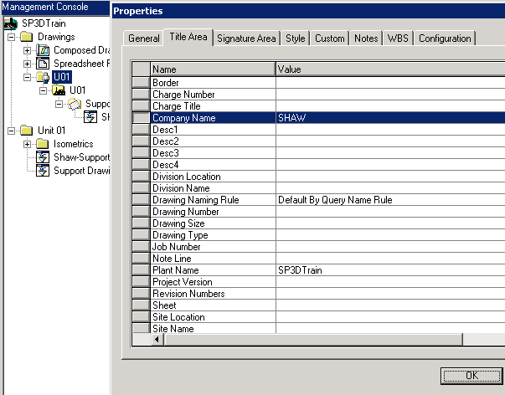
  - Under the Signature Area set Designed, Checked, and Approved fields to any desired values. Information entered here will be inherited by all the drawings under U01at the next Update-Now job.
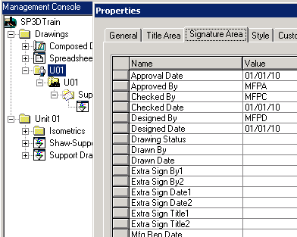
NOTE: In order to enter support properties specific to a single support drawing, the user will need to navigate down the full hierarchy, find the exact drawing needing the information changed, right click on it and use the Properties form. Any data entered this way will override U01-wide or plant-wide generic information like that entered in the steps above.
  - After using the Properties form, the document icon is switched from a green checked document to a crossed out document (meaning out-of-date). Run Update Now to incorporate the title block information into the drawing. After successful completion, enter the drawing in Edit mode and window in to the title block to review it.
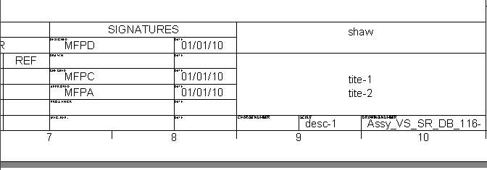
MANUAL ANNOTATIONS
The manual labels command allows the user to select a predefined label that will read a support’s part information from the plant database, and then paste it on the drawing. Users can also use the Text command to add any desired text. There is a requirement that the text be added in the Default layer, so that it is not removed the next time the Update Now command is used to update the drawing.
- Place a manual label using the manual labels command
  - Open a support drawing in edit mode
  - Select the manual labels command
  - From the ribbon bar select “Pipe Supports-Component Reference Circle”, circle enclosure, and leader on as noted below
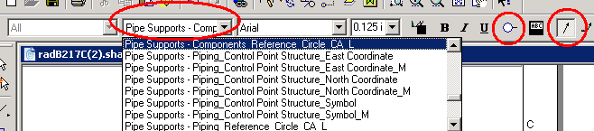
  - Click on a support component and place the callout reference number where needed. Notice it will match the existing reference callout number. This will only be needed when callouts are lost by accidental deletion for example
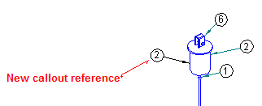
  - To place a name label, in the ribbon menu set the menu options as shown below and click on a support component to place its name label
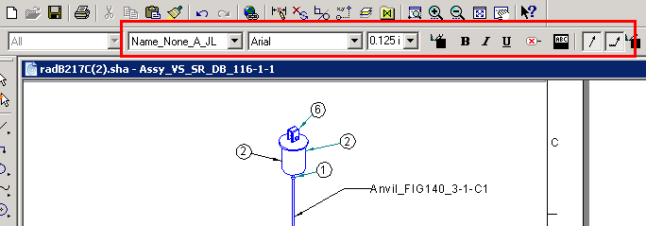

  - To place manual text, set the active layer to Default by selecting in the main menu Tools>Layers
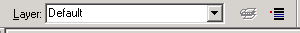
  - select the Text command , and set the text parameters as shown below
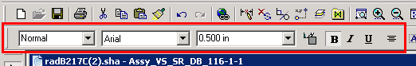
  - Place a review-only note on the drawing:
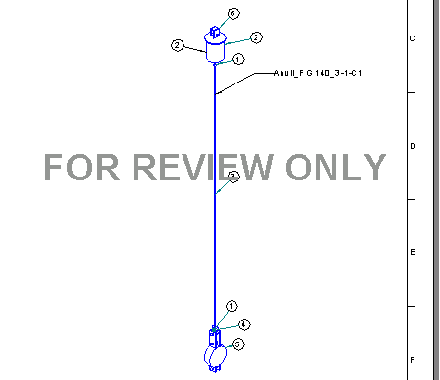
  - Save and exit the drawing
  - Run Update Now on the drawing modified with manual text
  - Enter the updated support drawing, verify that all manual annotations remained after the Update Now command executed successfully.

