PIPE SUPPORTS ORTHO EXTRACTION
- In Drawings and Reports task go to SP3DTrain>Drawings
- Right click Drawings and Select New…
- Pick Drawings By Query manager and OK
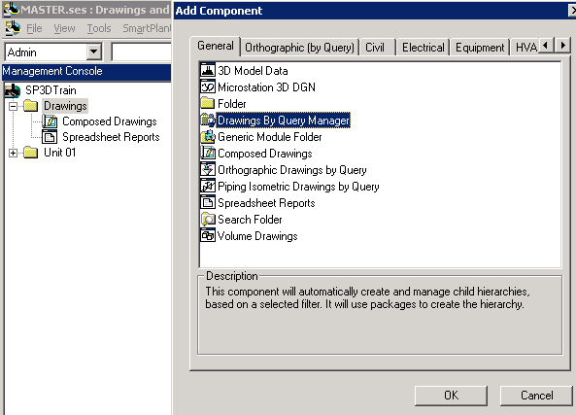
- Rename resulting folder to a logical name like the piping system containing the supports to be extracted, e.g. U01, U02, U03, etc. We will use U01 for this exercise
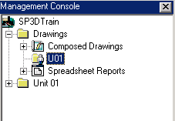
- Right click U01 and select Setup…
- From Filter pulldown select More…
- Select filter: Plant Filters>Training Filters>U01 and OK
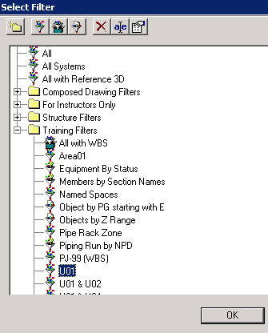
- From Package pulldown select More…
- Select package: “HngSup3View” and OK
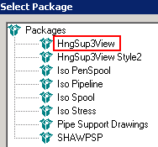
- OK on Setup form
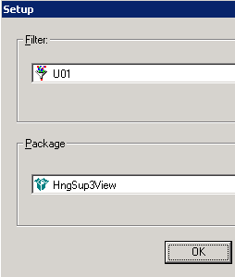
- Right click U01 and select Run Query…
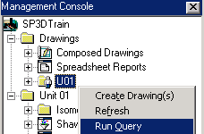
- After Run Query completes, a folder hierarchy is created inside U01, navigate down the subfolders, right click on the “HngSup3View” component (or any other name of the last component in the U01 hierarchy) and run Create Drawing(s)
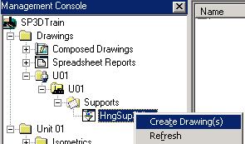
- A drawing named after the existing support(s) in that unit is generated with X on it:. The X indicates that a drawing is not up to date. Right click it and select Update Now.
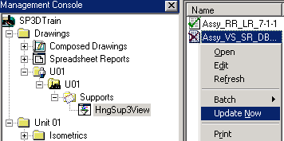
- When update completes, a green check mark appears in place of the X if extraction was successful. A yellow warning sign appears in place of the X if there were errors or warnings. To review or edit the drawing, right click it and select Edit.
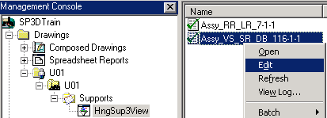
- If there were warnings or errors, right click the drawing and select View Log… Consult with CAE support about the meaning of the errors or warnings.
- The drawing may be annotated, and the views orientation can be revised. If such is the case, Update command must be used for the orientation revision to take effect. Manual annotations will be preserved if placed in the Default layer.
