PIPE SUPPORTS ORTHO EXTRACTION BY VOLUME
This procedure is time consuming, but useful in situations when graphic elements that are normally excluded from pipe support drawings by query need to be shown in a drawing. An example could be the graphics from an equipment item that the support must be attached to. By default supports drawings only show supports, piping, and structural elements. This procedure will capture any graphics from any other discipline that are within the range of the support.
In this example, the hanger’s drawing volume will be customized to show a complete pipe branch being supported.
- In SP3D, change tasks to Space Management
- Select the Create Space Folder command and name it U01volumes. Click Finish to save
- Find the hanger or support to be extracted on a drawing, select it, and window in to it. This example will be using the one support in training plant’s unit U01
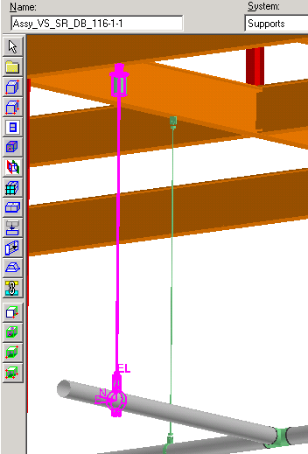
- Select the Place Volume by Selectset command (then click on the hanger if it wasn’t already selected). A wireframe box will appear around the hanger, it will turn solid once its attributes are defined and accepted.
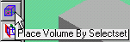
- Give the volume a name, a good idea is the same name as the support, define Type as shown below and set space folder to U01volumes. Click Finish to accept.
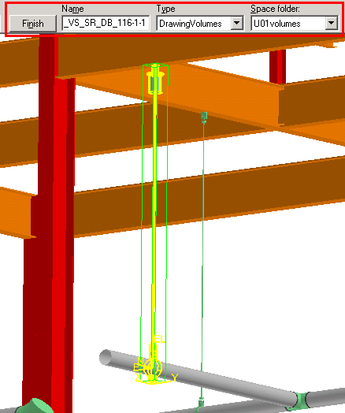
- With the support’s volume box selected, revise the planes of the volume to fully enclose the support, plus the top of the supporting beam, and the piping all the way to the tee.
NOTE: If any graphic item that should not appear on the ortho falls inside the volume, a style rule can be applied that excludes this other type of item during drawing extraction.
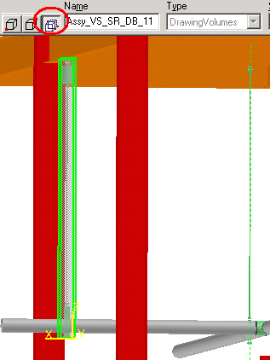=>>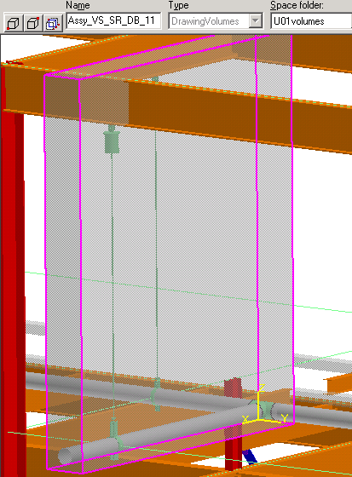
- Next, create a drawing using this volume: Select Tools> Drawing Console
- Right click on Drawings, on the menu select New…
- On the Add Component form, select Composed Drawings and OK
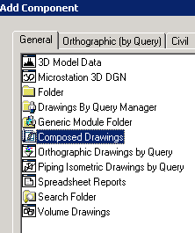
- Right click the New Composed Drawings component just created and select New Drawing
- Name it the same as the support, use the delivered layout and border templates as shown below, then OK
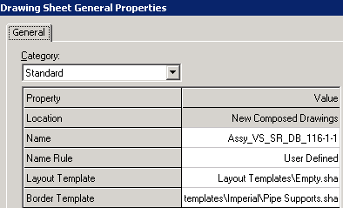
- A blank drawing template appears. Use the Place View command to create 3 views on the drawing for elevations and iso views of the support. The steps below outline the view creation parameters.
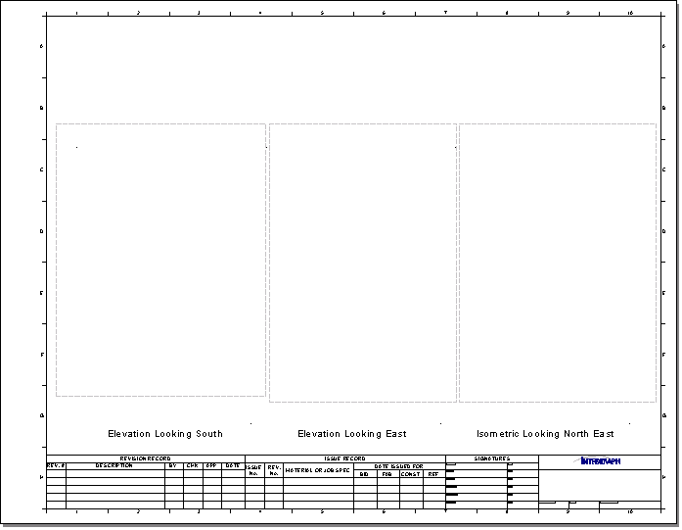
- For the South view, use the following style and parameters (scroll down to find looking direction option):
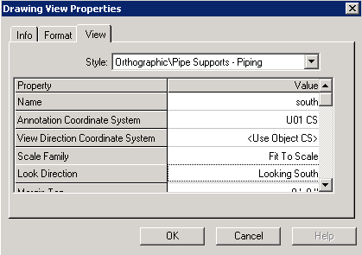
- For the East view, use the following style and parameters:
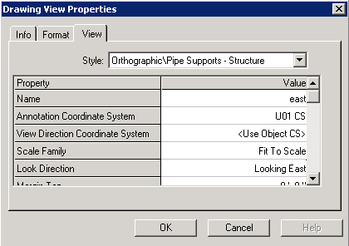
- For the Iso view, use the following style and parameters:
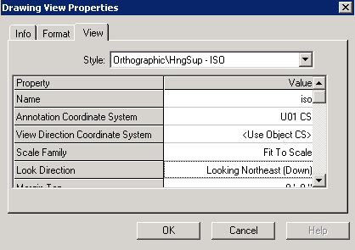
- Create a report view and place it above the iso view using the Place Report View command. Details for the report view are shown in the steps that follow.
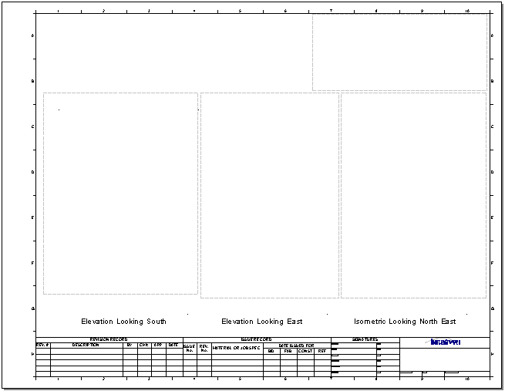
- Use the following report view parameters for a support parts BOM:
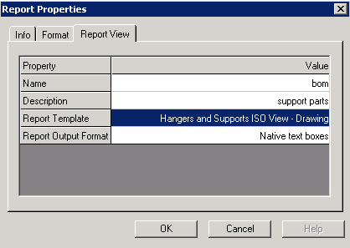
NOTE: Native text boxes are used instead of Excel because they translate as text into MicroStation. Excel report boxes are translated as an embedded image file into MicroStation.
- Create another report view and place it above the east view using the Place Report View command.
- Use the following report view parameters for supporting structure information:
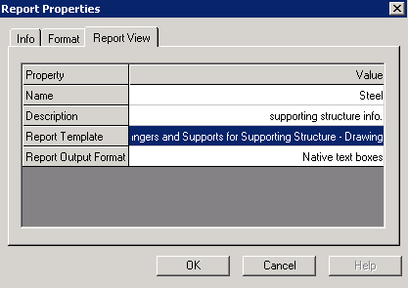
- Create another report view and place it above the south view using the Place Report View command.
- Use the following report view parameters for supported piping information:
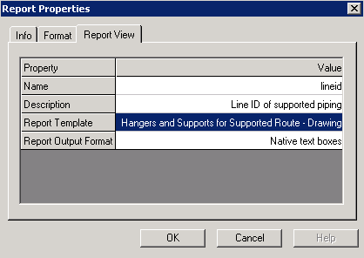
- Select the Looking South view frame in the drawing
- Select Associate Objects to View command
- Bring to front the 3D environment and select the volume around the hanger/support
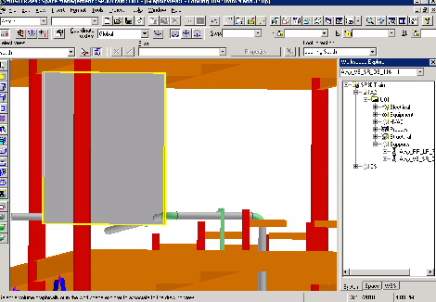
- Bring to front the ortho environment and select the save command . That links the view on the orthographic drawing with the 3D volume around the hanger.
- Repeat the view association process shown above for the East and Iso views
- Select the report view frame above the ortho iso view, then the Associate Objects to View command
- Bring to front the 3D environment and select the iso view, then Finish
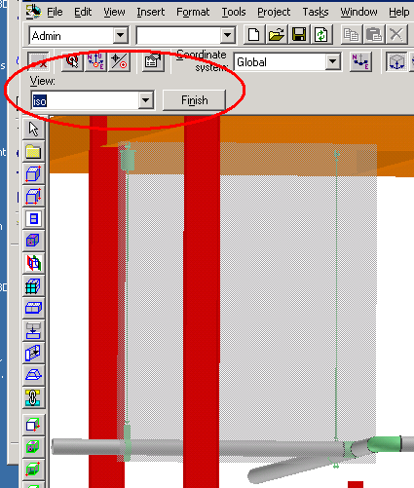
- Bring to front the ortho environment and select the save command .
- Repeat the same procedure to associate the report view above the East elevation view with this same “east” view. This will produce a supporting structure report with a callout number in the East view.
- Repeat the same procedure to associate the report view above the South elevation view with this same“south” view. This will produce a piperun report with a callout number in the South view.
- Save and exit the ortho environment
- In 3D, select Tools>Drawing Console
- Expand the New Composed Drawings component created earlier, the new drawing appears below, right click on it and select Update Now
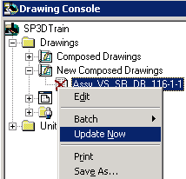
- When the update completes, and a green check mark appears on the drawing icon, right click the drawing and select Edit
- In the drawing, right click the South view’s frame, select Properties from the menu, then in the Format tab turn off the Show Border check box and OK
- Repeat for all the other graphic and report views to turn off their frames
- Drag reports to their proper location if needed
- Drag callout bubbles needing adjustment to their best location. New locations are preserved during future updates
