Notes:

(Last updated 3-28-2019).

Simulated setting: 2 time points, 5 co-exposures at each time point.

Run “AnalysisCode_VB_LKMR_NoWarnings2T.R”. In this file, you can set “Scenario1” and “Scenario2” to TRUE/FALSE depending on which true exposure-response function you want to simulate. This file calls the “DataSimulationCode_VB_LKMR2T5M.R” code, and in this file you can change “N” to a different sample size.

Run “SummaryAnalysis_VB_LKMR2T.R” to output the table comparing estimated h_hat to true_h.

Run “VB_RelativeImportance_5Metals2T.R” to plot the relative importance. The red points are the truth.

Run “VB_Heatmap_5Metals2T.R” to plot the heatmap. It plots the estimated vs. the true heatmaps.

The following pages plot the output for the different scenarios described above:

Page 2: Scenario 1, N = 300

Page 3: Scenario 1, N = 200

Page 4: Scenario 1, N = 100

Page 5: Scenario 2, N = 300

Page 6: Scenario 2, N = 200

Page 7: Scenario 2, N = 100

N = 300, Scenario 1:

> print("VB: Intercept, Slope, R^2, RMSE")

[1] "VB: Intercept, Slope, R^2, RMSE"

> print( round(Summary.MFVB, 2) )

[,1] [,2] [,3] [,4]

[1,] -0.01 0.00 0.00 0.32

[2,] -0.07 0.96 0.96 0.27

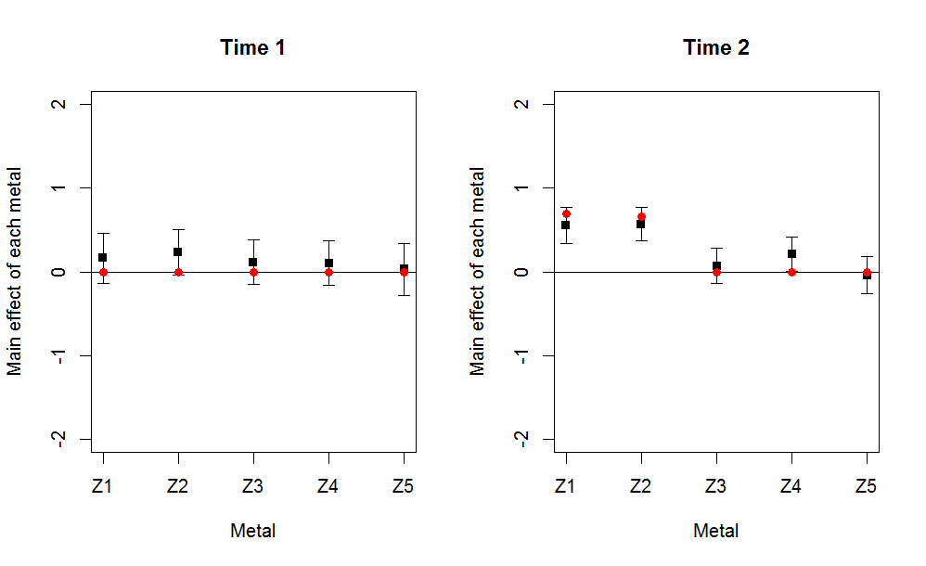

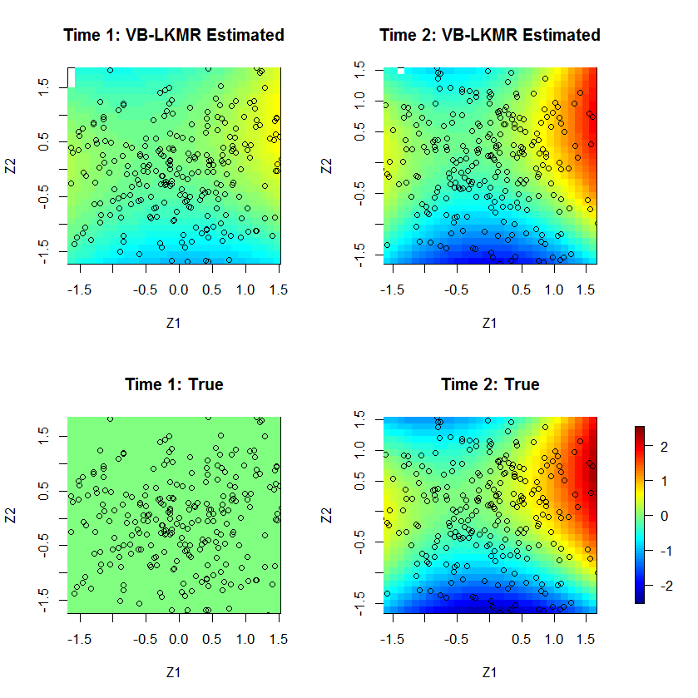

N = 200, Scenario 1:

> print("VB: Intercept, Slope, R^2, RMSE")

[1] "VB: Intercept, Slope, R^2, RMSE"

> print( round(Summary.MFVB, 2) )

[,1] [,2] [,3] [,4]

[1,] 0.03 0.00 0.00 0.39

[2,] 0.06 0.92 0.92 0.35

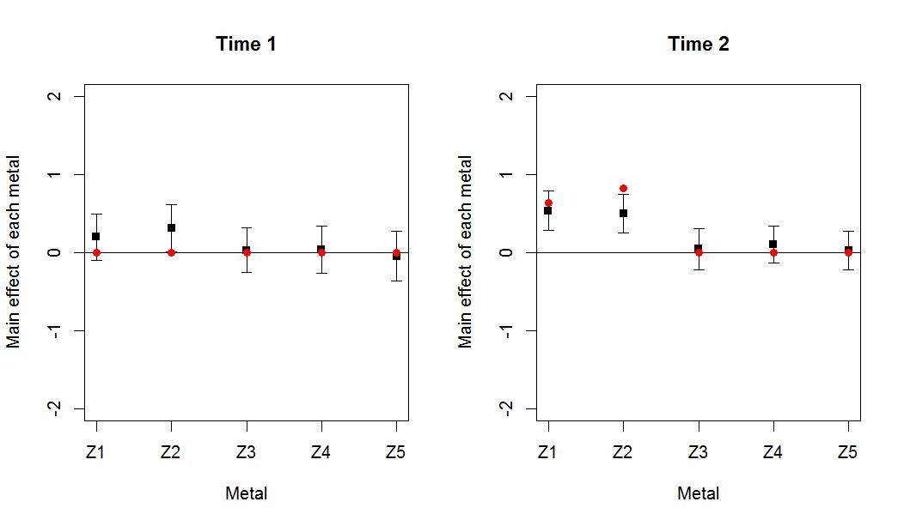

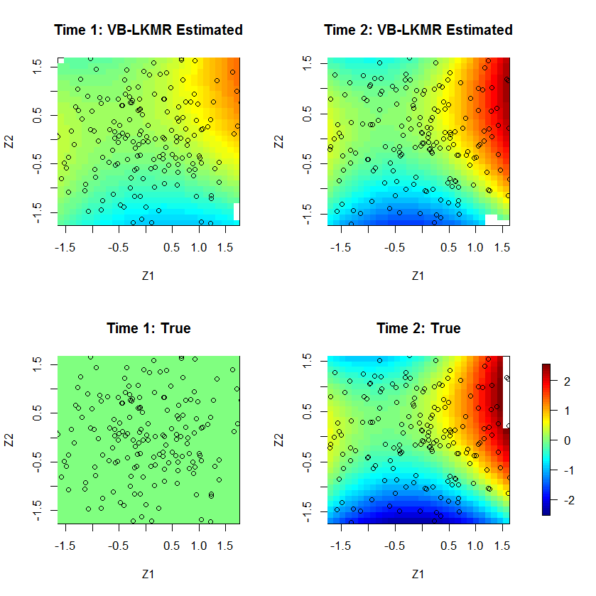

N = 100, Scenario 1:

> print("VB: Intercept, Slope, R^2, RMSE")

[1] "VB: Intercept, Slope, R^2, RMSE"

> print( round(Summary.MFVB, 2) )

[,1] [,2] [,3] [,4]

[1,] 0.01 0.00 0.00 0.67

[2,] -0.01 0.81 0.73 0.62

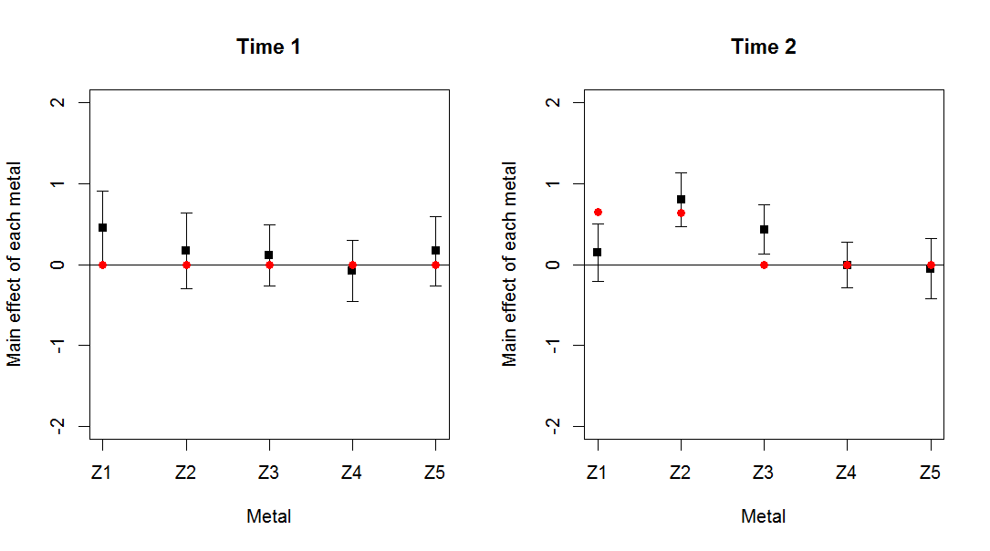

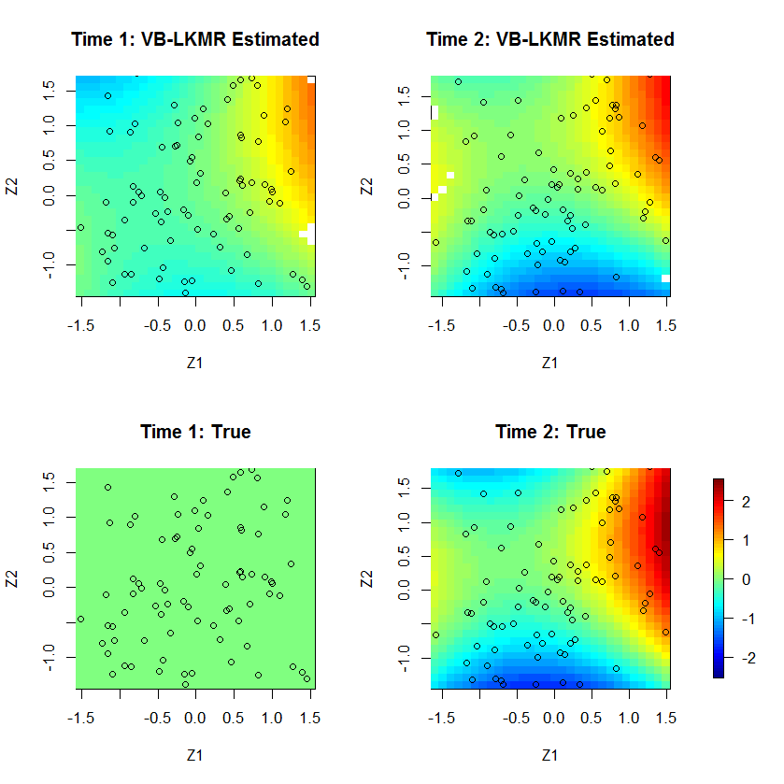

N = 300, Scenario 2:

> print("VB: Intercept, Slope, R^2, RMSE")

[1] "VB: Intercept, Slope, R^2, RMSE"

> print( round(Summary.MFVB, 2) )

[,1] [,2] [,3] [,4]

[1,] 0.08 0.77 0.89 0.50

[2,] -0.06 0.88 0.91 0.51

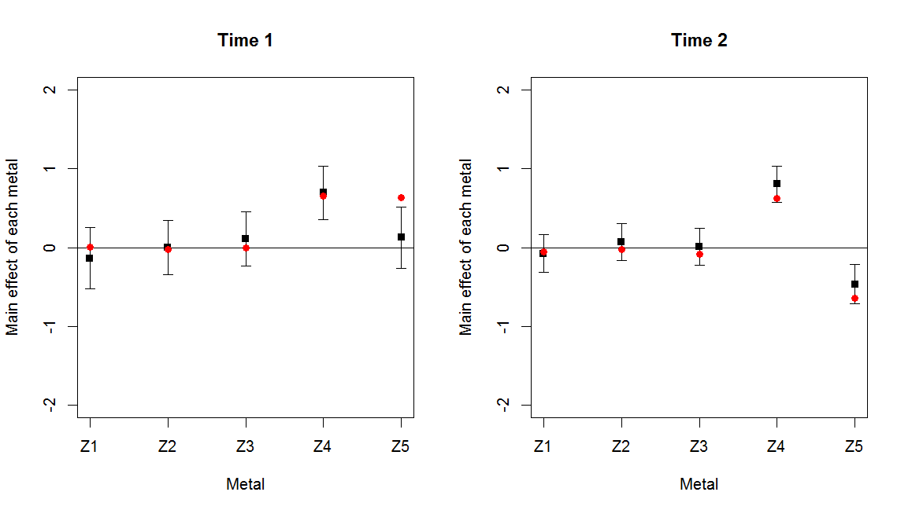

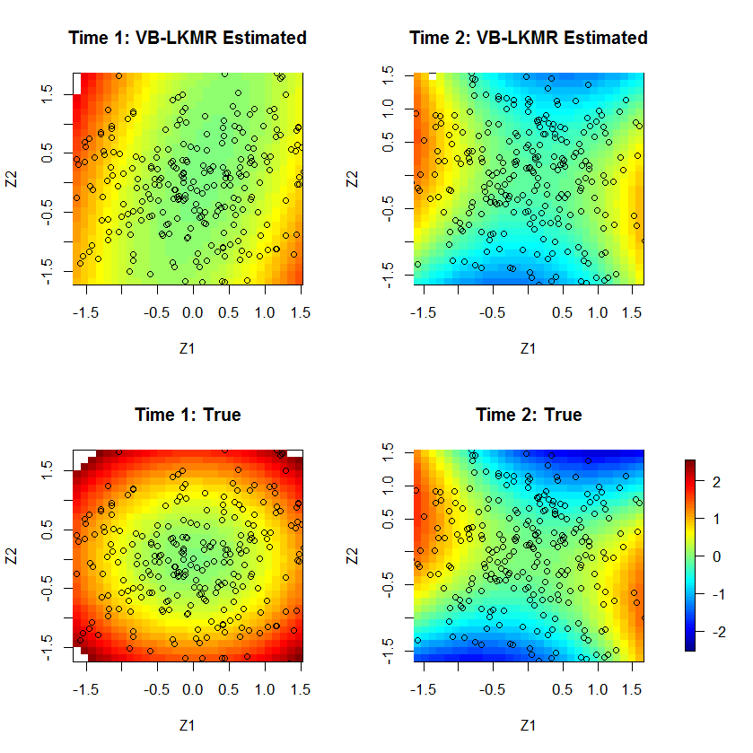

N = 200, Scenario 2:

> print("VB: Intercept, Slope, R^2, RMSE")

[1] "VB: Intercept, Slope, R^2, RMSE"

> print( round(Summary.MFVB, 2) )

[,1] [,2] [,3] [,4]

[1,] 0.16 0.70 0.86 0.67

[2,] 0.04 0.91 0.74 0.71



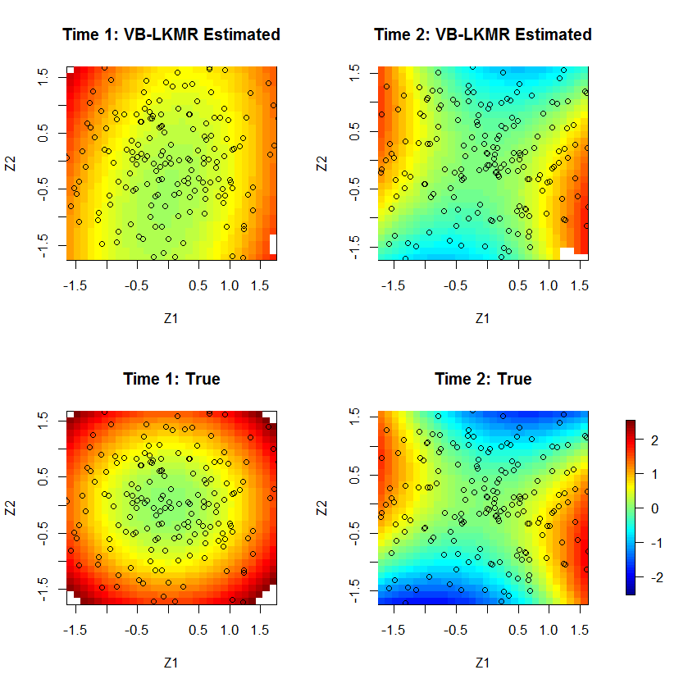

N = 100, Scenario 2

> print("VB: Intercept, Slope, R^2, RMSE")

[1] "VB: Intercept, Slope, R^2, RMSE"

> print( round(Summary.MFVB, 2) )

[,1] [,2] [,3] [,4]

[1,] 0.06 0.76 0.67 0.83

[2,] 0.07 0.75 0.62 0.89

