Tutorial Notes
- Send Torsten sumtxt function for getting the command the user used from sum.txt files
python *PyRate.py or whichever .py -h command → help screen for that command

Within-Code Notes
- Ctrl+F:
  - “Suff_out” to find naming conventions for output files. When you run a command and the resultant file has a long name w/ unclear acronyms, search this in PyRate.py to find what they mean
  - Also check “%s” “.txt” and “path_dir”

Tutorial 1: PyRate Input + Basic Run

Generating PyRate.py Input File

CSV From Outside Source: Open an R notebook
  - Load the file our functions will come from: source(“.../pyrate_utilities.r”)
  - Download fossil occurrences for a clade from the Paleobiology Database. E.g. search for the genus Canis
    - Check the box "Show accepted names only" in the "Select by taxonomy" section
    - Uncheck the box "Include metadata at the beginning of the output" in the "Choose output options" section.
    - Save it as a csv file, e.g. using the file name Canis_pbdb_data.csv.
  - Define a vector of all the extant species: extant_dogs = c("Canis rufus","Canis lupus","Canis aureus","Canis latrans","Canis mesomelas","Canis anthus","Pseudalopex gymnocercus","Canis adustus","Canis familiaris")
    - This way PyRate will create a column indicating which species are extinct and which are extant. Also, in the resulting *_PyRate.py input file, in list for that replicate, the array representing that species will end in 0 (representing the present day) to indicate that the species is extant
  - Parse raw PBDB data with extract.ages.pbdb(): extract.ages.pbdb(file = "../example_files/Canis_example/Canis_pbdb_data.csv", extant_species = extant_dogs)
    - Replicates: this argument specifies the number of times the age range (min and max) of each fossil occurrence should be resampled. Resampling = when the function creates that n number of datasets, in each dataset it will select a random age range for each species from within that species' original age range. Setting replicates = 10 will generate 10 replicated datasets in the PyRate input file, each with different age ranges selected for each species. Then in the downstream PyRate analysis, you can analyze each dataset separately, and the combined results will account for age uncertainties in the fossil record.
      - So if a fossil occurrence has a min age of 10 Ma and a max age of 12 Ma, and replicates=10 is specified, the function will generate 10 replicated datasets where the age of that fossil occurrence is randomly sampled between 10 Ma and 12 Ma for each of the 10 replicates.
    - Random: The random argument is set to TRUE by default, which means that the resampling of ages will be done randomly within the specified temporal ranges.
    - Cutoff: The cutoff argument can be used to remove fossil occurrences with an age range greater than the range you specify (in millions of years). For example, setting cutoff = 10 will remove all occurrences where the difference between the maximum and minimum age is larger than 10 million years.
    - 3 Output Files: * = name of the dataset
      - *.txt = dataset as a .txt
        - Then the function passes the .txt to the extract.ages() function, which creates the following two files
      - *_TaxonList.txt = list of species in the dataset and their status (extinct vs. extant). This is created because the extract.ages() function has the argument 'save_tax_list' set to TRUE by default
      - *_PyRate.py = PyRate formatted input, with the specified number of replicated datasets (if replicates 'argument' was used)
        - 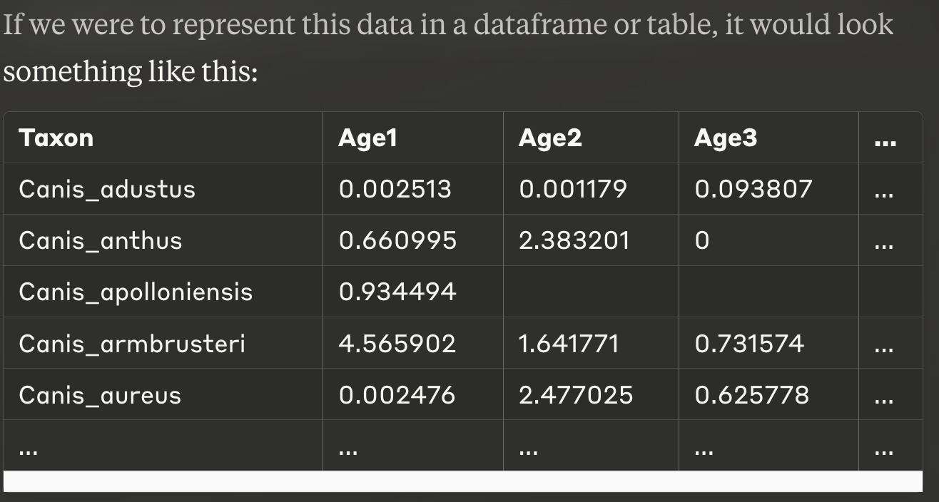
        - In the resultant file, there is a list of arrays containing a list of numbers. The list is one PyRate input dataset (one replicate), parsed from the raw data. In this example there is only one list (data_1) because we didn't specify any replicated data (replicates argument below)
        - Each array represents one taxon (species)
        - Each value in the array represents one fossil occurrence. Each value is a randomly sampled age (in mills of years) of the fossil occurrence for that taxon/array. Longer arrays = more occurrences of a fossil of that species, so more ages
        - The taxa_names variables at the end of the file = the order of the arrays
        - If a taxon is extant (still alive), the last value in its array is = 0 to represent the present day

  - Data Summary (Terminal)
    - Generate summary statistics for the dataset using the *_PyRate.py input file, and save it off as a .txt file with a name of your choosing
    - python PyRate.py *_PyRate.py -data_info | tee path/tutorial_1_data_summary.txt
    - Output: tutorial_1_data_summary.txt

CSV By Hand
  - Prepare a fossil occurrence table in .txt format with 4 columns: Species, Status (extinct or extant), min_age, max_age (in that order!!). An additional column can be included for a trait value (e.g., body mass)
  - Load the file our functions will come from: source(“.../pyrate_utilities.r”)
  - Parse raw data with extract.ages(): extract.ages(file = "../example_files/Ursidae.txt", replicates = 10)
    - Replicates and cutoff arguments available in this function too
  - 2 Output files:
    - *_PyRate.py: PyRate input file!
*_TaxonList.txt: list of species names

Input Dataset w/ a “Site” Column
  - If your data contains info on which site a fossil came from, and some fossils were found at the same site, we will randomize the ages by the common site, NOT by each fossil occurrence individually.
  - I.e., earlier we said extract.ages() and extract.ages.pbdb() (functions for parsing the raw data) would –> PyRate.py input file where each fossil's age was a random sample taken from within their individual, unique temporal age range (min_age to max_age)/
  - Now, we're saying that if we have data that specifies which site a fossil came from (a site column), and fossils share sites, we will instead assign each fossil occurrence an age that is a random sample of the SITE's unique temporal range. We'll average the min and max ages of all the fossils occurring at the same site, randomly sample within that, then assign EVERY fossil that occurred at that site the same age. So every fossil found at Site A will have the same randomly sampled age. Process:
- The average minimum age and maximum age of all fossils found in Site A will be calculated, and assigned as the temporal range for Site A, called 'mimima_1' and 'maxima_1' respectively
- The function runif() will randomly select an age from within each Site's range 'mimima_1' to 'maxima_1', round it to 6 decimal places, and store it as a new column (new entry in each array in *_PyRate.py) 'new_age'
- The resultant *_PyRate.py file will look the same as above except that each array (taxon/species) will only have a maximum of two (*caveat) values:
  - Instead of multiple values of resampled ages for each occurrence of that taxon/species, only one value corresponding to that species’ site's randomly sampled age.
  - *Caveat: If a species occurs in multiple sites, it will have a different random age for each site, so it will have one value for each site
  - A 0 value at the end of the array, if it's an extant species (discussed previously)

Check *_TaxonList.txt for Spelling Errors:
  - python PyRate.py -check_names path/*_TaxonList.txt
  - This will return a table ranking possible typos. You should check these yourself to see if they are errors. If they are, go back to the dataset, fix it, and re-run the needed steps above.
    - Ranks 0-1 = possible misspellings
    - Ranks 2-3 = possibly different names
  - Output: *_TaxonList_scores.txt

Preservation Models:
- Defining the preservation model for later use in the MCMC run
- Epoch = a predefined time interval. Can be based on geological, environmental, etc. criteria. Set by the user in PyRate.
- 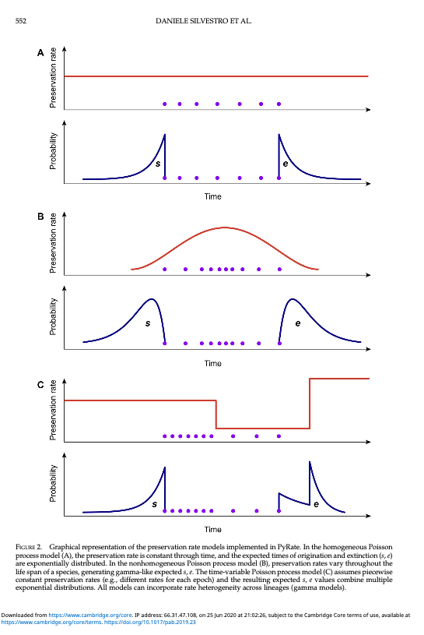
- q rate = preservation rate
- NHPP, HPP, TPP all deal with q rate temporal heterogeneity (or lack thereof, in the case of HPP) in different ways. However, they all assume all lineages have the same (possibly time-variable) q rate, which means they assume all lineages have equal chances of being preserved in the fossil record
- Adding the Gamma model to these 3 models will introduce lineage-specific rates, taken from the gamma distribution
- NHPP: Non-Homogenous Poisson Process of Preservation
  - Default model. Models q rate as a function of time Q(t) — a bell-shaped distribution where rates are lower at the two ends (origin and extinction of the lineage, which is what happens in the fossil record anyway). The rate's temporal heterogeneity is a continuous function, and is not defined by discrete epochs. All lineages have this same rate.
  - No additional flag is needed in your MCMC run
- HPP: Homogeneous Poisson Process
  - Simplest model, assigns a constant q rate through all time for all lineage: a single parameter
  - -mHPP: add this to your MCMC run
- TPP: Time-Variable Poisson Process
  - Rate heterogeneity through time, using discrete epochs rather than a continuous distribution like the NHPP
  - TPP explicitly introduces the idea of discrete epochs. Each epoch has its own individual, constant/unchanging preservation rate, allowing for abrupt changes in the preservation process at specific time points. TPP will estimate each preservation rate (and its individual prior probability distribution, more on that below) in each epoch independently. So, basically it's a piecewise compilation of HPP likelihoods across multiple time periods, each with their own preservation rate.
  - Create an epochs_q.txt file (or any other name), defining your epochs. No header, just one column with ages/time bins
  - -qShift path/to/epochs_q.txt -pP shape rate
  - PyRate will assign each time bin a gamma distribution, which can be thought of as the prior probability P(A) on that time bin’s q rate = how likely it was that that fossil was preserved, before taking into account the fossil occurrence data
  - It then randomly selects a q rate from each gamma distribution to assign as the q rate for that time bin
  - Using a probability distribution as the prior for each preservation rate allows PyRate to incorporate uncertainty and variability in the estimated q rates across different epochs
  - Gamma distributions have 2 parameters allowing the user to control its shape → control the prior probability → flexible framework to express prior beliefs while still letting the data inform posterior estimates
  - -pP (optional) controls those 2 parameters = shape and rate, both default to 1.5. This default assumes q rates are more likely to be concentrated around moderate values, with a lower robbaility of extremely high or low rates
    - Shape > 1 = unimodal (single peak) distribution. 1.5 = unimodal
    - Shape < 1 = exponentially decreasing distribution
    - Rate = scaling the gamma distribution = variability in q rates = changing the mean and variance of the preservation rates
      - Larger rate = distribution concentrated around smaller values
      - Smaller rate = more spread out distribution
    - -pP 0 0 → PyRate will estimate both parameters of the prior from the data
  - The model will use these priors as starting points/guides for the outputted preservation rates for each interval. These outputs = the posterior probability (P(A|B) = our model's updated belief about the preservation rates after we considered both
    - P(A) the prior probabilities (gamma distributions of the preservation rate in each epoch). How you set this obviously affects your posterior calculation, the ultimate output/goal of the model: P(A|B)
    - and P(B|A) the likelihood of observing the data (fossil occurrences)
- Gamma Model: introducing Rate Heterogeneity Across Lineages to other models
  - -mG Added to any of the 3 Preservation models above! Not its own model
  - Applies a gamma distribution to each taxon’s preservation rate, so that each lineage’s q rate is chosen from that distribution (just like TPP’s process) → lineage-specific heterogeneity
  - The Gamma model for lineage heterogeneity only adds a single parameter, which voids over-parameterization
- Gamma + TPP → Save Per-Lineage Relative Preservation Rates
  - -qShift path/to/epochs_q.txt -pP shape rate -mG -log_sp_q_rates
  - Save the estimated relative preservation rate (not s or e rate) for each lineage

Maximum Likelihood Test for Best Preservation Model
  - python PyRate.py .../*_PyRate.py -qShift path/to/epochs_q.txt -PPmodeltest
  - Doesn’t test Gamma model, but you should take the best model among NHPP, HPP, or TPP outputted from this command, and add -mG to it

MCMC Analysis: Generating pyrate_mcmc_logs Directory
- Ok: so, we have chosen a Preservation Model (conceptually, we haven’t run it yet)
- We haven’t chosen a Birth-Death Model, but there are a ton of options talked about in Tutorials 2, 4, 5
- In this tutorial we use the default: BDS, Birth-Death Model with Rate Shifts. Both MCMC options, BDMCMC and RJMCMC use BDS as default. So you don’t have to indicate anything
- python PyRate.py path/*_PyRate.py
  - No flag or -A 4 for RJMCMC
  - -A 0 for parameter estimation, -A 1 for marginal likelihood/thermodynamic integration, -A 2 for BDMCMC, -A 3 for DPP (Dirichlet Process Prior)
    - All RTT graphs for -A 0 will be flat, because -A 0 performed 'parameter estimation'. You will see in your log files lambda_0 and mu_0, which are the constant rates. However, the mode -A 0 can also infer shifts when you combine it with -mL and -mM, respectively, and each set to a value > 1 (e.g. -mL means having two speciation rates and one shift; -mL 3 is three rates and two shifts).
    - Both BDMCMC (-A 2) and RJMCMC (-A 4, default) estimate the # and timing/placement of rate shifts (temporal rate heterogeneity). Therefore, they cannot be used with -fixShift. If you specify -A 2 or -A 4 with -fixShift, the model will default back to -A 0 every time
    - The difference is that they use different methods of proposing a rate shift. BDMCMC uses birth-death proposals, RJMCMC uses reversible jump proposal mechanisms
    - In practice, RJMCMC has been shown to work better than BDMCMC
    - See the -fixShift argument below
    - Note that any use of a BDNN model (a later tutorial) will lead to -A 0 every time as well
  - Preservation model flag:
    - No flag to default to NHPP
    - -mHPP for HPP
    - -qShift path/to/epochs_q.txt -pP shape rate for TPP, where -pP is optional
    - Gamma model flag -mG
  - Section 7. If you want to set fixed time bins for the BD model (BDC Skyline Model): do -fixShift path/to/bd_epochs_q.txt
    - bd_epochs_q.txt can be the same or diff from the epochs_q.txt in the TPP (I.e., can be the same file if you want to use the same time bins for Preservation and S+E (Birth-Death)
    - -fixShift cannot be used with -A = 2 or -A = 4. Calling -fixShift will lead to -A = 0, which is basic parameter (rate) estimation MCMC. This is because with -fixShift, you provide a file where you are specifically setting the # of timing of rate shifts. -A 4 (default), and -A 2 are MCMC algorithms that try to estimate the # and timing of rate shifts as their own parameters. Obviously incompatible with the user setting those values.
  - Specify which randomized replicate (*Section 1.A.): -j 1 flag, where the "1" in this case indicates the replicate number we want to analyze
  - MCMC parameters:
    - -n 20000000 : do 20 million iterations or "steps" the MCMC algorithm will run (not 20 million states, depending on the acceptance/rejection rule). Default is 10 million! If the dataset is really large, Iterations may need to be increased in order to reach convergence
    - -s 5000: sample every 5,000. Default is 1,000! If the dataset is really large, you may need to sample the chain less frequently (increase -s) to reduce the size of the ouput files
    - n/s = the # of posterior samples the output log file will have.
    - So in this example, at 20 mill iterations, sampled every 5,000 –> the output log file will have 4,000 posterior samples
    - -p 100 = the program will show its progress every 100 iterations

Output Files
  - Directory: pyrate_mcmc_logs
  - All these file names will be *_#_Grj_sum.txt (for example), with the # corresponding to the # replicate (if applicable), and the Grj indicating that RJMCMC was used
- *_sum.txt: text file with the list of settings used in the analysis
- *_mcmc.log: tab-separated table with MCMC samples of:
  - Preservation Model: posterior, prior, likelihood (PP_lik)
  - Birth-Death Model: posterior, prior, likelihood (BD_lik)
  - Preservation Rate (q_rate)
    - q_rate's level of heterogeneity: gamma-distributed heterogeneity (alpha)
    - (q_0, q_1, q_2...) if you used TPP model
  - # of Sampled Rate Shifts (k_birth, k_death)
  - Origin time of the oldest lineage (root_age)
  - Total branch length (tot_length)
  - Times of S + E of all taxa/species in the dataset (*_TS, *_TE): I.e., origination and extinction times of each lineage
- sp_rates.log: tab-separated text file of sampled rates
- ex_rates.log: tab-separated text file of times of rate shifts
  - ^ Additional visualization commands can be added to a call of these log files, see the RJMCMC tutorial
- If you do not do RJMCMC, TDI, ADE, you will get:
  - *_marginal_rates.log: tab-separated table with posterior samples of the marginal rates of speciation rate, extinction rate, net diversification. calculated w/in 1 time unit (typically Myr)
    - Structure:
      - Each row is one sampled iteration of the MCMC chain (one “MCMC sample”), identified through the first column called “it”
      - Columns:
      - “it” (as above)
      - l_x = Speciation rate at time X (from the present back to that time x)
        - l = lambda = 𝛌 = speciation
      - m_x = extinction rate at time X (from the present back to that time x)
        - m = mu = μ = extinction
      - r_x = net diversification rate at time X (from the present back to that time x)
        - r = difference between speciation and extinction rates (r = λ - μ)
    - This file can be later processed using -plot (for RTT), but it cannot take -plotRJ (b/c it’s not compatible with RJMCMC)
  - Also, you want to make RTT plots (Section 5.C. or 5.F.) you need to add the command -log_marginal_rates 1 to get this older output file INSTEAD OF files 3 and 4 above:

Output Post-Processing
- Now you can interpret the S and E rates, the validity of different preservation models, and visualize temporal dynamics of diversification

Tracer
  - Put all the outputted log files into Tracer, a program for analyzing the performance of the MCMC. Check if MCMC has converged, look at the ESS's, determine the proportion of burn-in.
  - Replicate datasets obviously might converge to slightly different solutions, with different ESS's. “Convergence” = all those replicates converge to the same value

BD Model Sampling Frequencies (RJMCMC Only)
  - python PyRate.py -mProb .../*_mcmc.log -b 200 | tee .../BD_Sampling_Freq.txt
    - -b # flag: indicates how many beginning samples should be removed because in Tracer you decided that that # was the burn-in
      - Samples, not iterations. The number of samples you have will be = -n/-s flags from the analysis command in *Section 3
    - BD_Sampling_Freq.txt : can be named anything you want
  - Output: BD_Sampling_Freq.txt file with the relative probabilities of each BD model (each model is the same type, just with different number of rate shifts)
    - Obviously only RJMCMC analyzes different #'s of rate shifts, so the table below would only work if you did the -A 4 flag, or omitted the flag entirely in the MCMC analysis, because both indicate that you want to do an RJMCMC. Certain models are incompatible with -A 4 though! BDNN (BDNNmodel 1), any use of -fixShift
    - If you chose -A 2 for BDMCMC, -mProb would only show the posterior probability of the BD model, and possibly (??) some other parameter estimates. If you do
  - Example Output from tutorials/Canis_self_example/:
    - 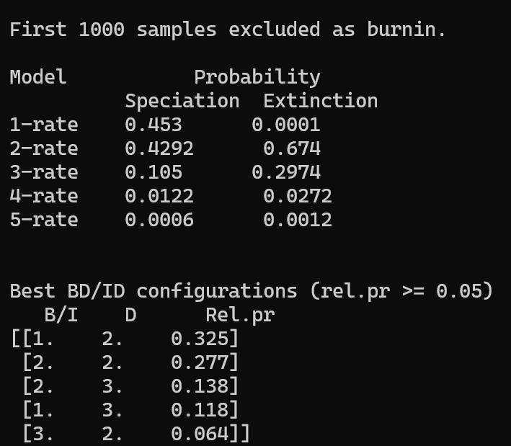
- Model Probability:
  - Speciation has a 45.3% probability of having 1 rate shift
  - Extinction has a 0.01% probability of having 1 rate shift, and on
  - So: it is most probable that we have 1 rate shift in Speciation, and 2 rate shifts in Extinction
- Best BD/ID configurations:
  - Terminology: BD/ID are different lineage diversification models, considered to be identical in this table
    - BD = Birth-Death Model
    - ID = Immigration-Death Model
    - "B/I" basically corresponds to origination (birth or immigration) in the BD and ID models respectively
  - B/I Column = how many rate shifts in origination
  - D Column = how many rate shifts in death for both models
  - The most probable configuration is 32.5% probable, with 1 rate shift for speciation, 2 rate shifts for extinction

Rates-Through-Time (RTT) Plots (non-RJMCMC)
- RTT plot: speciation, extinction, net diversification through time
- Only BDMCMC, BDNN, RJMCMC RTT’s will show anything other than a straight line! Because a model like -A 0 (parameter estimation, basic MCMC) for example isn’t estimating speciation and extinction rate shifts! For -A 0 log files, you will see lambda_0 and mu_0, which are the constant rates
- python PyRate.py -plot .../*_marginal_rates.log -b 200
  - do -plot2 instead of -plot for a different type of RTT which has a cloud of uncertainty instead of bars
- Output: a pdf with 4 tiles (if using -plot) or 3 tiles (if using -plot2) with speciation rate, extinction rate, net diversification rate, and longevity (if -plot) graphs
  - R script which you can run to create –>
  - PDF file with the RTT plots

Combining Replicates’ *_mcmc.log files
  - You should already have a directory (folder) with all your output and Input files in it, indicated below as path_to_your_log_files
  - python PyRate.py -combLog path_to_your_log_files -tag mcmc -b 100
    - -combLog is a generic command for combining files, but it only works on one type of file at a time. So whereas -combLogRJ will combine the .pkl, sp_rates.log, ex_rates.log, mcmc.log files of a BDNN output, -combLog requires that you specify (using the argument -tag) exactly which file type you want to combine when you call it
      - For example: MCMC and BDMCMC runs will output marginal_rates.log and mcmc.log files. To combine all needed MCMC or BDMCMC files, you’d have to use two steps:
        - python PyRate.py -combLog path_to_your_log_files -tag mcmc -b 100
        - python PyRate.py -combLog path_to_your_log_files -tag marginal_rates -b 100
    - -tag mcmc specifies to PyRate that it should combine (-combLog) all the files that contain mcmc in the file name. If you need to combine other files, just switch out the word that comes after -tag
    - This will not work if you already have a combined mcmc.log in there (if this isn’t the first time you’re running this for this directory), so just move those combined files out before you run it again
      - If you don’t specify a -tag, it’ll try to combine everything ending in .log (like mcmc.logs and marginal_rates.logs), and obviously those files might not have the same number of columns so it’ll lead to an error

  - Output:

Combined Replicates’ RTT Plot
  - python PyRate.py -plot path_to_your_log_files -tag Canis_pbdb -b 100
    - -tag Canis_pbdb : We used 'Canis_pbdb' as an example here. You should add part of the file name after the -tag so the command can combine all the marginal_rates.log files that contain that name
  - Output: combined_#mcmc.log where the # is the number of replicates

Preservation Rates Through Time Plot (TPP)
  - TPP model has different rates for different time bins, and we'd like to view those:
  - python PyRate.py -plotQ .../*_mcmc.log -qShift epochs.txt -b 100
    - epochs.txt: the text file with the times of rate shift you provided in Section 2.A.iii. May need full file path
  - Output: R script that you should run to get the graph

BD Models with Fixed Rate Shifts
- RJMCMC allows you to estimate timing and number of rate shifts using MCMC. If you want to fix those a priori though (based on external theory like geological epochs), you can do this by providing a file with pre-defined times of rate shifts, just like TPP took. This will turn off RJMCMC
- Remember that adding these time bins increases the model complexity, so you want to make sure you have sufficient data to support this complexity. Model assumes half-Cauchy prior distributions for speciation and extinction rates between shifts. Hyperprior on the half-Cauchy distribution's scale parameter, to reduce the risk of over-parameterization
- python PyRate.py .../*_PyRate.py -fixShift .../epochs.txt
  - Follow up with all of your other arguments, Preservation model, length of the MCMC, sampling frequency
- Output: the same 3 files as the previous analysis, but with these changes:
  - *_sum.txt
  - *_mcmc.log
    - # of Sampled Rate Shifts (k_birth, k_death) –> this # is now fixed, so instead we will get:
      - Speciation rates between shifts (lambda_0, lambda_1...)
      - Extinction rates between shifts (mu_0, mu_1...)
    - Estimated scale parameter on the half-Cauchy distribution of speciation rates (hypL) and extinction rates (hypM)
  - *_marginal_rates.log

Fixed Shifts at the Boundaries, While Searching for Rate Shifts Between Them
- Sometimes fossil data is only available during a certain time window, which means the min and max boundaries of that time window SEEM like they have rate shifts, when they actually don't (this is the edge effect, where the data at the edges of the time bin reflect a sampling bias).
- You can fix this by setting fixed times of rate shifts at the edges of that time bin (-edgeShift), where you know the dataset is cut off. You're basicaly setting temporal boundaries so you can truncate your analysis to just the rates within that time window.
- python PyRate.py <data_set> -A 4 -edgeShift max min
  - max = a NUMBER representing the maximum age boundary
    - If you only want to set a maximum age boundary, just set min = 0
  - min = a NUMBER representing the minimum age boundary
    - If you only want to set a minimum age boundary, set max = to inf
  - -A 4: Then you run an RJMCMC on it to infer rate shifts within that time window

Plotting Fixed Boundary Results
  - plotRJ command (see RJMCMC tutorial) with -root_plot and -min_age_plot tags

Tutorial 2: (BD) PyRateContinuous

Bayesian Workflow:
- Taking the *_mcmc.log output file from Tutorial 1, using its estimates times of origination and extinction (ts and te), to
- Create an input file for further analysis using PyRateContinuous
- Which is a program that contains several Birth-Death models in PyRate: constant-rate, exponential, linear, ecological limit, dynamic upper limit
  - Depending on the model type, it can incorporate environmental variables like temperature
- You choose the priors + hyperpriors on birth and death rates, environmental effect parameters
- You choose a BD model type
- PyRateContinuous will calculate likelihood of those te and ts’s given sampled MCMC parameters
- MCMC samples the posterior: birth rates, death rates, enironmental effects, other possible variables depending on the BD model chosen
- The BD model chosen outputs diversity trajectory curves: s and e over time

Getting ts, te: PyRate.py

Input file creation: -ginput
- Extracting the mean estimated times of origination and extinction per species and optionally adding it to a table w/ clade info (if using PyRateMCDD, Tutorial 4) in order to input it intoPyRateContinuous (Tutorial 2), PyrateMCDD, PyRateMBD (both in Tutorial 4),
- ^Those models contain BD models with fixed times of s and e, as opposed to PyRate, which just takes occurrence data, that’s why they need this additional file created using -ginput, called *_se_est.txt
  - This is also why se_est.txt can only be created with NON-RJMCMC log files. They demand a fixed number of parameters, and RJMCMC has variable parameter space
- python PyRate.py -ginput .../*_mcmc.log -b 100
  - -b = # of burn in samples that should be discarded
  - If you provide -ginput a path to a directory containing multiple mcmc.log files, instead of just the path to a specific mcmc.log file, it will process each NON-RJMCMC mcmc.log file separately, creating these 3 outputs below for each one
  - -tag Canidae = provide -ginput a path to a directory, then add this tag. Tells the command to combine all *_mcmc.log files containing the word “Canidae” in their name. Useful for when you created replicates that all have separate *_mcmc.log files
    - The outputted *_se_ext.txt file will be a combination of all those replicates/log files, with separate columns for each species and all its replicates
  - -resample 10 = if you want to extract the estimated times of origination and extinction per species by sampling a specific # of MCMC samples (resample) from the posterior NOT by taking the mean from the *_mcmc.log
    - This will sample the ts and te’s from the MCMC’s ts and te samples 10 times, and store them in *_se_est.txt as additional columns
    - If you combine this with -tag Canidae, 10 ts and te’s from each Canidae file will be taken and concatenated into one table
- 3 Outputs: all in the same directory as the *_mcmc.log file
  - *_se_ext.txt: clade (only useful for MCDD model), species, estimated times of origination and extinction for each species. The PyRateContinuous (Tutorial 2), PyrateMCDD, PyRateMBD (both in Tutorial 4) input file!
    - ^All of these programs are BD models that assume ts and te’s are known/estimate, that’s why we need to use -ginput to generate this table containing ts’s and te’s
    - From now on, anything that calls *_se_est.txt takes the -d flag
    - This file is showing up in his example_files folder as “Genus_SE.txt” for some reason
  - Lineage through time (LTT) plot in PDF format: each lineage’s duration + diversity trajectory of the clade
  - R script format of the LTT plot above

Lineage Through Time (LTT) Plot (Range-Through Diversity Trajectory): -d .txt -ltt
- python PyRate.py -d *_se_est.txt -ltt 1
  - -ltt 1 = normal, will output the second graph (diversity trajectory of the clade) outputted by the -ginput command above in its own graph
  - -ltt 2 = log10-transformed diversity
  - -ltt 3 = each replicate is shown as its own individual line
  - -grid_plot 0.1 = optional tag that changes the size of the time bins. Default is 1Myr. If you set this 0.1 value, the diversity trajectory/diversity count will be computed in 0.1 Myr time bins
- 3 Outputs:
  - Table of estimated diversity trajectory of all clades, Used later for PyRateMBD.py PyRateMCDD.py analysis, in Tutorial 4
  - LTT plot PDF
  - R script that generated the LTT plot

PyRateContinuous Analysis: Several BD Models with fixed times of s and e
- Note that PyRateContinuous does not estimate times of origination and extinction nor preservation rates. This means that the number of parameters to be estimated is much smaller than in a standard PyRate analysis. Thus, setting the number of MCMC iterations between 100,000 and 1 million, will be sufficient for most data sets.
- Assumes that ts and te are known/estimated, typically in a previous PyRate analysis
- Infers clade-level diversification rates that change over time, some with the option to add continuous variable
- Inputs: PyRate’s *_se_est.txt from -ginput
- Outputs: s and e rates at each ts and te for the FULL CLADE

BD Models w/ Time-Continuous Correlates: -d flag
- BD models (so speciation and extinction rates) that are linearly or exponentially correlated (changing through time with) with a time-continuous variable such as:
- The clade’s own diversity (diversity dependence)
- Other time-continuous variables like paleo-environmental variables (temp, sea level, etc.)

Diversity-Dependent BD: -DD

S and e rates may correlate with the clade’s own sampled (range-through) diversity
  - python PyRateContinuous.py -d .../*_se_est.txt -DD -m
    - -m 0 = exponential correlation, s and e rates are exponential functions of the clade’s diversity
    - -m 1 = linear correlation, s and e correlate linearly with clade’s diversity
    - -m -1 = model testing! Null model where s and e rates are constant and independent of diversity. Compare results with the above -m flags
    - -n, -s, -b, -p = standard MCMC iterations and sampling parameters, respectively
      - -n between 100k and 1 million are sufficient here, because there are far fewer parameters to be estimated in PyRateContinuous than in PyRate. PyRate also estimates te, ts, and preservation rates
      - -p 100 = the program will show its progress every 100 iterations
    - -A = 0 = parameter estimation, 1 = thermodynamic integration
  - 1 Output file:
    - *_se_est_DD_0_exp.log OR *_se_est_DD_1_lin.log: posterior sample of all parameters:
      - Speciation (Gl)
      - Extinction (Gm)
  - Open the mcmc log file in Tracer

RTT Plots for the Diversity-Dependence BD Model: -plot
    - Use: estimated baseline speciation and extinction rates + diversity dependence parameters from the *_se_est_DD_0_exp.log
    - Get: marginal speciation and extinction rates through time
    - Same command as Section 1.b., but add: -plot .../*_se_est_DD_0_exp.log -b 200
      - -b = burn-in again. You need it for both the original *_se_est.txt file (extracted s and e times from PyRate’s MCMC analysis) and the Diversity Dependence MCMC log file.
    - 2 Output Files:
      - R script of the DD’s RTT plots
      - PDF file OF THE rtt

Other Time-Continuous Variable Dependent BD: -c .txt
  - You need to provide a tab-separated.txt file with a header (first row) and 2 columns for time and variable values. Example in example_files/temperature.txt:
    - 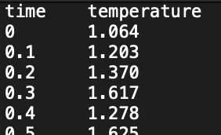
    - Here, Time 0 = the present day
    - Time 0.1 = 100,000 years ago
    - Time needs to cover the entirety of the times in the *_se_est.txt file
    - PyRateContinuous will assign temperature values that correspond to each speciation and extinction event (ts and te) when calcuatling rates
  - python PyRateContinuous.py -d .../*_se_est.txt -m 0 -c temperature.txt
    - Later on in Tutorial 4 MBD model, we will see how to include multiple time-continuous variables
    - Obviously, temperature.txt is just an example. Rename to any variable you want
      - The variable will also first be shifted so that its value at time 0 (present day) is = 0.
        - Every value will have time 0’s value subtracted from it. So at Time 0.1, temperature = 1.203-1.064
      - The variable will then automatically be re-scaled to a range 0-1
        - For each current value: (current value - dataset’s minimum value) / dataset’s range which is (maximum value - minimum value)
        - Standardizing the variable (temperature) in this way makes the effect of the variable comparable across datasets (change in temp of 20% led to…)
        - -r = control the rescaling. -r 0 (default) = automatic rescaling. -r 1 = turning off the rescaling, using only the raw values (after shifting). -r set to a positive value = multiplier for the variable, before the automatic rescaling. Used to adjust the magnitude of the variable’s effect.
          - This flag only refers to recalling in PyRateContinuous! PyRate.py has a different meaning for -r and has a -rescale
    - -m 0 = exponential correlation
    - -m -1 = linear correlation
    - -c = indicating the continuous variable correlate .txt file is coming next
    - Output files:
      - Mcmc log file: *_se_est_m0_mcmc.log
        - MCMC info
        - The variable’s correlation parameters: speciation (Gl) and extinction (Gm)
        - Baseline (present day) speciation (L0) and extinction (M0) rates
      - Summary file: *_se_est_m0_sum.txt

RTT Plots for the Time-Continuous Correlate BD Model: -plot
    - Done separately from the above command
    - Same command as Section 2.b., but add: -plot .../*ouputted mcmc from above.log -b 100
    - Output:
      - R Script: *_se_est_m0_RTT.r
      - PF plot: *_se_est_m0_RTT.pdf

Model Testing with Thermodynamic Integration (TI)
- Compare Birth-Death model types! DD linear vs. DD exponential, or DD vs. Temperature-Dependent
- Creating the log file that will be later used for TI’s P(B) calculation:
  - Use Section 2.b. Other Time-Continuous Variables Correlated BD command + -A 1 flag
  - python PyRateContinuous.py -d .../*_se_est.txt -m 0 -c temperature.txt -A 1
    - -A 1 = TI flag
      - 10 scaling categories by default, each with their own separate MCMC run (as controlled by the MCMC flags).
    - MCMC flags: TI is an algorithm that samples MCMC states! So it needs MCMC flags.
      - An iteration flag of -n 1000000 will run 10 mill iterations PER scaling category
- Run this for command for each model (each should have its own *_se_est.txt file) you want to compare
- 1 Output:
  - Log file that the command below will use to calculate P(B)
- Comparing the P(B) across models: use the -A 1 flag for every run of that BD model
  - Direct PyRateContinuous to a directory containing the log files outputted from the TI command. Then the -mL flag will use each of those log files to calculate the P(B) for that model.
  - python PyRateContinuous.py -mL .../path_to_my_logfiles -b 100
  - # Outputs:
    - .txt file containing the P(B)’s of all models
    - MCMC log files containing only the “cold” part of the MCMC states that the TI algorithm sampled
- Put the log files into Tracer
- Also use them for parameter estimation

Tutorial 3: PyRate.py RJMCMC

Analysis
Flag is technically -A 4, but RJMCMC is now the default so you can leave it out. If you want other options, you will need to specify the -A flag
- Default uniform prior on time of rate shifts
- Default time bin cannot be < 1 time unit (1 myr)
  - -min_dt 0.5 = change the time bin to 0.5 myr → rate shifts can be separated by at least 0.5 myr

Output
- *_sum.txt: text file with the list of settings used in the analysis
- *_mcmc.log: tab-separated table with MCMC samples of:
  - Preservation Model: posterior, prior, likelihood (PP_lik)
  - Birth-Death Model: posterior, prior, likelihood (BD_lik)
  - Preservation Rate (q_rate)
    - q_rate's level of heterogeneity: gamma-distributed heterogeneity (alpha)
    - (q_0, q_1, q_2...) if you used TPP model
  - # of Sampled Rate Shifts (k_birth, k_death)
  - Origin time of the oldest lineage (root_age)
  - Total branch length (tot_length)
  - Times of S + E of all taxa/species in the dataset (*_TS, *_TE): I.e., origination and extinction times of each lineage
- sp_rates.log: tab-separated text file of sampled rates
- ex_rates.log: tab-separated text file of times of rate shifts

Model Probabilities
Take the *_mcmc.log file and calculate sampling frequencies of birth-death models with different #’s of rate shits
- python PyRate.py -mProb *_mcmc.log -b 200
  - -b = burn in again
- Output:
  - Terminal table with the relative probabilities of birth-death models with different #’s of rate shifts

Plot RTT and Rate Shifts
- python PyRate.py -plotRJ path_to_log_files/ -b
  - Input mcmc files need “root_age” and “death_age” columns
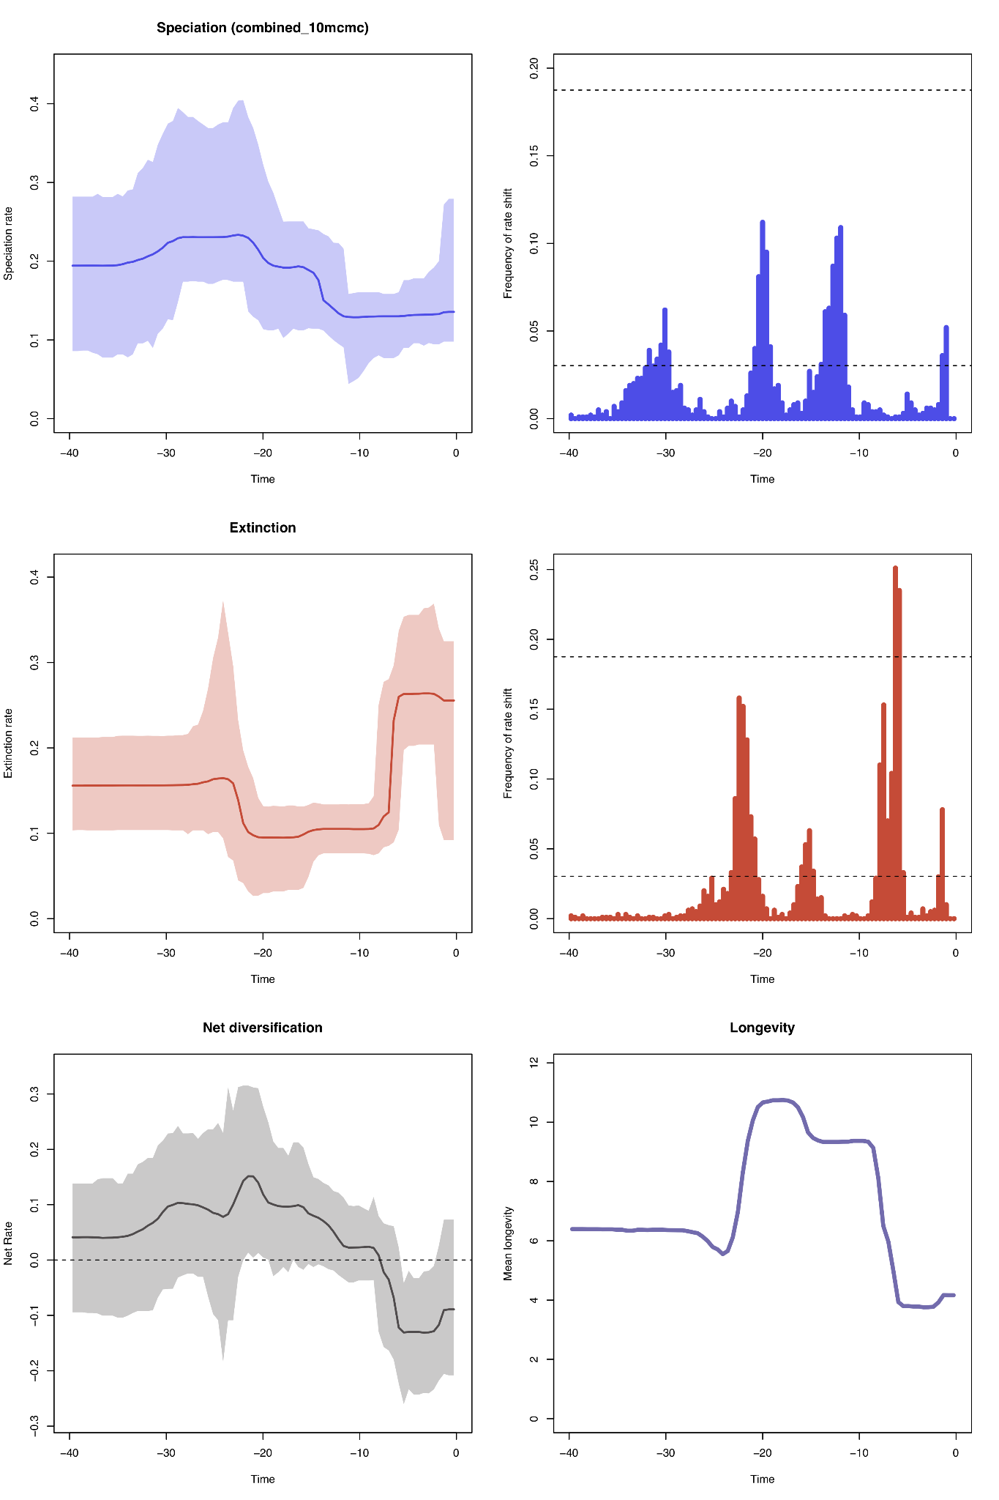
  - -tag file_name = limit the plotting to just files with that file_name in their file name
  - If you changed the time bins in the RJMCMC run using -min_dt 0.5, you have to also change the time bins in the RTT’s here. So add the same ^ tag to the plot
  - Changing the resolution of the plot:
    - -grid_plot 0.1 = 0 is default, corresponds to 100 bins across the dataset’s full time frame. 0.1 will set the bin size to 0.1 Myr. changing the bin size using this tag
  - Limit the plot’s age/time period:
    - -root_plot 10 = cut the plot down to a given maximum age (hold old it is from today) (so 10 → will only show marginal rates in the most recent 10 time units)
    - -min_age_plot = cut the plot down to a given minimum age
    - Example: -root_plot 23 -min_age_plot 5.3 → a plot spanning only a certain period of time (in this example, the Miocene, which was 23 million years ago - 5.3 million years ago)
  - -logT 1 = plot log10-transformed RTT
- Output: if multiple log files are in that directory, they will all be plotted individually in the files below
  - R script for:
    - RTT plots
    - Histograms of inferred times of rate shifts. Will have 2 horizontal dashed lines showing the thresholds for positive evidence of a rate shift
      - Bottom line: logBF = 2 = positive evidence of a rate shift
      - Top line: logBF = 6 = strong evidence of a rate shift
      - Any point in the histogram outside of those thresholds show sampling frequencies for a rate shift that are high enough to indicate a time of significant rate change
    - Bayes Factors for determining which rate shifts (timing) are supported by significant posterior probability
  - PDF of RTT

Combining Replicates -combLogRJ
- -combLogRJ is better than -combLog, b/c it will automatically combine multiple types of files, rather than you needing to specify exactly which file type you want to combine. The “RJ” makes you think it’ll only work for RJMCMC, but no. It works for everything
Make sure all replicates’ log files are in the same directory
- python PyRate.py -combLogRJ path_to_log_files -b 1000 -tag Canis
  - -resample 100 = sub-sampling each replicate by taking 100 random samples from each replicate’s inputted log file, and saving them into the combined log files (below)
    - Resampling = instead of using all samples from the MCMC chain (after burn-in), specify a specific number of randomly selected posterior samples considered in the plot. Enough to approximately represent the posterior distribution
  - This will not work if you already have a combined mcmc.log in there (if this isn’t the first time you’re running this for this directory), so just move those combined files out before you run it again
- Output: n = number of replicates
  - combined_n_mcmc.log
  - combined_n_sp_rates.log
  - Combined_n_ex_rates.log
- Selecting only specific columns to take from the mcmc input files:
- python PyRate.py -combLog path_to_log_files -b 1000 -tag Canis -col_tag posterior root_age root_death
  - -col_tag = taking only those 3 columns from each replicate’s log file to be combined into the output log files
  - Remember that -combLog needs the -tag argument

Running PyRate on Large Datasets
If you have 100’s-1000’s of lineages, MCMC will require a long time to reach convergence. PyRate can approximate a Gibbs sampler to more efficiently sample the ts’s and te’s
- Gibbs only works for TPP or HPP preservation models
- Gibbs vs. MCMC: two different types of MCMC algorithms
  - MCMC updates all params at once from their proposal distributions, accepting it according to an acceptance probability, so not every proposal is accepted
  - Gibbs approximates params’ full conditional posterior distributions (that param’s values holding all other variables constant), then samples the param’s value from that, skipping any sort of acceptance step
- -se_gibbs -fU # # # → add this flag to your PyRate analysis run
  - -fU = update frequencies to set most of the updates (>90%) to focus on speciation, extinction, and preservation rates
  - q: .02, l/m: .18, cov: .08

Tutorial 4: (BD) MCDD, MBD, Covar, ADE

Multiple-Clade Diversity-Dependent Model (MCDD): PyRateMCDD.py
MCDD as been deprecated in favor of MBD below
- Input file: you need to create a *_MCDD.txt w/ 4 columns + any additional columns needed for replicates, one row per species
- Clade column ID’ing which clade that species belongs to (0-n)
- Species ID
- Times of origination from the *_se_est.txt file outputted by PyRate.py -ginput in Tutorial 2
- Times of extinction from the *_se_est.txt file outputted by PyRate.py -ginput in Tutorial 2
- Once you’ve created *_MCDD.txt, you can run it using PyRateMCDD.py
  - PyRateMCDD.py -d /path_to/*_MCDD.txt
    - MCMC tags -n and -s are optional
    - -c # = if you want to analyze only specific clades at once. -c 0 for the first clade, -c 1 for the next, etc. It will compare that specific clade’s BD process with ALL of the clade’s diversities. How the diversity-dependent effects from all clades affects the s and e of just that clade.
- ??something about switching on and off diversity dependent parameters here*

Multivariate Birth-Death Model (MBD): PyRateMBD.py

Summary:
- Input: Time = rows, traits = columns
- A better method of inferring multiple-clade diversity dependence
- Estimation of s and e as a function of multiple time-continuous variables/predictors/correlates
- Preventing over-parameterization:
- Uses horseshoe prior algorithm to perform variable selection, by shrinking correlation parameters that are noise around zero → effectively distinguishing them from those that are significantly different from zero, and therefore represent true signal → reducing the risk of over-parameterization and the need for explicit model testing
- OR you can use gamma hyper-priors to constrain the correlation parameters. Do this when you don’t have a ton of predictors (2-4 correlates)

Input:
- *_se_est.txt (clade, species, estimated ts and te’s) + one predictor_px file per additional time-continuous predictor
  - In each predictor_px file: tab-separated table with two columns: “time” (integers starting at 0 and increasing as we move back in time_ and “predictor”
  - Examples here
  - Put all of them in a folder called predictors_MBDmodel

Command:
- Basically the same as the Time-Continuous Model in Tutorial 2, -c becomes -var (both flags point to the predictor(s)) and the path to the single predictor’s .txt file becomes a path to a directory with the multiple predictors’ .txt files
- The time-continuous variable/predictors will be shifted and rescaled, the same way they are in the Time-Continuous Model in Tutorial 2
  - The variable will first be shifted so that its value at time 0 (present day) is = 0.
  - The variable will then automatically be re-scaled to a range 0-1
- PyRateMBD.py -d /path_to/*_se_est.txt -var /path_to/predictors_MBDmodel -m 1
  - -m 1 = linear model (s and e rates exponential functions of the time-continuous variable)
  - -m 0 = default exponential model
  - -var = indicating the continuous predictors’ directory is coming next
  - -r = control the rescaling
  - -out outname: add the outname string to the outputted file names
  - -minT 2.58: truncate at a minimum age (most recent Ma)
  - -maxT 23: truncate at a maximum age (furthest Ma)
  - -rmDD 1 remove self-diversity dependence (by default included in the analysis)
  - -hsp 0: use Gamma hyper-priors (on the correlation parameters’ Gaussian priors’ precision parameters 1/variance) instead of default Horseshoe prior. The tutorial says to only use gamma when you’re only testing 2-4 correlates (variables), but Torsten said to never really use Gamma b/c horseshoe is better always
  - MCMC tags: -n, -s

MCDD using MBD:
- Predictors Input: the table outputted by the -ltt flag in Tutorial 2’s LTT plot, which contains diversity trajectories of all clades. Those diversity trajectories for all those clades become predictors in MBD’s MCDD
- PyRateMBD.py -d /path_to/*_se_est.txt -var /path_to/ltt_table -m 1
  - -rmDD 1: remove the current clade’s (the clade in the * part of *_se_est.txt)
  - All the same flags as above
Output: *se_est_0_lin_MBD.log, “lin” or “exp” depending on what -m flag you used (linear or exponential). I’m not sure what the “0” refers to, as all my runs (gamma, horseshoe, lin or exp all had 0’s in the file name)
- Inside that file:
  - G = the strength of the correlation between that environmental variable (MBD predictor) and either s or e rates
  - l = extinction, m = speciation
  - So G10_0 = the exponential (m = 0) correlation parameter (G) on extinction (l) for the first correlate (_0)
- W = the shrinkage weights on the correlation parameters
  - A higher shrinkage weight indicates more regularization was implemented, the correlation param was larger, indicating that there was more predicted variation caused by that correlate
  - Any shrinkage weight > 0.5 indicates that that predictor is signficant

Summarizing Results:
- After you get the ouputted *_m_lin_MBD.log, re-run the MBD command with the additional -plot flag and that file
- PyRateMBD.py -d /path_to/*_se_est.txt -var /path_to/predictors_MBDmodel -m 1 -plot *_0_lin_MBD.log
  - In this example, -m 1 means linear
  - If using the default Horseshoe prior, -plot will also include shrinkage weights (Wl and Wm for speciation and extinction, respectively) for all predictors.
  - These weights = the statistical support for each predictor, because the larger they are, the more shrinkage happened, the larger those original correlation parameters on that predictor for that rate were. I.e., that correlate causes larger variation in that rate
  - Posterior estimates for s and e are in the plots

CoVar (Trait Correlated Diversification) Model
- Input: -trait_file: Species = rows, traits = columns
- Make Input Trait File: “Species” column for species name (make sure they’re identical to that in the PyRate file), “Trait” column for the trait values
  - If you leave out a species, that species will be omitted from the analysis
  - If you include a species with a trait value of NA (no information from it, instead of just omitting it), that species’ trait value will be imputed by the MCMC
- python PyRate.py *_PyRate.py -trait_file trait_input_file.txt -mCov 5 -logT 1 -pC 0
  - *_PyRate.py = original PyRate occurrences input file
  - -trait_file = indicating that the trait file is following
  - Traits should be log transformed:
    - Your traits can’t be negative and log transformed, it’ll throw an error in most software, not just PyRate
    - -logT 0 = trait is not transformed, left as it is in the input file, default
    - -logT 1 = trait is log_e transformed
    - -logT 2 = trait is log10 transformed
  - The traits can be set to only correlate with s, e, q
    - -mCov 1 correlated speciation rate (1 correlation parameter is estimated)
    - -mCov 2 correlated extinction rate
    - -mCov 3 correlated speciation and extinction rates (2 correlation params estimated)
    - -mCov 4 correlated preservation rate
    - -mCov 5 correlated speciation, extinction, preservation rates (3 correlation params estimated)
  - Default prior on the correlation parameters is a normal distribution centered at 0, with std = 1 = -pC 1
    - -pC 0.1 → std = 0.1, etc.
    - -pC 0 = telling PyRate to estimate the std from the data, using hyperpriors. This is the best option to use when you have 2+ correlation params (-mCov 3 or 5)
  - Output:
    - Mcmc.log
    - Marginal_rates.log

Age Dependent Extinction (ADE) Models: Bayesian
- This is a Bayes implementation, the deep learning/neural networks immpliementaiton is ADE-NN
- Assumes that e rates are only a function of species age. The mean e rate is constant. Therefore, ADE should only be tested within time windows with roughly constant s and e rates
- Cannot be used with BDMCMC or RJMCMC
- python PyRate.py *_PyRate.py -ADE 1 -qShift epochs.txt or -mHPP -filter max_age min_age
  - *_PyRate.py = original PyRate occurrences input file
  - -qShift or -mHPP because ADE can only be used with TPP or HPP preservation models
  - -filter = set a maximum age and minimum age for taxa, dropping all those outside that range
- 1 Output:
  - Including estimated shape and scale params of the Weibull distribution
  - If W_shape is not significantly different from 1 → ADE rates can be rejected/no evidence of ADE.
  - W_shape > 1 = e rates increase w/ species’ age

Birth-Death Chronospecies (BDC) Model
- py PyRate.py *_PyRate.py -tree *.tre
  - *.tre = tree file in NEXUS format
  - -bdc = enforce compatible s and e rates under the BDC model
  - -eqr = set rates to be equal
  - -fixShift = sets up rate shifts a the epochs boundaries. If you use it with -bdc → BDC Skyline Model
- Plotting BDC: code in R! PyRate/plot_functions_BDC_model.R

Tutorial 5: (BD) Dispersal Extinction Sampling Models (DES)
- DES does not include speciation process, but rather focuses on dispersal as the source of new lineages in an area. Birth = dispersal in DES
- Each model will output the following predictions: dispersal rates (d12 from area A to B, and d21 from area B to A), extinction rates in each area (e1 and e2), preservation/sampling rates in each area (q1 and q2)
  - Normal MCMC output: posterior probs, model parameters
  - Additional DES model types will output additional predictions
- This model assumes that present data is complete, because sampling probability at the present time is not modelled (and therefore only past time bins get incomplete sampling modelled).
  - In the code, this is implemented by setting the vector rho_at_present = 1 (present) if a species is present in that area in the most recent time bin, or 0 (not present), with no in-betweens (no uncertainty)
  - This makes the present distribution a “ground truth,” because all historical processes (dispersal, extinction, sampling) are inferred in a way that must lead to this known end state. More recent rates are most strongly influenced by recent time periods
  - This makes it important to use well-sampled recent occurrence data
- For past data (fossils), the model accounts for incomplete sampling through heterogenous estimated preservation rates, q, just like normal PyRate does
- Estimates biogeographic rates (dispersal rates and extinction rates) between 2 discrete areas (area-specific rates), whereas PyRate focuses on estimating s and e rates through time. So it’s biogeographic vs. temporal contexts
- The geographic areas should generally be native species ranges (the areas where species naturally occur/are indigenous to rather than moved there) to avoid anthropogenic (human) influence

DES Input file Creation:

Input Files to create Input Files: 2 files with the same taxon occurrences (species, earliest and latest age)
- One file classifying each into time bins, which will follow the tag -fossil in the input file creation command
- One file classifying each into 2 discrete, pre-defined geographic areas, which will follow the tag -recent, in the input file creation command.
  - Classifying occurrences into geographic areas is called area-coding, and the file can be derived via 2 methods: discrete area classification input or from coordinate inputs
  - Discrete Area Classification Input: Derived from 2 .txt files using a PyRateDES.py Terminal command
    - Table with fossil occurrences and their location
      - CarnivoraFossils.txt
      - 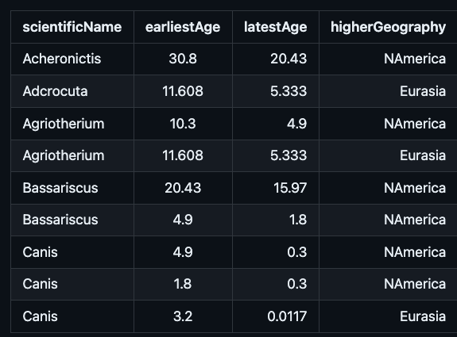
      - OR CarnivoraFossilsSite.txt, where a “site” column is specified. This is useful if a fossil assemblage/site contains several occurrences. In this case, we want to consider these occurrences as coeval, then randomize their age w/in the SITE’S temporal range.
    - Table with recent distributions, of all taxa, as discrete area classifications, with one row per taxa in each area, as (CarnivoraRecent.txt)
      - 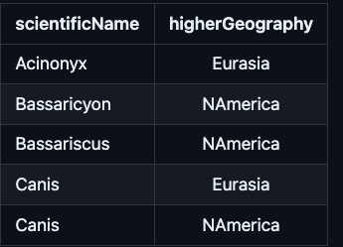
      - Notice that Canis has two rows instead of one, because it showed up in both areas in recent times
  - Species distributions as coordinates: Using speciesgeocodeR R package
    - Have a genus_coordinates.txt file with the occurrences + the longitude and latitude
    - Have a genus_regions.shp file with geographic regions
    - Have a genus_recent_coordinates.txt with the occurrences + most recent longitude and latitutde
    - Use this speciesgeocodeR script on the two files above →
    - 2 outputs
      - Fossil occurrences (same as CarnivoraFossils.txt above)
      - Recent fossil distributions (same as CarnivoraRecent.txt above)

Once you have these necessary files, you can create the DES input files:
  - python PyRateDES.py -fossil path_to/CarnivoraFossils.txt -recent path_to/Carnivora/CarnivoraRecent.txt -wd path_to_working_directory/Canivora -filename Carnivora -bin_size 0.5 -rep 10
    - -fossil: the path to the fossil occurrences .txt is next
    - -recent: path to the most recent taxa distributions .txt is next
    - -wd: path to the working directory where you want to put the generated input files (same wd as the input files for the input files)
    - -filename: the name that you want the generated input files to have
    - -bin_size: in the same units as the fossil ages, usually millions of years, the size of the time bins. Affects resolution, but should be guided by data availability
    - -rep: number of replicates you want (re-sampling from max to min age range for each fossil)
    - -trim_age: optional flag for cutting the dataset off at a maximum (oldest) age. So any fossil whose re-sampled age exceeds this flag will be omitted.
    - -translate: optional flag to remove all data from present day to that #. So -translate 66 will remove the Cenozoic era, which is everything from 66 million years ago to today. Obviously, the file following -recent will have to be empty, because using this flag indicates using completely extinct taxa
      - If you use this flag, you can only use the Skyline model!
      - -qtime: rate shift should be set to bin_size/2, and all rates after this shift should be ignored. Time of -translate will need to be subtracted from other ages of -qtime
    - -taxon: optional, specifies the name of the column with the taxon/species names, if it is not currently named “scientificName”
    - -area: optional, specifies the name of the column in both input files with the geographic distribution, in case it is not “higherGeography”
    - -age1: optional, specifies the name of the column in both input files with the earliest age, in case it is not “earliestAge”
    - -age2: optional, specifies the name of the column in both input files with the latest age, in case it is not “latestAge”
    - -timeline: optional, overrides -bin_size by allowing time bins of different sizes. Example: -timeline 0.5 2.0 5.0 10.0 20.0
    - -site: optional, if you have site data (CarnivoraFossilsSite.txt)! Specifies the name of the column in the -recent .txt file with the site ID of the assemblage for each occurrence, in case it is not called “site”
      - -site “”: do this if you want ages to be randomized, but not by site
    - -data_in_area 1: (1 or 2) a flag telling DES to only look in geographic area 1, because you only have data for that area or you’re only interested in that area. So DES is run only on taxa dispersing, going extinct, being sampled in area 1, none of its calculations consider the other area.
    - -plot_raw: optional, generates a PDF plot in -wd of the observed diversity trajectories and 95% credible intervals in each of the 2 areas
  - Output(s): DES input file(s)
    - Carnivora_1.txt → Carnivora is what followed the -filename tag, and 1 indicates the replicate number

Simulated DES input data: use simDES R package to simulate input files for a DES analysis under different time-variable dispersa, enxtion, and sampling rates or with an influence of traits on dispersal and extinction
  - simDES code in the Tutorial

DES Analysis Command:
- Most of these can be combined! If you want a Skyline model where dispersal rates vary over time and vary with a categorical trait + extinction rates vary with a time-variable covariate predictor, you would do -TdD -TdE -mG -qtimes -catD -varE flags

DES with constant rates: dispersal, e and sampling rates are constant through time, but different between the 2 geographic areas
  - python PyRateDES.py -d ./example_files/DES_examples/Carnivora/Carnivora_1.txt
    - Carnivora_1.txt: DES input file created above, replicate 1
    - -out: optional, allows you to name the output log file
    - MCMC -n is default 100k generations/iterations, and -s is default 100 iterations, -p 100 while → the program showing an update about its progress every 100 iterations
    - -A 0: default, Bayesian inference MCMC analysis. Output: MCMC log file w/ parameter estimates and their uncertainties (posteriors)
      - -A 1: Thermodynamic Integration (model comparison) + -A 0’s Bayesian MCMC output
      - -A 2: Approximate Maximum Likelihood. Quick exploration of parameter space to output point estimates of parameters that maximize likelihood values, and potentially a measure of fit like AIC or BIC
      - -A 3: Maximum Likelihood test using Subplex algorithm. Same output as -A 2
      - -A 2 and 3 are preferred for large datasets since they’re faster
  - 1 Output: Carniovra_1_0_TdD_TdE.log
    - Summarize the Bayesian analysis in the outputted DES log file using this command. It will output the mean and 95% credible interval for all parameters
    - python PyRateDES.py -d ./example_files/DES_examples/Carnivora/Carnivora_1.txt -TdD -TdE -sum ./example_files/DES_examples/Carnivora/Carnivora_1_0_TdD_TdE.log

Time-Dependent DES (temporal rate heterogeneity)
  - DES command above + -TdE and -TdD flags
  - -TdD: would specify time-dependent dispersal rate
  - -TdE: would specify time-dependent extinction rates

Preservation Rate Heterogeneity Across Taxa:
  - DES command above + -mG flag
    - -mG: just as in other analyses, -mG flag assigns different q (preservation/sampling) rates to each taxon from a Gamma distribution. It affects the preservation model! Sampling heterogeneity is computationally inexpensive in general, as it only adds a single free parameter to the model. Plus, it improves rate estimation. Therefore, -mG should always be included in DES models
    - -ncat 4: Mean sampling rate across all taxa = q, sampling heterogeneity = a discretized Gamma distribution with n categories. Default 4 Gamma categories is usually sufficient to account for heterogeneity across lineages. A higher number → more computation time.
      - What is “discretizing” a Gamma distribution? Chopping the distribution into 4 pieces, and taking the mean or median of each piece, and assigning each taxon into one of those 4 pieces. All the taxa in the lowest 25% of the Gamma distribution get assigned that 25%’s mean or median q rate, and so on. This is faster to compute than giving a unique q rate from the Gamma distribution to each taxon, while still allowing lineage-heterogeneity and approximating the continuous Gamma distribution

Skyline Model: Piece-wise temporal rate heterogeneity. A time-variable DES with rate shifts
  - DES command above + -mG + -qtimes 20.43 15.97 13.65 11.63 7.25 5.33 2.58 -n 1000001 -s 1000 -p 1000 -TdD -TdE
    - -mG: q rate (preservation/sampling) heterogeneity across lineages again
    - -qtimes: dispersal, extinction, and preservation rates can shift at discrete moments in time, specified in this argument
    - -symd, -syme, -symq: constrains all dispersal rates, all extinction rates, and all preservation rates (respectively) to be equal between areas
    - -constr: forces only certain rates that you choose to be constant across time, while others can vary across time.
      - -constr 1: constrains dispersal rate (d12) from area A to B to be constant over time
      - -constr 2: constrains dispersal rate (d21) from area B to A to be constant over time
      - -constr 2: constrains extinction e1 in A to be constant over time
      - -constr 4: constrains extinction e2 in B to be constant over time
      - -constr 5: constrains sampling q1 in A to be constant over time
      - -constr 6: constrains sampling q2 in B to be constant over time
      - ^ can use multiple of the above at once: ex: -constr 3 5
    - Output: normal DES output, except that rate predictions are provided for each different time interval

Covariate Dependent DES: time-variable predictor + DES as a function of it
  - Input: a .txt predictor file in a separate directory
    - 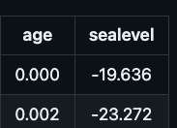
    - Dispersal, extinction can have multiple predictors and/or their own separate predictors. Put all predictor .txts into the same directory
  - python ./PyRateDES.py -d ./example_files/DES_examples/Carnivora/Carnivora_1.txt -varD ./example_files/DES_examples/Carnivora/covariate_dispersal -varE ./example_files/DES_examples/Carnivora/covariate_extinction
    - The -TdD and -TdE flags should NOT be used w/ Covar DES
    - -varD: the covariate predictor .txt file(s) that you want to covary with dispersal rates. Dispersal, extinction can have multiple predictors and/or their own separate predictors. Put all predictor .txts into the same directory
    - -varE: the covariate predictor .txt file(s) that you want to covary with extinction rates.
    - -r: As with any covariate model, rescaling happens automatically and can be controlled with this flag
    - -qtimes: allow sampling rate to vary over time
    - -mG: allow sampling rates to vary over lineages
    - -lgD -lgE: making the effect of the environmental variable on dispersal and/or extinction rates respectively follow a logistic curve rather than an exponential
    - -linE: making the effect of the environmental variable linear
    - -symCovD: forces the effect of the covariate on dispersal rates to be the same (symmetrical) for both areas via indices
      - -symCovD 1: forces the effect of just the first covariate on dispersal rates to be symmetric for both areas via indices.
    - -symCovE: forces the effect of the covariate on extinction rates to be the same (symmetrical) for both areas via indices
    - -constrCovD_0: sets the effect of the covariate(s) on dispersal to zero
      - You can add “index” numbers after these flags to refer to only specific covariates.
      - In the code, covar_parD is the array of dispersal covariates
        - Even indices (0, 2, 4…) correspond to D rates from area B → area A
        - Odd indices (1, 3, 5…) correspond to D rates from area A → area B
      - -constrCovD_0 1 4:
        - 1 → Constrains (sets to 0) the effect of the FIRST covariate on dispersal rate from area A to area B
        - 4 → Constrains the effect of the SECOND on dispersal rate from area B to A
        - 1 & 3 would → the effect of covariates 1 and 2 would be set to 0 for dispersal rates in area A → area B.
    - -constrCovE_0: sets the effect of the covariate on extinction to zero
      - In the code, covar_parE is the array of extinction covariates
        - Even indices correspond to E rates in area A
        - Odd indices correspond to E rates in area B
  - Output: normal DES output + predictions of the covariate(s)’ effects on rates

Diversity-Dependent DES: does dispersal into an area decline w/ the increase in diversity of that area? Does extinction rate increase with increase in diversity of that area?

Diversity → carry capacity, effects of competition and niche filling
  - python ./PyRateDES.py -d ./example_files/DES_examples/Carnivora/Carnivora_1.txt -DivdD -DivdE
    - -DivdD: Diversity-Dependent Dispersal model
    - -DivdE: Diversity-Dependent Extinction model
    - -symDivD: constrains the effect of diversity on dispersal rates to be equal/symmetric in both areas
    - -symDivE: constrains the effect of diversity on extinction rates to be equal/symmetric in both areas
    - -DdE: Invasion DES model. If you’re wondering whether immigrating taxa (invasion) drive resident taxa in an area to extinction, you’re testing whether the number of dispersal events (invasions/immigrations, movements of lineages between areas) increases extinction rates
      - -DivdE makes extinction rates depend on diversity, whereas -DdE makes local extinction rates depend on the rate of dispersal (number of dispersal events) into an area
    - -constrDivdD_0 and -constrDivdE_0 set the diversity effect on dispersal or extinction to zero through indices. E.g. -constrDivdD_0 2 removes the effect for dispersal from area B to A and -constrDivdE_0 1 specifies diversity-independent extinction in area A.
  - Output: normal DES output + predictions of diversity effects on rates

Trait Dependent DES: we did covariate and diversity’s effects on rates. Now we can do continuous or categorial traits’ effects on these rates
  - Continuous Trait Input:
    - 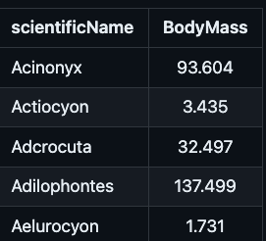
  - Continuous Trait Command
    - python ./PyRateDES.py -d ./example_files/DES_examples/Carnivora/Carnivora_1.txt -TdD -TdE -traitD ./example_files/DES_examples/Carnivora/Body_mass_1.txt
      - -traitD and -traitE specify the continuous traits influencing dispersal and extinction, respectively.
      - -logTraitD 0 or -logTraitE 0: By default, all traits are internally log-transformed. These flags will turn off log trait transformation.
      - This can be combined w/ Covariate Dependent DES (-varE and -varD), as well as -qtimes and -mG
  - Categorical Trait Input obviously need to be numerically coded:
    - 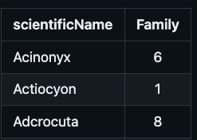
  - Categorical Trait Command:
    - python ./PyRateDES.py -d ./example_files/DES_examples/Carnivora/Carnivora_1.txt -TdD -TdE -catD ./example_files/DES_examples/Carnivora/FamilyGenera.txt
      - -catD and -catE specify the categorical traits influencing dispersal and extinction, respectively.

Summarizing DES:
- 2 Outputs from DES:
  - mcmc.log, not named that
  - margal_rates.log
- Summarize model probabilities: take mcmc.log + -b burn in → mean and credible intervals of the model parameters
  - python ./PyRateDES.py -d ./example_files/DES_examples/Carnivora/Carnivora_1.txt -TdD -TdE -qtimes 2.58 5.33 7.25 11.63 13.65 15.97 20.43 -mG -plot + -sum ./example_files/DES_examples/Carnivora/Carnivora_1_0_TdD_TdE.log -b 1000
- Plot model output: take marginal_rates.log + -b burn in → plot the DES (dispersal and extinction rates, per area) trajectory over time
  - python ./PyRateDES.py -d ./example_files/DES_examples/Carnivora/Carnivora_1.txt -TdD -TdE -qtimes 2.58 5.33 7.25 11.63 13.65 15.97 20.43 -mG -plot ./example_files/DES_examples/Carnivora/Carnivora_1_0_q_2.58_5.33_7.25_11.63_13.65_15.97_20.43_TdD_TdE_marginal_rates.log -b 200 -plotCI 0.75 0.95
    - -plotCI: specify the width of the credible intervals. If you do 0.75 and 0.95 like this example above, you will get 2 intervals, one of 75% and one of 95%, plotted w/ different opacities
  - Output:
    - R script for RTT
    - PDF RTT

BDNN Tutorial
- 2 feed-forward neural networks, one for speciation, one for extinction
- Benefits of NN’s: does not need a priori assumptions about the shape, non linear and non-monotonic responses of rates to variation in predictors + accounting for interactions among predictors
- Inputs: categorical (usually one-hot encoded, like geographic regions), continuous (environment, trait measurements), time is rescaled and added as a predictor by default
  - ^ Can take time data to get time-dependent rate changes without having to specify a prior discrete shift points
- MCMC samples neural network params (weights), runs the FFNN with those weights, gets point estimates of rates, ts’s, te’s, which are then used to calculate species specific rates
  - Combines all those pt estimates from all those NN configurations to get distributions for those rates in the end
- Process for one MCMC sample:
  - With each MCMC sample, only ONE neural net is updated: speciation or extinction
    - This is also why BDNN can’t be parallelized. One NN run through can only be done concurrently
  - For that neural net, either ts, te, q, OR one layer’s weights will be updated
  - If the weights are updated, then we re-run all the matrix operations from that layer onwards, through the newly configured neural net
    - The previous un-updated layers get cached, which speeds up the process relative to re-running the entire NN
  - We get new species specific rates
  - We calculate the new birth-death likelihood → new posterior distribution value
  - The posterior dist value that is sampled the most = the most likely configuration of the NN = the most likely ts, te, q, species-specific rates values
  - Also the point estimates of the predictions (ts, te, q, and rates) at each configuration of the NN (i.e., at each MCMC sample) lead to a probability distribution for the values of each ts, te, q, and rate

- Time-series pedictors and time effects (s and e variance over time) are default binned in 1 myr time bins. So if you have a continuous temperature curve (-BDNNtimevar file), the model would use the average temp for each 1 myr breakdown of that curve → computationally efficient
- If you use -fixShift and provide your own time bin file, you can specify when you want the s and e rates to vary
  - Then any -BDNNtimevar file with time-variable predictors would have their values averaged to fit w/in -fixShift’s bins
  - Benefit: maybe you want to delineate a larger bin to cover periods w/ fewer fossil occurrences → faster BDNN run
- User can specify the # of layers and node
- Activation function: ReLu or tanh in hidden layers, exponential function (to ensure positive rates) in output layer
- Parameters: network weights, inferred with Bayesian MCMC → has uncertainty estimates
- Predictions/Outputs: point estimates of speciation and extinction rates (events/million yrs) for that data + uncertainty estimates (?). Optional q (preservation) rates
- The most important predictors can be ranked

Input: Examples (note that log Body mass and paleotemp are z-transformed)
- PyRate.py input file (created from occurrence data)
- Species-specific, unordered categorical and/or continuous, trait(s) data table following the -trait_file command. Rows = species (one per species), columns = traits
- Time-series/time-continuous predictors following the -BDNNtimevar command. Rows = time bins, columns = predictors
Data preparation:
- Categorical with multiple traits → ohe
- Categorical where species can be multiple at once → ohe but some will have 1’s for multiple columns
  - Analyze later with -BDNN_groups, re-combining into one group
- Continuous traits and time-series predictors should be z-transformed (centering on 0) to improve model convergence
  - Continuous traits that DO NOT go negative should be log10 transformed first, then z-transformed
  - Their original mean and standard deviation should be stored in a Backscale.txt file so that when we later call the plotting function, the file can be used to display the results in their original scale
  - Time-series mean and std: first get both for each species through all time, then average those values for all species together → get mean and std → add it to Backscale.txt
- Ordered categorical (ex: scale of 1-10 = 10 states where the order matters), should be centered on zero by subtracting the median value
  - Find the median, round up or down to the closest integer. Add that median to the Backscale.txt for use later when you call the -plotBDNN_effects flag, you can add the -plotBDNN_trans_features + this Backscale.txt file to make the plot more meaningful. Std = 1
  - Subtract that “median” from all values → centering roughly at 0
  - Then set std to 1 in Backscale.txt so that we can have integers for the body sizes
  - These centered values are not exactly the same as when using z-scaling (meaning their 95% interval is exceeding beyond +/- 1.96) but this should be fine for 7 categories. If the trait has more than 7 states, it should be better converted to a continuous trait.
- 0 centering is important because our default activation function is tanh, which is symmetric around 0, [-1, 1] range. If your data is centered at 0, it makes full use of the range of tanh.
  - If your data’s mean was for example 2 instead of 0, most input would be in tanh’s saturation region (positive side), where the derivative is very small (flatter slope) and therefore gradients are very small

Command: -BDNNmodel 1
- python PyRate.py *_PyRate.py -fixShift .../Time_windows.txt -BDNNmodel 1 -BDNNtimevar .../Paleotemperature.txt -qShift .../Stages.txt -mG -trait_file .../Traits.txt -s 2000 -n 200000 -p 10000
  - -A 0: default for BDNN, parameter estimation or basic MCMC is the ONLY option for BDNN. any other -A value will just default back to -A 0
  - -BDNNmodel: 1 → use BDNN for s and e. 2 → use BDNN more sampling predictions. 3 → use BDNN for sampling, s, and e
  - -BDNN_taxon_time_tables: see section “Custom Predictors” under “Output Post-Processing’
  - -BDNNtimetrait: Default when using -fixShift option. Time is rescaled and then added as a predictor
    - -1 auto-rescaled to [1, 0] by dividing all time values by the maximum time value, where 1 = the oldest fossil and 0 = present day.
    - If > 0, that non-zero number will be used as a specific rescaling factor by multiplying the timetrait by that value. Not sure why that’s an option
    - If = 0, time will not be a predictor
    - *see 3 screenshots in a row below
  - -BDNNtimevar: Time-variable predictors, applied to all species the same way
    - Rows = ages (times), column = variable, z-transformed

    - Takes the -fixShift time bins, makes that a time vector containing those bins + 0 (for the presentday)
    - If the time-variable predictors’ values in -BDNNtimevar do not have the same time binning as -fixShift, their values are interpolated to fit within the -fixShift values
    - Then for each -fixShift time bin, we get an array of inputs for the neural network containing:
      - For each species as rows: species-specific traits (never change, diff for each species), time specific traits (same for all species, change in each time bin, do not match the original values in -BDNNtimevar if -fixShift is diff from -BDNNtimevar’s bins), then -fixShift’s rescaled time bins
      - Then if you’ve used -BDNNtimetrait, will add the rescaled time bins to the input data as well
      - 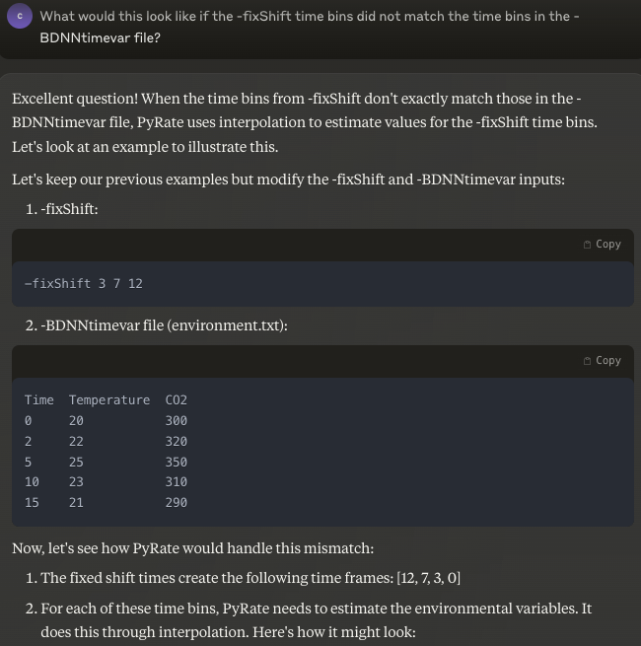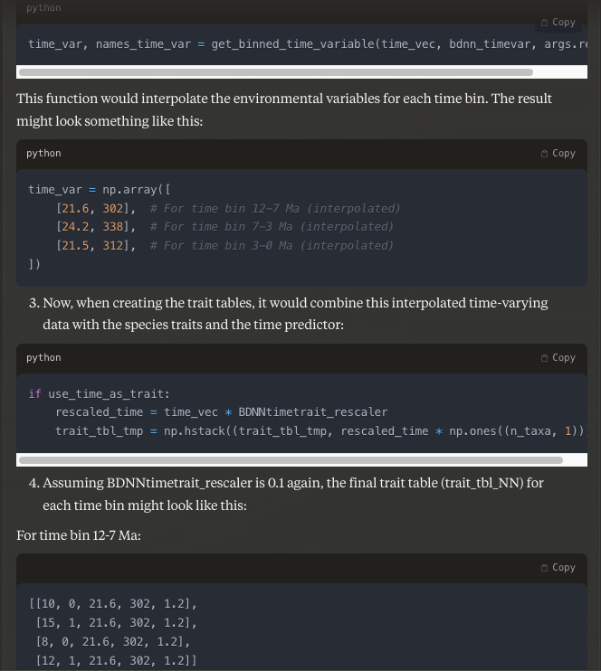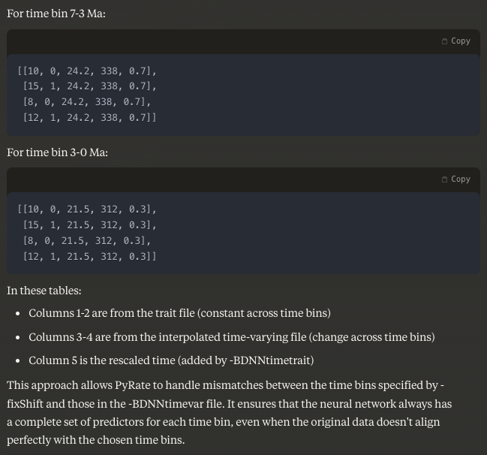
  - -trait_file: unchanging species traits, different per species
    - Rows = species, columns = variables
  - -translate: helpful if you are working with extinct taxa only. Shifts all occurrences so that the most recent is at the present day, reducing the empty space from now til that most recent occurrence.
    - Example: if all of your species are from 200 million years ago and older, and are therefore all extinct: -translate -175.0 → shifts all the occurrences towards the present (removing 175.0 years from their ages). All time variable predictor files (-BDNNtimevar) will be adjusted automatically, and time re-scaling (-BDNNtimetrait) will now be more evenly distributed (instead of all the times being crunched around 0, they’ll be spread out more evenly)
    - This also speeds up the program, for the reason explained under -fixShift below
    - If you are working with completely extinct clades, always use -translate when:
      - You are NOT using -fixShift
      - You ARE including time as a trait, by using the default value for -BDNNtimetrait of -1 or any user chosen value >0
      - Using -fixShift like I did, with the last number in this file being 208, means that there is a large time bin from 208-0 with no occurrences. And this doesn't do any damage except slow things down/make the matrix bigger for no reason. So using -translate to shift the completely extinct species towards the future is not technically necessary as long as I am NOT including time as a trait (which means I'm using -BDNNtimetrait 0). But using -translate to shift the completely extinct species towards the future IS necessary if I DO include time as a trait (using -BDNNtimetrait -1, or >0, or just excluding it entirely, since the default value is -1).
  - -fixShift: Optional. One column, no header, time bins for the birth-death model, fixed times of rate shifts. If you do not use this, BDNN has default 1-myr time bins.
    - Including -fixShift time bins will make the program faster, but will not suggest to BDNN that there should be discrete rate shifts at those boundaries. The BDNN predictor “time” is something included by default (you would have to turn it off manually by using -BDNNtimetrait 0) can only capture gradual transitions in rates. Time as it is included as a trait using the default -BDNNtimetrait -1 will only affect the predictors (because all the predictors are interconnected/modulate each other in a neural network), but according to Torsten “will not be bent and twisted enough or have discrete shifts.” If you want to suggest sudden/discrete rate shifts at specific points in time, you would have to do some tricks:
      - Use RJMCMC instead of BDNN. RJMCMC excels in identifying shifts, but struggles with finding gradual transitions.
      - Provide a -BDNNtimevar file that contains time as rows, in whatever resolution (I think in Torsten’s example from the email, which you could probs find by searching “imptaient” or “truncated” or “refactor” he chose 0.1, which I think is 100k years??). And have one column per time bin you want, then a binary value of 0 or 1
        - ^ These are stage predictors, binary
      - However, if you have environmental trait files (following -BDNN_timevar) that have been binned into unequal intervals (like not all 5 myr or 1myr), it is better to provide -fixShift that matches those unequal -BDNN_timevar bins
    - Why is BDNN is painfully slow without -fixShift and -translate? Both are influencing how many matrix multiplications are performed by the neural network. By default we have one species x (traits + timevar + time) matrix per one million years. Each of these matrices is then multiplied by the weights in the first layer. The resulting dot product is multiplied with the weights of the next layer and so one.
    - The -fixShift allows to override the default 1 myr bins and reduces the number of matrices. The same when you do -translate because you get rid of 200 bins where you do not have fossil occurrences (this is all for the situation when we were working with completely extinct clades that went extinct 200 million years ago)
    - Also note that if later you want to bin/truncate PDP plots, the values by which you want to truncate the plots (values passed to the arguments -root_plot and -min_age_plot) need to be included in the fixShift file. If you want 1 Myr resolution but also want to bin/truncate the PDP plots later, you’ll have to create a -fixShift file that has 1 Myr resolution AND those years that you want to truncate the plots by. For example, if your analysis spans 300-200, and you want 1Myr bins, usually you could just leave out -fixShift since BDNN’s default time bins are 1Myr. But if you also later want to get PDP plots that don’t span the entire 300-200, but go 298.5-240, you need to make a fixShift file that looks like: 300, 299, 298.5, 298, 297…
  - -qShift: Optional. One column, no header, time bins specifying the TPP model. Can use any other Preservation model, TPP used here as an example
  - Should always use -mG: species-specific sampling heterogeneity from preservation model
  - -BDNNnodes 16 8: defines the number of layers and nodes in each layer. Default is 2 layers of 18 and 8 nodes respectively
    - If you have very few predictors, you should reduce the complexity of your network by reducing the # of nodes
    - -BDNNnodes 4 2 → if you have 3 predictors, for example
    - Also, if you reduce the # of nodes, you need to use the -BDNNupdate_f argument!
    - In the example of -BDNNnodes 4 2, you’d follow with -BDNNupdate_f 0.3
    - -BDNNupdate_f 0.3 is an increase from default 0.1 (which means that 10% of the weights in each layer are updated). If I did 0.1, since we have so few nodes, it’s possible that no weights would be updated.
    - With -BDNNnodes 4 2, you have:
      - Input layer to hidden layer: 1 * 4 = 4 weights
      - Hidden layer to output layer: 4 * 2 = 8 weights
      - Bias terms: 4 + 2 = 6 bias weights
    - The default -BDNNupdate_f updates 10% of weights per layer. This means:
      - Input layer: 10% of 4 weights = 0.4 weights (rounds to 0)
      - Hidden layer: 10% of 8 weights = 0.8 weights (rounds to 0)
      - Bias terms: 10% of 6 weights = 0.6 weights (rounds to 0)
    - This is problematic because with such small layers, rounding down means no weights get updated! You should increase the -BDNNupdate_f value to ensure at least one weight per layer gets updated in each MCMC iteration.
      - For example, setting -BDNNupdate_f 0.25 would update:
        - Input layer: 25% of 4 = 1 weight
        - Hidden layer: 25% of 8 = 2 weights
        - Bias terms: 25% of 6 = 1-2 weights
    - This would ensure the network can actually learn from the data.
  - -BDNNoutputfun: activation function of the output layer
    - 0) abs, 1) softPlus, 2) exp, 3) relu 4) sigmoid 5) sigmoid_rate (default=5)
    - Exponential is default, because it forces strictly positive output values. Since this function can grow very quickly, scaling and stability of your inputs and intermediate layers have to be well done
  - -BDNNactfun: activation function of the hidden layers
    - 0) tanh, 1) relu, 2) leaky_relu, 3) swish, 4) sigmoid (default=0)
    - Tanh is default. The benefit is that it allows for + and - interactions, bc it spans [-1, 1], and aoids vanishing gradients (relative to sigmoid). It was mainly chosen just because it has the best results though
  - -BDNNreg: affects regularization. BDNN automatically sets to 1.0 → assigns “no effect” (each predictor having no effect) the highest probability → the higher the positive values of a predictor’s effect, the larger the weight applied to it → a “shrinkage” factor to ouputted rates, pushing predictions towards a baseline of 1, which represents no effect → reducing overfitting w/ more conservative preditions
    - Conceptually = turning it higher means indicating the belief that extreme rate variations are less likely
    - -BDNNreg -1.0: turns reg off
    - -BDNNreg -1.0 1.0: turns reg off for speciation, on for extinction
    - -BDNNreg 1.0 2.0: default reg for speciation, higher reg for extinction, etc. for other combos
  - Output: .../pyrate_mcmc_logs/
    - _mcmc.log
      - t_reg_lam, t_reg_mu = regularization
      - BDNN without -fixShift uses default 1 myr time bins, but since each replicate has a different oldest age, each individual replicate will have a different number of time bins (replicate 1 might have 100 time bins, replicate 2 might have 102, etc.).
      - Log files: columns = metrics like network weights, ts’s for each species, te’s for each species. Rows = one MCMC sample. Each replicates’ log file should have the same shape (as long as they each had the same # of MCMC samples -s)
    - ex_rates.log
    - sp_rates.log
    - per_species_rates.log
    - .pkl,
    - _sum.txt

Command for Re-starting an MCMC Run: -restore_mcmc + -out
- python PyRate.py *_PyRate.py -restore_mcmc ..../pyrate_mcmc_logs/*_mcmc.log -out “” -BDNNmodel 1 -trait_file .../Traits.txt -BDNNtimevar …/Paleotemperature.txt -mG -n 200001 -p 20000 -s 5000 -j
  - -restore_mcmc mcmc.log: if you made -n too small and want to continue the MCMC chain from the last sample. Make sure to provide all the same files as the initial run (-fixShift, -qShift, -BDNNtimevar, -trait_file, -BDNN_taxon_time_tables, etc.).
    - It’s taking the last mcmc sample and starting the MCMC from there
    - Use case: if you had a huge burn-in so you need more iterations, use this to restore from that point on, to skip that burn-in period
    - NOT an append: use -out -restore_mcmc → then combine the two log files together once you get at the end using Excel or Beast submodule log combiner
    - Always use this with -out otherwise it WILL override the original file.
  - Always include -j so that the resulting file is named properly (marked with the correct replicate name), unless of course you’re restoring a combined mcmc.log. Although don’t see why you’d do that

Combining Multiple Replicates’ MCMC Runs: -combBDNN
- python PyRate.py -combBDNN .../pyrate_mcmc_logs -b 20 -resample 100 -tag file_name
  - -resample 100: sub-sampling from each replicates’ log file so that the combined files aren’t too big
  - -tag file_name:

  - Output: .../pyrate_mcmc_logs/
    - combined_i_mcmc.log
    - combined_i_ex_rates.log
    - combined_i_sp_rates.log
    - combined_i_per_species_rates.log
    - combined_i.pkl

Output Post-Processing

Marginal S & E RTT Plot: -plotBDNN
  - S and e rates through time. X axis = time, y axis = s rate, e rate, net diversification rate, longevity
  - python PyRate.py -plotBDNN .../pyrate_mcmc_logs/*_mcmc.log -b 0.1
    - -plotBDNN: uses the *_sp_rates.log and *_ex_rates.log from the pyrate_mcmc_logs directory
    - -plotBDNN_groups RTT_groups.csv: optional, if you only want to make the RTT plot for certain taxa
      - RTT_groups.csv: one row per grouping. Each row has multiple taxa names that you want to group together, or you could do taxa that are less than 100 pounds vs. more than 100 pounds, etc.
  - Output: saved to the specified directory w/ the mcmc.log file
    - PDF RTT
    - Rscript RTT

Partial Dependence Plots (PDP): -plotBDNN_effects like the above RTT’s, but per predictor

Visual representation of if we only changed one predictor or pair of predictors, keeping all else constant, what would happen to the predictions/output? That = the global effect of that predictor or pair of predictors
  - X axis = trait, predictor, or (if you use -BDNN_groups flag) group of traits, group of predictors
    - X axis ticks = observed values of the predictor/trait at the inferred te or ts
  - Y axis = s rate, e rate, net diversification
  - python PyRate.py -plotBDNN_effects .../pyrate_mcmc_logs/*mcmc.log -plotBDNN_transf_features .../Backscale.txt -b 0.1 -resample 100
    - plotBDNN_transf_features .../Backscale.txt: use this if you z-transformed your traits and time-series predictors. It will use the Backscale.txt to revert the, to their original scales
      - This will not revert any log 10 transformation that you’ve done
      - Backscale.txt: used to rescale the traits in the plots
        - Need to be created by the user, beforehand
        - Should be one .txt PER TIME BIN
        - Rows = mean, std, in that order
        - Columns = every feature that has been scaled!
    - -BDNN_groups: Optional. A Python dictionary containing categorical traits from your trait file follows, in JSON string format (dictionary is enclosed in “{}”). Used on ohe’d predictors that all belong to the same class
      - To make -BDNN_groups work on Windows you have 2 options:
        - Use Command Prompt with diff formatting: -BDNN_groups "{\"biome\": [\"Arctic\", \"Temperate_N\", \"Tropical\", \"Temperate_S\", \"Antarctic\"]}"
          - ^In Linux or Mac, use single quotes on the outside instead of double, no slashes
        - Use PowerShell like this: --% -BDNN_groups "{\"biome\": [\"Arctic\", \"Temperate_N\", \"Tropical\", \"Temperate_S\", \"Antarctic\"]}"
        - --% -BDNN_groups "{\"biome\": [\"Arctic\", \"Temperate_N\", \"Tropical\", \"Temperate_S\", \"Antarctic\"], \"mat_z_trans\":[ \"mat_z_trans\"]}"
      - In this example we have 1 key:value pair: biome+ a list of column names from the trait file. Biome was a multi-categorical trait (“biome” is an arbitrary name, it doesn’t show up in the trait file. The key value doesn’t have to show up anywhere, it’s just what the PDP graphs will use as a title later) that got one-hot encoded out, and now we want them to all be graphed in one graph together, instead of in a bunch of separate graphs
    - -resample: instead of using all samples from the MCMC chain (after burn-in), specify a specific number of randomly selected posterior samples considered in the plot. Enough to approximately represent the posterior distribution. 100 is usually sufficient
      - That being said, for official publications, you prob shouldn’t use -resample
    - -root_plot and -min_age_plot: truncating PDPs by a oldest maximum age (root_plot) and a minimum youngest age (min_age_plot) so you cut the full time period down to just that portion
  - Output: saved to the specified directory w/ the mcmc.log file
    - PDF PDP
    - PTP.r

Partial Dependence Rates: -BDNN_interaction
  - Does the same thing as above, but for more than 2 predictors. So if you have 10 predictors and you want to see the effect of 3, marginalizaed over the other 7, use this
  - PDP’s (above) are visual displays of the effect of single predictors or 2-way interactions between two predictors on s and e rates. This command gets us a numerical representation (partial dependence rate) of the effects of any combination of predictors: ex: if these three predictors had these 3 values, what would the speciation rate be?
  - This command will take 100 points/values spanning each continuous predictor, and calculate the s or e rates at those predictor values. For 3 predictors this would be 100³, so it’s computationally expensive to do this → the PDP curve
  - Partial dependence rate: the average effect of a predictor on the outputted rates.
  - python PyRate.py -BDNN_interaction .../pyrate_mcmc_logs/*mcmc.log -plotBDNN_transf_features .../Backscale.txt -b 0.5 -resample 3
    - -BDNN_groups: if you want to get one partial dependence rates for each group of > 2 predictors. In this case you can group categorical and continuous as you’d like, based on whatever combo of predictors you care to look at
      - Ex: "{\"BodyMass\": [\"BodyMass\"], \"Temperature\": [\"Temperature\"], \"taxon\": [\"Amphicyonidae\", \"Canidae\", \"Felidae\", \"FeliformiaOther\", \"Hyaenidae\", \"Musteloidea\", \"Ursidae\", \"Viverridae\"]}"
    - -BDNN_interaction_fix: species-specific s and e rates at their ts and te, with values of predictors EXCLUDING the effects of the predictors specified in -BDNN_groups
      - If we added this flag w/ the example of -BDNN_groups above, we would get s and e rates at ts and te of each taxon, calculated as if body mass, temperature, and family did not matter
  - Output: 4 .txt files, 2 per s and e
    - *_pdp.csv
      - Columns = BDNN_groups names
      - Rows = values of each column used to calculate the last three columns, mean predicted rate, lwr and upr bounds of the 95% CI of the rate (s or e depending on the file you’re looking at)
      - 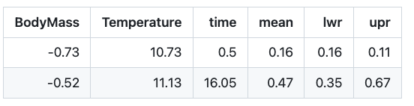
    - .txt
      - At each of the model’s estimated ts’s or te’s (depending on the file), what the predictors’ values are. I.e, if a predictor is temperature, what the temperature is at each of BDNN’s estimated times of speciation

Predictor Importance: -BDNN_pred_importance
  - (1) Whether rate variation is correct:
    - Coefficient of variation for S and E rates: CV is a measure of dispersion in a dataset = std/mean. It is calculated for s and e rates, per species in each time-bin
    - ^This will not show up if you set -BDNN_nsim_expected_cv 0
    - BDNN allows rates to vary across species and time. Here we assess whether that variation is statistically significant, i.e., whether the BDNN variation is > the variation we’d expect to observe in a model where diversification rates were actually constant (the “null” hypothesis)
    - To do this, PyRate will create a constant rate model and feeds it multiple simulated datasets using the same root age and similar # of taxa (within 25% of the real dataset) as the real dataset
    - It will calculate the variation in rates for each simulated dataset’s run through that constant rate model
    - It determines the 95th percentile of these simulated rate variation = cv_expected
    - If the real data’s rate variation (cv_empirical) is > this 95% threshold, it suggests that the real data’s rate variation is > than expected by chance under a constant rate model → the variation in rates is statistically significant → BDNN model (or any model allowing for rate variation) is more appropriate than a constant rate model
  - (2) Ranking the importance of the predictors using 3 explainable AI metrics:
    - Marginal posterior probability of that predictor having an effect
    - Effect size of that predictor on the rates (SHAP values, can be + or -, larger in abs magnitude = stronger effect)
    - Effect of the predictor on model fit (feature permutation)
  - python PyRate.py -BDNN_pred_importance .../pyrate_mcmc_logs/*_mcmc.log -b 0.1 -BDNN_nsim_expected_cv 0
    - -BDNN_pred_importance_nperm: how many permutations, default 100 . Feature permutations will use the current time bins (set by the user in -fixShift and/or -qShift, or default 1 myr) and permute the values of each predictor within those bins, then see how the model’s likelihood changes. This is done several times per predictor, to see how important a predictor is to the model.
    - -BDNN_pred_importance_window_size: If your time bins are very small (like < 0.1 myr), the permutation (above) can take forever, since you’ll have to permute the values of each predictor within many bins multiple times. Set this to 0.5 to make the permutations happen in 500 kyr time bins, for example.
    - -resample: number of samples to keep from the log file to use for these calculations, if you have a ton of MCMC iterations, the calculation of predictor importance could take forever. So you’ll want to decrease this number
    - -BDNN_groups: optional, specify which predictors belong in the same class. Likely don’t need it unless you want pairwise comparisons of those groups. Like if you have a “biome” group with binary variables for 0 (not in that biome) vs. 1 (in that biome), and 5 biomes total, and you use -BDNN_groups, yo will end up with pred importance rows that compare the effect of presence in one biome to the effect of presence in another, rather than the effect of presence in one biome vs. absence in that same biome, which is more likely what you want.
    - -BDNN_pred_importance_interaction: rank 2-way interactions of predictors in addition to per-predictor. May slow things down depending on the number of predictors
      - -BDNN_mean_shap_per_group: use with -BDNN_groups to use the mean of the SHAPs instead of the sum of the SHAPs of all the members of each group to get overall importance of the group. Helpful when a trait has many states
    - -BDNN_nsim_expected_cv: # of simulations to use to get expected cv, coefficient of variation, default = 100, reduce it to make it faster
      - Set this to 0 if you have extinct clades
    - -plotBDNN_transf_features .../Backscale.txt:
  - Output:
    - (1) Printed on Terminal screen:
      - Extinction: # > expected = # = greater variation than what we’d get under constant rate model, which means some of our predictors are influencing s and e rates
      - _coefficient_of_rate_variation.csv: compare cv_empirical to the cv_expected, the upper 95% quantile of rate variation (cv) under a constant diversification process (null model)
        - ^This will not show up if you set -BDNN_nsim_expected_cv 0
        - cv_expected: expected amount of rate variation under a constant diversificiaton process (null model) that is fed simulated datasets that have the same root age and a similar # of taxa as the actual dataset (+- 25% the number of taxa)
        - cv_empirical: at each MCMC sample, BDNN calculates an s and e rate for each species. cv_empirical is calculated by averaging that sample’s rates across all species, then averaging across all samples
        - If cv_empirical > cv_expected, it implies we can look into which predictors are causing this variation
        - 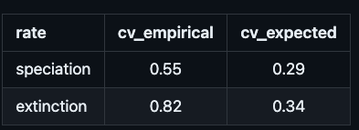
    - (2) Ranked importance of predictors using consensus of 3 explainable AI metrics:
      - Sp_predictor_influence.csv
      - Ex_predictor_influence.csv
    - Sp_shap_per_species.csv
    - Ex_shap_per_species.csv
    - R script and PDF of lineage-specific rates, estimation of how they are affected by the predictors’ values
      - Contribution_per_species_rates.r
      - Contribution_per_species_rates.pdf
        - Most important predictor is closest to the top, then going down is 2nd most important, etc.
        - They are RANKED but we don’t know how MUCH one is more important than the other
        - Color (key on the right) shows how much above average (?) (0) that predictor group or predictor value had

Custom Predictors Files:
  - -trait_file assumes that species traits do not change over time.
  - -BDNNtimevar assumes all species experience the same time-series predictors (usually enviornmental) over time.
  - However, we can built custom tables
  - -BDNNtimetrait -1: default. Makes BDNN that includes the effect of time. Time is automatically rescaled to the range 1-0, where 1 is oldest fossil and 0 is present
  - -BDNNpath_taxon_time_tables: flag directing the BDNN to the directory with a unique input table for each time bin, for extinction and speciation
    - Allows diff predictors for extinction vs. speciation, predictors to have diff values in each time bin, applied differently to different species, diff in diff areas
  - We can change that by inputting a custom-built table, in the standard -trait_file .txt format, with species in rows, traits and/or paleoenvironmental variables in columns
    - But columns could be traits that differ among geographic areas, or human influence that only affects extinction, but not speciation or VV
  - Export your trait tables so that you can modify them to get the right format: same command as a BDNN analysis, but + -BDNNexport_taxon_time_tables and no MCMC flags
    - python PyRate.py .../Carnivora_occs.py -fixShift .../Time_windows.txt -BDNNmodel 1 -BDNNtimevar .../Paleotemperature.txt -qShift .../Stages.txt -mG -A 0 -trait_file .../Traits.txt -BDNNexport_taxon_time_tables
    - + -fixShift: IF you use this flag, it means you’re providing time bins .txt, where each trait/variable has a different value in each time bin. You need trait tables in the same file format as above, but you need one table per time-bin/boundary
      - Name them accordingly: 01.txt for the most recent bin, 02.txt, etc.
      - -BDNNpath_taxon_time_tables: flag directing the BDNN to the directory with those tables
        - You can provide two paths, where the first is for custom tables of speciation rate predictors, and the second is for extinction rates
        - Allows diff predictors for extinction vs. speciation, predictors to have diff values in each time bin, applied differently to different species, diff in diff areas
      - -fixShift: defining the time bins. Optional, if you don’t use it, you need one table per 1 million years
    - Output: BDNN_predictors folder

Custom Predictors Command:
  - python PyRate.py .../Carnivora_occs.py -fixShift .../Time_windows.txt -BDNNmodel 1 -BDNNpath_taxon_time_tables .../load_predictors/speciation .../load_predictors/extinction -qShift .../Stages.txt -mG -A 0 -s 10 -n 1000
    - In this example, the predictors are: per-time bin custom tables
      - W/ humans being present in the past 500k years in Eurasia, but not in North America
      - W/ paleotemperature trajectories that are continent specific
    - Output: .../pyrate_mcmc_logs/
      - _mcmc.log
      - _ex_rates.log
      - _sp_rates.log
      - _per_species_rates.log
        - Put this into Tracer, highlight all species’ mu or lam, and you can see the variation in ex or sp rates!!
      - .pkl,
      - sum.txt

Additional BDNN Notes:

-pred_importance: *_predictor_influence.csv file interpretations

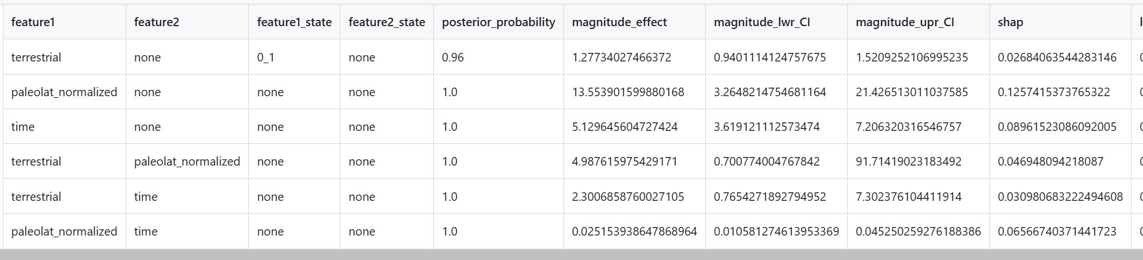
  - feature1_state = pairwise comparison of two categories of one categorical feature
    - If it says “none” that’s because it’s continuous, or because it’s an interaction row
  - posterior_probability = consistency of the effect
    - Continuous trait: that % of the time the highest temp on gradient is higher than the lowest temp on the gradient
      - Difference of highest point of the shaded area in one point of the line vs. lowest point in shaded area, averaged across the line. Check his email to confirm
    - in 96% of the MCMC samples, being non-terrestrial (0) led to a higher extinction rate
    - Ranges from 0 - 1, the closer to 0 and 1 = the higher the consistency of the effect of that predictor. 0.5 = basically no difference of which is higher
  - Magnitude_effect (not shown here): search ‘magnitude_effect’ or ‘mag’ in bdnn_lib. All functions are under “# Credible differences” section
    - First state has that #x higher e or s rate than the other state
    - Row 1: One categorical predictor only (binary or any with states, such as “taxon” above): partial dependence rate of state 0 / pdr of state1 → state 0 has a larger pdr than state 1
    - Row 2 and 3: One continuous predictor only. They cannot be interpreted like they are in regression coefficients, where one unit change of the predictor results in an x unit change of the dependent variable. In NN’s features have potentially non-linear effects. So magnitude = find the two MCMC samples that differ the most across all generations, then divide them → magnitude independent of however the predictor was scaled or its units
      - 1 = the feature has a consistent effect across its range
      - > 1 = the largest feature value is stronger than the weakest by that factor, although we do not know in what direction
    - Row 4: The highest mean extinction rate along the paleolatitude gradient (all MCMC samples) is greater than the lowest mean extinction rate in every MCMC sample (since posterior_probably = 1) by about 13.5x. Which is about 0.126 more extinction events per species per myr (the shap)
    - Interaction between categorical and continuous:
    - ^ Done across all MCMC samples, then take the mean of all those ratios
    - Value interpretations:
      - = 1 → rate is the same regardless of the feature’s value
      - > 1 = the factor by which the rate increases when the feature is changed from its minimum to its maximum observed value, or between states
      - 0-1 = decrease in rate
  - shap = effect size of the predictor in units of events per myr. Ex: row 1: we expect that in the next 1 myr, non-terrestrial is associated will have .026 more extinction events compared to terrestrial
  - delta_lik = how much the model likelihood decreases (changes = delta) when permuting the predictor. Larger decreases = predictor is more important to the model
  - rank = consensus of the previous 3

BDNN Tuning Suggestions:
  - Low number of traits = reduce model complexity.
  - -BDNNupdate_f 0.05 0.05 0.25, default 0.1
    - = what percentage of weights you want the network to update during each backpropogation. First set of weights = 3 predictors * 16 nodes = 48 weights. 0.05 of that = 2 weights updated instead of default 0.1 of that = 5 weights updated
    - Want the first layer of weights to be smallest since that has the most nodes
    - When too many weights are updated (especially of the first set), the BD_lik may decrease a lot and the proposed update will not be accepted. With many weights we could afford to update some of them because each will have a small leverage on the likelihood. Less updates mean the model is less explorative and may not find the highest likelihoods
  - Low ESS (high uncertainty): increase -BDNNupdate_se_f: same as above but for ts’s and te’s. Increases the share of proposed moves?
  - -se_gibbs: omits -mG and in addition samples origination and extinction conditional on the speciation, extinction, and sampling rate (it is slower though)

Non-BDNN Tuning Suggestions
Multimodality:
- If ESS is super low for one run, check the marginal density plots of various TS’s and TE’s: it’s possible that they’re multimodal. This means PyRate is saying that there are 2 (or however many peaks there are) possible/likely times of speciation (that species might have originated at either point)
  - This can lead to bad ESS because the MCMC chain might not be taking a large enough jump from one peak to be able to get to the other. If it is taking too small a step, it might end up in the valley between the two peaks, which is a location/sample with low likelihood, implying a period of low speciation rate. Thus, the jump will be lower than the original starting point (one of the peaks), causing the move to be rejected
  - The default jump size/step size for each MCMC iteration is sampled from a uniform distribution of [-0.5,0.5] — this means each proposed jump is at MOST 0.5 Ma into the future or into the past from the current point
  - If you’re working with data where your two peaks/two potential times of speciation are 10 Ma apart, for example, it becomes really hard for any proposed MCMC jump to be accepted
  - When the chain finds one node/peak, it’ll get stuck exploring that region → consecutive samples are highly correlated → poor ESS
  - Trace plots can look like it has achieved stationatiry, but it might just be stuck at that one value without having properly explored both values
  - Marginal density plots may be multimodal, but the size of the modes is deceiving, bc it could just depend on where the chain got stuck the longest
- Suggestion: increase step size with -tT argument. Generally aim for a step; size of 20-25% the distance between the two modes
- General suggestions for MCMC (not specific to PyRate): use adaptive step sizes, implement parallel tempering to help chains jump between modes, use a mixture proposal distribution that occasionally makes larger jumps, run multiple chains with different starting points

Output File Naming Conventions
BDNN
- 16_8: 16 and 8 notes respectively in the hidden layers
- TVc:
  - T = the effect of time is added as a trait (default, -BDNNtimetrait argument)
  - V = you used the -timevar argument to add time continuous predictors
  - c = a constant baseline rate (i.e., the bias term in the neural network). Rather than shifting the baseline, time is added as a trait itself (T above)
- BDS: you used -fixShift
- BD1-1: you used -r > 0 or -thread > 0
General:
- BD1-1: Birth death model with constant speciation and extinction rates = -A 0
  - This is a legacy naming convention from the origins of PyRate when users had to manually set the number of rate shifts they wanted for s and e. When users manually chose 2 rate shifts for speciation and 3 for extinction, for example, the file would be:
    - BD2-1: BD model with 2 shift speciation rate and constant extinction rates = -A 0 -mL 2
    - BD3-2: 3 shifts in speciation rate, 2 shifts in extinction rate = -A 0 -mL3 -mM 2
  - Now they have -A 2 and -A 4 for inferring the # of rate shifts, so no need to set them manually
  - If you use -r -A will be forced to 0, so it will be MCMC, not RJMCMC (-A 4, default), and the output file will be named BD1-1
  - Same for -thread > 0?? According to the code that shouldn’t happen, but anytime I use -thread (and no -r), I still get output files with BD1-1
  - Even if you don’t call -A 0, if the output file has "BD1-1", it must have been run with -A 0
  - Any command that used multiple MCMC chains (parallelization) (-r > 0) will be forced into -A = 0 (TDI == 0), even if -A 4 was explicitly chosen (and even if not, since -A 4 is default anyway).
  - If I used -r with -A 4 (RJMCMC) or no -A flag (implied -A 4), the -A 4 was overridden and changed to -A 0, MCMC.
  - -A 4 and -A 0 runs will always have a different # of columns, which means they cannot be combined or concatenated!!
    - If you have a BD1-1 log, it cannot be combined with any RJMCMC logs
  - This does not matter for BDNN, obviously, because BDNN will always be -A 0. So if you use BDNN w/ multithreading (-thread or -r), you will get BD1-1 named logs, but they will have the same # of columns as BDNN’s non-BD1-1 named logs. So you can restore and concatenate the two types
- BDS (see above)
- Covhp = hyper prior (-pC 0)
- Covhprj = hyper prior and RJMCMC
- _G = -mG argument = heterogenous sampling rates (preservation model) across lineages
- Any -r > 0 will force -A 0, despite the fact that -A 4 is default, even if -A 4 is explicitly called.

Additional Arguments
Parallelization: not working, experimental. Torsten said it’s not worth it
- Not available for main BDNN run. Can be used for BDNN post-processing
- -r → only available for PyRateContinuous.py paralellizing MCMC chians so you can run multiple at once
  - The parallelization is not just dividing the tasks. Rather in MC3 algorithms multiple MCMC chains are created that explore the parameter space. Some of them are jumping quickly ('hot chains') around to cover more of the space while others are more stationary ('cold chains'). When one of the hot chains finds a good combination of parameters, it will inform the cold chains who then move to this spot and go on sampling from there. In theory, this should help to achieve a quicker convergence and better estimates. However, in practice only a few programs get it right, PyRate is not one of them lol
  - Not available for TDI=1 (thermodynamic integration)
  - Not available for BDMCMC
  - Will lead to an output of marginal_rates.log instead of sp_rates.log and ex_rates.log (these two are meant to be outputted by RJMCMC, which leads me to believe that -r cannot be used for RJMCMC either).
  - Using -thread with no -r or using neither -thread or -r leads to 2 separate files
  - Any use of -r will lead to marginal_rates.log
    - THIS IS (I think) BECAUSE -R DOES NOT WORK WITH RJMCMC, so if you use -A 4 and -r (as I have been doing), it will default back to regular MCMC, which outputs marginal_rates.log
- -thread #1 #2 → WITHIN CHAIN (multiple may be specified with -r above) number of threads (=# of CPU cores) for parallel BD likelihood calcultations and NHPP model likelihood calculations respectively. Defaults to 0, 0 = no multithreading
  - Keep this total # < the # of CPU cores you have available
  - Not available for BDNN
Other:
- '-discrete',help='Discrete-trait-dependent BD model (requires -trait_file)', action='store_true', default=False)
- '-twotrait',help='Discrete-trait-dependent extinction + Covar', action='store_true', default=False)
- ‘-seed’ = tell the run to start with certain initial parameter values. Use this when you want to start independent runs at the same place, making their results more comparable
Note on extant species (use of the flag -N and how input data should be structured)
- The sampling model can’t account for 100% complete sampling at the present, so you should NOT add in extant species occurrences that have no fossil record. I.e., you shouldn’t add in occurrence rows for presently living occurrences. Doing so would inflate rates and create edge biases. The program is only good for handling fossil data without present species diversity
  - The question we have as a result is, what if you have extant species? Obviously in the preparation of the data (the very first step using PyRate, the R poriton, where you use extract.ages) you can specify extant_species vector
  - But what if your occurrence dataset has NO fossil occurrences from the extant species? So you have a clade with fossil occurrences and extinct species, but that clade also has living species, but no occurrences of it? So if you specified that living, no occurrence species in the extant_species vector, nothing would happen. Can we add dummy occurrence data that has min_age = 0 and max_age = 0? No, as in the parent bullet point, you uhsould not
- The -N flag is noted as an option in the original paper and in the program as a method of specifying the number of extant species in a clade, by going -N 8, for example. But Daniele Silvestro says that actually this doesn’t bring any improvements, so you should never use it.
- What’s the solution for including present diversity in an analysis though? For PyRate, nothing really. Even changing the birth-death prior in order to make the shape reflect info about present diversity doesn’t really do anything to the estimates
  - Daniele says all we can do is “use the FBD model in a phylogenetic context e.g. using BEAST, which Gabriela and I discussed a while back as something interesting to try. These models are not perfect and might fail to pick up signals from ancient events like the K-Pg but might be better to detect accelerated diversification towards the recent”

ADE-NN Tutorial:
https://github.com/dsilvestro/PyRate/tree/master/ADE-NN

