Yihan Shi 604637697

Industry Seminar – Time Series

HW 2

Forecast **monthly** home price return (diff(log(home price)) on the largest 30 metros:

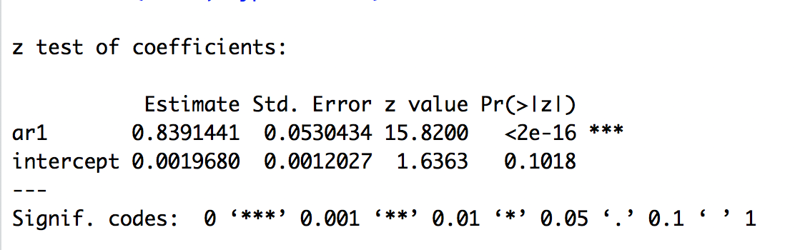

Monthly yoy returns can give analysts better understanding of how home price has evolved and how does it compare to that of one year before.

The average p value across largest 30 metro areas for this additional predictor is 0.191 with median p being 0.063, so it can be considered non-significant or considered at 20% significance level. Therefore, most of the additional predictors cannot help with improving the model.