CMSC203_Lab4

Instructor: Prof. Alexander

Student: Yana Li

Lab_4 screen shots:

Task 4:

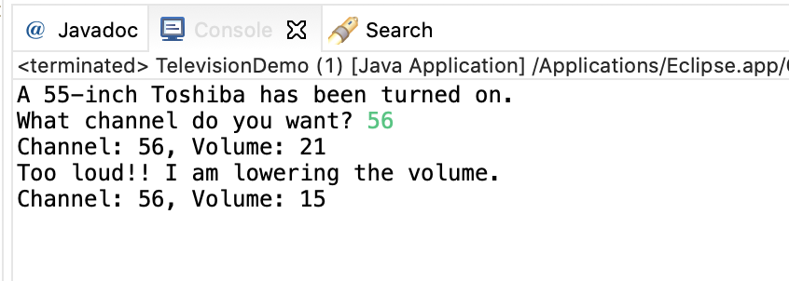

Task 5:

