**Assignment 4**

Class: CMSC204 #34208

Instructor: Prof. Khandan Monshi

Summary of Description: course data structure

Due Date: 04/01/2022

Student’s Name: Yana Li

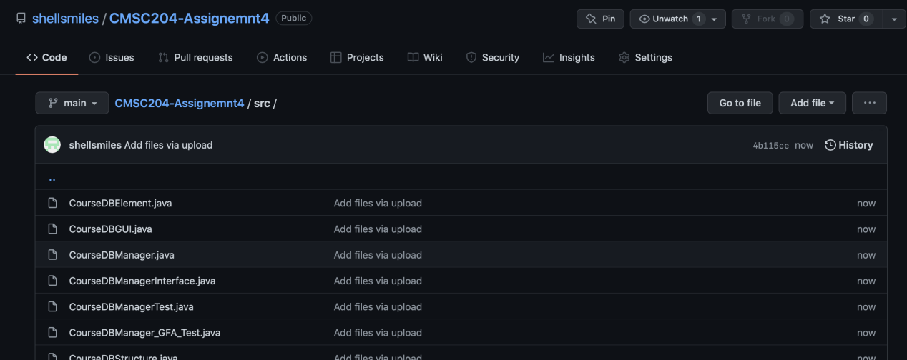

Experience:

* 1. I am struggle with using comparaTo() and equals() for comparing the fields of each elements. I was also struggled with getting fields from the elements.
  2. Also, I have being confused why i have to create inner Node class.
  3. I successfully use inner Interator to go through ADT.

LinkedList<CourseElement>[]] hashTable = new LinkedList[];

The base of hashTable is an array.// hashTable= new LinkedList [ ];

Each element of the array is a LinkedList with CourseElement object// LinkedList<CourseElement>[ ] hashTable;

E1

E2

Linkedlist=null

A[2]

A[3]

A[0]

A[1]

Linkedlist=nullnull

E3

The linnkedlist add a CourseElement