Assignment0- Part 2: Github

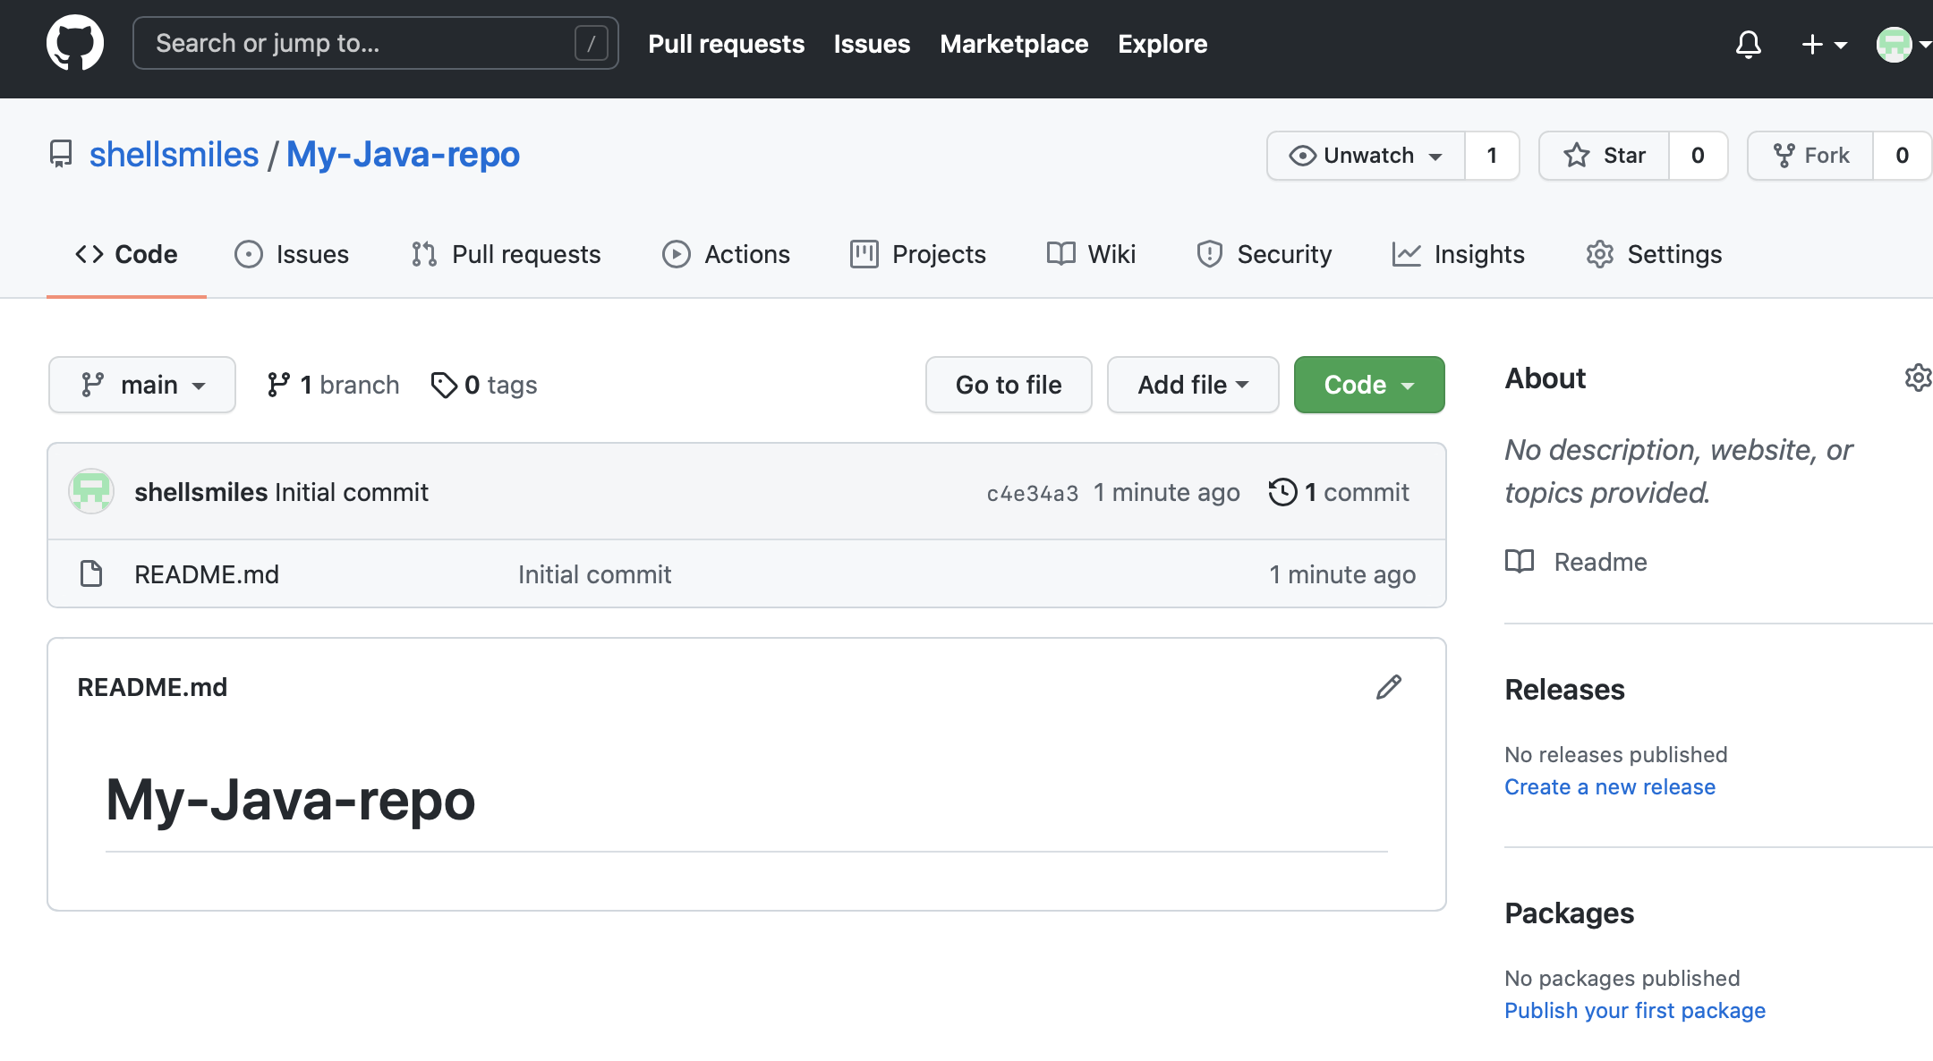

Assignment0- Part 2: JDK installation

Step1:

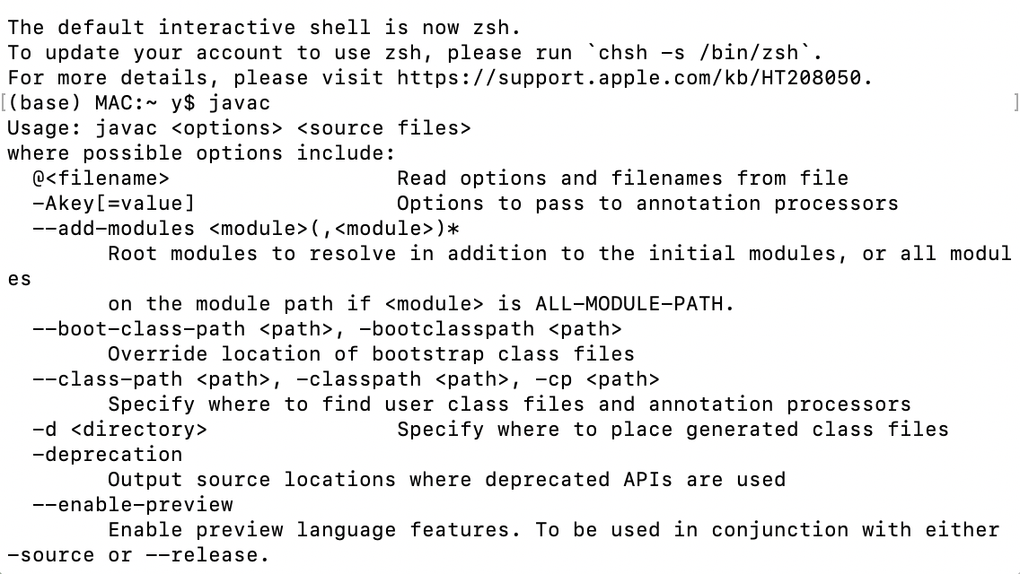

Step2

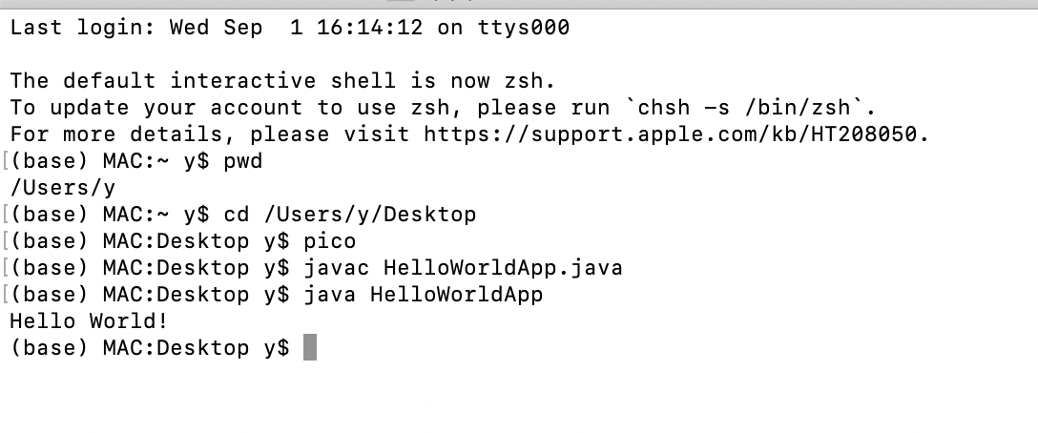

Assignment0- Part 3: Eclipse Installation

Step1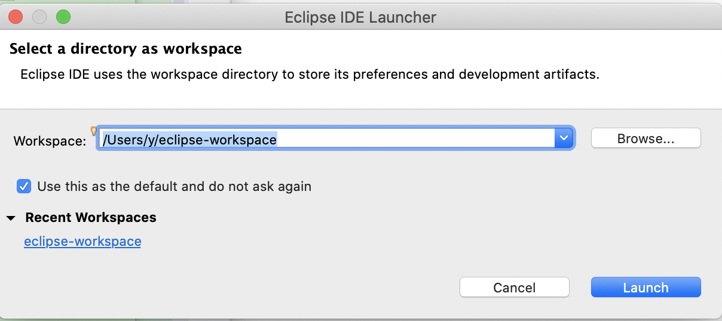

Step2

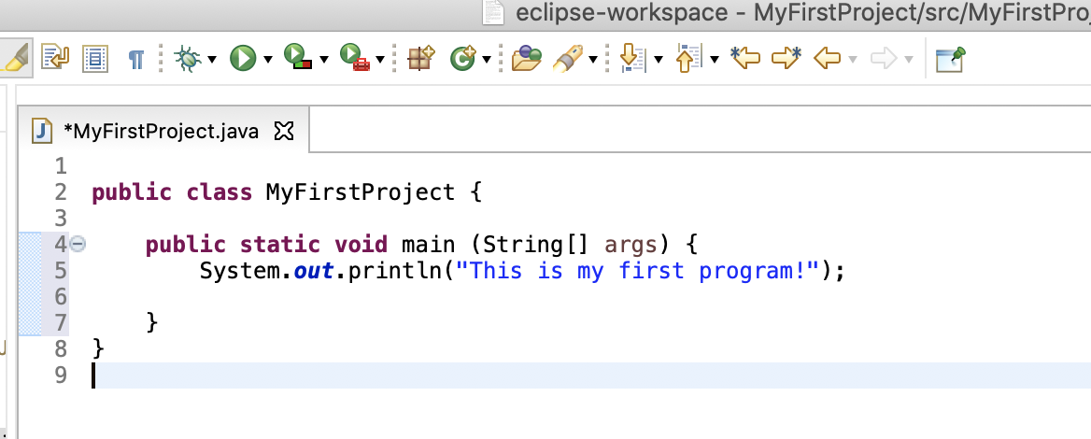

Assignment0- Part 3: Setup Junit

a.

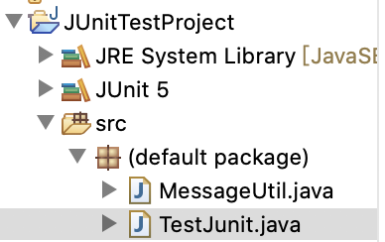

b.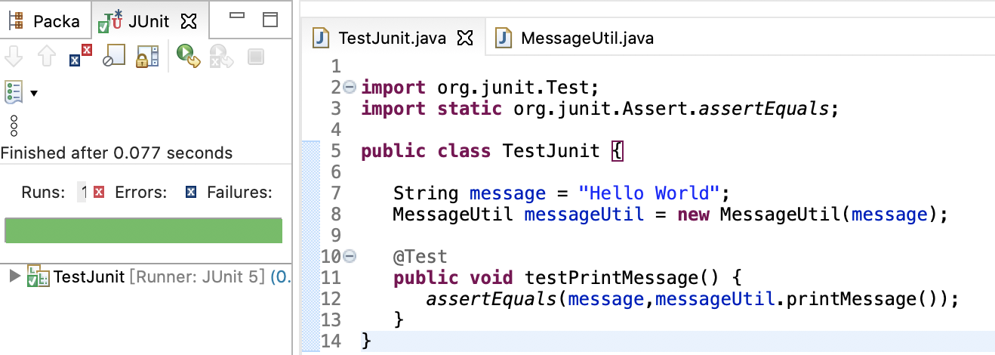

Change java file’s current directory to a new one:

1. Open terminal.
2. Create a new file. Choose one from a or b.
   1. Type the file content into Terminal application.
      1. Type cd<space> followed by the directory path.

Or :

The source files you create should be kept in a separate directory. You can create a directory by using the command mkdir. For example, to create the directory examples/java in the /tmp directory, use the following commands:

cd /tmp

mkdir examples

cd examples

mkdir java

To change your current directory to this new directory, you then enter:

cd /tmp/examples/java

* + 1. 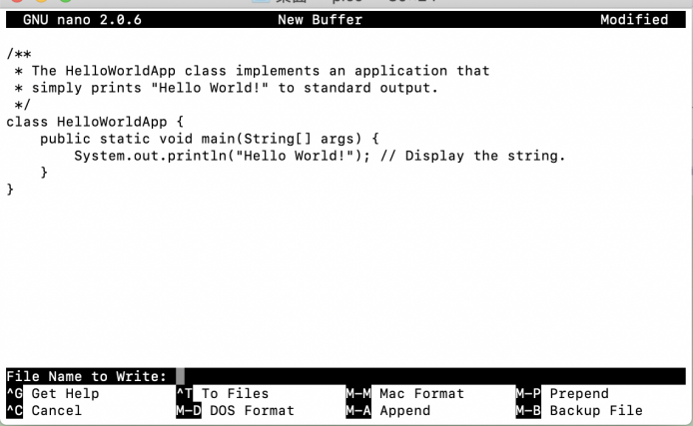Create the source file: Type “pico,” ( it shows a blank buffer, see screen shot below.)--- Type codes of the source file. ---Enter “Ctrl-O” and then, at the bottom where you see the prompt “File Name to write:” ---Entering the directory in which you wish to create the file, followed by ”<file name>.java” ---Enter Ctrl-x to exit Pico.
  1. Save or export from other places.

1. Compile the Source File into a .class File
   1. Type cd<space> followed by the source file’s directory path. ( for example, I entered cd /Users/y/Desktop

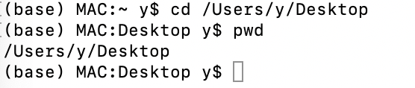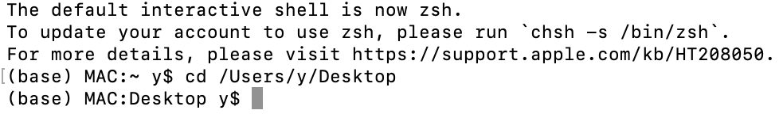

* 1. Type pwd (to look in the directory and show it again.

1. Type ls ( lowcase L and S) (to check and show all files on this directory). 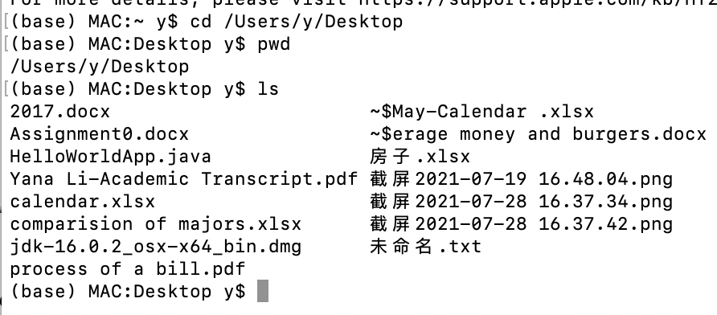
2. Ready to compile the source file. Type “javac <file name.java>
3. To check if it is compiled, type “dir”. There should be a .class file.
4. Type “java <file name>” without .java, then it works!



--module-path /Library/Java/JavaVirtualMachines/javafx-sdk-11.0.2/lib --add-modules javafx.controls,javafx.fxml