Cube.dae
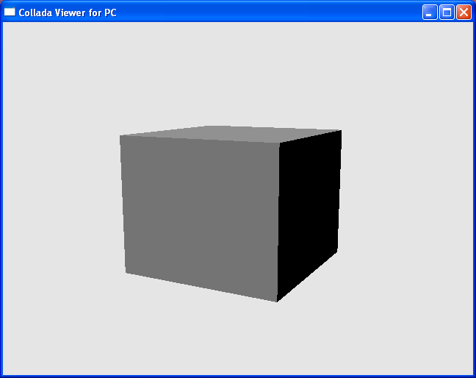

“cube.dae” is a simple example of a COLLADA document that describes a three-dimensional cube object. There are two nodes in its visual scene, they are
<node id="pCube1" name="pCube1" type="NODE">
<node id="directionalLight1" name="directionalLight1" type="NODE">

The <mesh> element in the <library_geometries> element contains all the geometric information for the “pCube1” node.

The three <source> elements in <mesh> contain the raw data arrays and an access description for them. In this example, the first source contains the vertex position information with a <float_array> element. The <accessor> element declares that the output of source is three dimensional coordinates (x, y, z). The second <source> element in the example contains vertex-normal information. The third <source> element contains texture coordinates information.

For the <triangle> element in the cube geometry, there are three <input> elements that describe the sources of vertex positions, normals and texture coordinates. The <p> element contains indexes that reference into the <source> elements, using the semantic described by the <input> elements. The offset attribute indicates the index from the <p> element that the input will use to sample the source data.

The <profile_COMMON> element shown below encapsulates a set of values and declarations for a platform-independent fixed-function shader. The specified Lambert shader takes a grey diffuse color as a parameter, with no ambient light and no shininess, and the effect is non-reflective and non-transparent.

<library_effects>
<effect id="lambert1-fx">
<profile_COMMON>
<technique sid="common">
<lambert>
<emission>
<color>0 0 0 1</color>
</emission>
<ambient>
<color>0 0 0 1</color>
</ambient>
<diffuse>
<color>0.4 0.4 0.4 1</color>
</diffuse>
<transparent opaque="RGB_ZERO">
<color>0 0 0 1</color>
</transparent>
<transparency>
<float>1</float>
</transparency>
<index_of_refraction>
<float>1</float>
</index_of_refraction>
</lambert>
<extra>
<technique profile="FCOLLADA"/>
</extra>
</technique>
</profile_COMMON>
</effect>
</library_effects>

Cage.dae
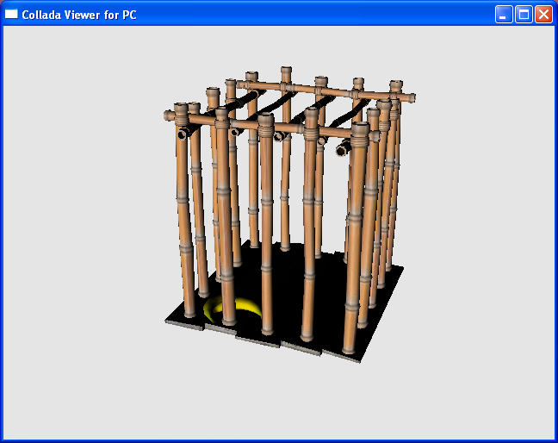

This cage model comprises four sets of <polylist> describing the geometries of the banana, the bamboo cane, the bamboo joint and the floor board.

Four sets of <instance_material> and <instance_effect> are instantiated and attached to these geometries. The <bind_material> element binds a specific material to a piece of geometry, binding varying and uniform parameters at the same time. The <effect> elements pass four image files, “ties.tga”, “banana,tga”, “bamboo.tga” and “wooden_boards.tga” to GPU shader to map the images to the geometries. The “lambert5-fx” effect element here specifies Lambert shading effect.

The information in <texture><extra> element specifies what operations to perform to sample image data at a given coordinate. Such instructions include information on how to map the coordinate onto the image, such as wrap, mirror or noise.

<library_materials>
<material id="lambert5" name="lambert5">
<instance_effect url="#lambert5-fx"/>
</material>
<material id="lambert6" name="lambert6">
<instance_effect url="#lambert6-fx"/>
</material>
<material id="lambert3" name="lambert3">
<instance_effect url="#lambert3-fx"/>
</material>
<material id="lambert4" name="lambert4">
<instance_effect url="#lambert4-fx"/>
</material>
</library_materials>

<library_effects>
<effect id="lambert5-fx">
<profile_COMMON>
<technique sid="common">
<lambert>
<emission>
<color>0 0 0 1.0</color>
</emission>
<ambient>
<color>0 0 0 1.0</color>
</ambient>
<diffuse>
<texture texture="file6" texcoord="UVSET0">
<extra>
<technique profile="MAYA">
<wrapU>1</wrapU>
<wrapV>1</wrapV>
<mirrorU>0</mirrorU>
<mirrorV>0</mirrorV>
...
...

</effect>
</library_effects>

<node id="cage" name="cage" type="NODE">
<rotate sid="rotateZ">0 0 1.000000 0</rotate>
<rotate sid="rotateY">0 1.000000 0 0</rotate>
<rotate sid="rotateX">1.000000 0 0 0</rotate>
<instance_geometry url="#cageShape-lib">
<bind_material>
<technique_common>
<instance_material symbol="lambert5SG" target="#lambert5">
<bind semantic="UVSET0" target="#cageShape-lib-map1"/>
</instance_material>
<instance_material symbol="lambert6SG" target="#lambert6">
<bind semantic="UVSET0" target="#cageShape-lib-map1"/>
</instance_material>
<instance_material symbol="lambert3SG" target="#lambert3">
<bind semantic="UVSET0" target="#cageShape-lib-map1"/>
</instance_material>
<instance_material symbol="lambert4SG" target="#lambert4">
<bind semantic="UVSET0" target="#cageShape-lib-map1"/>
</instance_material>
</technique_common>
</bind_material>
</instance_geometry>
</node>

Duck.dae
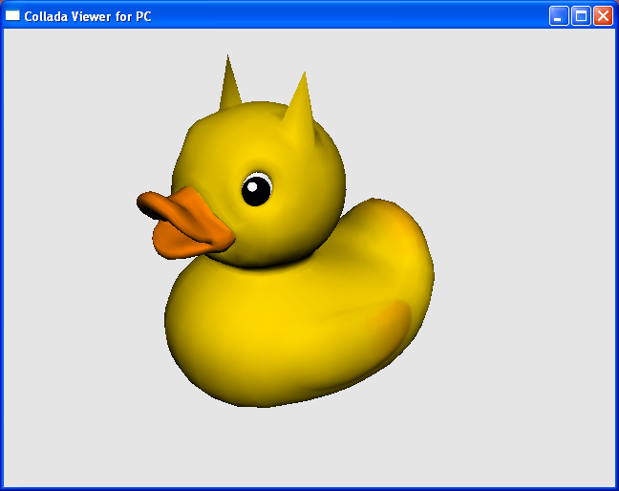

In the visual scene of “duck.dae”, in addition to geometry and light element, a <camera> element is placed in the scene to define viewing parameters. As shown below, the “cameraShape1” element defines perspective projection, with field of view, aspect ratio and the viewing frustum.

<library_cameras>
<camera id="cameraShape1" name="cameraShape1">
<optics>
<technique_common>
<perspective>
<yfov>37.8491</yfov>
<aspect_ratio>1.5</aspect_ratio>
<znear>1</znear>
<zfar>10000</zfar>
</perspective>
</technique_common>
</optics>
</camera>
</library_cameras>

The <profile_COMMON> element shown below encapsulates a set of values and declarations for a platform-independent fixed-function shader. <profile_COMMON> effects are designed to be used as the reliable fallback when no other profile is specified in the current
effects runtime. The Blinn shader element creates a shading effect that takes “file2-sampler” image as its diffuse color, with no ambient light and low shininess. The effect is non-reflective and non-transparent.

<profile_COMMON>
<newparam sid="file2-surface">
<surface type="2D">
<init_from>file2</init_from>
<format>A8R8G8B8</format>
</surface>
</newparam>
<newparam sid="file2-sampler">
<sampler2D>
<source>file2-surface</source>
<wrap_s>WRAP</wrap_s>
<wrap_t>WRAP</wrap_t>
<minfilter>NONE</minfilter>
<magfilter>NONE</magfilter>
<mipfilter>NONE</mipfilter>
</sampler2D>
</newparam>
<technique sid="common">
<blinn>
<emission>
<color>0 0 0 1</color>
</emission>
<ambient>
<color>0 0 0 1</color>
</ambient>
<diffuse>
<texture texture="file2-sampler" texcoord="TEX0"/>
</diffuse>
<specular>
<color>0 0 0 1</color>
</specular>
<shininess>
<float>10</float>
</shininess>
<reflective>
<color>0 0 0 1</color>
</reflective>
<reflectivity>
<float>0.5</float>
</reflectivity>
<transparent opaque="RGB_ZERO">
<color>0 0 0 1</color>
</transparent>
<transparency>
<float>1</float>
</transparency>
<index_of_refraction>
<float>1</float>
</index_of_refraction>
</blinn>
</technique>
</profile_COMMON>

<sampler2D> contains instructions on how to read data at a 2D coordinate from an <image>. It references the <image> and specifies what operations to perform to sample the data at a given coordinate. The <sampler2D> element in “duck.dae” is an example of the most common sampler type. It repeats a texture across a surface regardless of any UVs exceeding the 0-to-1 range. It linearly magnifies or minifies the texture if it needs to be enlarged or scale down.

Cad.dae
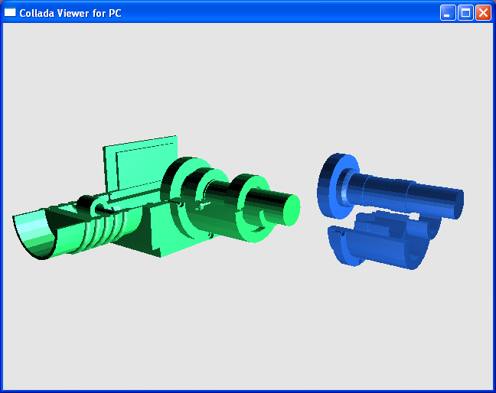

“cad.dae” demonstrates COLLADA key-frame animation that animates the movement of a motor in operation.

Two motors are placed in the scene created by “cad.dae”, one green with the name “motor”, and one blue with the name “transform1”. The blue “transform1” node contains four child nodes within, “m1”, “m2”, “m3” and “m4”. Each of these four nodes is animated using separate <animation> element. The animation that rotates the motor shaft (the “m1” node) about the Z axis 360 degrees in approximately 2 seconds is shown below:

<animation id="m1.rotateZ">
<source id="m1.rotateZ_m1_rotateZ.ANGLE-input">
<float_array id="m1.rotateZ_m1_rotateZ.ANGLE-input-array" count="5">0.041666 0.416667 0.833333 1.25 1.66667</float_array>
<technique_common>
<accessor source="#m1.rotateZ_m1_rotateZ.ANGLE-input-array" count="5" stride="1">
<param name="TIME" type="float"/>
</accessor>
</technique_common>
<technique profile="MAYA">
<pre_infinity>CONSTANT</pre_infinity>
<post_infinity>CONSTANT</post_infinity>
</technique>
</source>
<source id="m1.rotateZ_m1_rotateZ.ANGLE-output">
<float_array id="m1.rotateZ_m1_rotateZ.ANGLE-output-array" count="5">362.52 440.971 533.776 631.415 719.657</float_array>
<technique_common>
<accessor source="#m1.rotateZ_m1_rotateZ.ANGLE-output-array" count="5" stride="1">
<param name="ANGLE" type="float"/>
</accessor>
</technique_common>
</source>
...
...

</animation>

<sampler id="m1.rotateZ_m1_rotateZ.ANGLE-sampler">
<input semantic="INPUT" source="#m1.rotateZ_m1_rotateZ.ANGLE-input"/>
<input semantic="OUTPUT" source="#m1.rotateZ_m1_rotateZ.ANGLE-output"/>
<input semantic="INTERPOLATION" source="#m1.rotateZ_m1_rotateZ.ANGLE-interpolations"/>
<input semantic="IN_TANGENT" source="#m1.rotateZ_m1_rotateZ.ANGLE-intangents"/>
<input semantic="OUT_TANGENT" source="#m1.rotateZ_m1_rotateZ.ANGLE-outtangents"/>
</sampler>
<channel source="#m1.rotateZ_m1_rotateZ.ANGLE-sampler" target="m1/rotateZ.ANGLE"/>

<node id="m1" name="m1" type="NODE">
<rotate sid="rotateZ">0 0 1 496.05</rotate>
<rotate sid="rotateY">0 1 0 0</rotate>
<rotate sid="rotateX">1 0 0 0</rotate>
<instance_geometry url="#m1.stp.lib.geo">
<bind_material>
<technique_common>
<instance_material symbol="BlueSG" target="#Blue"/>
</technique_common>
</bind_material>
</instance_geometry>
</node>

In animation element “m1.totateZ”, the Z rotation angle of “m1” evolves over time. In <source> element "m1.rotateZ_m1_rotateZ.ANGLE-input”, semantic “TIME” expressed in seconds is used as the animation key for the samples. Source element "m1.rotateZ_m1_rotateZ.ANGLE-output" is used to provide the corresponding angles, using the “ANGLE” semantic.

As specified in <input semantic="INTERPOLATION”…>, if the rendering time is between the keys, the animation output value is calculated using the Bezier interpolation.

Seymourplane.dae
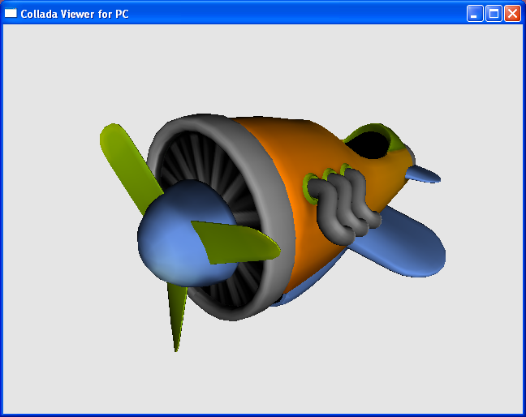

“seymourplane.dae” demonstrates a simple key-frame animation in COLLADA that rotates the airplane propeller.

In “seymourplane.dae”, the propeller, the <prop> element is the child node of the “plane” node. Only the propeller is being animated in this example. The animation that rotates the propeller about the Z axis 348 degrees in 1 second is defined as below:

<animation id="prop_rotateZ">
<source id="prop_rotateZ_prop_rotateZ_ANGLE-input">
<float_array id="prop_rotateZ_prop_rotateZ_ANGLE-input-array" count="2">0 1</float_array>
<technique_common>
<accessor count="2" offset="0" source="#prop_rotateZ_prop_rotateZ_ANGLE-input-array" stride="1">
<param name="TIME" type="float"/>
</accessor>
</technique_common>
<technique profile="MAYA">
<pre_infinity>CONSTANT</pre_infinity>
<post_infinity>CONSTANT</post_infinity>
</technique>
</source>
<source id="prop_rotateZ_prop_rotateZ_ANGLE-output">
<float_array id="prop_rotateZ_prop_rotateZ_ANGLE-output-array" count="2">0 348</float_array>
<technique_common>
<accessor count="2" offset="0" source="#prop_rotateZ_prop_rotateZ_ANGLE-output-array" stride="1">
<param name="ANGLE" type="float"/>
</accessor>
</technique_common>
</source>

...
...

</animation>

<sampler id="prop_rotateZ_prop_rotateZ_ANGLE-sampler">
<input semantic="INPUT" source="#prop_rotateZ_prop_rotateZ_ANGLE-input"/>
<input semantic="OUTPUT" source="#prop_rotateZ_prop_rotateZ_ANGLE-output"/>
<input semantic="IN_TANGENT" source="#prop_rotateZ_prop_rotateZ_ANGLE-intangents"/>
<input semantic="OUT_TANGENT" source="#prop_rotateZ_prop_rotateZ_ANGLE-outtangents"/>
<input semantic="INTERPOLATION" source="#prop_rotateZ_prop_rotateZ_ANGLE-interpolations"/>
</sampler>
<channel source="#prop_rotateZ_prop_rotateZ_ANGLE-sampler" target="prop/rotateZ.ANGLE"/>

<node id="prop" name="prop">
<translate sid="translate">0 0 5.40413</translate>
<rotate sid="rotateZ">0 0 1 15</rotate>
<rotate sid="rotateY">0 1 0 0</rotate>
<rotate sid="rotateX">1 0 0 0</rotate>
<instance_geometry url="#propShape-lib">
<bind_material>
<technique_common>
<instance_material symbol="shineSG" target="#shine">
<bind_vertex_input semantic="TEX0" input_semantic="TEXCOORD" input_set="0"/>
</instance_material>
</technique_common>
</bind_material>
</instance_geometry>
</node>

In animation element “prop_rotateZ”, the Z rotation angle of “prop” evolves over time. In <source> element "prop_rotateZ_prop_rotateZ_ANGLE-input”, semantic “TIME” expressed in seconds is used as the animation key for the samples. Source element "prop_rotateZ_prop_rotateZ_ANGLE-output-array" is used to provide the corresponding angles, using the “ANGLE” semantic.

As specified in <input semantic="INTERPOLATION”…>, if the rendering time is between the two keys, the animation output value is calculated using the linear interpolation.

Dominos.dae
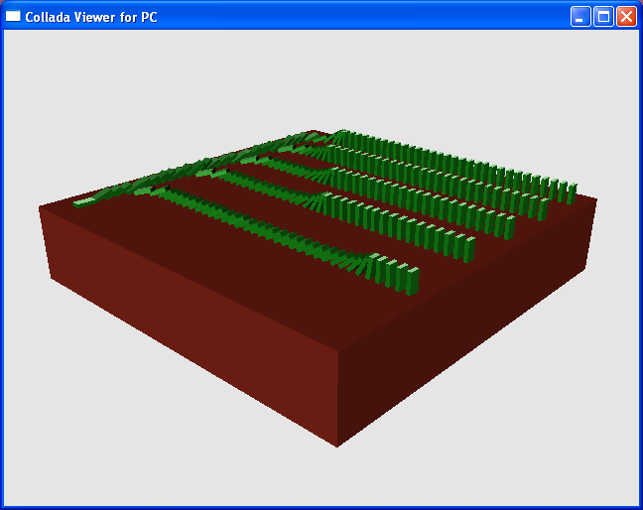

“dominos.dae” simulates the movement of two hundred and four domino tiles colliding based on the laws of physics. Node “pCube204” starts out with a position rotated 21.8678 degrees along the X-axis, this starts the falling domino effect.

<node id="pCube100" name="pCube100" type="NODE">
<translate sid="translate">4.6458 1 -3.36465</translate>
<rotate sid="rotateZ">0 0 1 0</rotate>
<rotate sid="rotateY">0 1 0 0</rotate>
<rotate sid="rotateX">1 0 0 0</rotate>
<instance_geometry url="#pCubeShape100">
<bind_material>
<technique_common>
<instance_material symbol="phong1SG" target="#phong1"/>
</technique_common>
</bind_material>
</instance_geometry>
</node>

<library_physics_scenes>
<physics_scene id="MayaNativePhysicsScene">
<instance_physics_model url="#MayaNativePhysicsModel">
<instance_rigid_body target="#pCube100" body="rigidBody100">
<technique_common/>
</instance_rigid_body>
...
...
</physics_scene>
</library_physics_scenes>

As shown above, physics models, which are defined in <library_physics_models>, are instantiated in a physics scene similarly to how visual geometry is instantiated in a visual scene. This instance assigns "rigidBody100" to its node – “pCube100”.

The physics properties for “rigidBody100” are defined in <physics_material> with the following dynamic friction coefficient, bounciness and static friction coefficient values.

<physics_material id="rigidBody100-material" name="rigidBody100-material">
<technique_common>
<dynamic_friction>0.2</dynamic_friction>
<restitution>0.6</restitution>
<static_friction>0.2</static_friction>
</technique_common>
</physics_material>

The <rigid_body> element describes the simulated domino tiles as objects that do not deform with the following properties:
<dynamic>: moveable.
<shape><box>: a box-shape object.
<hollow>: if set to true, the object mass is distributed along the surface of the shape.
<half_extents>: represents the extents of the box. The tile dimension is 1 x 2 x 0.4 in this case.

<library_physics_models>
<physics_model id="MayaNativePhysicsModel">
...
...
<rigid_body name="rigidBody100" sid="rigidBody100">
<technique_common>
<dynamic sid="rigidBody1002">1</dynamic>
<instance_physics_material url="#rigidBody100-material"/>
<shape>
<hollow>true</hollow>
<box>
<half_extents>0.5 1 0.2</half_extents>
</box>
</shape>
</technique_common>
</rigid_body>
...
...
</physics_model>
</library_physics_models>

Astroboy_walk.dae
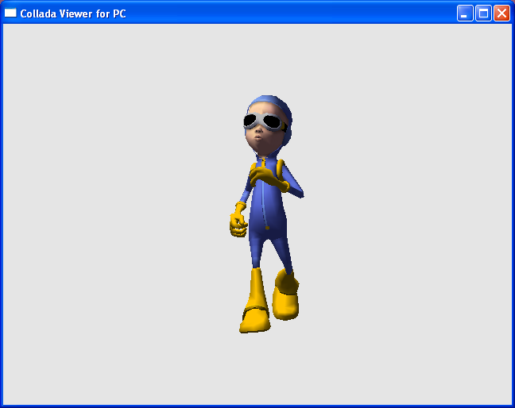

“astroboy_walk”.dae uses vertex skinning to animate boy in continuous walking motion. A set of 44 matrix transforms (bones) are created for the boy character model, and 63 <animation> elements are used to rotate and translate these bone matrices to create the walking motion.

The <controller> “boyShape-skin” describes how each vertex in the default pose “#boyShape” is affected by one or more of these 44 bones. The number in <vertex_weights><vcount> describes how many bones control each specific vertex, and each of these matrix is assigned a weighting factor (from 0 to 100 percent), specified in <vertex_weights><v> as an index into the "boyShape-skin-weights-array", which indicates how much that bone affects each vertex.

<library_geometries>
<geometry id="boyShape" name="boyShape">
<mesh>
<source id="boyShape-positions" name="position">
. . .
</library_geometries>

<library_controllers>
<controller id="boyShape-skin" name="skinCluster1">
<skin source="#boyShape">
<bind_shape_matrix>1 0 0 0 0 1 0 0 0 0 1 0 0 0 0 1</bind_shape_matrix>
<source id="boyShape-skin-joints">
<Name_array id="boyShape-skin-joints-array" count="44">bone0 bone1 bone2 bone3 bone4 bone5 bone6 bone7 bone8 bone9 bone10 bone11 bone12 bone13 bone14 bone15 bone16 bone17 bone18 bone19 bone20 bone21 bone22 bone23 bone24 bone25 bone26 bone27 bone28 bone29 bone30 bone31 bone32 bone33 bone34 bone35 bone36 bone37 bone38 bone39 bone40 bone41 bone42 bone43</Name_array>
<technique_common>
<accessor source="#boyShape-skin-joints-array" count="44" stride="1">
<param name="JOINT" type="Name"/>
</accessor>
</technique_common>
</source>
<source id="boyShape-skin-bind_poses">
<float_array id="boyShape-skin-bind_poses-array" count="704">
. . .
</float_array>
<technique_common>
<accessor source="#boyShape-skin-bind_poses-array" count="44" stride="16">
<param name="TRANSFORM" type="float4x4"/>
</accessor>
</technique_common>
</source>
<source id="boyShape-skin-weights">
<float_array id="boyShape-skin-weights-array" count="1160">
. . .
</float_array>
<technique_common>
<accessor source="#boyShape-skin-weights-array" count="1160" stride="1">
<param name="WEIGHT" type="float"/>
</accessor>
</technique_common>
</source>
<joints>
<input semantic="JOINT" source="#boyShape-skin-joints"/>
<input semantic="INV_BIND_MATRIX" source="#boyShape-skin-bind_poses"/>
</joints>
<vertex_weights count="2619">
<input semantic="JOINT" source="#boyShape-skin-joints" offset="0"/>
<input semantic="WEIGHT" source="#boyShape-skin-weights" offset="1"/>
<vcount>
1 1 1 . . .
. . .

</vcount>
<v>
33 0 33 0 33. . .
. . .

</v>
</vertex_weights>
</skin>
</controller>
</library_controllers>

The <instance_controller> instantiates a <controller> element “boyShape-skin”, and associateds it with a set of <skeleton> identified as “astroBoy_newSkeleton_root”, “astroBoy_newSkeleton_L_pinky_01”, etc.

<instance_controller url="#boyShape-skin">
<skeleton>#astroBoy_newSkeleton_root</skeleton>
<skeleton>#astroBoy_newSkeleton_L_pinky_01</skeleton>
<skeleton>#astroBoy_newSkeleton_L_middle_01</skeleton>
<skeleton>#astroBoy_newSkeleton_L_index_01</skeleton>
<skeleton>#astroBoy_newSkeleton_L_thumb_01</skeleton>
<skeleton>#astroBoy_newSkeleton_R_pinky_01</skeleton>
<skeleton>#astroBoy_newSkeleton_R_middle_01</skeleton>
<skeleton>#astroBoy_newSkeleton_R_index_01</skeleton>
<skeleton>#astroBoy_newSkeleton_R_thumb_01</skeleton>
. . .

</instance_controller>

Morph.dae
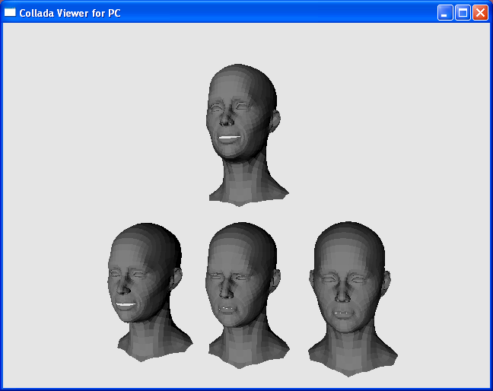

This example renders four human heads, three at the bottom row and one at the top. A morphing controller animates the human head at the top row to changes its facial expression repeatedly as if it is speaking. Three sets of geometries “polySurfaceShape1”, “polySurfaceShape2” and “polySurfaceShape3” are used to render the bottom row head figures, from left to right, respectively. “polySurfaceShape1” is also used as the base mesh to blend with two morph target meshes “polySurfaceShape2” “polySurfaceShape3” to form the final mesh which is used to render the head figure at the top row.

A <morph> contains an array of morph weights, which describe how the base mesh and target meshes are blended. To animate change of facial expression, <animation> elements "blendShape1_bMouth2" and "blendShape1_bMouth3” are used to change the values of morph weights "mouthShape-morph-morph_weights(0)" and "mouthShape-morph-morph_weights(1) to create different geometries for the human face.

<library_controllers>
<controller id="polySurfaceShape_morph" name="blendShape1">
<morph source="#polySurfaceShape1">
<source id="mouthShape-morph-targets">
<IDREF_array id="mouthShape-morph-targets-array" count="2">polySurfaceShape2 polySurfaceShape3</IDREF_array>
<technique_common>
<accessor count="2" source="#mouthShape-morph-targets-array">
<param name="MORPH_TARGET" type="IDREF"/>
</accessor>
</technique_common>
</source>
<source id="mouthShape-morph-morph_weights">
<float_array id="mouthShape-morph-morph_weights-array" count="2">0 0</float_array>
<technique_common>
<accessor count="2" source="#mouthShape-morph-morph_weights-array">
<param name="MORPH_WEIGHT" type="float"/>
</accessor>
</technique_common>
</source>
<targets>
<input semantic="MORPH_TARGET" source="#mouthShape-morph-targets"/>
<input semantic="MORPH_WEIGHT" source="#mouthShape-morph-morph_weights"/>
</targets>
</morph>
</controller>

<animation id="blendShape1_bMouth3">
<source id="blendShape1_bMouth3_mouthShape-morph-morph_weights_0_-input">
<float_array id="blendShape1_bMouth3_mouthShape-morph-morph_weights_0_-input-array" count="5">0.5 1.0 1.5 2.0 2.5</float_array>
<technique_common>
<accessor count="5" source="#blendShape1_bMouth3_mouthShape-morph-morph_weights_0_-input-array">
<param name="TIME" type="float"/>
</accessor>
</technique_common>
<technique profile="MAYA">
<pre_infinity>CONSTANT</pre_infinity>
<post_infinity>CONSTANT</post_infinity>
</technique>
</source>
<source id="blendShape1_bMouth3_mouthShape-morph-morph_weights_0_-output">
<float_array id="blendShape1_bMouth3_mouthShape-morph-morph_weights_0_-output-array" count="5">0 1 1.5 1 0</float_array>
<technique_common>

...

<sampler id="blendShape1_bMouth3_mouthShape-morph-morph_weights_0_-sampler">
<input semantic="INPUT" source="#blendShape1_bMouth3_mouthShape-morph-morph_weights_0_-input"/>
<input semantic="OUTPUT" source="#blendShape1_bMouth3_mouthShape-morph-morph_weights_0_-output"/>
<input semantic="IN_TANGENT" source="#blendShape1_bMouth3_mouthShape-morph-morph_weights_0_-intangents"/>
<input semantic="OUT_TANGENT" source="#blendShape1_bMouth3_mouthShape-morph-morph_weights_0_-outtangents"/>
<input semantic="INTERPOLATION" source="#blendShape1_bMouth3_mouthShape-morph-morph_weights_0_-interpolations"/>
</sampler>
<channel source="#blendShape1_bMouth3_mouthShape-morph-morph_weights_0_-sampler" target="mouthShape-morph-morph_weights(0)"/>
</animation>

Mushroom.dae
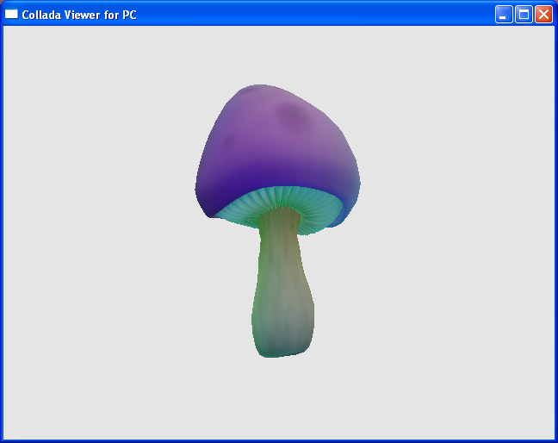

“mushroom.dae” uses Cg shaders to create a wiggling effect. The following excerpt of “mushroom.dae” demonstrates how COLLADA use shaders written in the NVIDIA Cg language.

<library_effects>
<effect id="wigglatexadescent-fx" name="wigglatexadescent">
<profile_CG platform="PC-OGL">
<include sid="default" url="wigglatexadescent.cgfx"/>
<newparam sid="WorldITXf">
<semantic>WORLDINVERSETRANSPOSE</semantic>
<float4x4>0 0 0 0 0 0 0 0 0 0 0 0 0 0 0 0 </float4x4>
</newparam>
<newparam sid="WorldViewProjXf">
<semantic>WORLDVIEWPROJECTION</semantic>
<float4x4>0 0 0 0 0 0 0 0 0 0 0 0 0 0 0 0 </float4x4>
</newparam>

<technique sid="PixelShaderVersion">
<pass sid="zero">
<depth_test_enable value="true"/>
<shader stage="VERTEX">
<compiler_target>arbvp1</compiler_target>
<name source="default">wtdVS</name>
<bind symbol="WorldITXf">
<param ref="WorldITXf"/>
</bind>
<bind symbol="WorldViewProjXf">
<param ref="WorldViewProjXf"/>
</bind>
...
...
</shader>

<shader stage="FRAGMENT">
<compiler_target>arbfp1</compiler_target>
<name source="default">wtdFS</name>
<bind symbol="WorldITXf">
<param ref="WorldITXf"/>
</bind>
<bind symbol="WorldViewProjXf">
<param ref="WorldViewProjXf"/>
</bind>
...
...
</shader>

...
...
</profile_CG>
</effect>
</library_effects>

<profile_CG>: encapsulates effects for use with the Cg shader.
<include>: imports shader source code “wigglatexadescent.cgfx”.
<newparam>: declares bindable parameters to feed “wigglatexadescent.cgfx”.
<shader>: setup compilation information for vertex and pixel shaders
<compiler_target>: specifies shader target binary profile to be ‘arbfp1’.
<bind>: assigns values to shader input parameters. e.g. binds all 0’s to shader semantic WORLDINVERSETRANSPOSE.
<param>: Refers to an existing parameter created by <newparam>.

<visual_scene id="DefaultScene" name="mushroom140">
<node id="Mushroom_resting2" name="Mushroom_resting2" sid="Mushroom_resting2">
<rotate sid="rotateZ">0 0 1 0 </rotate>
<rotate sid="rotateY">0 1 0 0 </rotate>
<rotate sid="rotateX">1 0 0 0 </rotate>
<instance_geometry url="#Mushroom_resting2Shape-lib">
<bind_material>
<technique_common>
<instance_material symbol="phong1" target="#wigglatexadescent">
<bind_vertex_input semantic="TEXCOORD0" input_semantic="TEXCOORD"/>
</instance_material>
</technique_common>
</bind_material>
</instance_geometry>
</node>
</visual_scene>

It is the <instance_geometry>’s <instance_material><bind_vertex_input> makes the connection between the <texture>’s texcoord attribute and the mesh’s texture coordinate array.

Demo.dae
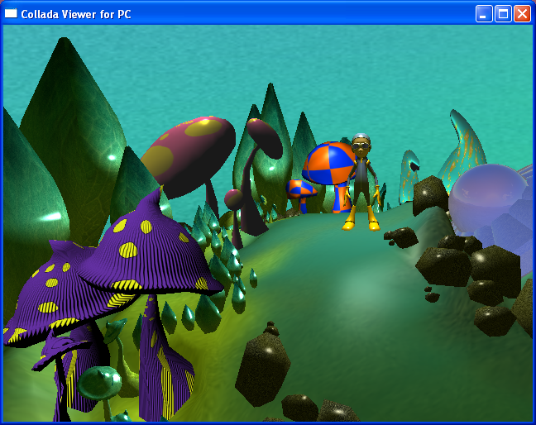

In this demo, the COLLADA assets describe a sky dome, a small planet, a number of objects with chrome-like appearance, a boy and a spaceship with reflective surface. The “skyDome” node serves as the environment map in the scene, with the spaceship rendered with believable reflections.
There are four cameras in this scene, plus one default one provided by the ColladaViewer application. The camera view can be changed by clicking the middle mouse button or pressing the TAB key, or by pressing the <START> button on a PS3 controller. Camera node “FlyCamera” is being animated by "FlyCamera_translate-anim" so that it is constantly changing position.
<node id="FlyCamera" name="FlyCamera" sid="FlyCamera">
<translate sid="translate">3.57358 12.3349 7.70789 </translate>
<rotate sid="rotateZ">0 0 1 356.406 </rotate>
<rotate sid="rotateY">0 1 0 32.905 </rotate>
<rotate sid="rotateX">1 0 0 -375.692 </rotate>
<scale sid="scale">1 1 1 </scale>
<instance_camera url="#FlyCameraShape-lib"/>
<extra>
<technique profile="MAYA">
<visibility sid="visibility0">true</visibility>
</technique>
</extra>
</node>

<animation id="FlyCamera_translate-anim">
. . .
<channel source="#FlyCamera_translate-anim-sampler" target="FlyCamera/translate"/>
</animation>

Notes:

The <extra> elements in the sample DAE files are exported by DCC tools to provide arbitrary additional platform specific data that is not covered in the COLLADA specification.

