Lab 9 Example papaja

|  |
| --- |
| Cory K. Costello1 |
| 1 University of Oregon |
|  |

# Author note

Correspondence concerning this article should be addressed to Cory K. Costello, Department of Psychology, 1227 University of Oregon, Eugene, OR, 97403. E-mail: [ccostell@uoregon.edu](mailto:ccostell@uoregon.edu)

Abstract

One or two sentences providing a **basic introduction** to the field, comprehensible to a scientist in any discipline.

Two to three sentences of **more detailed background**, comprehensible to scientists in related disciplines.

One sentence clearly stating the **general problem** being addressed by this particular study.

One sentence summarizing the main result (with the words “**here we show**” or their equivalent).

Two or three sentences explaining what the **main result** reveals in direct comparison to what was thought to be the case previously, or how the main result adds to previous knowledge.

One or two sentences to put the results into a more **general context**.

Two or three sentences to provide a **broader perspective**, readily comprehensible to a scientist in any discipline.

*Keywords:* Example, papaja, reproducible reporting

Word count: X

Lab 9 Example papaja

We could start our introduction here, potentially saying something about the history of the Big Five (Goldberg, 1990), or about Roberts and colleagues’ (2005). We could also mention McClelland & Judd (1993).

# Methods

We report how we determined our sample size, all data exclusions (if any), all manipulations, and all measures in the study.

## Participants

We have 2800 participants who completed some or all of the Big Five.

## Material

## Procedure

## Data analysis

We used R (Version 3.6.2; R Core Team, 2019) and the R-packages *corx* (Version 1.0.2; Conigrave, 2019), *dplyr* (Version 0.8.3; Wickham et al., 2020), *forcats* (Version 0.4.0; Wickham, 2020), *ggplot2* (Version 3.2.1; Wickham, 2016), *papaja* (Version 0.1.0.9842; Aust & Barth, 2018), *purrr* (Version 0.3.3; Henry & Wickham, 2019), *readr* (Version 1.3.1; Wickham, Hester, & Francois, 2018), *stringr* (Version 1.4.0; Wickham, 2019), *tibble* (Version 2.1.3; Müller & Wickham, 2019), *tidyr* (Version 1.0.0; Wickham & Henry, 2020), and *tidyverse* (Version 1.3.0; Wickham, Averick, et al., 2019) for all our analyses.

# Results

Table 1:

*Descriptive statistics of Big Five Scale Scores.*

|  |  |  |  |  |  |
| --- | --- | --- | --- | --- | --- |
| scale | Mean | Median | SD | Min | Max |
| agree | 4.65 | 4.80 | 0.90 | 1.00 | 6.00 |
| conscientious | 4.27 | 4.40 | 0.95 | 1.00 | 6.00 |
| extraversion | 4.15 | 4.20 | 1.06 | 1.00 | 6.00 |
| neuroticism | 3.16 | 3.00 | 1.20 | 1.00 | 6.00 |
| openness | 4.59 | 4.60 | 0.81 | 1.20 | 6.00 |

*Note.* This table was created with apa_table().

Table 2:

*Example corr matrix*

|  |  |  |  |  |
| --- | --- | --- | --- | --- |
|  | 1 | 2 | 3 | 4 |
| 1. agree | - |  |  |  |
| 2. conscientious | .26*** | - |  |  |
| 3. extraversion | .46*** | .26*** | - |  |
| 4. neuroticism | -.19*** | -.23*** | -.22*** | - |
| 5. openness | .15*** | .20*** | .21*** | -.09*** |

*Note.* * p < 0.05; ** p < 0.01; *** p < 0.001

Table 3:

*Regressing Conscientiousness on Age and Education*

|  |  |  |
| --- | --- | --- |
|  | Model 1 | Model 2 |
| Intercept | $4.30$ $[4.26$, $4.33]$ | $4.16$ $[4.03$, $4.28]$ |
| Age | $0.01$ $[0.00$, $0.01]$ | $0.01$ $[0.01$, $0.01]$ |
| Education College Grad |  | $0.02$ $[−0.13$, $0.18]$ |
| Education Finished HS |  | $0.05$ $[−0.12$, $0.21]$ |
| Education Grad Degree |  | $0.06$ $[−0.09$, $0.22]$ |
| Education Some College |  | $0.25$ $[0.11$, $0.38]$ |
| $R^{2}$ [90% CI] | $.01$ $[0.00$, $0.02]$ | $.02$ $[0.01$, $0.03]$ |
| $F$ | 22.16 | 10.93 |
| $df_{1}$ | 2 | 6 |
| $df_{2}$ | 2575 | 2571 |
| $p$ | < .001 | < .001 |
| $AIC$ | 6,979.81 | 6,955.69 |
| $BIC$ | 6,997.38 | 6,996.68 |
| $ΔR^{2}$ |  | $.01$ |
| $F$ |  | 8.06 |
| $df_{1}$ |  | 4 |
| $df_{2}$ |  | 2575 |
| $p$ |  | < .001 |
| $ΔAIC$ |  | -24.12 |
| $ΔBIC$ |  | -0.70 |

*Note.* Model comparison compares a model with just age to a model that has age and education.

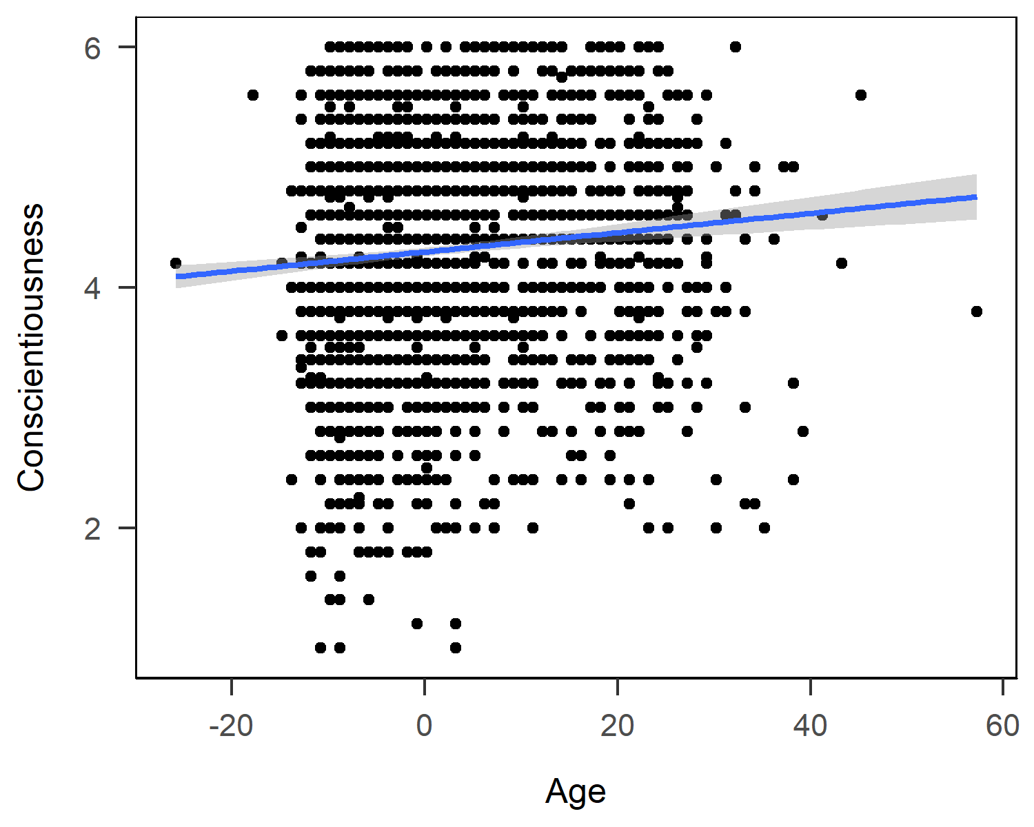

Figure 1: Conscientiousness by Age.

We calculated scale scores for each of the Big Five. Descriptive statistics for each Big Five scale are shown in Table 1, where it is apparent that means were near the scale midpoints of 4.5, with the exception of neuroticism which had a much lower mean of 3.13.

Scale inter-correlations can be found in Table 2, where one can see that the smallest correlation was between neuroticism and opennes (*r* = -0.09) and the largest correlation was between extraversion and agreeableness (*r* = 0.46).

We next examined the extent to which grand-mean centered age and education are related to conscientiousness, based on the postulates of social investment theory (Roberts et al., 2005). The results from a model with just age and a model with age and education are shown in Table 3 below. Age had a small but significant, positive association with conscientiousness, both when education is ($b=0.01$, 95% CI $[0.01$, $0.01]$, $t(2571)=5.54$, $p<.001$) and is not ($b=0.01$, 95% CI $[0.00$, $0.01]$, $t(2575)=4.71$, $p<.001$) included as a covariate. Education did significantly but modestly improve the model (). Interestingly, the pattern of results did not follow a monotonic increase from some highschool to graduate degree. Indeed, the only significant difference in conscientiousness across education was between participants who didn’t finish high school and participants who reported having some college ($b=0.25$, 95% CI $[0.11$, $0.38]$, $t(2571)=3.63$, $p<.001$). At the sample average age, participants who didn’t finish highschool had an average conscientiousness score of ( $M_{SomeHS}$ = 4.16) while participants with some college had an average conscientiousness score of ( $M_{SomeCollege}$ = 4.40). The remaining effects of education were small and non-significant (see Table 3).

Figure 1 depicts the small, linear increase of conscientiousness across the age range of our participants.

# Discussion

# References

Aust, F., & Barth, M. (2018). *papaja: Create APA manuscripts with R Markdown*. Retrieved from <https://github.com/crsh/papaja>

Conigrave, J. (2019). *Corx: Create and format correlation matrices*. Retrieved from <https://CRAN.R-project.org/package=corx>

Goldberg, L. R. (1990). An alternative" description of personality": The big-five factor structure. *Journal of Personality and Social Psychology*, *59*(6), 1216–1229. doi:[https://doi.org/10.1037/0022-3514.59.6.1216](https://doi.org/https://doi.org/10.1037/0022-3514.59.6.1216)

Henry, L., & Wickham, H. (2019). *Purrr: Functional programming tools*. Retrieved from <https://CRAN.R-project.org/package=purrr>

McClelland, G. H., & Judd, C. M. (1993). Statistical difficulties of detecting interactions and moderator effects. *Psychological Bulletin*, *114*(2), 376.

Müller, K., & Wickham, H. (2019). *Tibble: Simple data frames*. Retrieved from <https://CRAN.R-project.org/package=tibble>

R Core Team. (2019). *R: A language and environment for statistical computing*. Vienna, Austria: R Foundation for Statistical Computing. Retrieved from <https://www.R-project.org/>

Roberts, B. W., Wood, D., & Smith, J. L. (2005). Evaluating five factor theory and social investment perspectives on personality trait development. *Journal of Research in Personality*, *39*(1), 166–184.

Wickham, H. (2016). *Ggplot2: Elegant graphics for data analysis*. Springer-Verlag New York. Retrieved from <https://ggplot2.tidyverse.org>

Wickham, H. (2019). *Stringr: Simple, consistent wrappers for common string operations*. Retrieved from <https://CRAN.R-project.org/package=stringr>

Wickham, H. (2020). *Forcats: Tools for working with categorical variables (factors)*. Retrieved from <https://CRAN.R-project.org/package=forcats>

Wickham, H., Averick, M., Bryan, J., Chang, W., McGowan, L. D., François, R., … Yutani, H. (2019). Welcome to the tidyverse. *Journal of Open Source Software*, *4*(43), 1686. doi:[10.21105/joss.01686](https://doi.org/10.21105/joss.01686)

Wickham, H., François, R., Henry, L., & Müller, K. (2020). *Dplyr: A grammar of data manipulation*. Retrieved from <https://CRAN.R-project.org/package=dplyr>

Wickham, H., & Henry, L. (2020). *Tidyr: Tidy messy data*. Retrieved from <https://CRAN.R-project.org/package=tidyr>

Wickham, H., Hester, J., & Francois, R. (2018). *Readr: Read rectangular text data*. Retrieved from <https://CRAN.R-project.org/package=readr>

Aust, F., & Barth, M. (2018). *papaja: Create APA manuscripts with R Markdown*. Retrieved from <https://github.com/crsh/papaja>

Conigrave, J. (2019). *Corx: Create and format correlation matrices*. Retrieved from <https://CRAN.R-project.org/package=corx>

Goldberg, L. R. (1990). An alternative" description of personality": The big-five factor structure. *Journal of Personality and Social Psychology*, *59*(6), 1216–1229. doi:[https://doi.org/10.1037/0022-3514.59.6.1216](https://doi.org/https://doi.org/10.1037/0022-3514.59.6.1216)

Henry, L., & Wickham, H. (2019). *Purrr: Functional programming tools*. Retrieved from <https://CRAN.R-project.org/package=purrr>

McClelland, G. H., & Judd, C. M. (1993). Statistical difficulties of detecting interactions and moderator effects. *Psychological Bulletin*, *114*(2), 376.

Müller, K., & Wickham, H. (2019). *Tibble: Simple data frames*. Retrieved from <https://CRAN.R-project.org/package=tibble>

R Core Team. (2019). *R: A language and environment for statistical computing*. Vienna, Austria: R Foundation for Statistical Computing. Retrieved from <https://www.R-project.org/>

Roberts, B. W., Wood, D., & Smith, J. L. (2005). Evaluating five factor theory and social investment perspectives on personality trait development. *Journal of Research in Personality*, *39*(1), 166–184.

Wickham, H. (2016). *Ggplot2: Elegant graphics for data analysis*. Springer-Verlag New York. Retrieved from <https://ggplot2.tidyverse.org>

Wickham, H. (2019). *Stringr: Simple, consistent wrappers for common string operations*. Retrieved from <https://CRAN.R-project.org/package=stringr>

Wickham, H. (2020). *Forcats: Tools for working with categorical variables (factors)*. Retrieved from <https://CRAN.R-project.org/package=forcats>

Wickham, H., Averick, M., Bryan, J., Chang, W., McGowan, L. D., François, R., … Yutani, H. (2019). Welcome to the tidyverse. *Journal of Open Source Software*, *4*(43), 1686. doi:[10.21105/joss.01686](https://doi.org/10.21105/joss.01686)

Wickham, H., François, R., Henry, L., & Müller, K. (2020). *Dplyr: A grammar of data manipulation*. Retrieved from <https://CRAN.R-project.org/package=dplyr>

Wickham, H., & Henry, L. (2020). *Tidyr: Tidy messy data*. Retrieved from <https://CRAN.R-project.org/package=tidyr>

Wickham, H., Hester, J., & Francois, R. (2018). *Readr: Read rectangular text data*. Retrieved from <https://CRAN.R-project.org/package=readr>