Browse the web interface for the NameNode; by default it is available at:

* NameNode - <http://localhost:50070/>
* 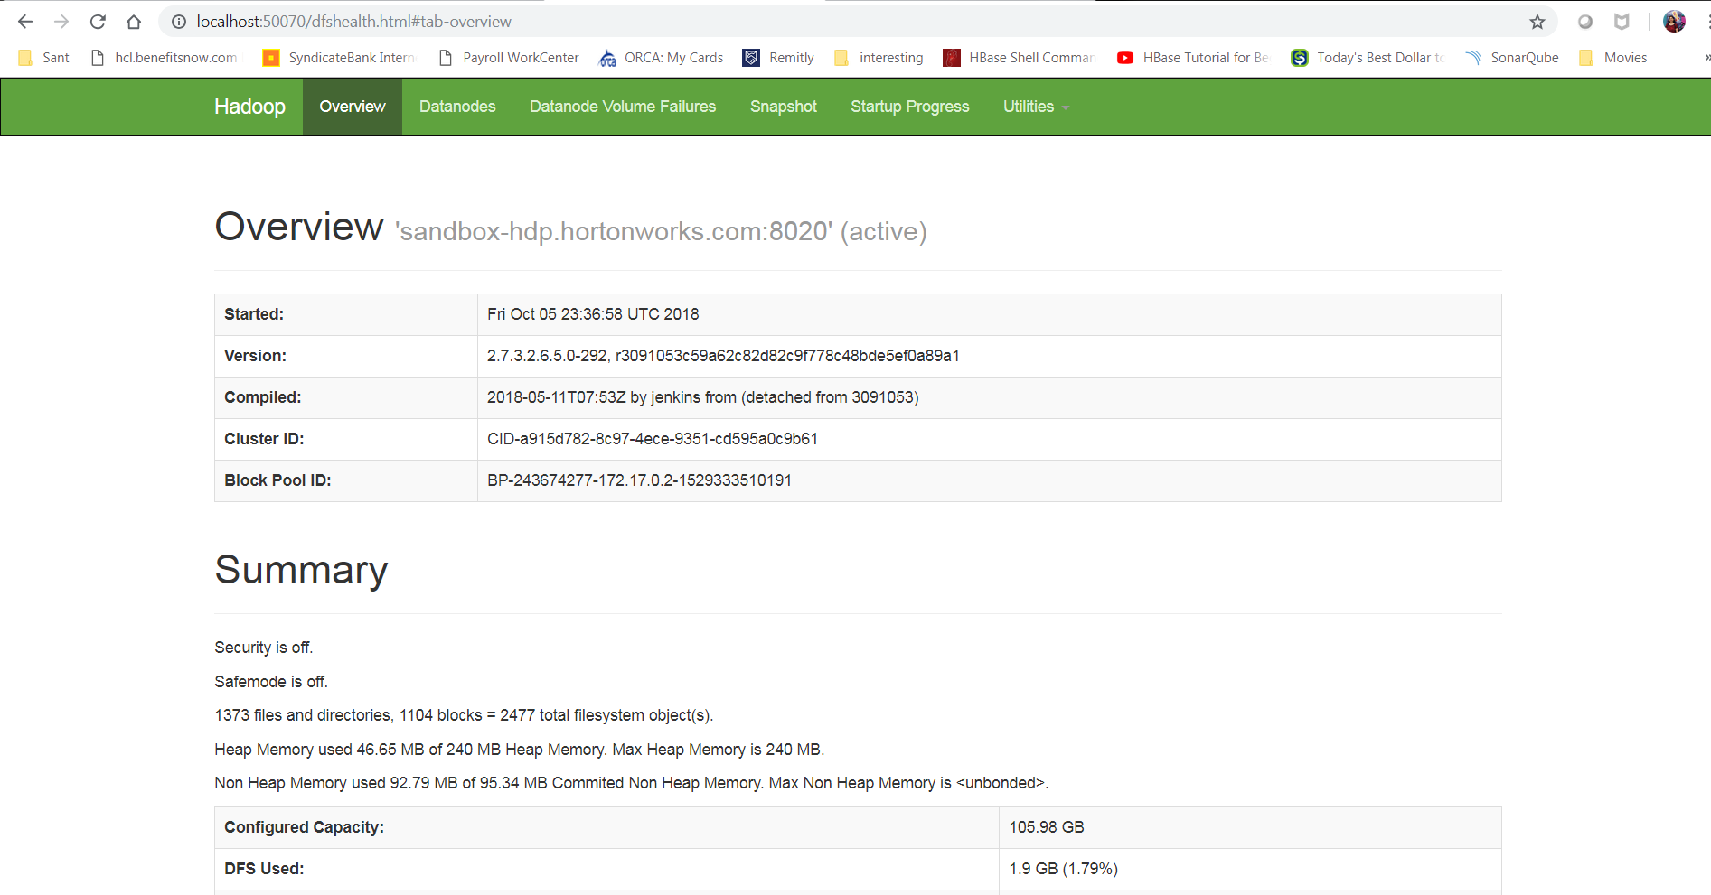

Browse the web interface for the ResourceManager; by default it is available at:

* ResourceManager - <http://localhost:8088/>
* 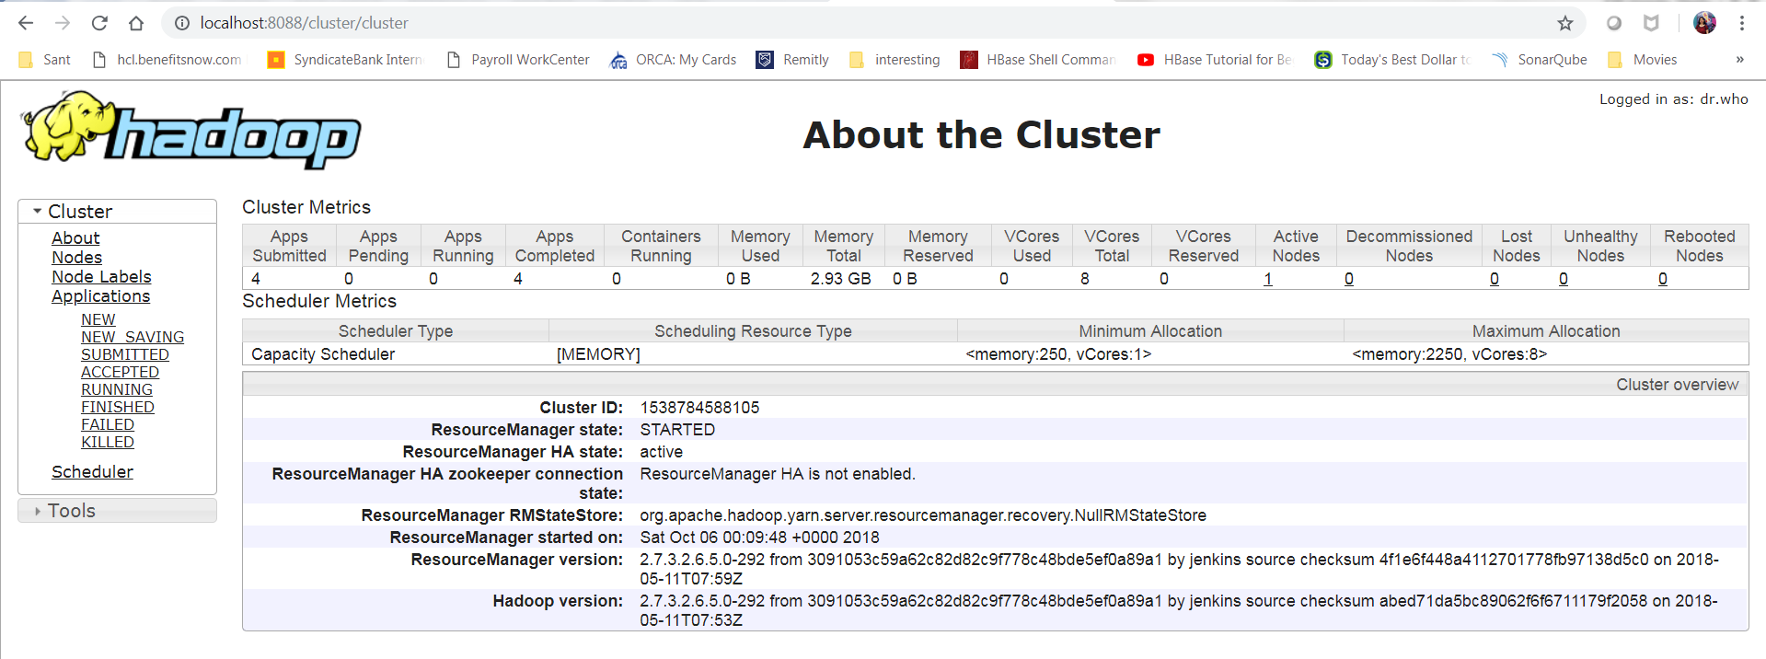

Typically one machine in the cluster is designated as the NameNode and another machine as the ResourceManager, exclusively. These are the masters. Other services (such as Web App Proxy Server and MapReduce Job History server) are usually run either on dedicated hardware or on shared infrastructure, depending upon the load.

* The rest of the machines in the cluster act as both DataNode and NodeManager. These are the slaves.
* HDFS daemons are NameNode, SecondaryNameNode, and DataNode. YARN daemons are ResourceManager, NodeManager, and WebAppProxy. If MapReduce is to be used, then the MapReduce Job History Server will also be running. For large installations, these are generally running on separate hosts.