formance Testing

Boeing-eCFD

Revision History
Version No | Date | Prepared by/Modified by | Significant Changes
1.0 | 14-Aug-2017 | Shelly/Krishna | Performance test results for the eCFD pre environment

Table of Contents
1.1. Performance Test Details 4
1.2 Test Execution Instructions and Results 4

Performance Test Details

S.NO | Test Description | Details
1 | Concurrent User Load Test in eCFD Application using Jmeter script | 10 User count
2 | Ingesting 100 Solution.json files in a single curl command in DA | 100 Solution.Json count
3 | Ingesting 100 MB file in a single plan using curl command in DA | 100 MB file size
4 | Search plan in eCFD Application using Jmeter script | WIP
5 | Time taken by DA to process a Solution.Json by harvesting the Postgres data | WIP

1.2 Test Execution Instructions and Results
Instructions
Below are the details of the tests.
- Concurrent User Load Test in eCFD Application using Jmeter script.
Test Setup/Execution Steps:
Step1: Setup the Jmeter on the machine where the test need to be run to connect the environment.The apache Jmeter setup is available here.Open command prompt,goto Jmeter bin folder and start Jmeter bat.

Step2: In the Jmeter application open the file option from the menu bar and load the below Load testing script
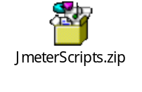
Step 3:Click on the “HTTP Request Defaults” on the left hand side window and change the Server name/IP to the Pre environment as shown below
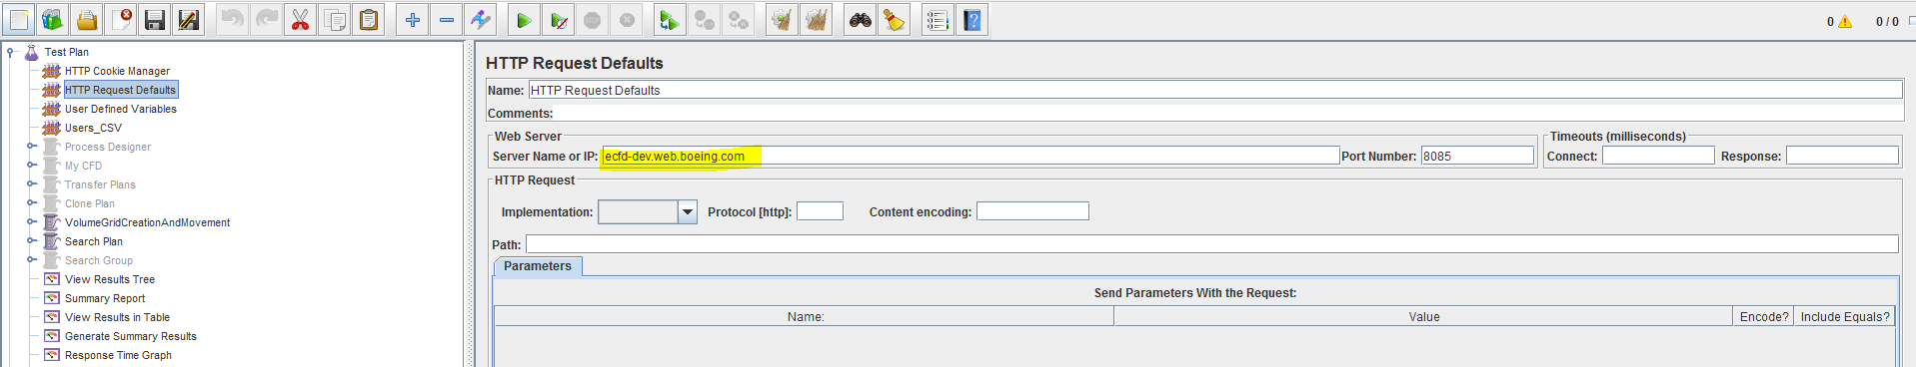
Step 4: Click on the “User Defined Variable” link in the Test plan on the left hand side window and do the environment changes accordingly as below
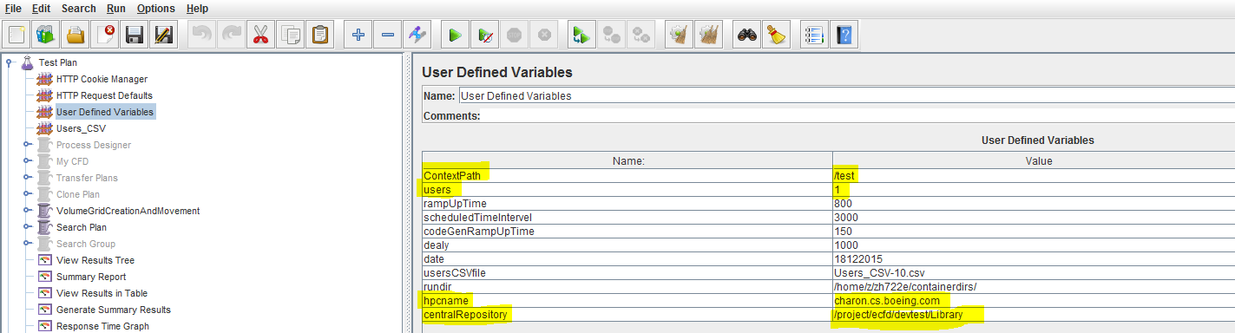

Step 5: Open the CSV file present in Jmeter scripts folder and change the test user’s Bemsid and run directory path on the HPC server.

Step 6: Click on the “Summary Report” link on the left hand side window and click on the greeon arrow button the top menu bar to run the test

Result:
Below are the results captured while running on Pre environment:
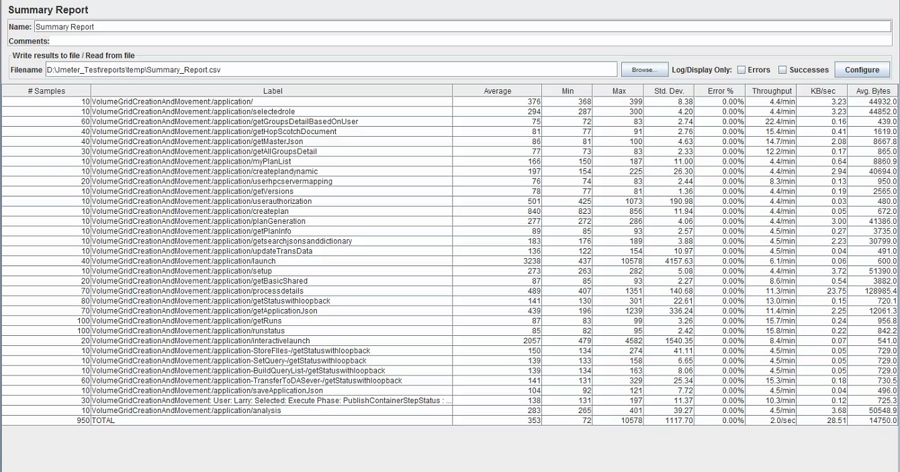
Attached here

Test Result Summary: The max time taken by the request call in eCFD application is 2seconds only.

- Ingesting 100 Solution.json files in a single curl command in DA
Test Setup/Execution Steps:
Step1: Setup a shell script to create a curl command using 100 files present in the Charon directory that need to be tested.
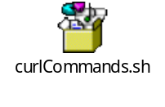
Update the script according to the file count and the eCFD URL

Step 2:Connect to Hadoop HDO3 edgeNode ,copy the script in some directory and run the script

Test Result Summary: The max time taken by the shell script with curl command to ingest

- Ingesting 100 MB file in a single plan using curl command in DA
Step 1: Logon to
- Search plan in eCFD Application using Jmeter script
- Time taken by DA to process a Solution.Json by harvesting the Postgres data

