**"Luna and the Missing Stars"**

Every evening, she would climb the tallest tree and count the stars.

But one night… the stars were gone.

Not one twinkle. Not one shine.

"Where did they go?" Luna gasped.

She grabbed her lantern and set off into the dark forest.

תמונה שמכילה ירח, מנורה, לילה

תוכן שנוצר על-ידי בינה מלאכותית עשוי להיות שגוי.

She met Owl first.  
"I saw a shadow flying fast," he said. "Toward the mountain."

"Thank you!" Luna called, hurrying on.

Next, she found Bear snoring in a cave.  
“Did you take the stars?” she asked.

Bear blinked. “Stars? No, just dreaming of honey.”

תמונה שמכילה ירח, תמונה, סרט מצויר, לילה

תוכן שנוצר על-ידי בינה מלאכותית עשוי להיות שגוי.

Finally, Luna reached the mountain peak.

There, a tiny dragon sat, cradling the stars in its wings.

"They’re so pretty," the dragon whispered. "I just wanted to

keep them."

Luna sat beside him.  
"They are beautiful. But they belong to everyone."

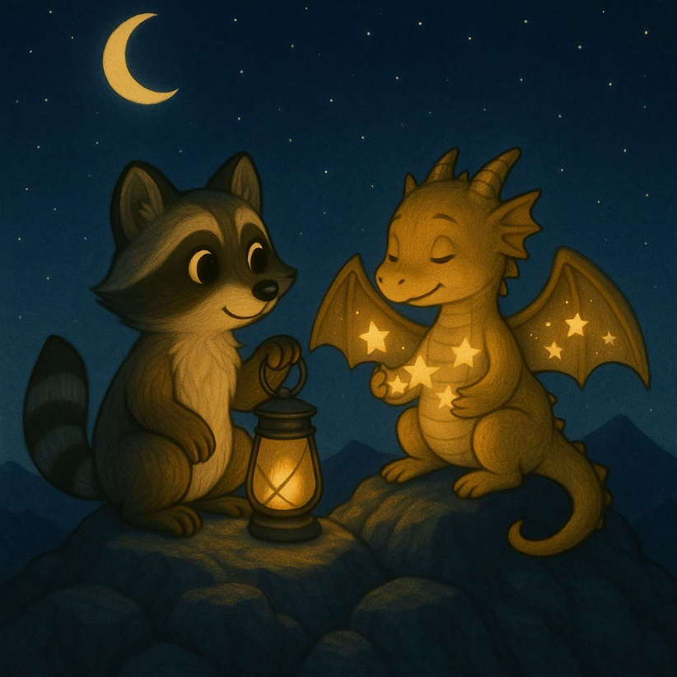

The dragon looked sad.  
"I didn’t mean to steal."

Luna smiled. “Let’s share them together.”

So, they flew up, side by side—  
and one by one, they placed the stars back in the sky.

That night, the forest glowed again.

Luna and the dragon watched the stars sparkle above.

And from then on, every night, they counted them—together.

תמונה שמכילה צורת בעל חיים, תמונה, אומנות, סרט מצויר

תוכן שנוצר על-ידי בינה מלאכותית עשוי להיות שגוי.